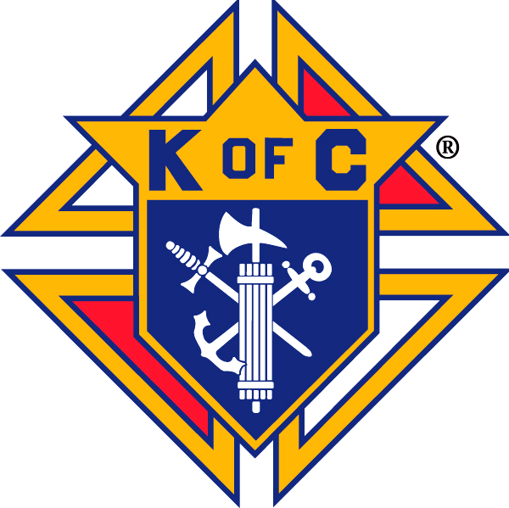The Knights of Columbus are sponsoring a Day of Reflection by their State Chaplain,



**Father William Lesak:**

* **The Three Forms of Discipleship: Essential Discipleship, Mature Discipleship**

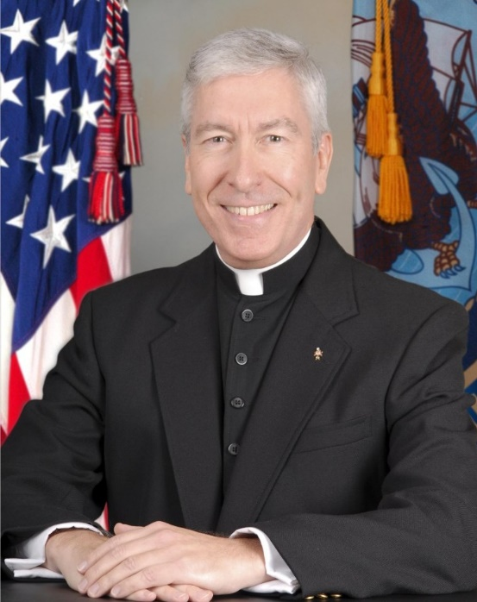

**& Radical Discipleship**

* **The Future Church & the Trends Shaping and Reforming the Church in the**

**21st Century.**

* + **Why Are Young Catholics Abandoning the Church & Where Are They Going?**

Cost is $10 per person to cover costs. Register at: <https://www.signupgenius.com/go/60b0949aeac23a13-september>

**(There is a $1 service fee if you pay online.)**

This is a mini-retreat in an interactive, intimate setting. The “Day” will start with Mass and include a light breakfast and box lunch. Open to all adults of the parish, however, registration is limited to the first 50.

*Information: Dick Christian,* [*dchristian@imcsuretysolutions.com*](mailto:dchristian@imcsuretysolutions.com) *or 704-577-1911*