**Technology Overview:**

**-Packages**

We chose to do much research into available packages, and which prebuilt layouts and systems would best harness our creative vision of the high-fidelity model. The first package that best helped us harness technologies to achieve our goals was Bootstrap. Bootstrap is a free and open-source CSS framework providing a good baseline for forms, buttons and navigation. We used some of the templates and style sheets to speed up our development times and used that saved time to better integrate much more complex technologies described later.

-**Technologies**

Aside from the basics of HTML, CSS and breadcrumbs we implemented a variety of different more complex technologies to best aid in the production of our high-fidelity prototype. Firstly, we decided to use JavaScript to implement temporary storage of values entered in the checkout process. Next, we decided to implement google maps API to aid us displaying the possible rental locations. Finally, we used some of the frameworks from the Bootstrap library to best implement our vision of the checkout process.

**Design Deviations and Evolutions:**

Reflecting on our prototype evaluation in the previous milestone we began the process of reconsidering our layouts and features given the real user feedback. We first started by improving and highlighting the features and layouts that worked and were enjoyed by our potential users. Firstly, we put more time and effort into developing the map page on our website. This page was highlighted by three out of 4 of our potential users as being the most effective and efficient page. Much of our development went into improving that design and making sure the features highlighted by our potential users transferred and improved in the high-fidelity prototype. We also implemented feedback given by the class and some of our potential users by narrowing the rental location first by drop select menu’s before even showing the rental locations on the map. Many found frustrations in our previous prototypes by the lack of ability to narrow down the location by country then province and city.

Secondly, we took the feedback we received about the bike selection page and implemented a handful of changes. The first of those changes was to better display the length of rental information. In our last prototype we had the duration of the rental hidden behind a drop-down menu and many found that to be difficult to navigate and thought it would be best displayed prominently on the page header. We took that feedback in stride and made that change immediately. The second of those changes was to the descriptions of the bicycles. Many users found that they would have liked the option to see some of the technical details of the bikes as they might be more avid bike riders looking to rent something specific. Implementing that feedback, we added further descriptions underneath the bicycle images.

The final bit of design evolution comes from implementing a reactive website design that could resize for desktop as well as mobile to best service all our potential customers. We chose to do this as we learnt that many users might book on their laptops or home computers and then bring the QR code on their phones to scan and unlock the bikes they rented.

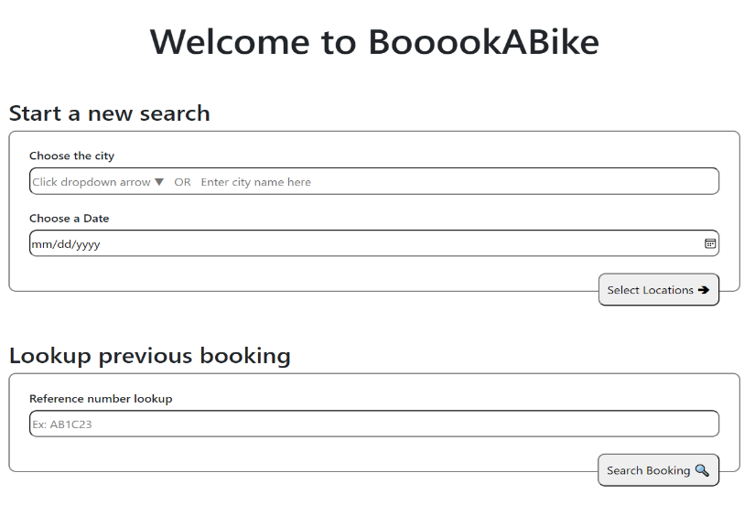**Usability “Sales Pitch”:**

* **Visibility:**

We created the title page with the design principle visibility completely in mind. We focused on highlighting the main functionality of the creating a new booking and looking up a previous booking option. With visibility in mind, we decided to hide the pop out calendar from the user unless it was selected as it is a secondary user function. We also focused on making visible properties that guide the user’s next step. Like a calendar symbol next to date, placeholder text in the inputs and a magnifying glass to signify the searching action.

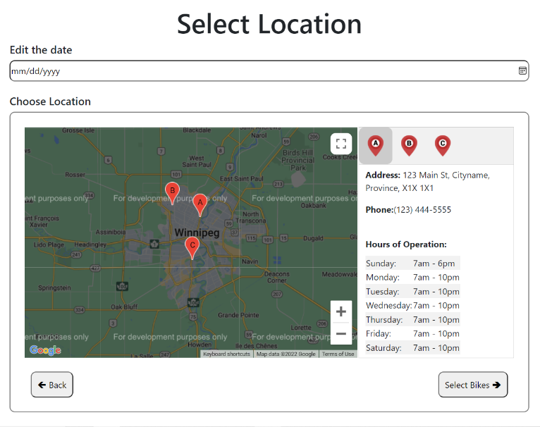

* **Diagnose and Recover from Errors:**

Looking at the location selection page we recognized that the user might change their mind on the date of the rental while selecting the location for the rental. We better understood this after watching a potential user try out the interface and change their mind on their rental date after seeing the hours of operation for the location they wished to rent from. Harkening back to the course material we learnt we thought that this would be an excellent location to implement a process that would aid in reducing capture errors. We reduce the capture errors by allowing the user to undo their previous date selection and choose a new one.

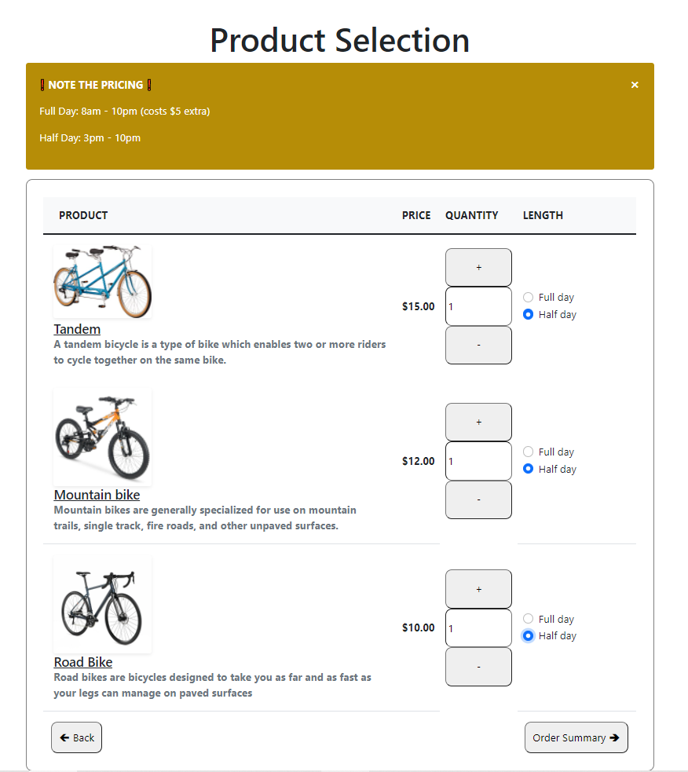

* **Simplicity**

Keeping in mind the very important design principle of simplicity we created our order page to be as simple and fool proof as possible. We strived to minimize the number of steps required to select quantity, type and length of rental while also providing the integral information our users require to make those purchasing decisions. This page only has 2 different types of controls. It has a quantity increase/decrease combo and a length checkbox. The use of only two types of controls promotes memorability and decreases user process time. Only necessary graphics and information are included on this page.

* Graphical user interface

  Description automatically generated with medium confidence**Affordance**

During our development the design principle of affordance really struck a cord with our team. The use of metaphors to suggest affordance is a very powerful tool. Within our website there are many different examples of our uses of affordance but the one we chose to highlight is the Pin drop as a location on a map. Putting a pin in a map to show a location of interest is an action that has migrated relatively unchanged as our mapping technology has continued to improve. The red pin has become synonymous with a point of interest or a destination. While developing this page we thought it was of the utmost importance to convey the locations accurately while also drawing the user’s attention battling with the complexities of a large map.

* 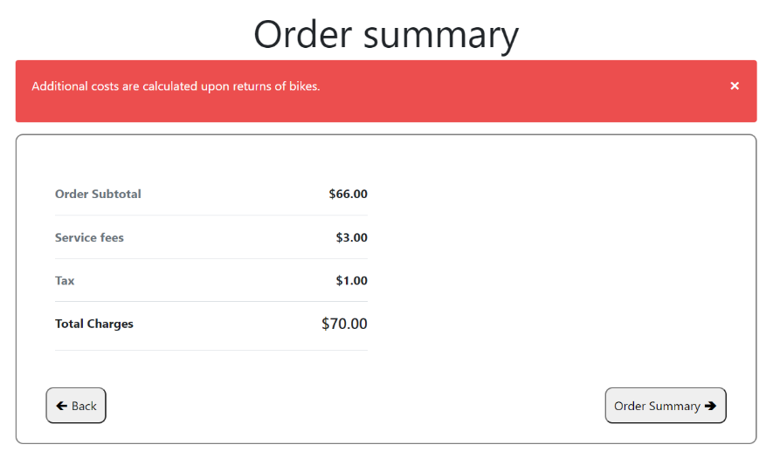**Consistency**

While examining each page of our website it is very clear that we considered the re use of design elements and the importance of keeping familiar and simple layouts for out pages. This consistency of graphics was very important to us when considering the layout for the forward and backwards buttons on each page. This consistency will help reduce frustration, learning time and errors in the scheduling process. Consideration also went into creating a UI that was consistent across all our pages so that our users knew if they had or had not left our site at any point during their usage.

* **Constraints**

Understanding the importance and necessity of constraints with the input of sensitive information. Our team decided to employ the use of the design principle constraints to give the accepted range of usage possibilities within our checkout page. Communicating with the user what the expected input should look like and verifying the inputs once inputted are paramount to the success and usability of a checkout page. Utilizing the Bootstrap package, we implemented a design that clearly shows the input constraints some of which are soft and some of which needed to be hard constraints. An example of a soft constraint was the need for some input under cardholder name. An example of a hard constraint was the need for the credit card number to be all numbers and of the credit card length (16 digits).