TransitRisk: Cost-Sensitive, Calibrated Next-Hour Delay Risk Forecasting for Urban Transit Operations

Abstract
Urban transit systems regularly experience delay spillovers that degrade reliability and increase both passenger and operator burden. This report presents TransitRisk, an end-to-end machine learning system for predicting next-hour elevated delay risk at the station-route-hour level. The implemented pipeline includes synthetic data generation, preprocessing, temporal feature engineering, model training, calibration, threshold optimization, uncertainty estimation, and dashboard deployment. The dataset starts from approximately 1.25M trip events and aggregates to approximately 153K station-route-hour records. Seven candidate classifiers are evaluated, and calibrated XGBoost is selected for deployment. On held-out test data, the final model achieves ROC-AUC 0.810, PR-AUC 0.766, F1 0.643, and Brier 0.169. A cost-sensitive threshold policy with (C_{FN}=5), (C_{FP}=1) yields (t_{cost}). Conformal prediction is integrated to expose uncertainty in operator-facing views.

I. Introduction
Transit delay is operationally costly because disruptions propagate across routes, stations, and time windows. Simple rule-based thresholds and short-horizon heuristics often fail under dynamic weather and demand conditions. TransitRisk addresses this gap with an end-to-end ML system that predicts whether a station-route pair will experience elevated delay in the next hour and converts risk estimates into actionable decisions.
Contributions
- End-to-end pipeline from synthetic data generation to deployed dashboard.
- Strict temporal split and leakage prevention.
- 38-feature design across temporal, lag, weather, and interaction categories.
- Calibration, cost-sensitive thresholding, and conformal uncertainty integration.
- Multi-tab decision support dashboard.

II. Dataset Description
A. Synthetic data motivation
Real transit operations data with route-level disruptions, weather linkage, and incident traces is often proprietary or restricted. We therefore use a synthetic dataset with realistic structure rather than arbitrary random data, enabling reproducible experimentation and full system testing.

B. Scale and granularity
- Trip-level events: approximately 1.25M
- Aggregated modeling table: approximately 153K
- Modeling unit: station-route-hour
C. Dimensional context
Each row includes:
- station and route identifiers,
- timestamp-derived temporal context,
- weather context (e.g., precipitation, wind),
- operational context (headway, demand, incident proxy, vehicle type),
- lag/rolling delay signals.
D. Target definition
Binary target: elevated delay in next hour.
$$y_{t+1}=1 \text{if next-hour mean delay}≥5\text{ min, else }0$$
This matches project code paths where next-hour delay is transformed into y_primary / is_delayed.
E. Split protocol
The core training pipeline uses a strict temporal split (60/20/20):
- Train: 60%
- Validation: 20%
- Test: 20%
Ordering checks in the feature-engineering stage confirm train < val < test in timestamp space.

III. Data Preprocessing
A. Cleaning and consistency checks
- schema verification and timestamp coercion,
- station-route consistency checks,
- invalid/missing signal handling at event and aggregated levels.
B. Aggregation
Raw trip events are converted to station-route-hour records with summary statistics (delay, demand/headway proxies, weather alignment, incident presence). This aggregation matches control-room decision resolution.
C. Missing-value strategy
Missing values are handled with train-consistent imputation and explicit unknown handling for categorical context. Critically, future values are not used to fill lagged features.
D. Temporal alignment and leakage prevention
- Features at time $t$ use only present/past information.
- Labels correspond to $t+1$.
- Temporal splits avoid future-to-past contamination.
- Lag validity checks are performed during feature engineering.
E. Encoding/scaling
Encoding and preprocessing are model-aware. Tree-based deployment model (XGBoost) minimizes sensitivity to aggressive scaling, while pipeline baselines (e.g., kNN/SVM) use standard scaling where required.

IV. Proposed Framework
A. Problem formulation
Given feature vector $x_{t}$ for a station-route-hour instance, predict:
$${\hat{p}}_{t+1}=P(y_{t+1}=1∣x_{t})$$
and derive action via threshold policy.
B. Pipeline overview
- Data generation and audit
- Aggregation to station-route-hour
- Feature engineering (38 features)
- Temporal split
- Multi-model training
- Calibration
- Cost-sensitive threshold optimization
- Conformal uncertainty layer
- Evaluation + dashboard deployment
C. Feature groups
- Temporal indicators (hour, peak periods)
- Lag features (e.g., recent delay history)
- Rolling statistics (short-window dynamics)
- Weather features
- Interaction features
- Context features (station/route/vehicle behavior proxies)
D. Model set and final choice
Evaluated models:
- Logistic Regression
- Naive Bayes
- kNN
- Decision Tree
- Random Forest
- SVM-RBF
- XGBoost
Final deployment model: calibrated XGBoost
E. Calibration and thresholding
Calibration experiments include Platt and isotonic analyses; deployed artifact uses calibrated XGBoost probabilities. Decision threshold is optimized under:
- $C_{FN}=5$
- $C_{FP}=1$
Resulting operational threshold:
- $t_{default}=0.50$
- $t_{F1}≈0.345$
- $t_{cost}≈0.163$
F. Uncertainty
Split conformal prediction produces prediction sets (target coverage ~90%, $α=0.1$) used to expose confidence behavior in the dashboard.

V. Workflow Diagram
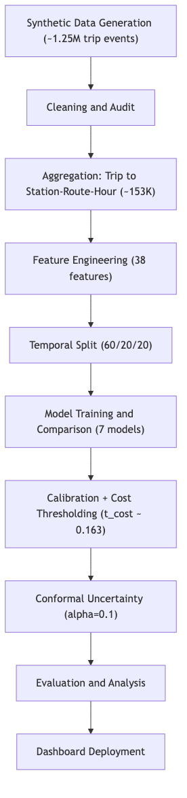
Figure 1: End-to-End Workflow of TransitRisk

VI. Experimental Design
A. Time-aware evaluation
Temporal split is mandatory for realistic deployment behavior in transit forecasting. Random splits can overestimate performance by mixing adjacent temporal regimes.
B. Metrics
- ROC-AUC: ranking ability
- PR-AUC: minority-class sensitivity under imbalance
- F1: thresholded balance
- Brier score: probability quality
C. Protocol
All candidate models are tested on held-out temporal test data. Cost-threshold behavior is analyzed separately from default threshold performance to reflect actual operational use

VII. Experimental Results
A. Model comparison
Model | ROC-AUC | PR-AUC | F1 | Brier
Logistic Regression | 0.7601 | 0.6764 | 0.5998 | 0.1916
Naive Bayes | 0.7083 | 0.5743 | 0.4887 | 0.2614
kNN | 0.7757 | 0.7185 | 0.5837 | 0.1851
Decision Tree | 0.7849 | 0.7249 | 0.5916 | 0.1782
Random Forest | 0.8061 | 0.7618 | 0.6691 | 0.1766
XGBoost (Final) | 0.8097 | 0.7662 | 0.6433 | 0.1691
SVM-RBF | 0.7534 | 0.6994 | 0.5853 | 0.1916
B. Interpretation
- XGBoost provides the strongest overall discrimination and best probability quality.
- Random Forest shows stronger F1 at the evaluated threshold, but XGBoost is better suited for calibrated risk-based decisioning.
- Cost-sensitive threshold $t_{cost}≈0.163$ intentionally shifts behavior toward catching risky cases (fewer costly misses).
C. Deployment-facing observations
- Risk spikes align with lagged delay + adverse weather combinations.
- Conformal uncertainty flags ambiguous situations where operators should use extra caution.
- Dashboard modules support both model diagnostics and operational action.

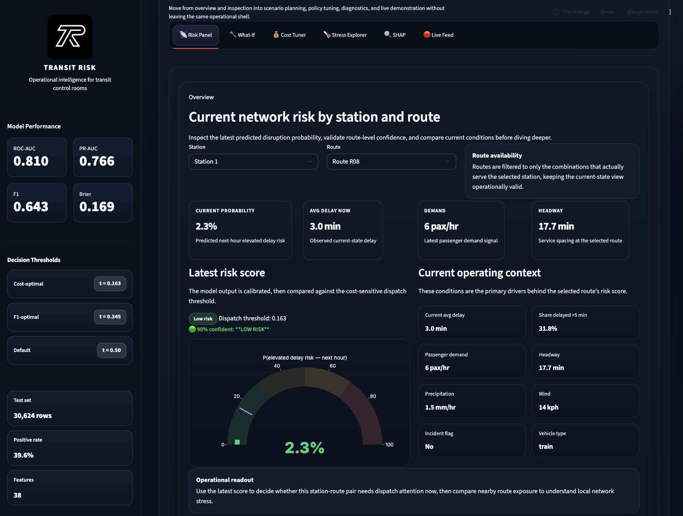
Figure 2: Dashboard Risk Panel

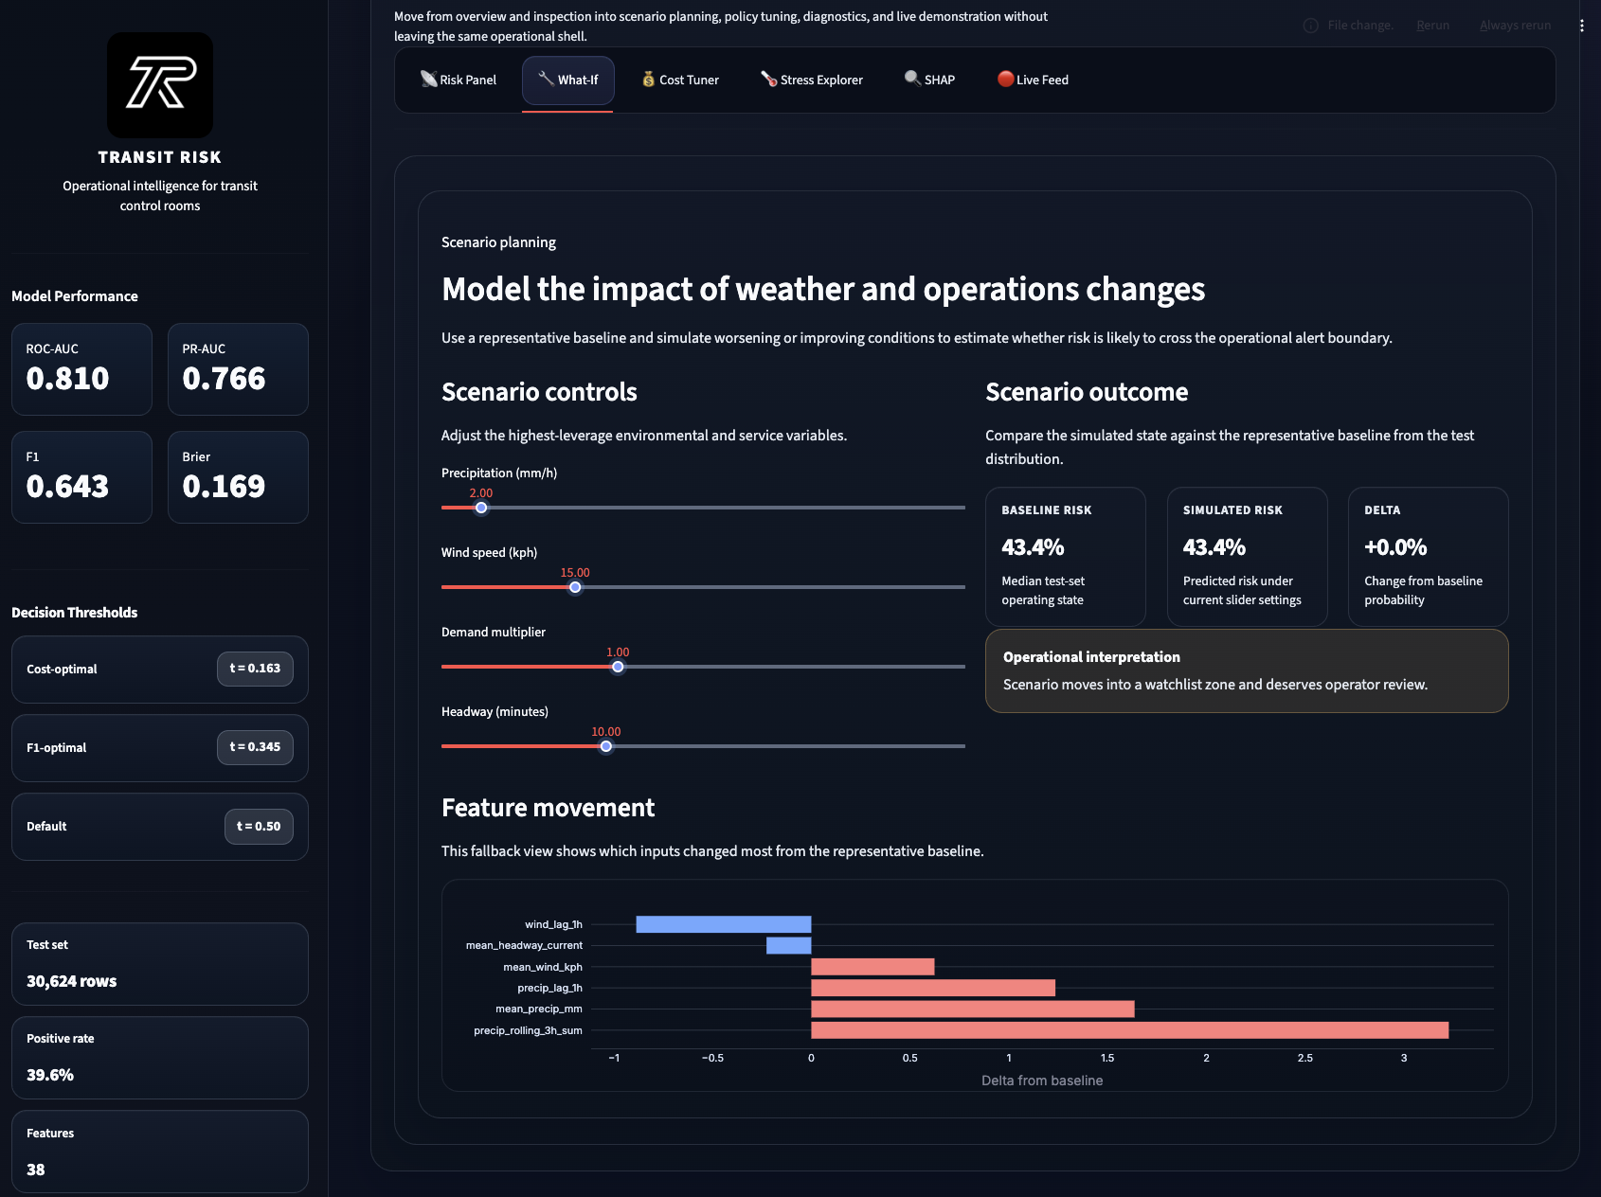
Figure 3: What-if Analysis Interface
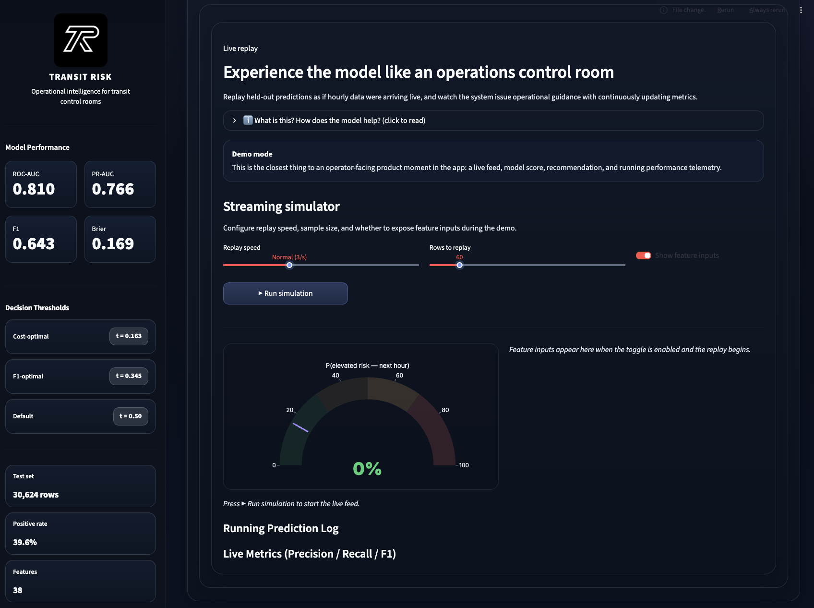
Figure 4: Live Feed Simulation View

VIII. System Architecture Diagram
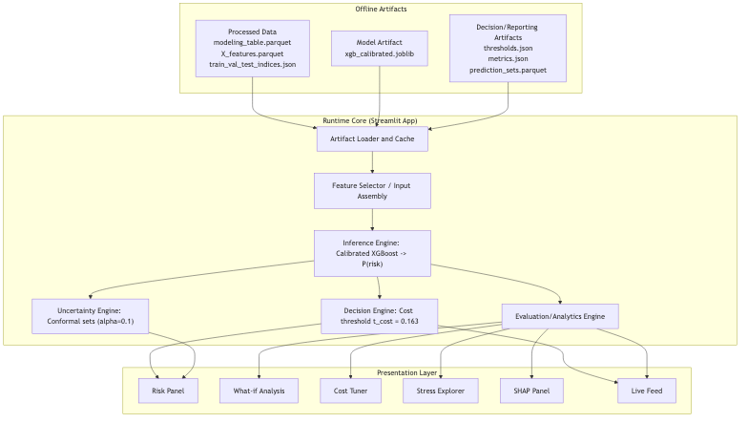
Figure 5: TransitRisk System Architecture

IX. Work Distribution
- Ayush: synthetic data design, aggregation, preprocessing QA.
- Manav: model development, dashboard integration, deployment flow.
- Parth: calibration, thresholding, conformal uncertainty, reporting.

X. Conclusion
TransitRisk demonstrates a full ML-to-operations pipeline for next-hour transit delay risk. The deployed system combines calibrated probabilistic forecasting, cost-aware decision policy, and uncertainty-aware interpretation in a practical dashboard.

