**Recommendations for further automation of Chatbot**

**conversation testing**

* If we have actual and expected result data sheet then we can pass all the data using data driven framework instead of passing manually in the script.

**What additional test suites should be created? Which tests would be functional vs non-functional?**

* We can add the stress testing
* We can check the load testing
* We can also add the security testing

**Recommendations or demonstrate integration with a CI/CD pipeline**

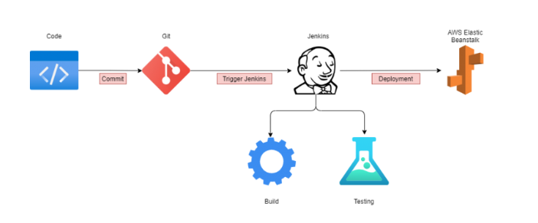

1. The developer develops the code and commits the changes to a centralized code repository.
2. When the repot detects a change, it triggers the Jenkins server.
3. Jenkins gets the new code and carries out the automated build and testing. If any issues are detected while building or testing, Jenkins automatically informs the development team via a preconfigured method, like email or Slack.
4. The final package is uploaded to AWS Elastic Beanstalk, an application orchestration service, for production deployment.
5. The elastic beanstalk manages the provisioning of infrastructure, load balancing, and scaling of the required resource type, such as EC2, RDS, or others.