**Module (jQuery Basic, Effects & Advanced) – 5**

**1. What is jQuery?**

**ANS:** jQuery is a JavaScript Library.

jQuery greatly simplifies JavaScript programming.

jQuery is easy to learn.

**2. How to Apply CSS Using jQuery, How to Add Class and Remove Class in**

**jQuery , jQuery Animation?**

**ANS :**

Apply CSS :

<!DOCTYPE html>

<html>

<head>

<script src="https://ajax.googleapis.com/ajax/libs/jquery/3.6.4/jquery.min.js"></script>

<script>

$(document).ready(function(){

  $("button").click(function(){

    alert("Background color = " + $("p").css("background-color"));

  });

});

</script>

</head>

<body>

<h2>This is a heading</h2>

<p style="background-color:#ff0000">This is a paragraph.</p>

<p style="background-color:#00ff00">This is a paragraph.</p>

<p style="background-color:#0000ff">This is a paragraph.</p>

<button>Return background-color of p</button>

</body>

</html>

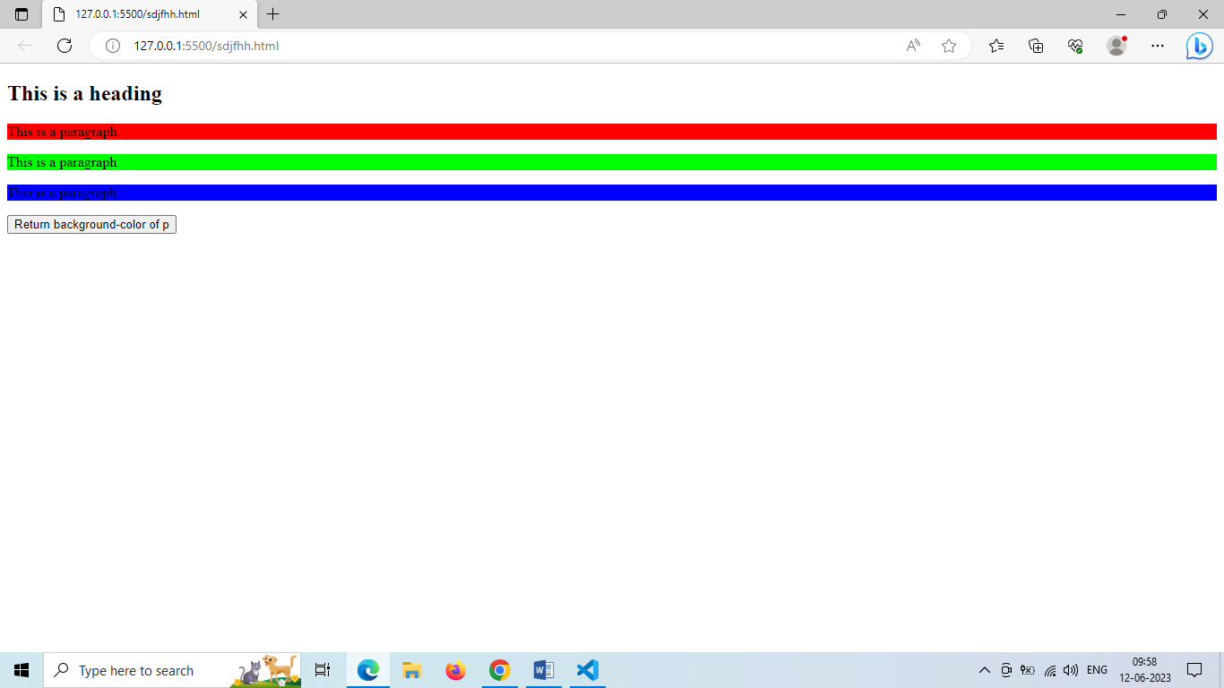

**Add class :**

<!DOCTYPE html>

<html>

<head>

<script src="https://ajax.googleapis.com/ajax/libs/jquery/3.6.4/jquery.min.js"></script>

<script>

$(document).ready(function(){

  $("button").click(function(){

    $("h1, h2, p").addClass("blue");

    $("div").addClass("important");

  });

});

</script>

<style>

.important {

  font-weight: bold;

  font-size: xx-large;

}

.blue {

  color: blue;

}

</style>

</head>

<body>

<h1>Heading 1</h1>

<h2>Heading 2</h2>

<p>This is a paragraph.</p>

<p>This is another paragraph.</p>

<div>This is some important text!</div><br>

<button>Add classes to elements</button>

</body>

</html>

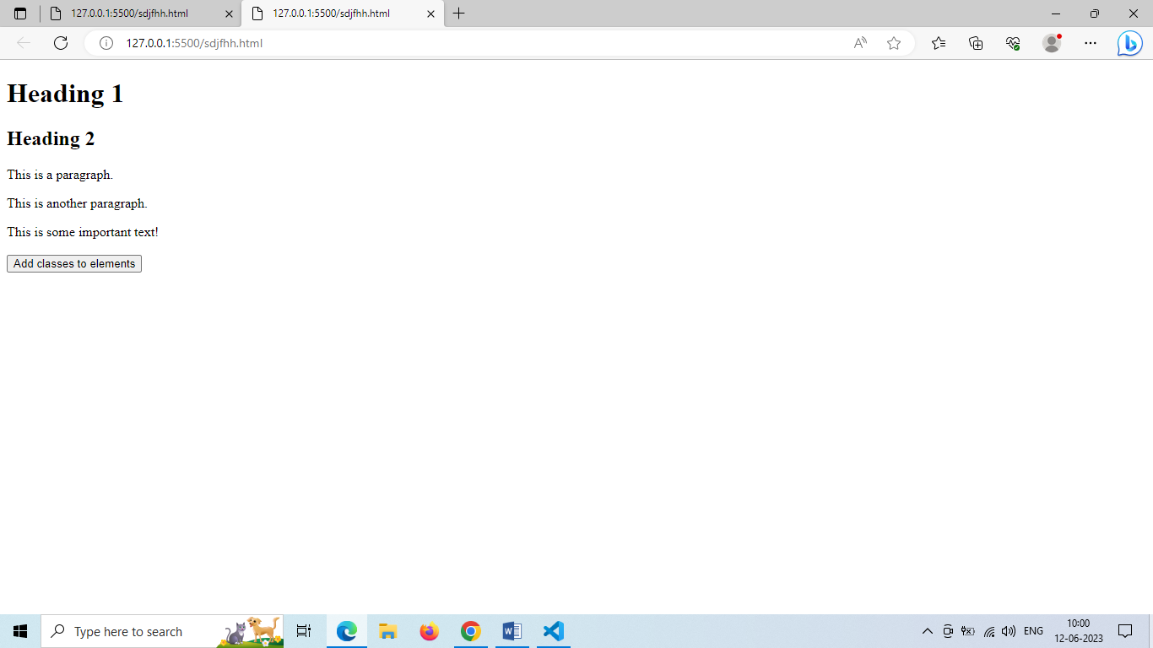

**Remove Class :**

<!DOCTYPE html>

<html>

<head>

<script src="https://ajax.googleapis.com/ajax/libs/jquery/3.6.4/jquery.min.js"></script>

<script>

$(document).ready(function(){

  $("button").click(function(){

    $("h1, h2, p").removeClass("blue");

  });

});

</script>

<style>

.blue {

  color: blue;

}

</style>

</head>

<body>

<h1 class="blue">Heading 1</h1>

<h2 class="blue">Heading 2</h2>

<p class="blue">This is a paragraph.</p>

<p>This is another paragraph.</p>

<button>Remove class from elements</button>

</body>

</html>

**Output :**

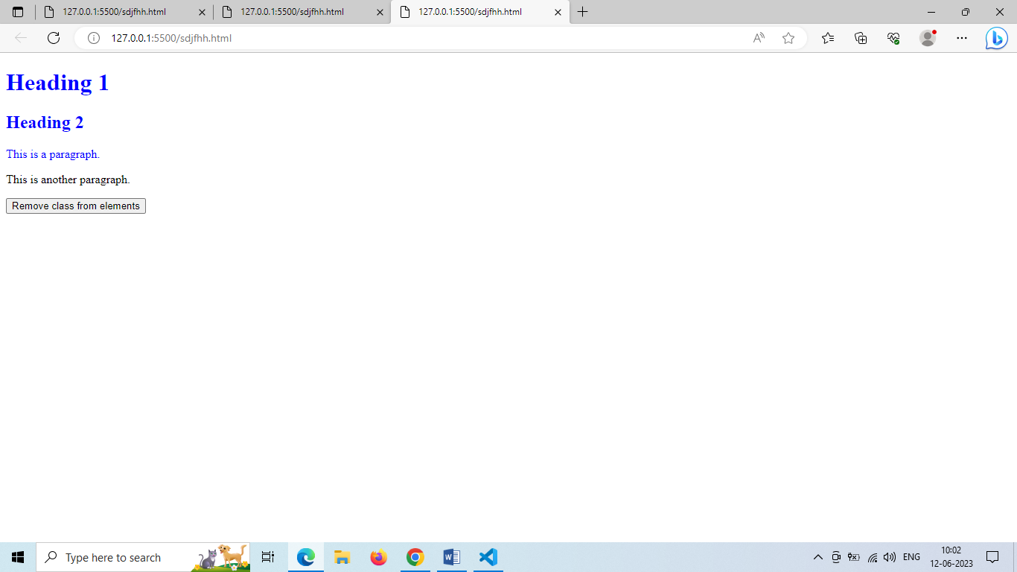

**3. How to create slider with animation?**

**ANS:**

<!DOCTYPE html>

<html>

<head>

<script src="https://ajax.googleapis.com/ajax/libs/jquery/3.6.4/jquery.min.js"></script>

<script>

$(document).ready(function(){

  $("#flip").click(function(){

    $("#panel").slideUp("slow");

  });

});

</script>

<style>

#panel, #flip {

  padding: 5px;

  text-align: center;

  background-color: #e5eecc;

  border: solid 1px #c3c3c3;

}

#panel {

  padding: 50px;

}

</style>

</head>

<body>

<div id="flip">Click to slide up panel</div>

<div id="panel">Hello world!</div>

</body>

</html>

