Smit Patel

M08582121

Charles Greenman

Project 3

**Operating System:**

Windows 10 (Intel Core I7)

**Language:**

We used python 3.7 IDE to compile and run our code in the command prompt with the example instructions given from the project3.pdf

**Libraries:**

We used pycryptodome, hashlib and imported Json

**Compile:**

In order to compile this code, we need to make sure, the root folder in the command prompt and use the main.py to run it with right file names for each of the 4 functions used. ( use the highlighted file names for the function)

**Key Generation Function:**

Root the folder in the command prompt and compile by **“python main.py keygen ../key/skaes.txt”**

Output:

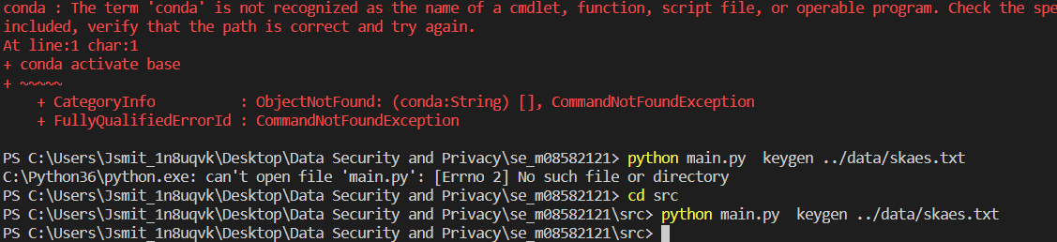

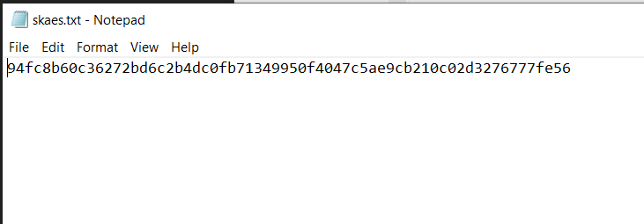

**Encryption Function:**

Root the folder in the command prompt and compile by **“python main.py enc ../data/skaes.txt ../data/index.txt ../data/files ../data/ciphertextfiles”**

Output:

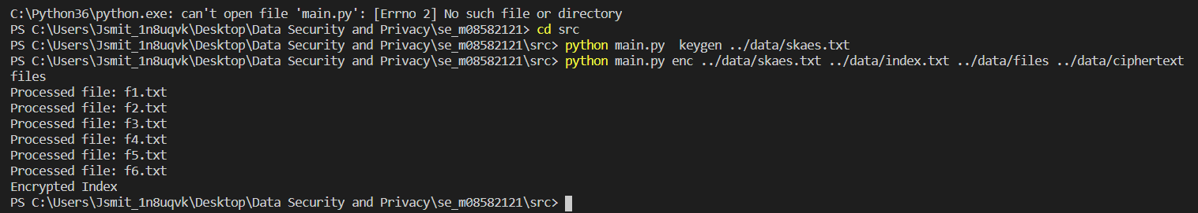

Indexfile Generated:

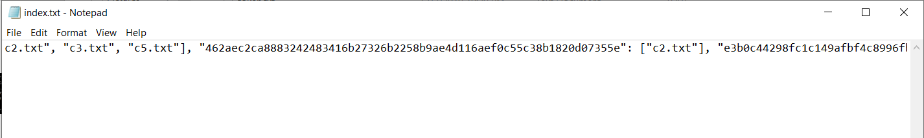

Ciptertextfiles Generated in the folder:

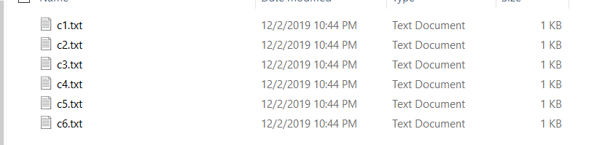

**Token Function:**

Root the folder in the command prompt and compile by **“python main.py token packers ../data/token.txt”**

Output:



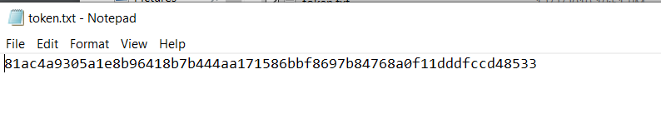

**Search Function:**

Root the folder in the command prompt and compile by **“python main.py search ../data/index.txt ../data/token.txt ../data/ciphertextfiles ../data/skaes.txt”**

Output:

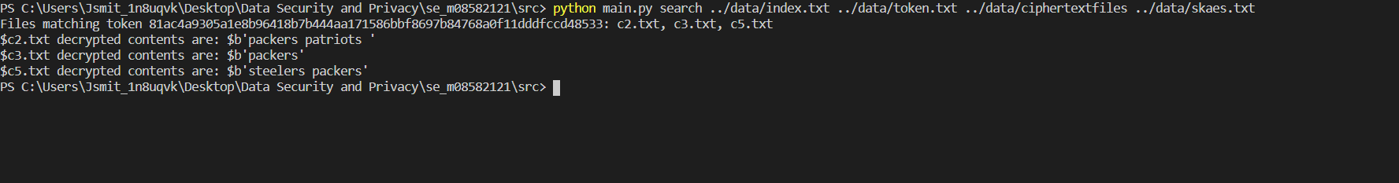

**\*The associated Token Files are decrypted (above).**