**Description Of project**

Live to dance Academy is a place to learn dance for the people who are interested.

It has following Pages :

Home Page,

About Page,

Programs,

Add New Program,

Admission Page

About Page has some info the Live to dance Academy.

Using Programs Page Admin can View, Add, Update Or delete the Programs.

Using Admission Page people can get register.

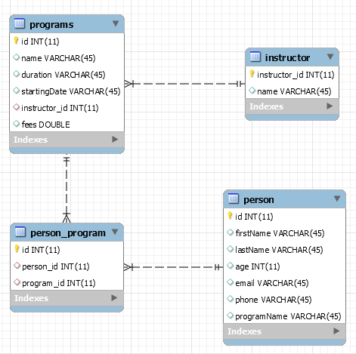

**Sequence Diagram Of Programs Page**



**Screenshots**

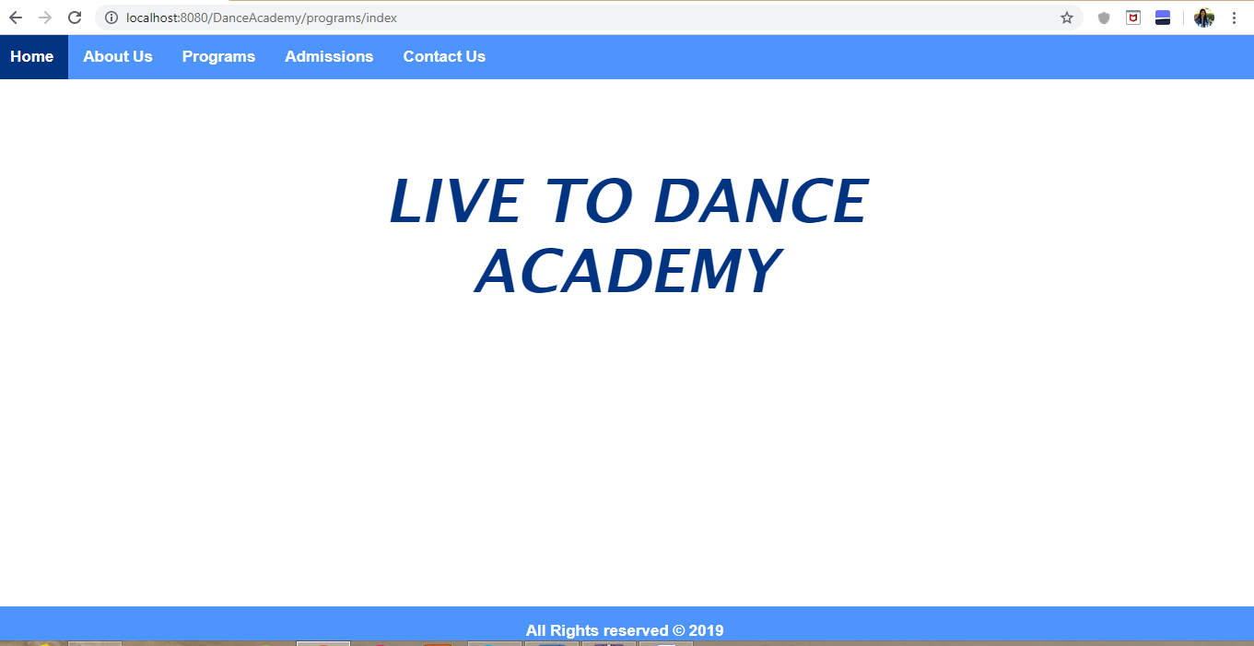

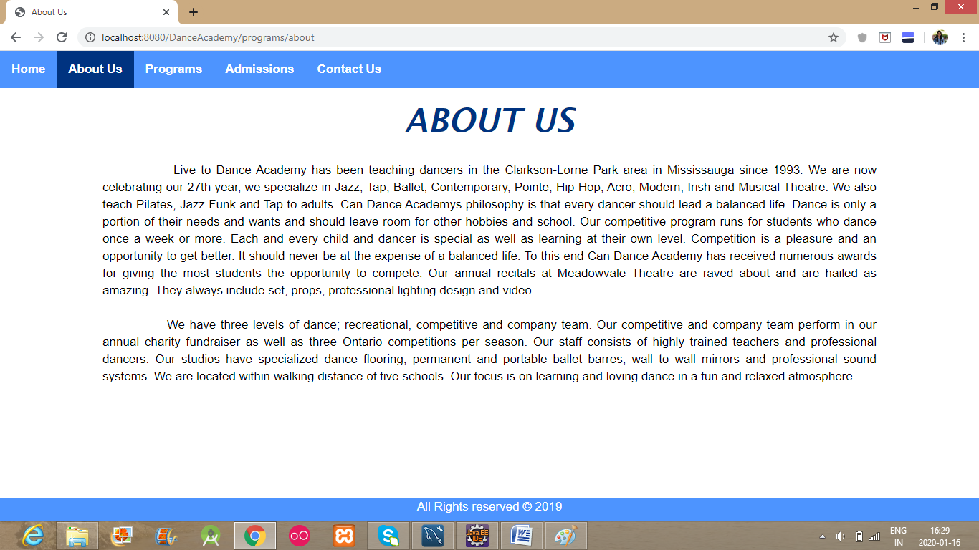

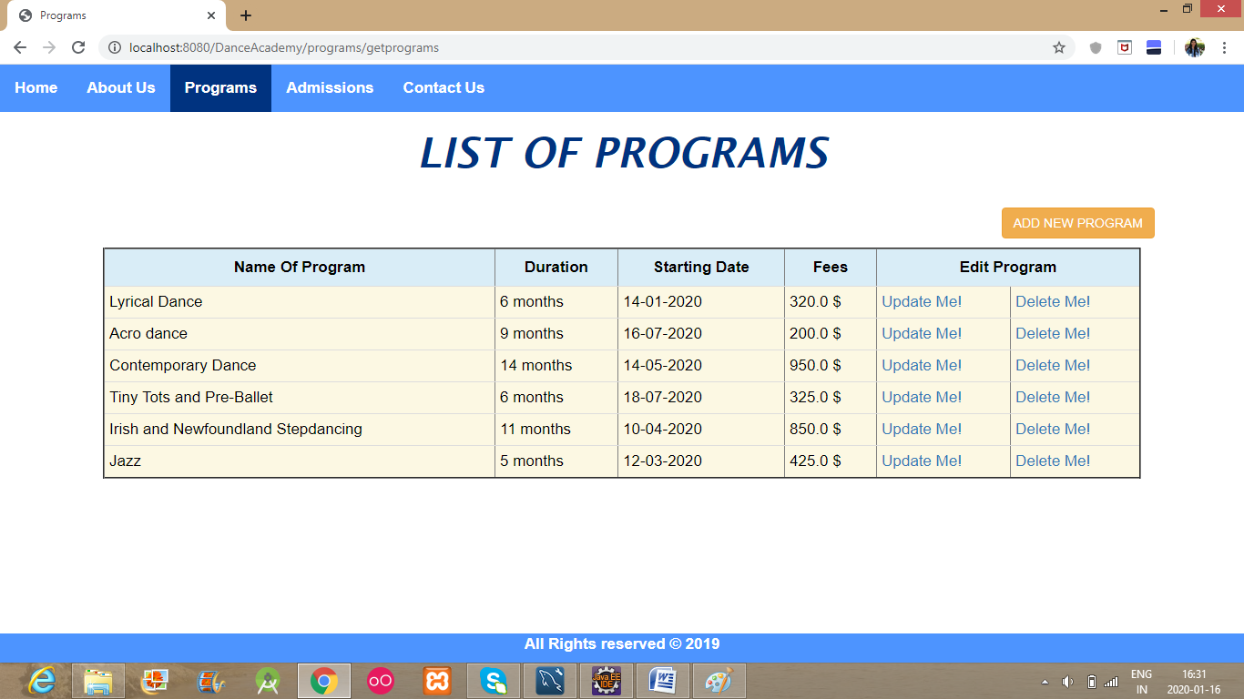

**Add New Program**

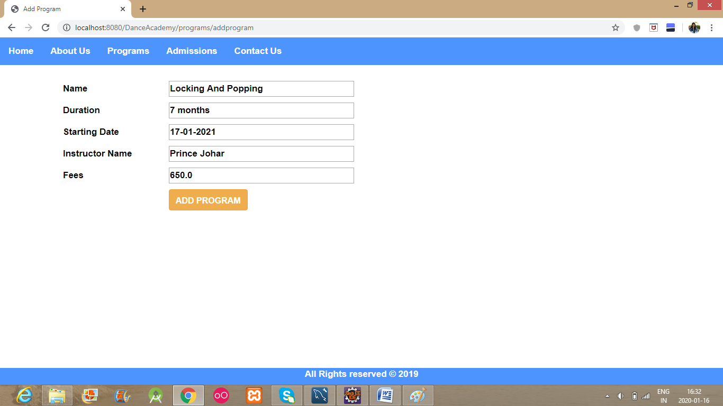

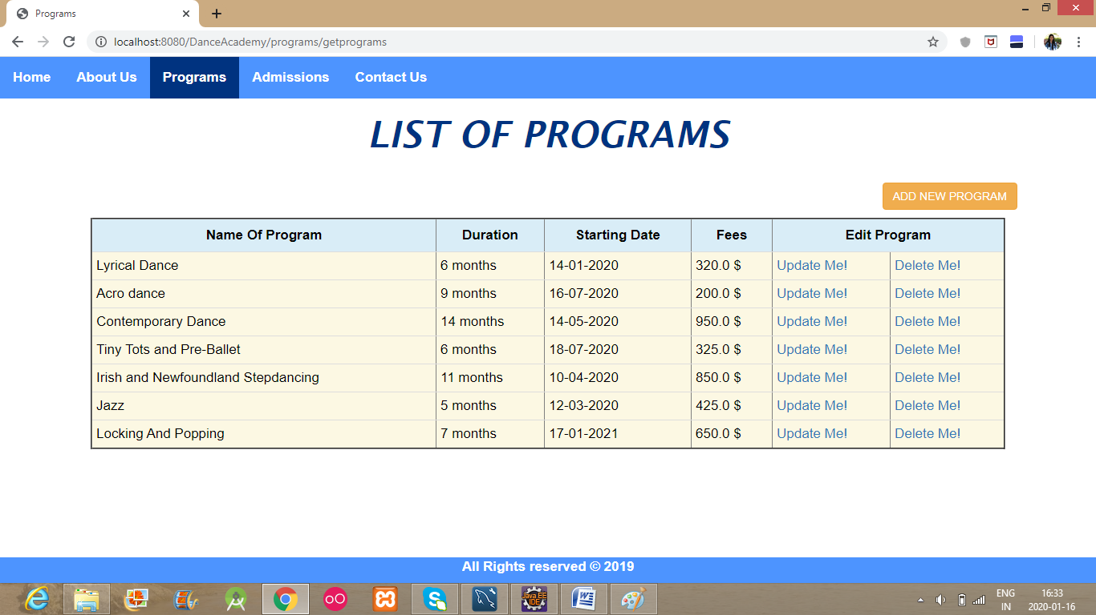

**Update A Program**

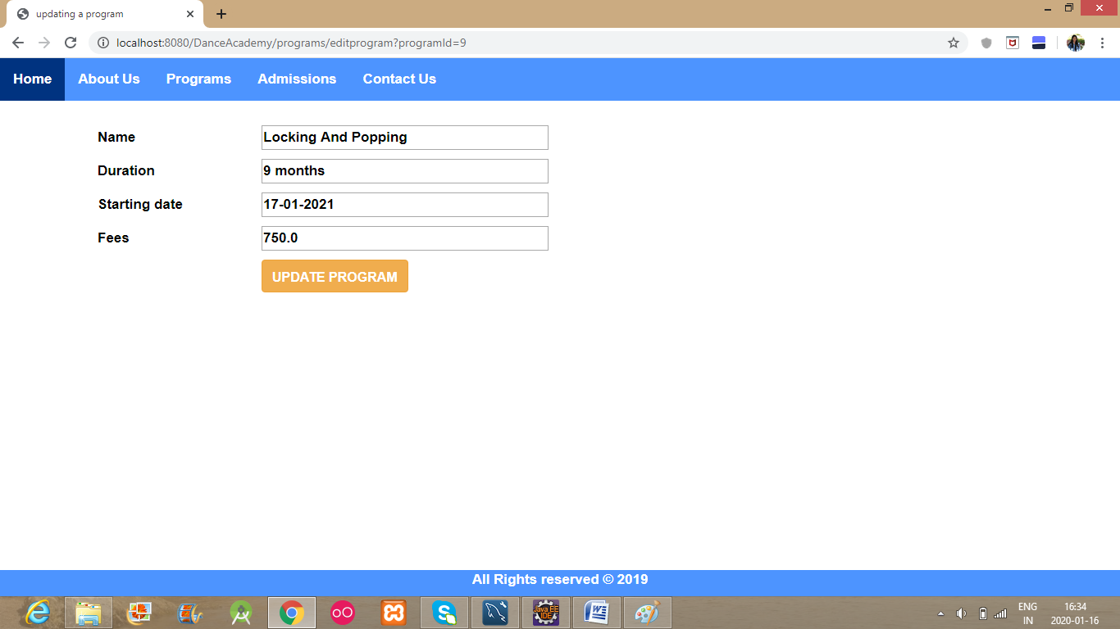

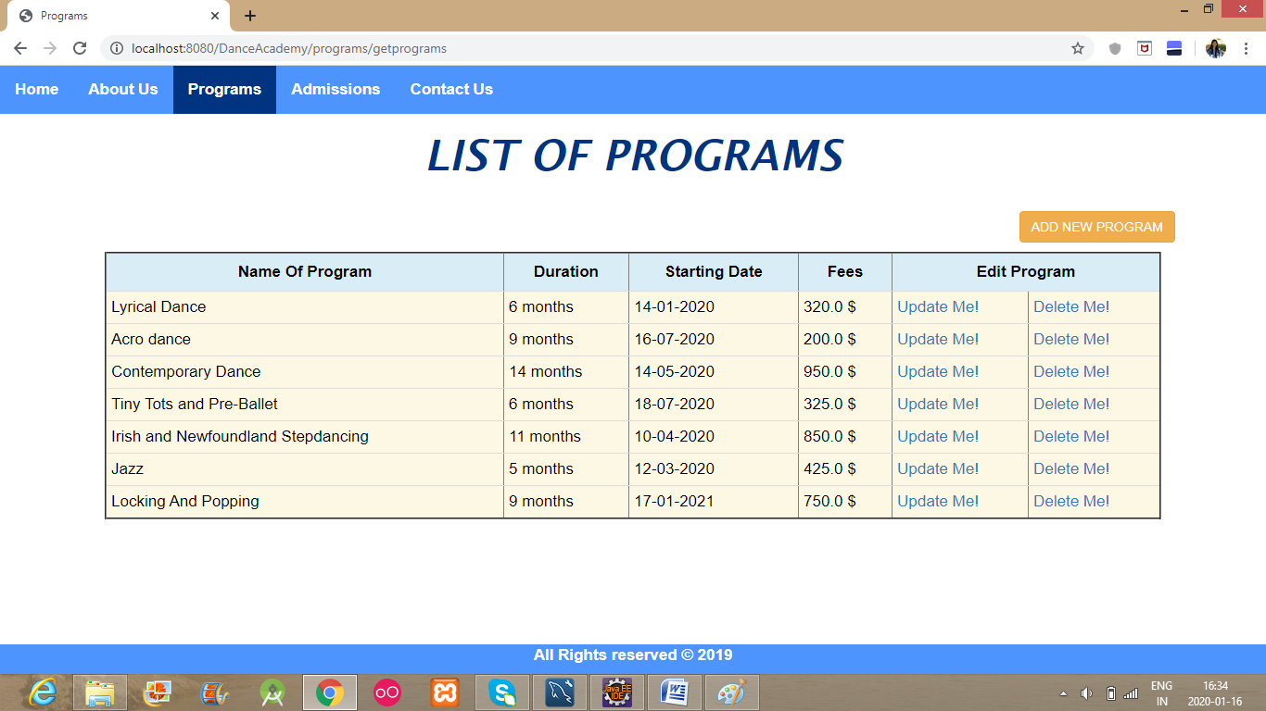

**Admission**

