Project Report on

**Image Colorization**

at

**Indice InfoTech**



**College Project Guide Prepared By** Prof. Amit Dangi Sir 19012531010 Alay patel

**B. Tech Semester VIII**

**(Computer Engineering-AI)**

April 2023

Submitted to,

Department of Computer Engineering-AI

U.V. Patel College of Engineering

Ganpat University, Kherva - 384012

**U.V. PATEL COLLEGE**

**OF**

**ENGINEERING**



**11/04/2023**

**CERTIFICATE**

TO WHOM SO EVER IT MAY CONCERN

This is to certify that **Mr. Alay Patel** student of B.Tech. Semester VIII (Computer Engineering-AI) has completed her/his full semester on site project work titled “**Image Colorization**” satisfactorily in partial fulfilment of the requirement of Bachelor of Technology degree of Computer Engineering-AI of Ganpat University, Kherva, Mehsana in the year 2022-2023.

College Project Guide Head, Computer Engineering Sign

Prof. Amit Dangi Sir Dr. Paresh M. Solanki

# Acknowledgement

It gives me great pleasure in expressing thanks and profound gratitude to **Mr.Meet Patel Sir**, Indice InfoTech, Ahmedabad) for his continued support throughout the project Work.

We would also like to thank my Faculty Guide, **Prof. Amit Dangi sir**, Department of Information Technology, U V Patel College of Engineering for his valuable guidance and continual encouragement throughout the Major project.

We are also thankful to **Dr. Rakesh Vanzara**, Head of Department, Information Technology, U V Patel College of Engineering, Mehsana for his continual kind words of encouragement and motivation throughout the Major Project.

We are thankful to all faculty members of the Department of Information Technology U V Patel College of Engineering, Mehsana for their special attention and suggestions towards the project work.

We are also thankful to the employees of Indice InfoTech for support and encourage me toward the training.

**Thank you, sir**

# Abstract

This project report presents a novel approach to image colorization using deep learning algorithms. The aim of the project is to transform black and white images into coloured images, using state-of-the-art deep learning techniques. The report begins by discussing the background and motivation for the project, highlighting the importance of image colorization in various fields such as digital restoration, archiving, and art. The report then provides a detailed description of the methodology used in the project, which involves training a deep neural network using a large dataset of colour images and their corresponding grayscale versions. The results of the experiments conducted on the model are presented, demonstrating the effectiveness of the proposed method in producing high-quality colorized images. Finally, the report concludes by discussing the limitations of the approach and the potential for future work in this field. Overall, this project offers a valuable contribution to the field of image processing and deep learning, providing a practical solution to the problem of image colorization.

**Table of Contents**

Acknowledgement i

Abstract ii

List of Figure VIII

List of Tables VIIIi

1. Introduction 1

1.1 Purpose 1

1.2 Project Scope 2

1.3 Problem Statement 2

1.4 OverVIIIew 3

2. Literature Survey 4

2.1 Literature Survey for Image Colorization 4

2.2 Literature Survey for Image Colorization 5

2.3 Literature Survey for Image Enhancement 5

2.4 Existing systems description 7

2.4.1 Imagecolorizer.com 7

2.4.2 Hotpot.ai 7

2.4.3 Colorizer.cc 7

2.5 Problems with existing systems 7

2.6 Solution applied in our project 8

3. Methodology 9

3.1 Tools and Technology 9

• Django 9

• JavaScript 9

• Python 10

• Open CV 10

4. Software Requirements Specification (SRS) 11

4.1 Feasibility Study 11

4.2 Hardware Requirements 11

4.3 Software Requirements 12

4.3.1 User 12

4.3.1.1 Sign Up 12

4.3.1.2 Login 13

4.3.1.3 Home 13

4.3.1.4 Upload Image 13

4.4 Project Planning 13

5. System Design 15

5.1 ActiVIIIty Diagram 15

5.2 Class Diagram 16

5.3 Sequence Diagram 17

5.4 Use Case Diagram 18

5.5 Data Dictionary 19

6. Prototype 20

6.1 Login Page 20

6.2 Signup Page 20

6.3 Home 21

6.4 Upload Image 23

6.5 Download Image 23

7. Implementation 25

8. Software Testing 28

8.1 Testing Plan 28

8.2 Testing Method Testing Method 28

8.3 Testing Cases 28

8.3.1 User 28

9. Conclusion & Future work 30

9.1 Conclusion 30

9.2 Future Work 30

10. Detail About Models 31

10.1 Image colorization 31

10.1.1 Architecture 31

10.1.2 Convolutional Neural Network 31

10.1.3 Conv Layer 31

10.1.4 LAB color space 31

10.2 Image Colorization 32

10.2.1 Architecture 32

10.2.2 Convolutional Neural Network 32

10.2.3 LSTM 33

10.2.4 SoftMax Activation Function 33

10.3 Image Enhancement 34

10.3.1 Architecture 34

10.3.2 Convolutional Neural Network 34

10.3.3 FSRCNN 34

10.4 Image auto background remoVIIIng 35

10.4.1 Architecture 35

10.4.2 Semantic Estimation 36

10.4.3 Detail Prediction 36

10.4.4 Semantic Detail-fusion 36

11. Reference 37

# List of Figure

Figure 5.1 ActiVIIIty Diagram 15

Figure 5.2 Class Diagram 16

Figure 5.3 Class Diagram 16

Figure 5.4 Sequence Diagram 17

Figure 5. 5 Sequence Diagram 18

Figure 5.6 Use case Diagram 18

Figure 6.1 Login page 20

Figure 6.2 Signup page 21

Figure 6.3 Home page 22

Figure 6. 4 Upload Image 23

Figure 6. 5 Download image 24

Figure 7.1 Home page 25

Figure 7. 2 Upload image 26

Figure 7. 3 Upload image 26

Figure 7. 4 Output image 27

Figure 10.1 Image colorization model 31

Figure 10. 2 Image Colorization model 32

Figure 10. 3 LSTM cell 33

Figure 10.4 Image enhancement model 34

Figure 10. 5 Image auto background remoVIIIng (MODnet) 35

# List of Tables

Table 4.1.1 Project Planning 13

Table 5.5.1 Data Dictionary 19

# Introduction

Image colorization is an important problem in the field of image processing, with applications in various domains such as digital restoration, archiving, and art. The process of colorization involves adding color to grayscale images, which can be a time-consuming and challenging task. Traditional methods for image colorization involve manual labor and often produce unsatisfactory results. With the recent advances in deep learning algorithms, there has been a growing interest in developing automated techniques for image colorization. Deep learning techniques have shown promising results in various image processing tasks, and image colorization is no exception. In this project, we explore the use of deep learning algorithms for image colorization, specifically using a deep neural network to transform black and white images into colored images. The proposed approach involves training a deep neural network on a large dataset of color images and their corresponding grayscale versions. The network is trained to learn the color distribution of the input images and use this information to generate a colorized version of the grayscale input image. The aim of this project is to demonstrate the effectiveness of deep learning techniques in image colorization and to provide a practical solution to this important problem. The remainder of this report presents the methodology used in the project, the results of the experiments conducted, and a discussion of the limitations and potential future work in this field.

## Purpose

The purpose of this project is to explore the use of deep learning algorithms for image colorization, with the goal of developing an automated technique that can efficiently and effectively transform black and white images into colored images. The project aims to contribute to the field of image processing by demonstrating the potential of deep learning techniques in solving the problem of image colorization. The proposed approach uses a deep neural network to learn the color distribution of a large dataset of color images and their corresponding grayscale versions, and uses this information to generate a colorized version of the grayscale input image. The ultimate objective of this project is to provide a practical solution to the problem of image colorization that can be used in various applications such as digital restoration, archiving, and art. Through this project, we hope to demonstrate the effectiveness of deep learning techniques in image processing and pave the way for further research in this field.

## Project Scope

The Software Requirements Specification captures all the requirements in a single document. The Image Colorization System that is to be developed provides the customer facility to convert image into caption. Other than that the Image Colorization System is supposed to have the following features:

1. Multiple Image Colorization
2. Video captioning

## Problem Statement

The problem statement for this project is that traditional methods for image colorization are time-consuming and produce unsatisfactory results. There is a need for more efficient and effective methods for image colorization that can produce high-quality results. The proposed solution is to explore the use of deep learning algorithms for image colorization, using a deep neural network to learn the colour distribution of a large dataset of colour images and their corresponding grayscale versions, and using this information to generate a colorized version of the grayscale input image.

## Overview

This project focuses on image colorization, which involves adding colour to grayscale images. The traditional methods for image colorization are time-consuming and produce unsatisfactory results, hence the need for more efficient and effective methods. The proposed solution is to explore the use of deep learning algorithms, specifically a deep neural network, to learn the colour distribution of a large dataset of colour images and their corresponding grayscale versions, and use this information to generate a colorized version of the grayscale input image. The aim of this project is to provide a practical solution that can be used in various fields and applications, such as digital restoration, archiving, and art.

# Literature Survey

## Literature Survey for Image Colorization

* + 1. (RNN) in order to generate captions. In the last 5 years, a large number of articles have been published on Image Colorization with deep machine learning being popularly used. Deep learning algorithms can handle complexities and challenges of Image Colorization quite well. So far, only three survey papers have been published on this research topic. Although the papers have presented a good literature survey of Image Colorization, they could only cover a few papers on deep learning because the bulk of them was published after the survey papers. These survey papers mainly discussed template based, retrieval based, and a very few deep learning-based novel image caption generating models. However, a large number of works have been done on deep learning-based Image Colorization. Moreover, the availability of large and new datasets has made the learning-based Image Colorization an interesting research area. To provided an abridged version of the literature, we present a survey mainly focus on the deep learning-based papers on Image Colorization.

## Disadvantages with existing systems

Existing systems for image colorization have some limitations and disadvantages, which include:

* Time-consuming manual input: Many traditional image colorization methods require manual input from experts, which can be time-consuming and subjective.
* Limited color palette: Some existing systems may have a limited color palette, which can result in unrealistic or inaccurate colorization of images.
* Inaccurate colorization: Existing systems may struggle with accurately colorizing complex images with intricate details, such as landscapes or portraits.
* Limited applicability: Some existing systems may only be applicable to specific types of images or scenarios, which limits their practical use in various fields and applications.
* Lack of consistency: Traditional methods for image colorization may produce inconsistent results across different experts, resulting in a lack of standardization and reproducibility.
  + The above limitations highlight the need for more efficient and effective methods for image colorization, which can produce high-quality results in a consistent and automated manner. Deep learning techniques have shown promise in addressing these limitations, providing a practical solution that can benefit various fields and applications.

## Proposed System

The proposed system is an automated web-based application for image colorization, using deep learning techniques to generate high-quality and realistic colorized images. The system will have a user-friendly interface, fast processing time, scalability, and accessibility from any device with an internet connection. It eliminates the need for manual input from experts and can handle large volumes of image colorization requests. The system is designed to provide a practical and efficient solution for image colorization, with potential applications in various fields such as digital restoration, archiving, and art.

## Advantages

There are various advantages of Image Colorization in multiple disciplines.

* It can be used for Visually impaired people to understand the environment.
* It can be used in areas where text is more used and it can be used to infer text from images. Image Colorization can also be used in self driving cars.
* It can be used by social networks to describe the image being uploaded by the user.
* It can be used in various NLP applications, where insights and summary is needed from the images.

# Methodology

We have trained Image Colorization using LSTM, CNN library. Because of performance issue here we used pretrained model for Image Colorization. The models are integrated to the backend using a Django. Django is a web framework. This means Django provides you with tools, libraries and technologies that allow you to build a web application. This web application can be some web pages, a blog, a wiki or go as big as a web-based calendar application or a commercial website. Every time the client performs an action, it is done in the form of a request. All the requests managed by Django application, which also handles the frontend.

## Tools and Technology

In this project we have used Python Programming Language along with LSTM, CNN to work with Image Data.

We used the following tools to implement the project -

HTML + CSS (for frontend)

Python + libraries such as Django (for backend)

Keras

TensorFlow

JavaScript

#### Django

Web framework defined for developing a web application which can be implemented on python.

#### JavaScript

JavaScript is a lightweight, cross-platform, and interpreted compiled programming language which is also known as the scripting language for webpages. It is well-known for the development of web pages; many non-browser environments also use it.

#### Python

Python is a computer programming language often used to build websites and software, automate tasks, and conduct data analysis. Python is a general-purpose language, meaning it can be used to create a variety of different programs and isn't specialized for any specific problems.

# Software Requirements Specification (SRS)

## **Feasibility Study**

Preliminary investigation examine project practicability, the chance the system are helpful to the organization. The most objective of the practicability study is to check the Technical, Operational and Economical practicability for adding new modules and debugging previous running system. All system is possible if they're unlimited resources and infinite time. There are unit aspects within the actability study portion of the preliminary investigation.

* **Technical feasibility:** It includes finding out technologies for the project, both hardware and software. For our project, system needs internet connection. While using our webapp, make sure you have a steady internet connection. It is also not an issue in this era where almost every home or office has Wi-Fi.
* **Operational feasibility:** It is the ease and simplicity of operation of proposed system. System does not require any special skill set for users to operate it. In fact, it is designed to be used by almost everyone.
* **Economic feasibility:** Here, we find the total cost and benefit of the proposed system over current system. For this project, the main cost is documentation cost. As far as maintenance is concerned, free of cost
* **Organizational feasibility:** This shows the management and organizational structure of the project. That won’t create any management issues and will increase the feasibility of the project.

## **Hardware Requirements**

The software is designed to be light-weighted so that it doesn’t be a burden on the machine running it. This system is being build keeping in mind the generally available hardware and software compatibility. Here are the minimum hardware and software requirement for our project.

**DEVELOPER-Side requirement:**

**Hardware**:

* Intel core i5 7th Generation.
* RAM 4GB or more.

**Software**:

* Windows 10(32-bit) or above.
* Python 3 or later.
* Django
* TensorFlow GPU
* OpenCV

**CLIENT-Side requirement:**

* Laptop or mobile phone with internet Connection

## **Software Requirements**

### User

#### Home

**Input**: click on any one of the Feature you wanted to use

**Process**: After click on any one of the features of our webapp you will be redirected

Upload image page where user need to upload image.

**Output**: Automatically whatever user selected feature going to execute and give an output image

#### Upload Image

**Input**: User need to upload an image

**Process**: After uploading an image model will execute on that image and output will be shown on webapp.

**Output**: Result of model

## **Project Planning**

Table 4.1.1 Project Planning

# System Design



## Activity Diagram

An activity diagram illustrates the dynamic nature of a system by modelling the flow of management from activity to activity. An activity represents AN operation on some category within the system that leads to an amendment within the state of the system. Typically, activity diagrams are accustomed model progress or business processes and internal operation. As a result of AN activity diagram may be a special quite state chart diagram, it uses a number of constant modelling conventions.

Figure 5.1 Activity Diagram

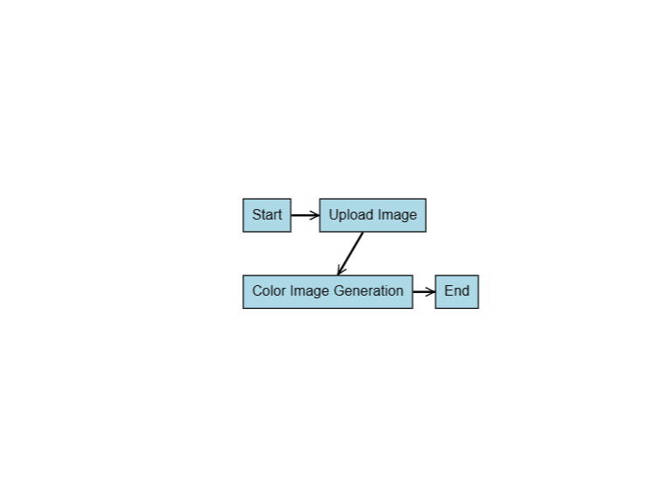

## Class Diagram

Figure 5.2 Class Diagram

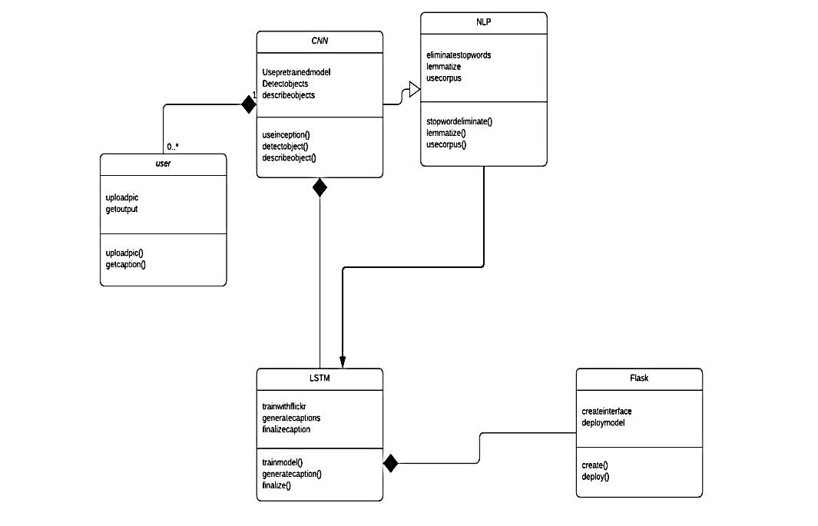

## Sequence Diagram

Figure 5.4 Sequence Diagram

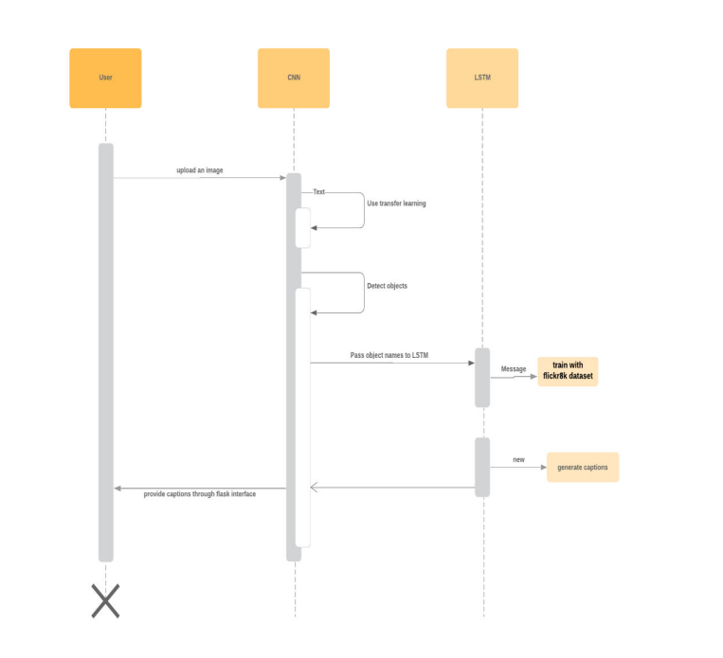

## Use Case Diagram

Figure 5.2 Use case Diagram

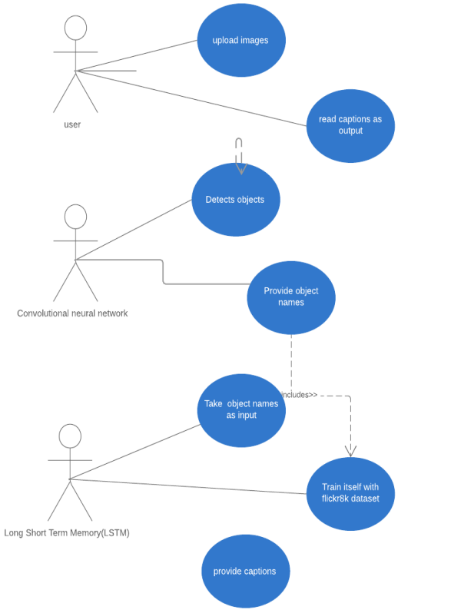

# Implementation

This chapter include snapshot of working project created by me. Our webapp you can use without login into account. Consider user selected a photo colorization and click on that. After clicking “try this” button, user will be redirected to upload image page where user need to give permission and after that user need to upload image and after uploading image model will run in backend and then after sometime output will be shown in upload image page for now.

Figure 7.1 Home page

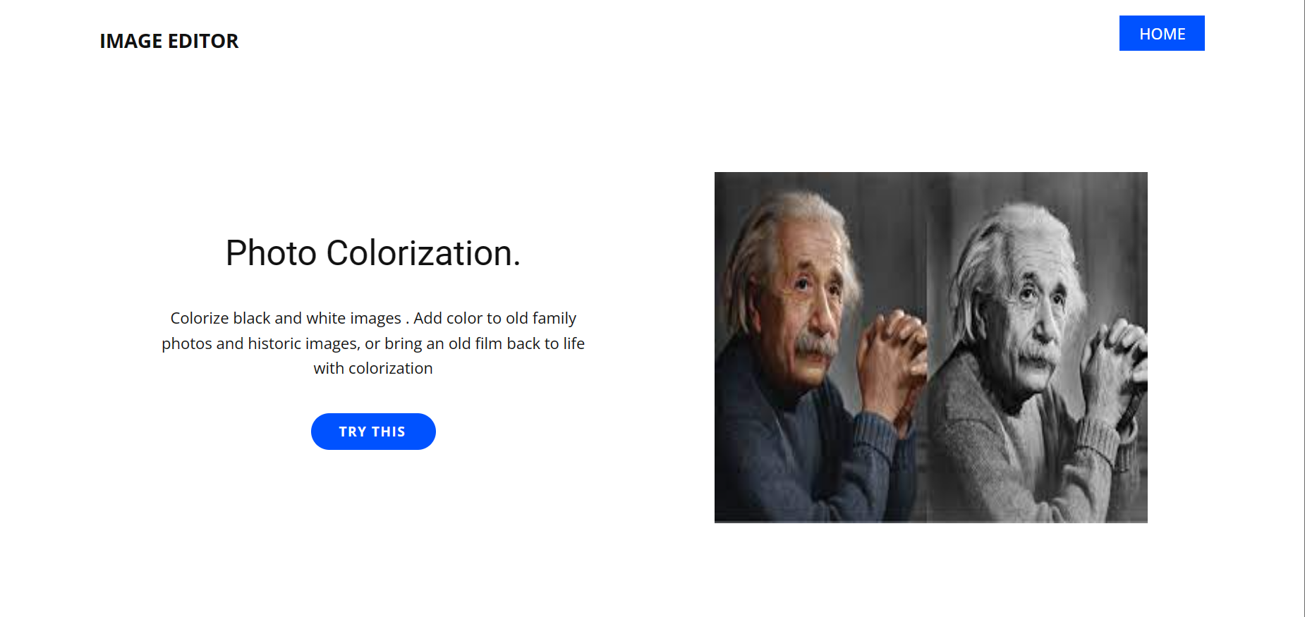

igure 7. 2 Upload image

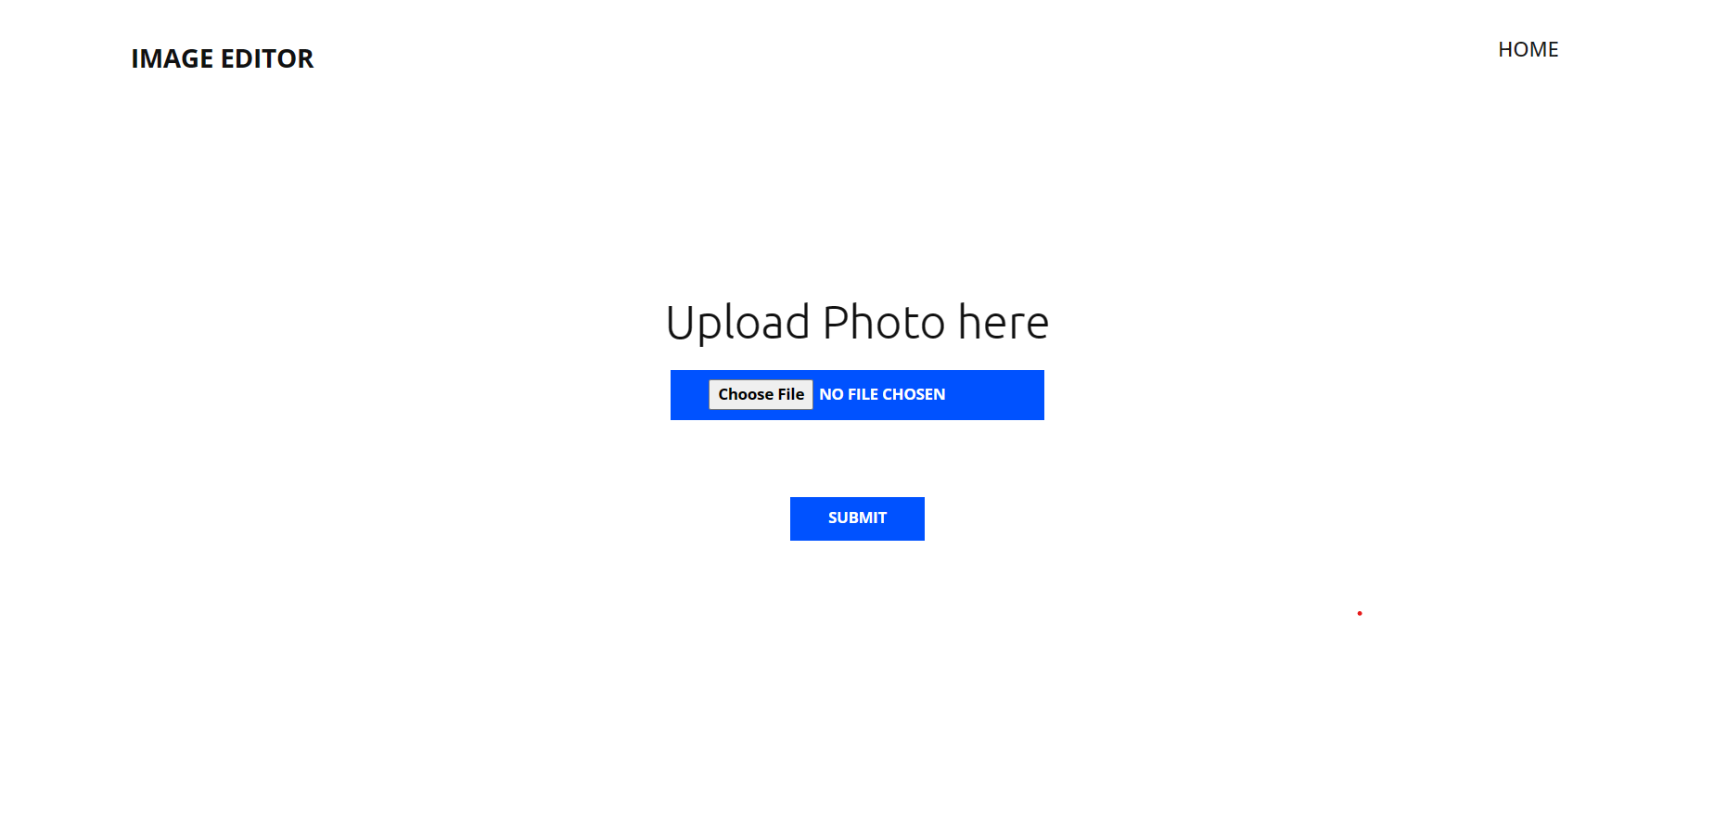

Figure 7. 3 Output image

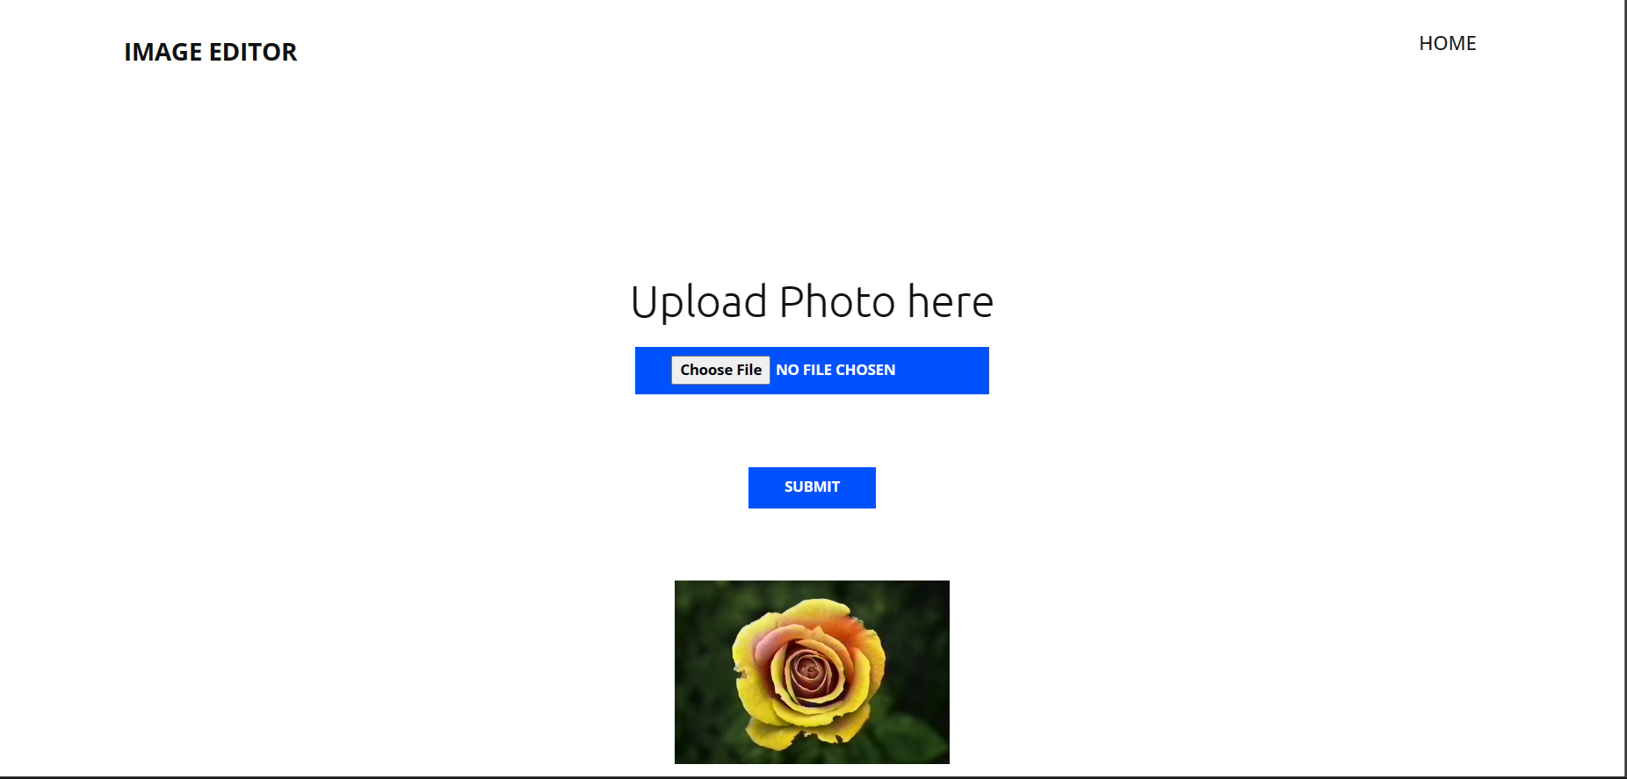

# Software Testing

Software testing is a process of running with intent of finding errors in software. Software testing assures the quality of software and represents final review of other phases of software like specification, design, code generation etc

## Testing Plan

A Test Plan is a detailed document that describes the test strategy, objectives, schedule, estimation, deliverables, and resources required to perform testing for a software product. Test Plan helps us determine the effort needed to validate the quality of the application under test. The test plan serves as a blueprint to conduct software testing actiVIIIties as a defined process, which is minutely monitored and controlled by the test manager. This system follows a coding and testing strategy for every small change for those particular changes and after completion of coding the system gets tested for the last time

## Testing Method Testing Method

In testing methods, we are going with unit testing in which system is tested unified. That means each and every component added to the system is going to be tested whenever it will be added to the system for the first time before final release.

## Testing Cases

Here is the list of test cases which is covered by unified testing models.

### User

Figure 8.3. 1 Test cases

|  |  |
| --- | --- |
| **Purpose** | **Result** |
| Verify if the data in password field is either Visible as asterisk or bullet signs | Pass |
| Verify if error page is shown | Fail |
| Verify if user can click on all the “try this” button | Pass |
| Verify if user can upload image | Pass |
| Verify if user upload image with wrong format get error message | Fail |
| Verify if user able to download image | Pass |
| Verify if user able to get desire output | Pass |
| Verify if user use Image Colorization | Pass |

# Conclusion & Future work

## Conclusion

Image Colorization has many advantages in almost every complex area of Artificial Intelligence. The main use case of our model is to help Visually impaired to understand the environment and made them easy to act according to the environment. As, this is a complex. task to do, with the help of pre trained models and powerful deep learning frameworks like TensorFlow and Keras, we made it possible. This is completely a Deep Learning project, which makes use of multiple Neural Networks like Convolutional Neural Network and Long Short-Term Memory to detect objects and captioning the images. To deploy our model as a web application, we have used Django, which is a powerful Python's web framework.

## Future Work

In future we'll add multiple future like Video captioning,. Also, user can store their data and download image , see their history. Also, we try to build a mobile app same as our webapp so people can download on their phones. We try to build offline mobile application. this web app is for limited user we'll try to solve this problem also.

# Detail About Models

## Image Colorization

So, to make our image caption generator model, we will be merging these architectures. It is also called a CNN-RNN model. CNN is used for extracting features from the image. We will use the pre-trained model Xception. LSTM will use the information from CNN to help generate a description of the image.

### Architecture

Figure 10. 2 Image Colorization model

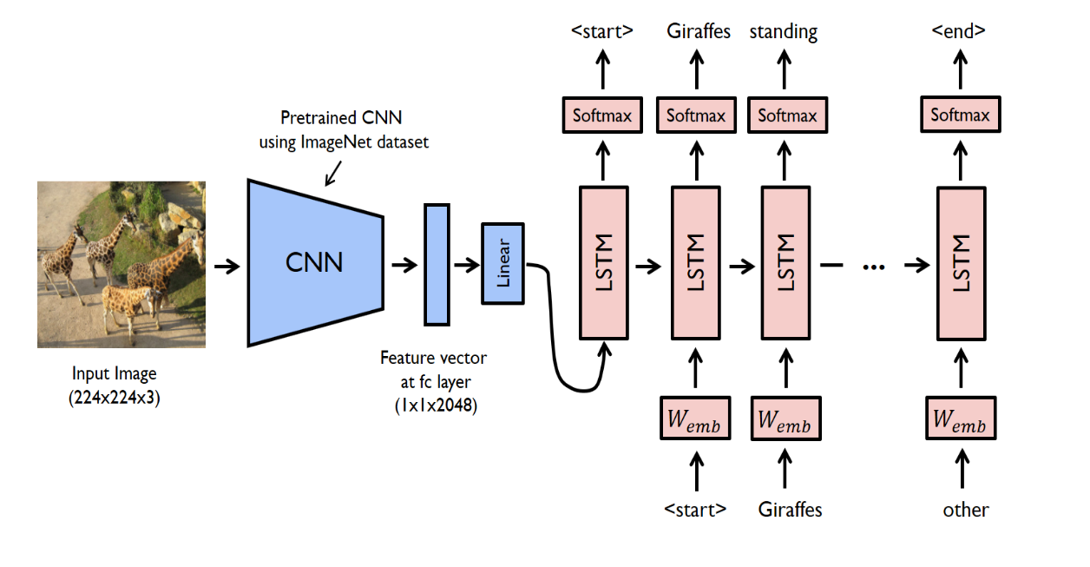

### Convolutional Neural Network

A CNN is made up of multiple layers of neurons, each of which is a nonlinear operation on a linear transformation of the preceding layer's outputs. The layers mainly include convolutional layers and pooling layers. The convolutional layers have weights that need to be trained, while the pooling layers transform the activation using a fixed function.

### LSTM

LSTM stands for Long short-term memory; they are a type of RNN (recurrent neural network) which is well suited for sequence prediction problems. Based on the preVIIIous text, we can predict what the next word will be. It has proven itself effective from the traditional RNN by overcoming the limitations of RNN which had short term memory. LSTM can carry out relevant information throughout the processing of inputs and with a forget gate, it discards non-relevant information.

Figure 10. 3 LSTM cell

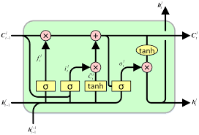

### SoftMax Activation Function

The SoftMax function is used as the activation function in the output layer of neural network models that predict a multinomial probability distribution. That is, SoftMax is used as the activation function for multi-class classification problems where class membership is required on more than two class labels.

# Reference

1. Hwang J, Zhou Y. Image colorization with deep convolutional neural networks. InStanford University, Tech. Rep. 2016.
2. Anwar, Saeed, Muhammad Tahir, Chongyi Li, Ajmal Mian, Fahad Shahbaz Khan, and Abdul Wahab Muzaffar. "Image colorization: A survey and dataset." *arXiv preprint arXiv:2008.10774* (2020).
3. Baldassarre, F., Morín, D.G. and Rodés-Guirao, L., 2017. Deep koalarization: Image colorization using cnns and inception-resnet-v2. *arXiv preprint arXiv:1712.03400*.
4. Wang, Zhihao, Jian Chen, and Steven CH Hoi. "Deep learning for image super-resolution: A survey." *IEEE transactions on pattern analysis and machine intelligence* 43.10 (2020): 3365-3387.
5. Dong, C., Loy, C. C., He, K., & Tang, X. (2015). Image super-resolution using deep convolutional networks. *IEEE transactions on pattern analysis and machine intelligence*, *38*(2), 295-307.
6. Minaee, SherVIIIn, et al. "Image segmentation using deep learning: A survey." *IEEE transactions on pattern analysis and machine intelligence* (2021).
7. Hossain, M.Z., Sohel, F., Shiratuddin, M.F. and Laga, H., 2019. A comprehensive survey of deep learning for Image Colorization. *ACM Computing Surveys (CsUR)*, *51*(6), pp.1-36.
8. Wang, C., Yang, H., Bartz, C. and Meinel, C., 2016, October. Image Colorization with deep bidirectional LSTMs. In *Proceedings of the 24th ACM international conference on Multimedia* (pp. 988-997).
9. Colorizing Old B&W Photos and VIIIdeos With the Help of AI | by Marcelo Rovai | Towards Data Science
10. Black and white image colorization with OpenCV and Deep Learning - PyImageSearch
11. Python based Project - Learn to Build Image Caption Generator with CNN & LSTM - DataFlair (data-flair.training)
12. Deep Learning based Super Resolution with OpenCV | by XaVIIIer Weber | Towards Data Science
13. OpenCV Super Resolution with Deep Learning - PyImageSearch
14. Single image super-resolution with deep neural networks - Martin Krasser's Blog (krasserm.github.io)
15. Remove the background from images using AI and Python (livecodestream.dev)