Assignment-2

(Bash –Scripting)

Notes

* Assignment must be completed as an individual effort.
* All online submissions will be done via SLATE (Email submissions will NOT be accepted).
* Please refer to the [Academic Dishonesty Policy](http://www-acad.sheridanc.on.ca/~jollymor/acadDishonesty.html)
* Due date: Check slate for due date
* Please write and test all the shell scripts using the editor of your choice
* Total Marks=20
* If the files do not have this naming convention, you will lose marks:
  + firstname_menu.sh
  + firstname_string.sh
  + firstname_numbers.sh

**ScriptingPart1**: (5Marks)

Write a bash shell script <firstname_menu.sh> that will accomplish the following:

1. Display the following menu:
2. Display a long listing of the current directory
3. Display the current working directory
4. Display the current date and time
5. Quit

----------------------------------------------------------------------------------

* For option 1 display the long listing for the current directory
* For option 2 display who is logged on the system currently
* For option 3 display the current date and time
* For option 4 selection use exit

Hint:[Use case statement for the menu]

**Code:**

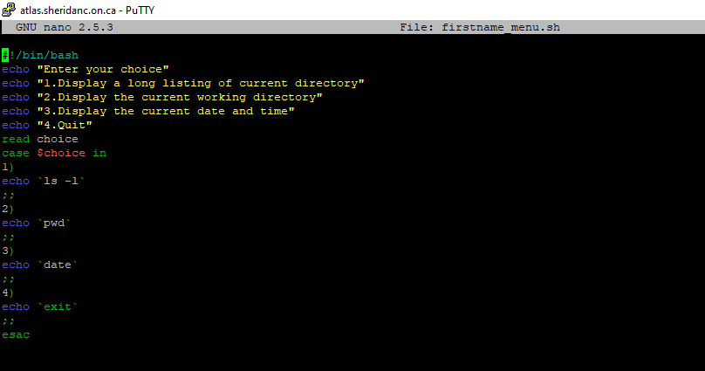

**Output:**

**Choice 1**

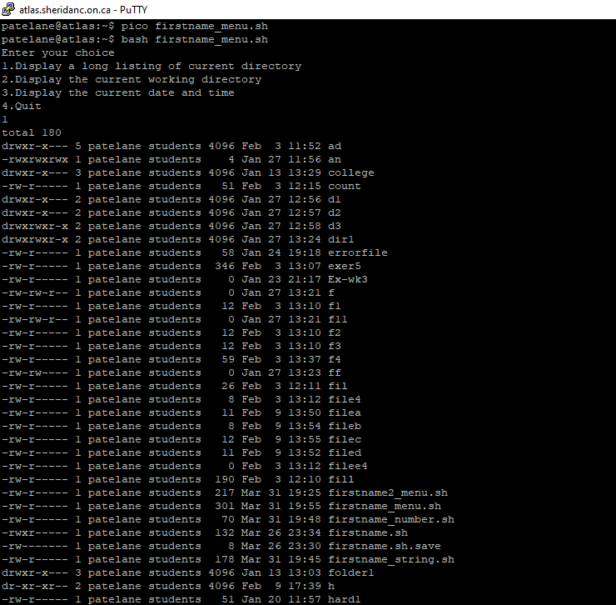

**Choice 2**

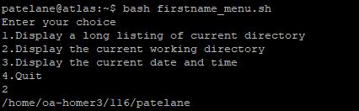

**Choice 3**

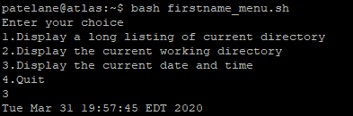

**Choice 4**

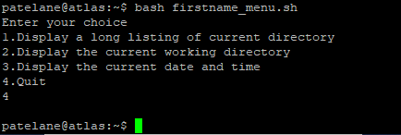

**Scripting Part2:** (5Marks)

Modify the above script and your shell script should continue to execute until the user selects option 4. Save it as <firstname2_menu.sh> **[**Hint: use loop]

**Code:**

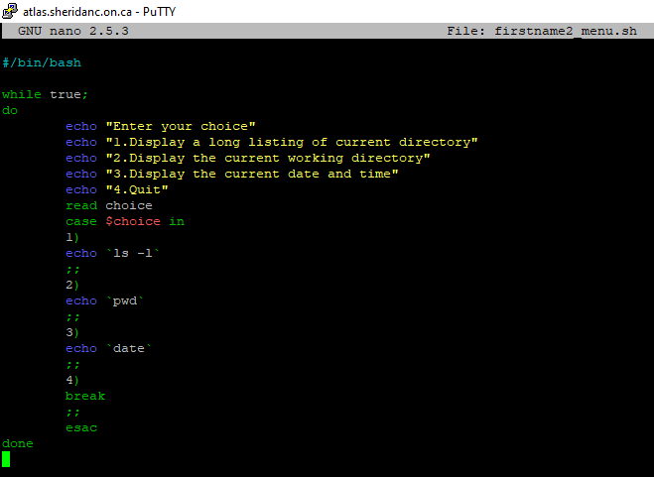

**Output:**

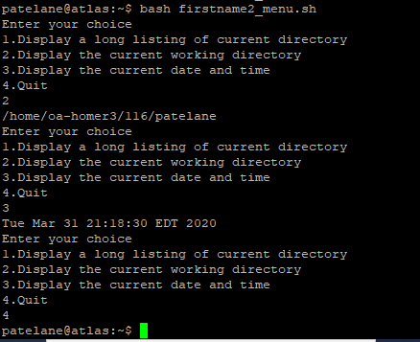

**Scripting Part3** :( 5Marks)

Write a script<firstname_string.sh> that would accept two strings from the user and would display a message stating whether the accepted strings are equal or not.

**Code:**

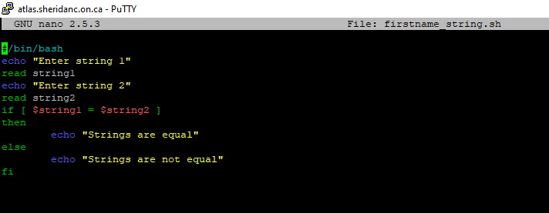

**Output:**

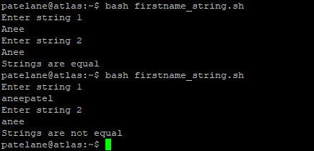

**Scripting Part4 and Part 5**: (2+3=5Marks)

Write the script <firstname_number.sh>that takes two command line arguments and then display all the numbers between two integers (including the numbers)

Print the numbers ascending order if the first number is smaller than the second and in descending order if the first number is greater than the second.

(Total: 2+3Marks)

**Code:**

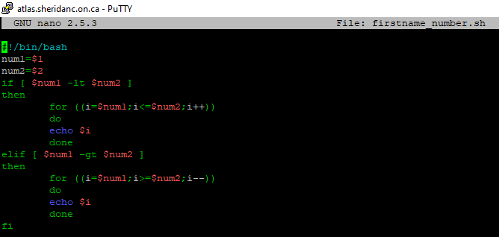

**Output:**

