TELE33324 ASSIGNMENT 4

Student Names/Student ID: Anee Patel (991548757)

Karn Bhavsar (991578281)

/20

This assignment is based on chapter 9 of the textbook, and involves configuring switches with VLANs, and enabling inter-VLAN communication on a router.

Submission Details

1. Assignment is due, hard copy by the start of class in week 12.

2. Submit the following documents as part of your submission:

* This document – complete with requested screenshots
* A print out of the FIVE configuration files (FOUR SWITCHES PLUS THE ROUTER). In Packet Tracer click on the device, click on “config” and click “export” beside the startup file CLEARLY LABEL EACH CONFIGURATION FILE TO INDICATE THE SWITCH OR ROUTER

3. You will be configuring the following network:

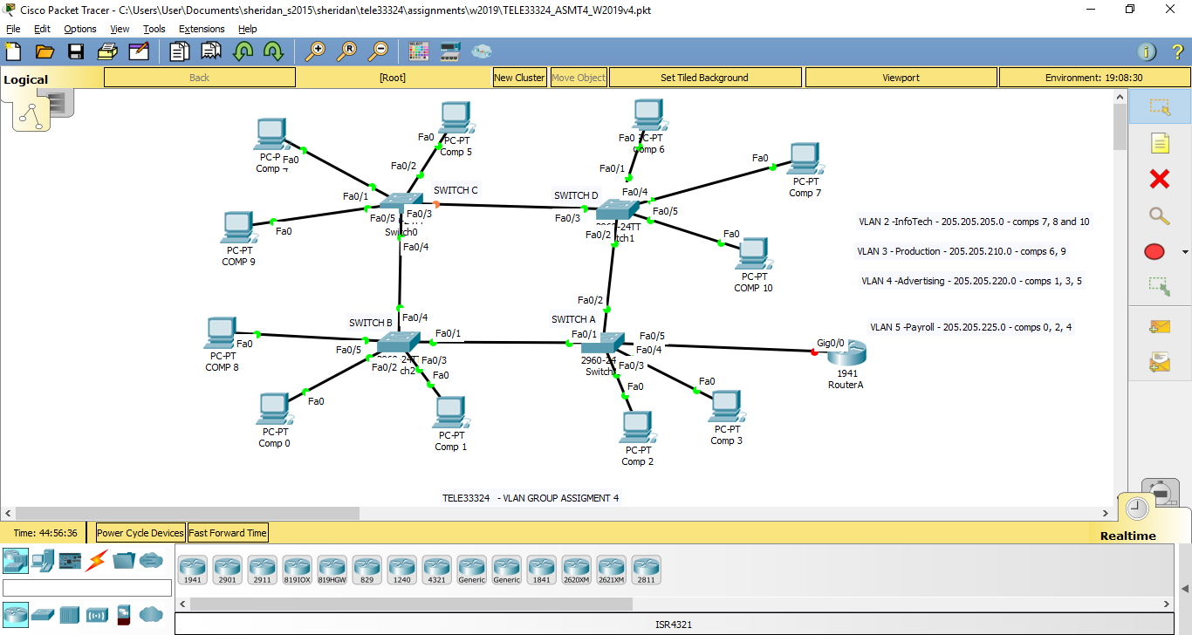

- Figure 1 -

4. Please note that the FOUR switches are 2960 (each with 16 FastEthernet ports) and the Router can be any model with a Fast Ethernet or higher interface. Use the PC-PT for the 11 computers.

5. Assign ip addresses and default gateways to each of the ELEVEN PCs. Use the text tool to indicate what ip address you are assigning to each of the eleven PCs.

\*\*\*\*\* Insert a screenshot of your topology here \*\*\*\*\* [3]

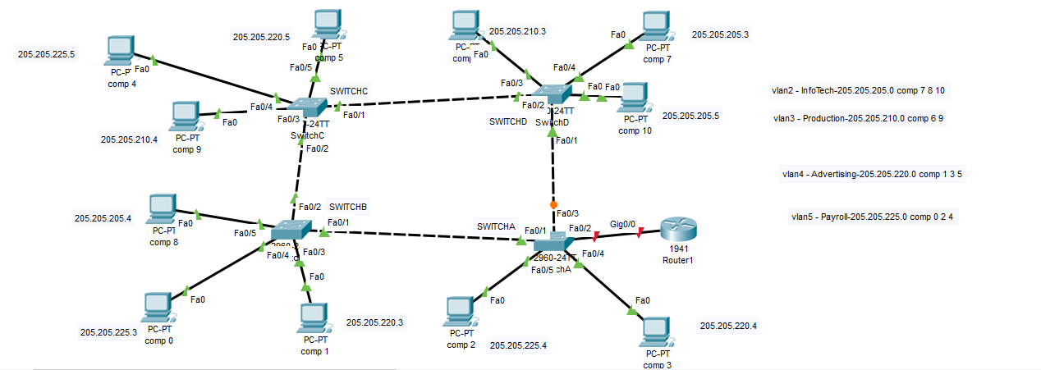

The marks for points 6 – 10 will be ascertained from the printouts of the config files for the FOUR switches and the Router.

6. Create the four VLANs on switch A, with the names given in figure 1. Set the domain name to TELE33324v4. This will be your VTP server.

\*\*\*\*\* Insert a screenshot of “show vlan brief” and “show vtp status” \*\*\*\*\* [2]

Switch A

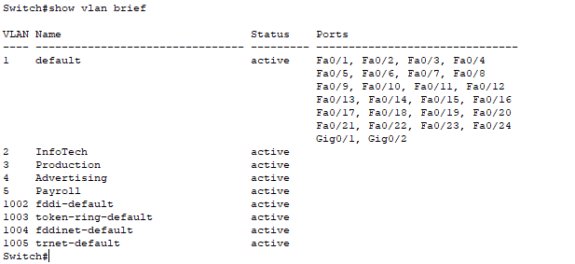

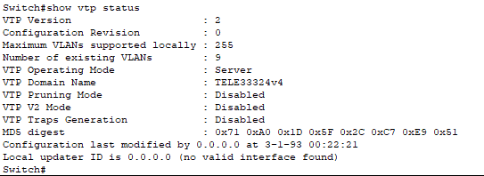

7. Set the ports on switch A to either ACCESS or TRUNK, as appropriate [2]

8. Set switches B, C and D to VTP clients, AFTER setting the domain name to

TELE33324v4.

\*\*\*\*\* Insert a screenshot of “show vlan brief” and “show vtp status” \*\*\*\*\* [2]

Switch B

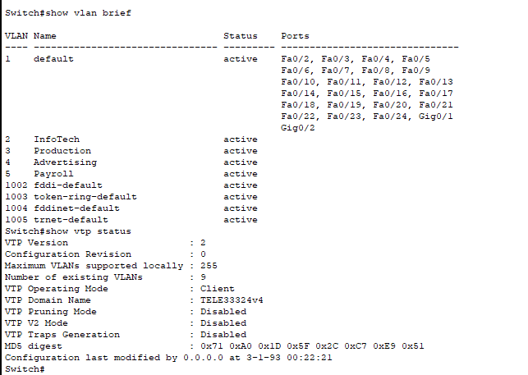

Switch C

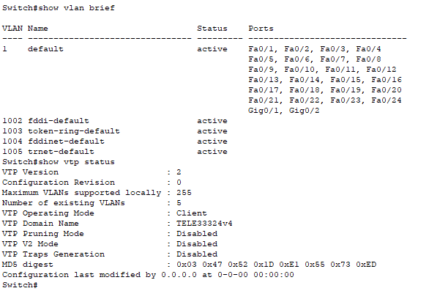

Switch D

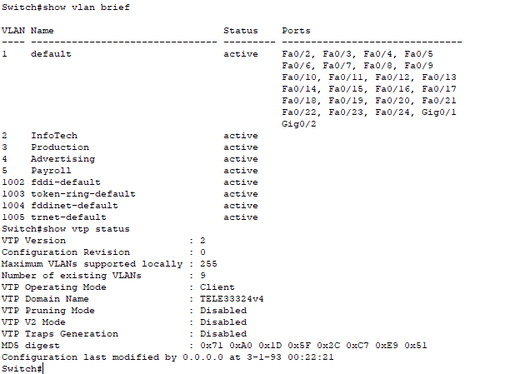

9. Set the ports on switches B, C, and D to either ACCESS or TRUNK as appropriate, 2 marks each for a total of [4]

10. Enable inter-vlan communication between VLANs 2 and 3 by creating appropriate

Subinterfaces on Router A on the connection to Switch A. [3]

11. Do screenshots of the following:

IF SCREENSHOTS ARE NOT CLEAR, COPY AND PASTE TO WORD.

Pick any computer on Vlan 2, and do successful pings to the other computers on Vlan 2 and Vlan 3

[2]

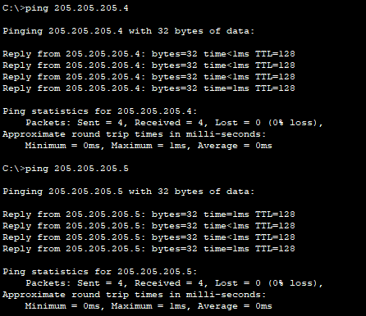

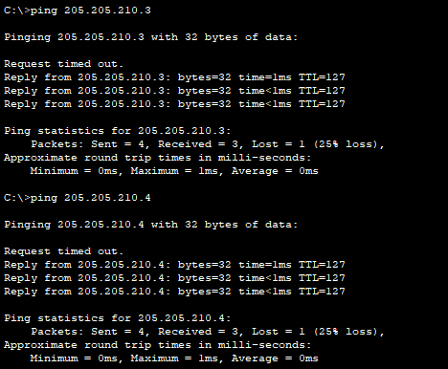

Pick any computer on Vlan 3, and do successful pings to the other computers on Vlan 3 as well as Vlan 2 [2]

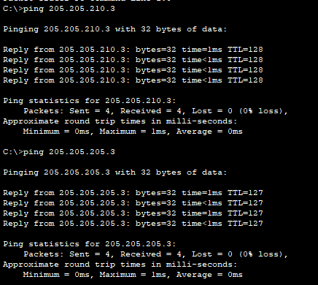

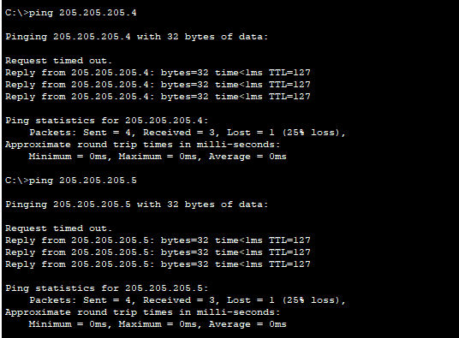

Router 1 config file

!

version 15.1

no service timestamps log datetime msec

no service timestamps debug datetime msec

no service password-encryption

!

hostname Router

!

!

!

!

!

!

!

!

ip cef

no ipv6 cef

!

!

!

!

license udi pid CISCO1941/K9 sn FTX15247ADE-

!

!

!

!

!

!

!

!

!

!

!

spanning-tree mode pvst

!

!

!

!

!

!

interface GigabitEthernet0/0

no ip address

duplex auto

speed auto

!

interface GigabitEthernet0/0.2

encapsulation dot1Q 2

ip address 205.205.205.1 255.255.255.0

!

interface GigabitEthernet0/0.3

encapsulation dot1Q 3

ip address 205.205.210.1 255.255.255.0

!

interface GigabitEthernet0/1

no ip address

duplex auto

speed auto

shutdown

!

interface Vlan1

no ip address

shutdown

!

ip classless

!

ip flow-export version 9

!

!

!

!

!

!

!

!

line con 0

!

line aux 0

!

line vty 0 4

login

!

!

!

end

Switch A config file

!

version 12.2

no service timestamps log datetime msec

no service timestamps debug datetime msec

no service password-encryption

!

hostname Switch

!

!

!

!

!

spanning-tree mode pvst

spanning-tree extend system-id

!

interface FastEthernet0/1

switchport mode trunk

!

interface FastEthernet0/2

switchport mode trunk

!

interface FastEthernet0/3

switchport mode trunk

!

interface FastEthernet0/4

switchport access vlan 4

!

interface FastEthernet0/5

switchport access vlan 5

!

interface FastEthernet0/6

!

interface FastEthernet0/7

!

interface FastEthernet0/8

!

interface FastEthernet0/9

!

interface FastEthernet0/10

!

interface FastEthernet0/11

!

interface FastEthernet0/12

!

interface FastEthernet0/13

!

interface FastEthernet0/14

!

interface FastEthernet0/15

!

interface FastEthernet0/16

!

interface FastEthernet0/17

!

interface FastEthernet0/18

!

interface FastEthernet0/19

!

interface FastEthernet0/20

!

interface FastEthernet0/21

!

interface FastEthernet0/22

!

interface FastEthernet0/23

!

interface FastEthernet0/24

!

interface GigabitEthernet0/1

!

interface GigabitEthernet0/2

!

interface Vlan1

no ip address

shutdown

!

!

!

!

line con 0

!

line vty 0 4

login

line vty 5 15

login

!

!

!

!

end

Switch B config file

!

version 12.2

no service timestamps log datetime msec

no service timestamps debug datetime msec

no service password-encryption

!

hostname Switch

!

!

!

!

!

spanning-tree mode pvst

spanning-tree extend system-id

!

interface FastEthernet0/1

switchport mode trunk

!

interface FastEthernet0/2

switchport mode trunk

!

interface FastEthernet0/3

switchport access vlan 4

!

interface FastEthernet0/4

switchport access vlan 5

!

interface FastEthernet0/5

switchport access vlan 2

!

interface FastEthernet0/6

!

interface FastEthernet0/7

!

interface FastEthernet0/8

!

interface FastEthernet0/9

!

interface FastEthernet0/10

!

interface FastEthernet0/11

!

interface FastEthernet0/12

!

interface FastEthernet0/13

!

interface FastEthernet0/14

!

interface FastEthernet0/15

!

interface FastEthernet0/16

!

interface FastEthernet0/17

!

interface FastEthernet0/18

!

interface FastEthernet0/19

!

interface FastEthernet0/20

!

interface FastEthernet0/21

!

interface FastEthernet0/22

!

interface FastEthernet0/23

!

interface FastEthernet0/24

!

interface GigabitEthernet0/1

!

interface GigabitEthernet0/2

!

interface Vlan1

no ip address

shutdown

!

!

!

!

line con 0

!

line vty 0 4

login

line vty 5 15

login

!

!

!

!

end

Switch C config file

!

version 12.2

no service timestamps log datetime msec

no service timestamps debug datetime msec

no service password-encryption

!

hostname Switch

!

!

!

!

!

spanning-tree mode pvst

spanning-tree extend system-id

!

interface FastEthernet0/1

switchport mode trunk

!

interface FastEthernet0/2

switchport mode trunk

!

interface FastEthernet0/3

switchport access vlan 3

!

interface FastEthernet0/4

switchport access vlan 5

!

interface FastEthernet0/5

switchport access vlan 4

!

interface FastEthernet0/6

!

interface FastEthernet0/7

!

interface FastEthernet0/8

!

interface FastEthernet0/9

!

interface FastEthernet0/10

!

interface FastEthernet0/11

!

interface FastEthernet0/12

!

interface FastEthernet0/13

!

interface FastEthernet0/14

!

interface FastEthernet0/15

!

interface FastEthernet0/16

!

interface FastEthernet0/17

!

interface FastEthernet0/18

!

interface FastEthernet0/19

!

interface FastEthernet0/20

!

interface FastEthernet0/21

!

interface FastEthernet0/22

!

interface FastEthernet0/23

!

interface FastEthernet0/24

!

interface GigabitEthernet0/1

!

interface GigabitEthernet0/2

!

interface Vlan1

no ip address

shutdown

!

!

!

!

line con 0

!

line vty 0 4

login

line vty 5 15

login

!

!

!

!

end

Switch D config file

!

version 12.2

no service timestamps log datetime msec

no service timestamps debug datetime msec

no service password-encryption

!

hostname Switch

!

!

!

!

!

spanning-tree mode pvst

spanning-tree extend system-id

!

interface FastEthernet0/1

switchport mode trunk

!

interface FastEthernet0/2

switchport mode trunk

!

interface FastEthernet0/3

switchport access vlan 3

!

interface FastEthernet0/4

switchport access vlan 2

!

interface FastEthernet0/5

switchport access vlan 2

!

interface FastEthernet0/6

!

interface FastEthernet0/7

!

interface FastEthernet0/8

!

interface FastEthernet0/9

!

interface FastEthernet0/10

!

interface FastEthernet0/11

!

interface FastEthernet0/12

!

interface FastEthernet0/13

!

interface FastEthernet0/14

!

interface FastEthernet0/15

!

interface FastEthernet0/16

!

interface FastEthernet0/17

!

interface FastEthernet0/18

!

interface FastEthernet0/19

!

interface FastEthernet0/20

!

interface FastEthernet0/21

!

interface FastEthernet0/22

!

interface FastEthernet0/23

!

interface FastEthernet0/24

!

interface GigabitEthernet0/1

!

interface GigabitEthernet0/2

!

interface Vlan1

no ip address

shutdown

!

!

!

!

line con 0

!

line vty 0 4

login

line vty 5 15

login

!

!

!

!

end

End of asssignment!