**Assignment 5 & 6**

**Web Programming**

* When a new user tries to register. It displays message ‘Connection made successfully’ and ‘Registered successfully’.

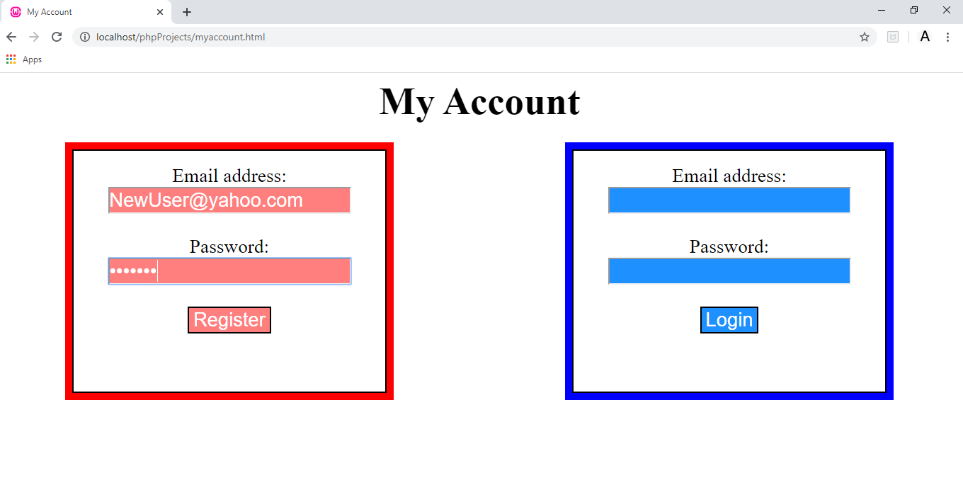

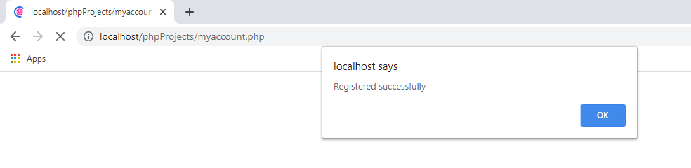

* It registers the user details in a table named accounts which is stored in database named shopping.

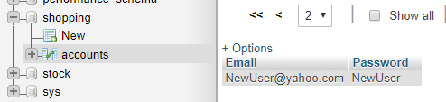

* If the user tries to register with same in register box, it displays ‘User already registered’.



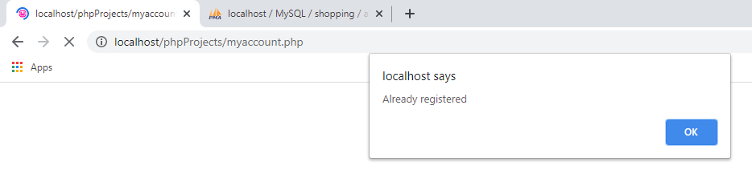

* If user enters same details in login box, it allows user to login and displays message ‘Welcome to shopping site’.

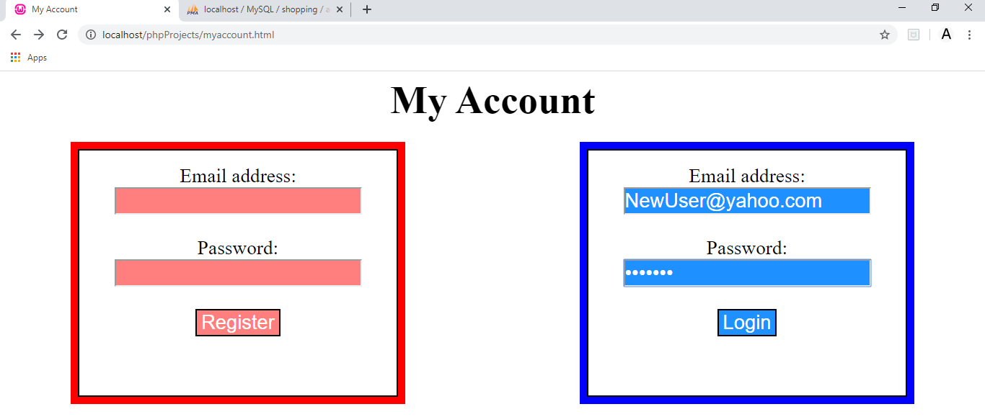

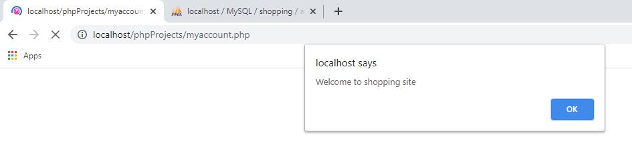

* If a new user enters details in login box without registering, it displays message ‘user not registered’.

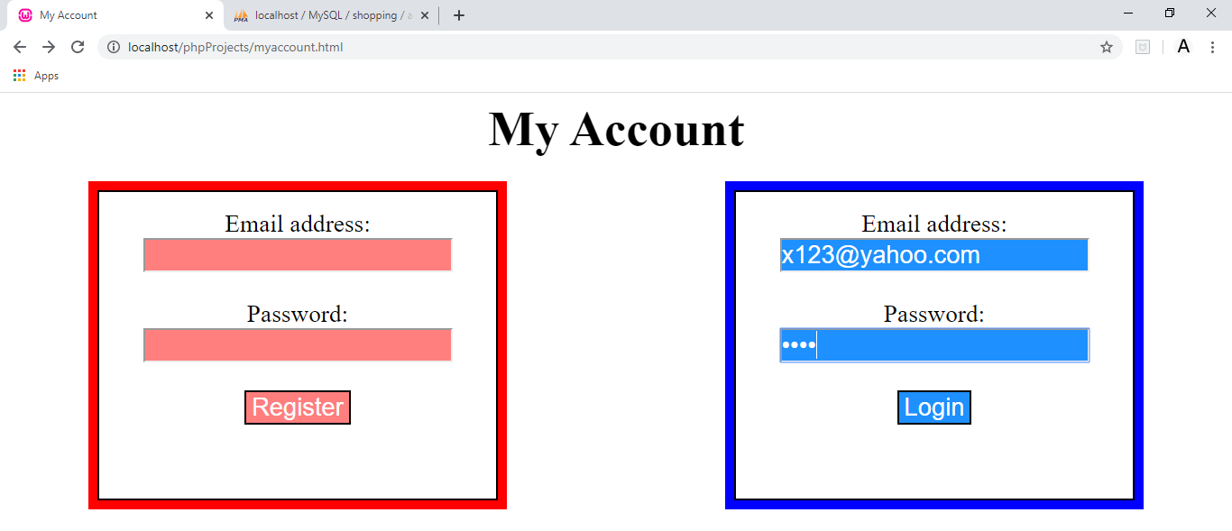

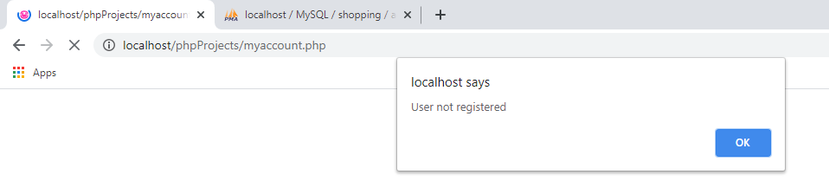

**Link for c-panel:**

<https://patelane.dev.fast.sheridanc.on.ca/phpProjects/myaccount.html>