SQL-Assignment-4

Database-link: - <https://github.com/microsoft/sql-server-samples/blob/master/samples/databases/northwind-pubs/instnwnd.sql>

1)Create a stored procedure in the Northwind database that will calculate the average

value of Freight for a specified customer.Then, a business rule will be added that will

be triggered before every Update and Insert command in the Orders controller,and

will use the stored procedure to verify that the Freight does not exceed the average

freight. If it does, a message will be displayed and the command will be cancelled.

CREATE PROCEDURE avg_freight

@customer_id varchar(40)

AS

BEGIN

select c.CompanyName,avg(Freight) AS "AVERAGE" from Customers c inner join orders o on c.CustomerID=o.CustomerID

where o.OrderID=@order_id group by c.CustomerID,CompanyName;

END

CREATE TRIGGER tr_orders_insert

on Orders

for insert

AS

BEGIN

declare @id VARCHAR(40);

select @id=CustomerID from inserted;

declare @freight money;

select @freight=Freight from inserted;

EXEC avg_freight @customer_id=@id;

if(exists(select 1 from orders WHERE CustomerID=@id HAVING avg(Freight)>@freight))

begin

print('row is not added' );

rollback

end

else

begin

print('row is added');

print('new order from CustomerID = '+ @id +' at ' + cast(getdate() as varchar(40)) );

end

END

CREATE TRIGGER tr_orders_update

on Orders

for update

AS

BEGIN

declare @id VARCHAR(40);

select @id=CustomerID from inserted;

declare @freight money;

select @freight=Freight from inserted;

EXEC avg_freight @customer_id=@id;

if(exists(select 1 from orders WHERE CustomerID=@id HAVING avg(Freight)>@freight))

begin

print(' row is not Updated ' );

rollback

end

else

begin

print(' row is Updated ');

print('new order from CustomerID = '+ @id +' at ' + cast(getdate() as varchar(40)) );

end

END

RUN:- exec avg_freight @customer_id='RICSU';



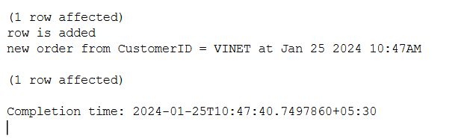

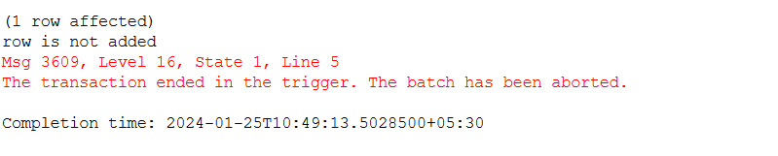

2)write a SQL query to Create Stored procedure in the Northwind database to retrieve

Employee Sales by Country

CREATE PROCEDURE country_sales

@firstname varchar(40),

@country varchar(40)

AS

BEGIN

select o.EmployeeID,e.FirstName,shipCountry,count(ShipCountry) as "Number of Sales" from orders o left join Employees e on o.EmployeeID=e.EmployeeID where e.FirstName=@firstname and shipCountry=@country group by o.EmployeeID,e.FirstName,ShipCountry

END

RUN:- exec country_sales @firstname='Andrew' ,@country='Denmark';

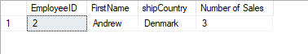

3) write a SQL query to Create Stored procedure in the Northwind database to retrieve

Sales by Year

CREATE PROCEDURE year_sale

@year int

AS

BEGIN

select count(year(OrderDate)) as "No of Sales",year(OrderDate) as "Year" from Orders

where year(OrderDate)=@year group by(year(OrderDate));

END

RUN:-- exec year_sale @year=1997;

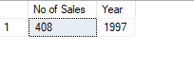

4) write a SQL query to Create Stored procedure in the Northwind database to retrieve

Sales By Category

CREATE PROCEDURE category_sales

@name varchar(40)

AS

BEGIN

select count(OrderID) as "Number of Orders",p.CategoryID,c.CategoryName from Products p inner join [Order Details] od

on p.ProductID=od.ProductID inner join Categories c on p.CategoryID=c.CategoryID where c.CategoryName=@name

group by p.CategoryID,c.CategoryName;

END

RUN:- exec category_sales @name='Condiments';

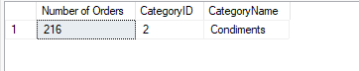

5) write a SQL query to Create Stored procedure in the Northwind database to retrieve

Ten Most Expensive Products

CREATE PROCEDURE expensive

AS

BEGIN

select top 10 ProductName,UnitPrice from Products order by UnitPrice desc;

END

RUN:- exec expensive;

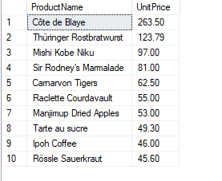

6) write a SQL query to Create Stored procedure in the Northwind database to insert

Customer Order Details

CREATE PROCEDURE add_orderDetails

@order_id int,

@product_id int,

@unitPrice float,

@quantity int,

@discount float

AS

BEGIN

INSERT "Order Details" VALUES(@order_id,@product_id,@unitPrice,@quantity,@discount);

END

RUN:- exec add_orderDetails [@order_id=10648,@product_id=42,@unitPrice=9.8,@quantity=10,@discount=0](mailto:@order_id=10648,@product_id=42,@unitPrice=9.8,@quantity=10,@discount=0);

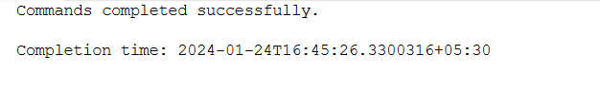

7) write a SQL query to Create Stored procedure in the Northwind database to update

Customer Order Details

CREATE PROCEDURE update_orderDetails

@order_id int,

@product_id int,

@unitPrice float,

@quantity int,

@discount float

AS

BEGIN

IF(@unitPrice is not NULL)

BEGIN

update "Order Details" set UnitPrice=@unitPrice where OrderID=@order_id and ProductID=@product_id;

END

IF(@quantity is not NULL)

BEGIN

update "Order Details" set quantity=@quantity where OrderID=@order_id and ProductID=@product_id;

END

IF(@discount is not NULL)

BEGIN

update "Order Details" set discount=@discount where OrderID=@order_id and ProductID=@product_id;

END

END

RUN-ANY:-

exec update_orderDetails @order_id=10956,@product_id=42,@unitPrice=11,@quantity=565;

exec update_orderDetails @order_id=10956,@product_id=42,@quantity=50;

exec update_orderDetails @order_id=10956,@product_id=42,@discount=0.10;

