Angular Drag & Drop Form Builder

**Created: 18/04/2022**

**By: Nam Khanh Do**

**Email:**[**donamkhanh@gmail.com**](mailto:donamkhanh@gmail.com)

Thank you for purchasing my script. If you have any questions that are beyond the scope of this help file, please feel free to email via my user page contact form [here](https://www.codester.com/donamkhanh). Thanks so much!

# Introduction

This is a concise front-end application developed with Angular. You can create a beautiful form with drag and drop visualization. You can get inspiration from it to make a draggable form; at the same time, you can also modify it to suit your own needs.

Main advantages of drag and drop editor are:

* You can add the necessary block or element just by dragging and dropping it and see the results right away;
* You can easily edit each element (change color, style, size and so on);
* You don’t need specialized knowledge to work with the editor;

# Features

* **Drag and Drop Elements**  
  If you want any element to appear in your template, simply drag it from the left side of the screen into the work area.
* **Create a Design Matching the Style of Your Site**  
  Change the background, text color, font size and style, as well as other parameters to suit your taste.
* **Social networks**Continue communicating with your subscribers on social networks, by adding links to your social media pages in your form.
* **Multilingual**This app support 2 languages: English and Vietnamese. But you can add as many as you want by duplicating the translation file then edit it in your language.
* **Responsive**The subscription forms you create with this app will be adapted for all screen formats. They will look good on even the smallest screens.
* **Dozens of elements**Currently, this app support 13 elements:

1. Section
2. Button
3. Text
4. Text field
5. Textarea
6. Dropdown
7. Checkbox
8. Radio
9. Image
10. Spacer
11. Separator
12. Social networks
13. Uploader

* **Preview**  
  See what your customer/client will see before you generate HTML.
* **HTML & JSON generation**You can easily generate your designed form to HTML or JSON

# Script Structure

In your downloaded zip file, you have folders, which looks something like this:

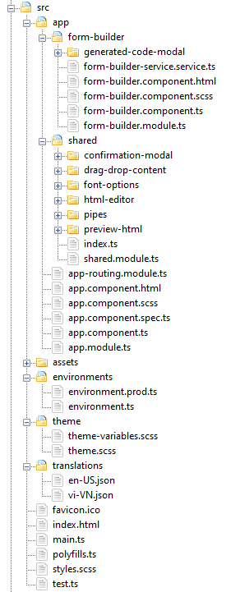

# How to install

### Prerequisites

* NodeJS installed
* NPM installed

To run this game in development mode, you just simply run following commands:

* **cd** <your_dowloaded_folder>/
* **npm install**: for installing dependency packages
* **npm start**: start the Angular development server at port 4200 by default

After run above commands, open your browser and enter **http://localhost:4200**, you should see this screen:

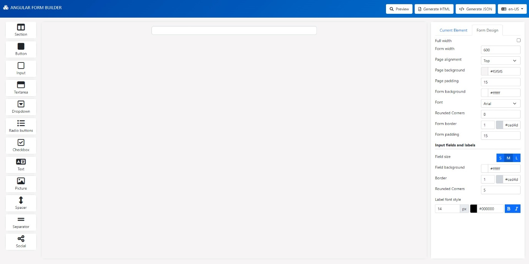

# Usage

To create a form, you just simple open browser and go to form builder area.

On the left, you see the elements that you can add to the form. In the center, there is a blank template for your future form.

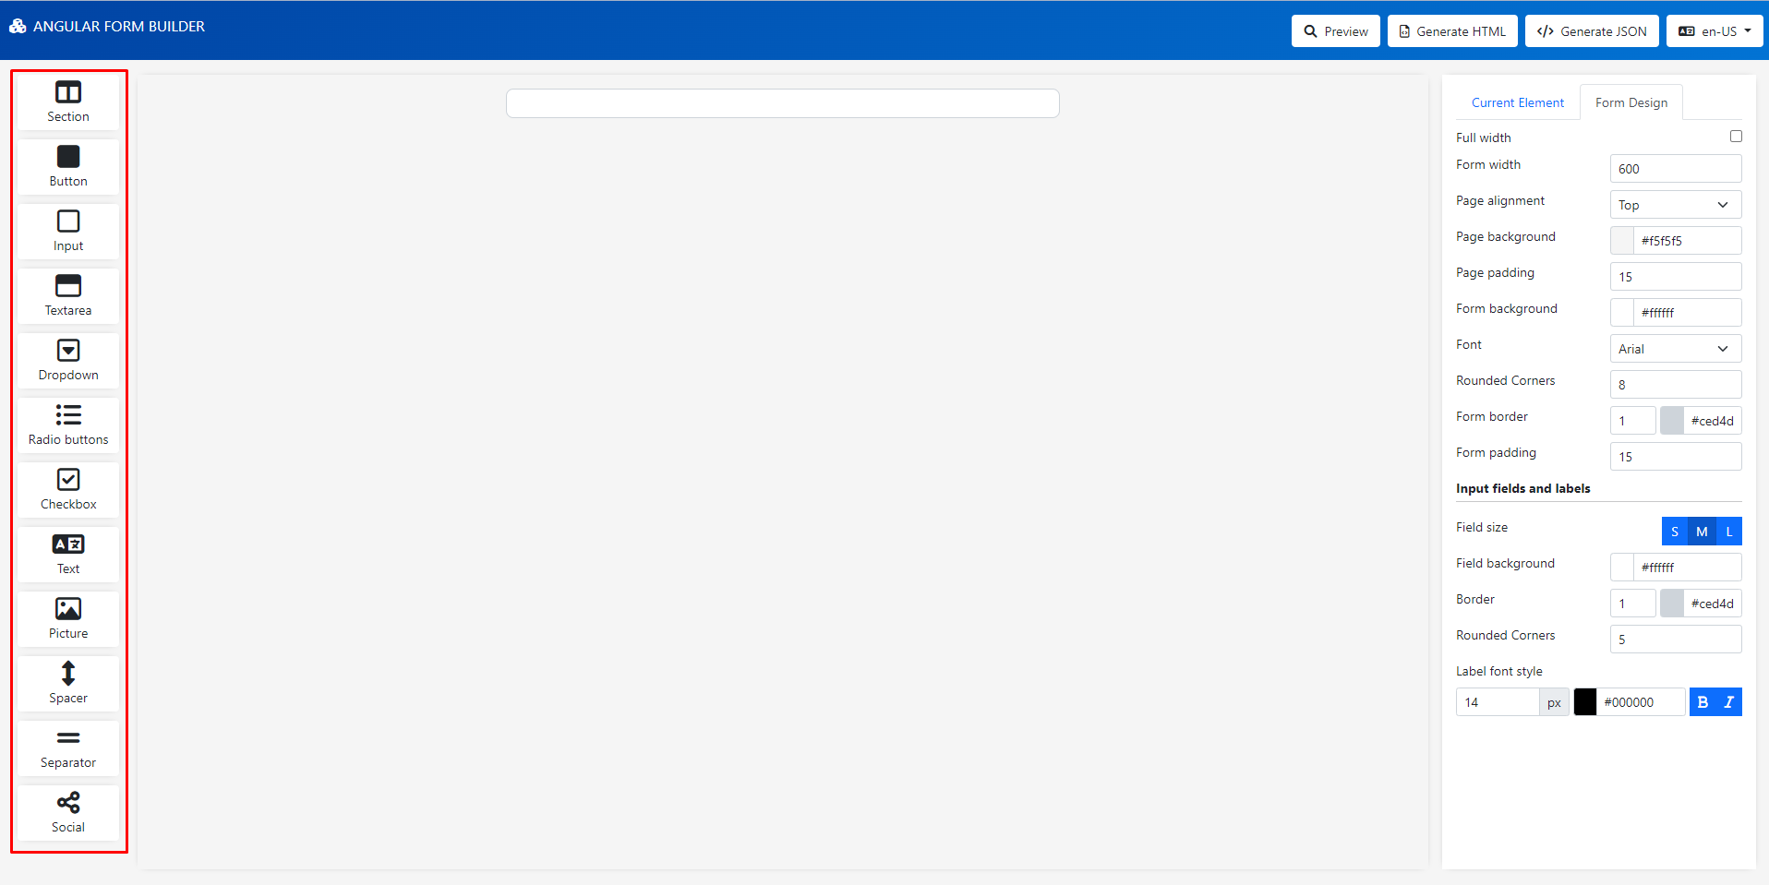

The panel on the right contains options for editing the selected element.

The overall design settings for your form are on the panel on the right called "Form Design" - here you can edit the general form background, form width, text color, the color of all links, fonts, font size and color, line height, field size etc.

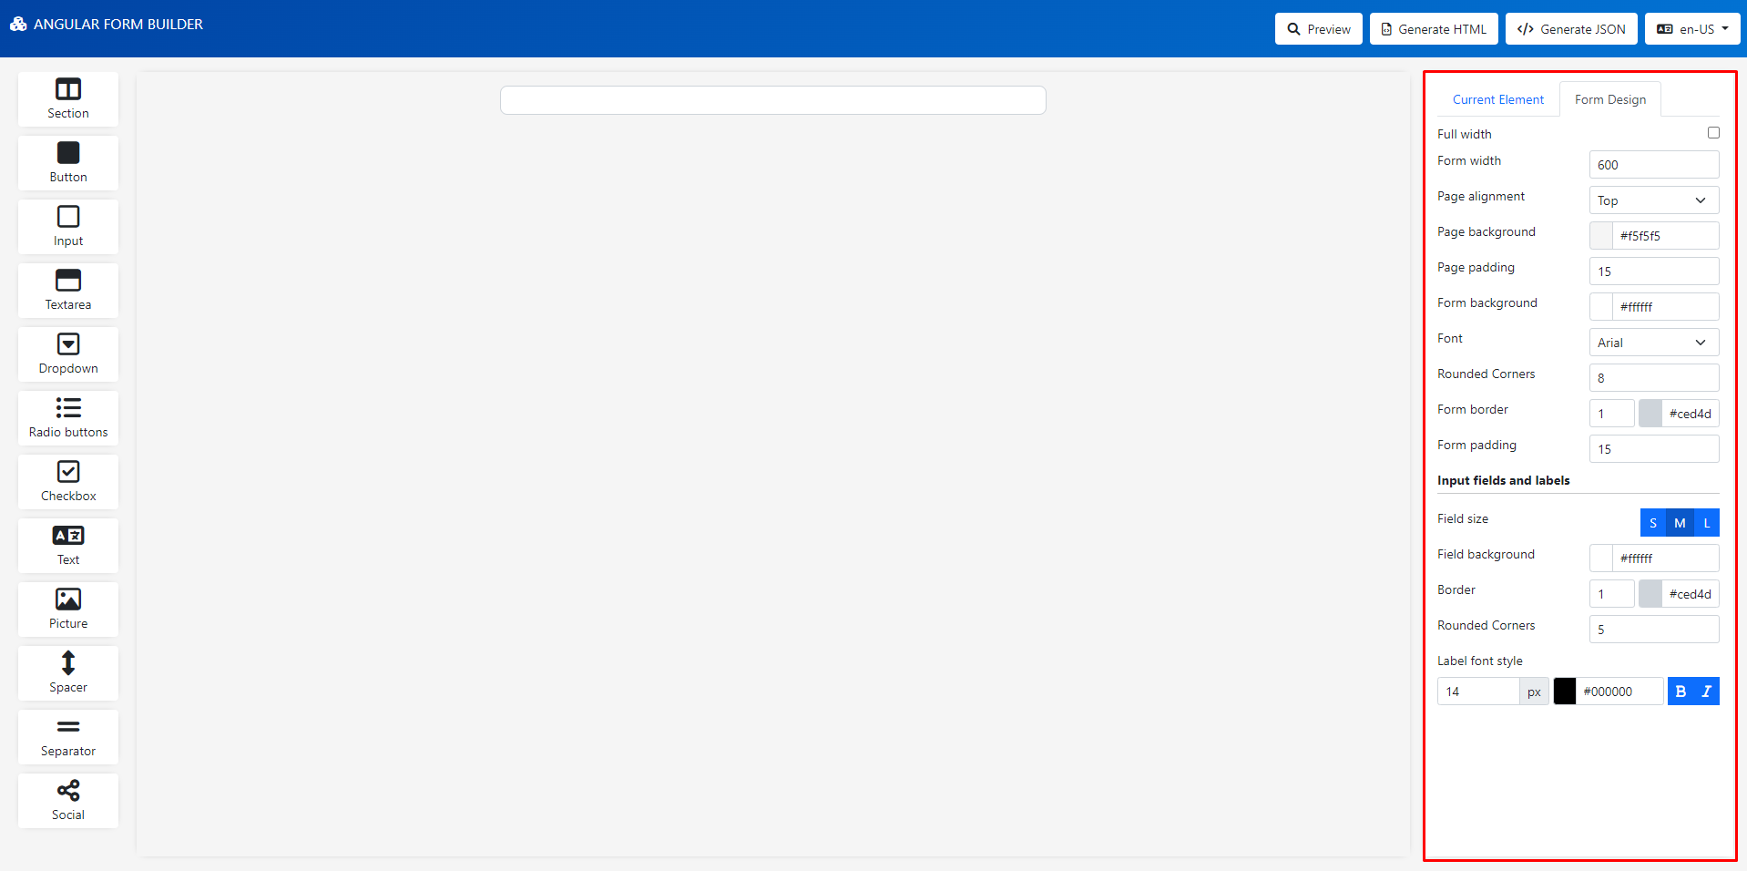

Note: We also have **Component settings** section in **Current Element** tab (only show when an element is selected). Basically, it is used to customize the container of an element such as background color, rounded corners, height and the inner padding.

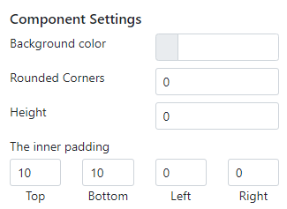

## Elements of the Drag-and-Drop Editor

### Section

With this element, you can add column to the form for separating structure block for each element in the form.

Click the “Section” element from the panel on the left then drag the corresponding section in to the form

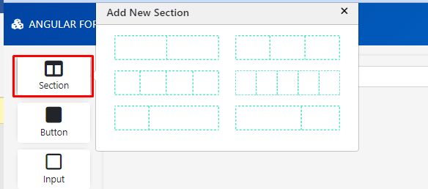

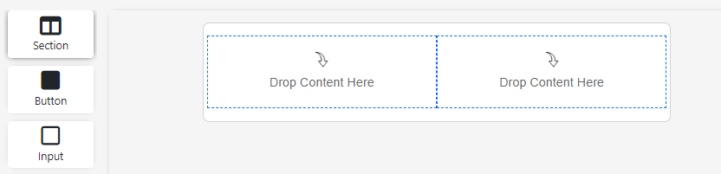

### Input box

With this element, you can add fields to the form.

Drag the "Input" element to the form. In the "Current Element" tab, choose the input type (support email, text, date, datetime and number) and enter the input field label. Optionally, you can enter placeholder text so that the user understands exactly what information is required.

“Field name” is a name of the element, it is generated uniquelly by default.

To prevent the form data from being submitted before the user fills it in completely, activate the "Set as required" option.

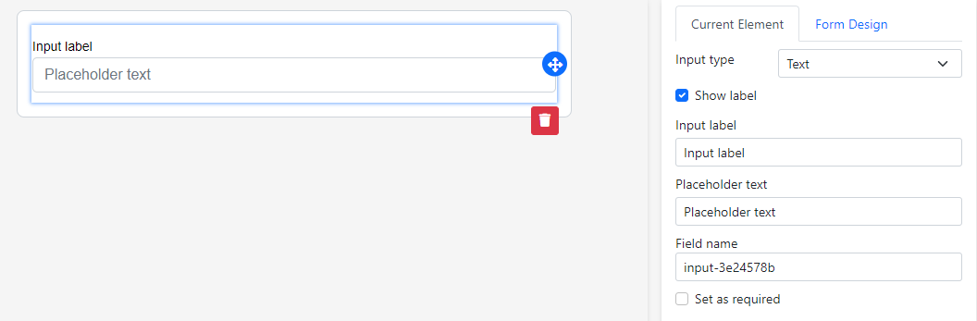

### Textarea

Drag the "Textarea" element to the form.

In the "Current Element" tab, enter the textarea label. Optionally, you can enter placeholder text so that the user understands exactly what information is required.

“Field name” is a name of the element, it is generated uniquelly by default.

To prevent the form data from being submitted before the user fills it in completely, activate the "Set as required" option.

### 

### Checkbox

This element might be handy for a form that suggests picking several options from a list. For instance, when your client subscribes to your email campaigns, they will be able to select categories of the updates: news, discounts, contests, event invitations, etc.

Drag the "Checkbox" element to the form. Add the checkbox label and name.

“Field name” is a name of the element, it is generated uniquelly by default.

To prevent the form data from being submitted before the user fills it in completely, activate the "Set as required" option.

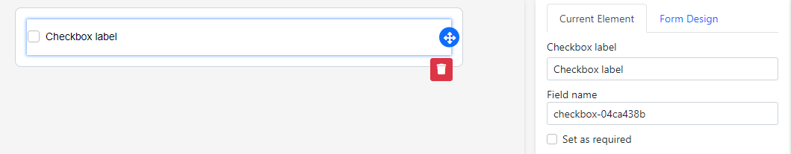

You can use checkboxes to get formal proof of subscribers' agreement with the terms and conditions of your subscription.

### Radio buttons

Use radio buttons to suggest several options.

Drag the "Radio buttons" element to the form. Add a label of a radio buttons group.

“Field name” is a name of the element, it is generated uniquelly by default.

Add the text and values for each option. The text is displayed to users in the form, and values will be sent to the request. To add more option, click on “Add option” link.

To prevent the form data from being submitted before the user fills it in completely, activate the "Set as required" option.

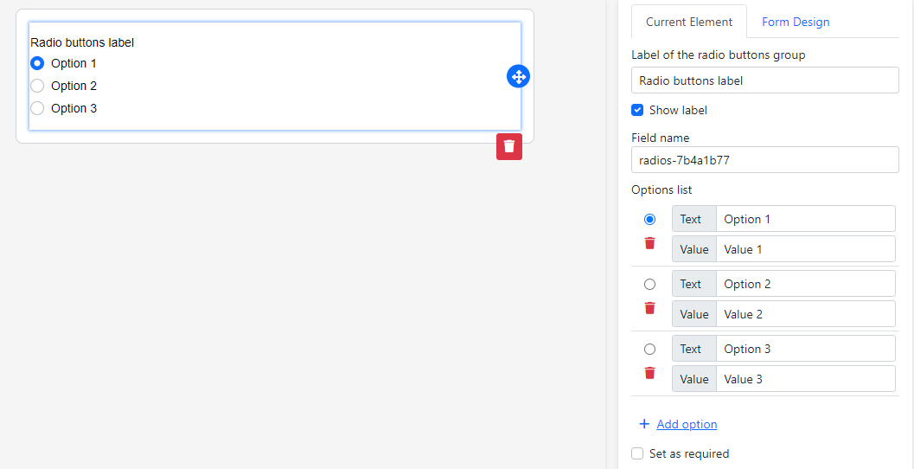

### Dropdown

Drag the "Dropdown" element to the form. Add a label of a drop-down list.

Add the text and values for each option. The text is displayed to users in the form, and values will be sent to the request. To add more option, click on “Add option” link.

“Field name” is a name of the element, it is generated uniquelly by default.

To prevent the form data from being submitted before the user fills it in completely, activate the "Set as required" option.

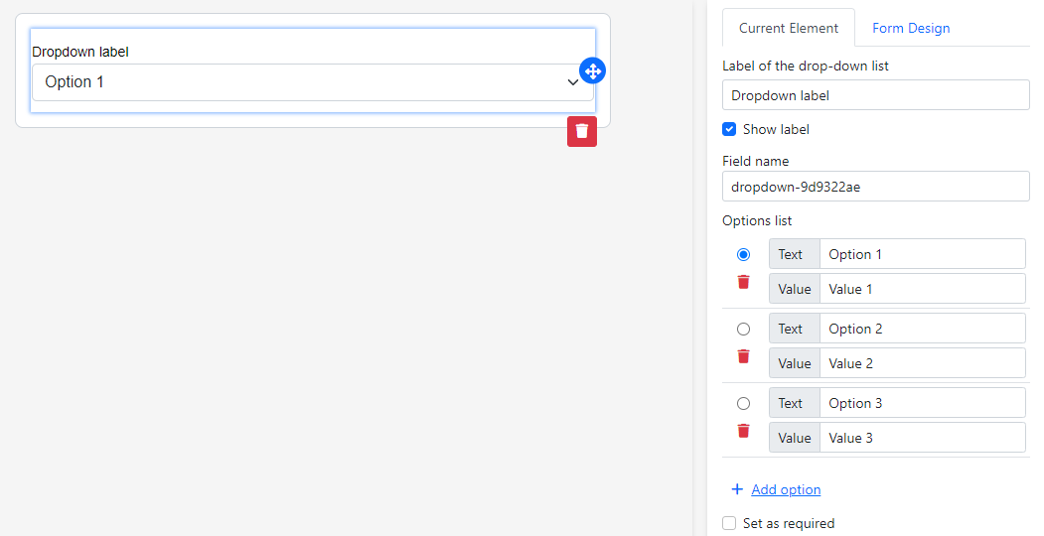

### Button

Drag the "Button" element to the form.

On the "Current Element" tab, you can select the button type (button or submit). You can also change the button text color, add link to button (if you enter the link, we will convert it to A tag HTML instead of button), and some other properties for customizing button look & feel.

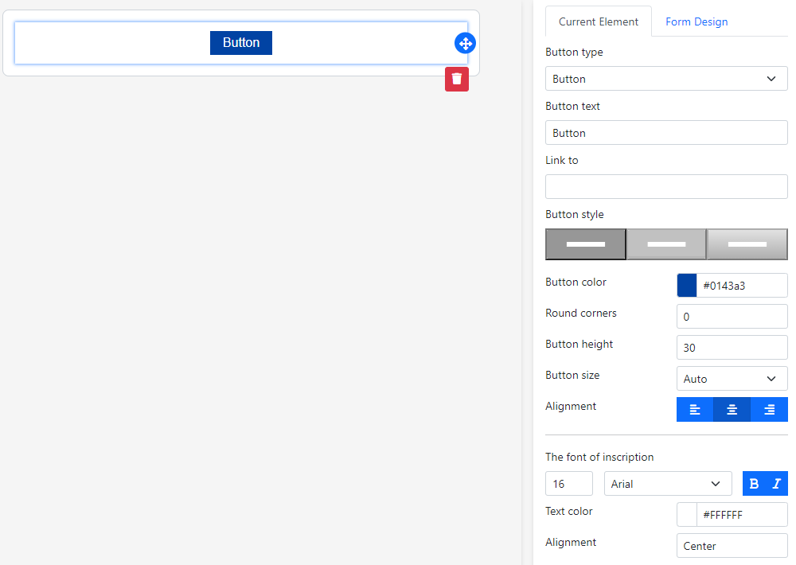

### Text

Choose the "Text" element from the panel on the left and drag it into the form.

In the form, you will see the visual display of the text in the element and options for styling the text on the right.

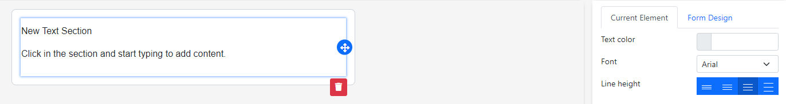

To change the text content, just click on the element, an inline WYSIWYG editor will be shown as below:

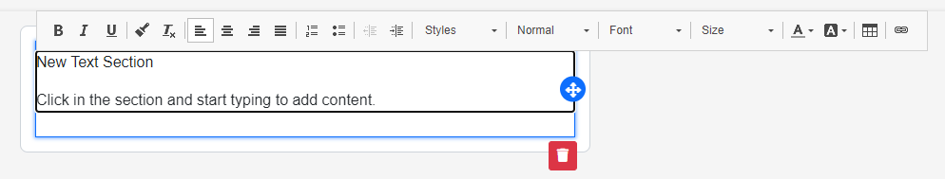

You make modifications in the editor to see how the form changes in real-time. The options available for editing on text are text color, font, line height, background color, background image, padding, block height.

### Image

Drag the "Image" element to the form.

On the "Current Element" tab, you can choose file for adding image, add alternative text, add link, set image width and set placement as you like.

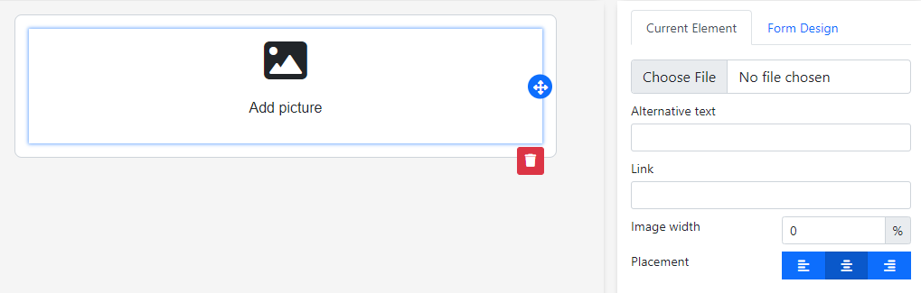

### Spacer

Use this to add space between elements of the form.

Drag the "Spacer" element to the form. Adjust the height of the spacer block using the number on the "Current Element" tab.

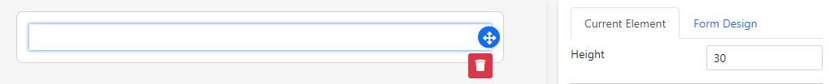

### Separator

Use this element to visually separate blocks of the form.

Drag the "Separator" element to the form. Adjust the size of the separator block, style of the separator and color of the separator on the "Current Element" tab.

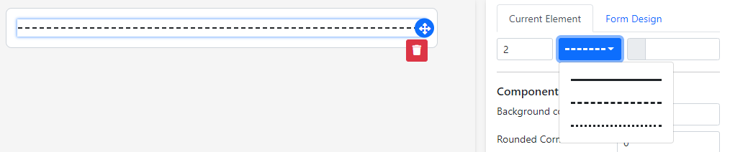

### Social

Use this to add social buttons to the form.

Drag the "Social" element to the form. By default, we will add 5 social networks: Facebook, Messenger, Google Plus, Twitter and Instagram.

On the "Current Element" tab, you can choose which social network to add by clicking “Add the button” link then choose the social network on dropdown button. We support 13 networks, including: Facebook, Messenger, Instagram, Telegram, Google Plus, Twitter, Whatsapp, LinkedIn, Youtube, Pinterest, Medium, Blogspot, Flickr, Slideshare, Snapchat, Tumblr, Viber

You also can change the placement position and alignment of these buttons.

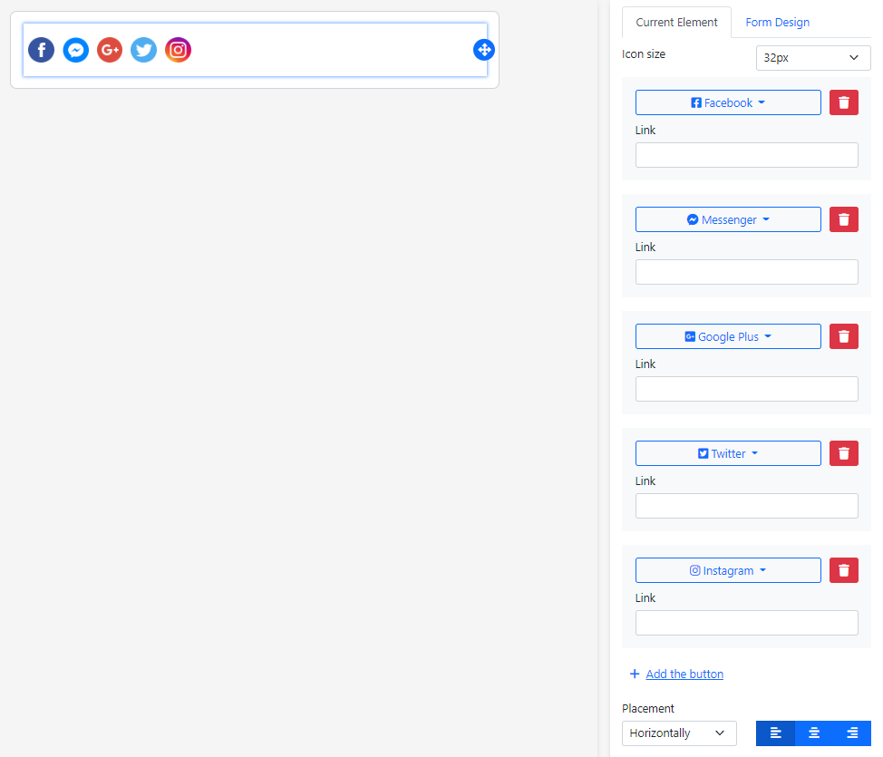

### Uploader

Use this to add an area for clicking/drag & dropping file to upload into the form.

Drag the "Uploader" element to the form. Adjust some properties on "Current Element" tab to change the look & feel of uploading area.

*Note: This is only client-side implementation for uploading file(s). You have to implement server-side for storing uploaded file to server.*

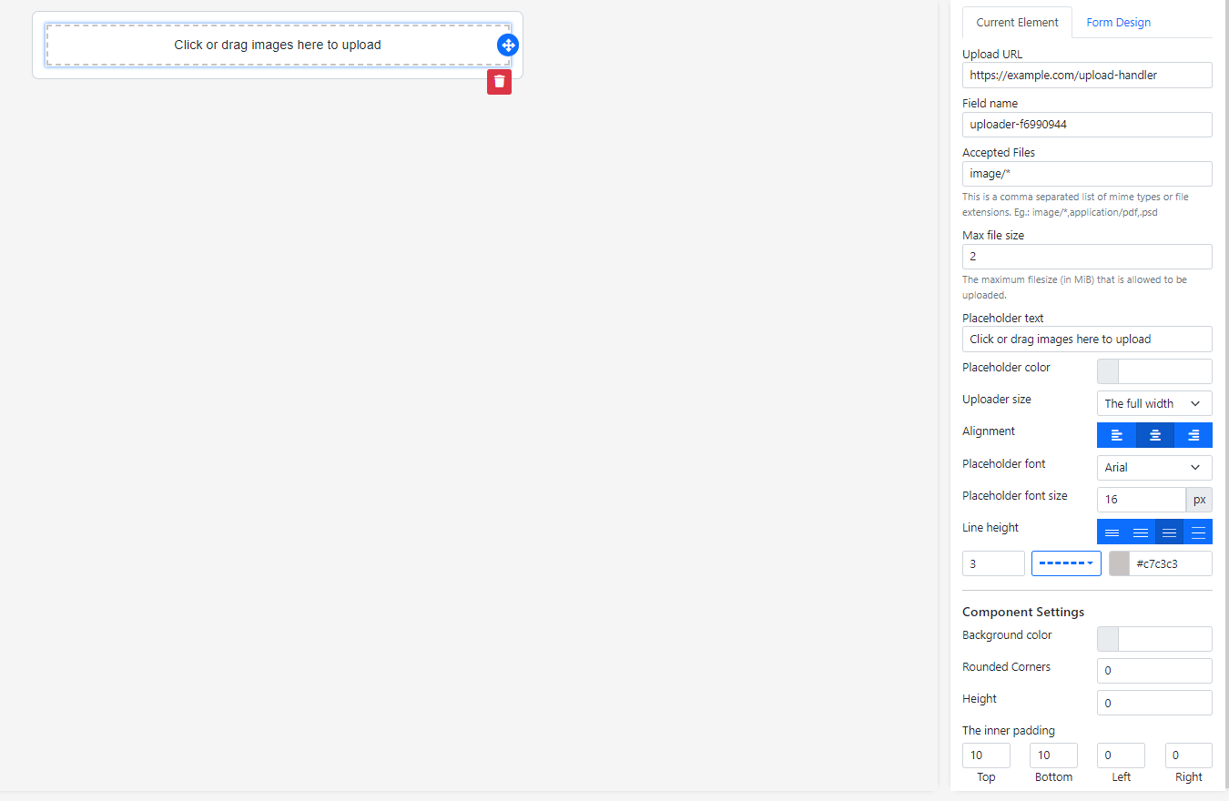

## Add more language

Here is the example for adding a new language, e.g Japanese (iso code is ja-JP)

* Add language code to “supportedLanguages” property in src\environments\environment.ts (and environment.prod.ts too)  
  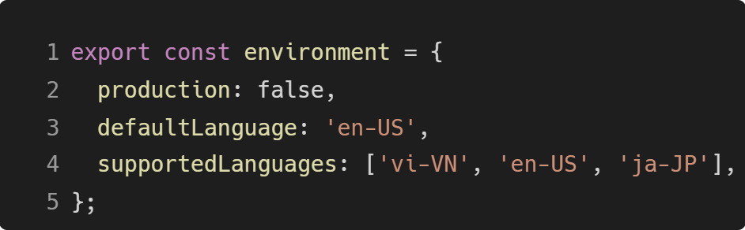
* Open file **package.json**, add ./src/translations/ja_JP.json to “i18n:extract”:  
  
* Open file /src/app/shared/i18n.service.ts  
  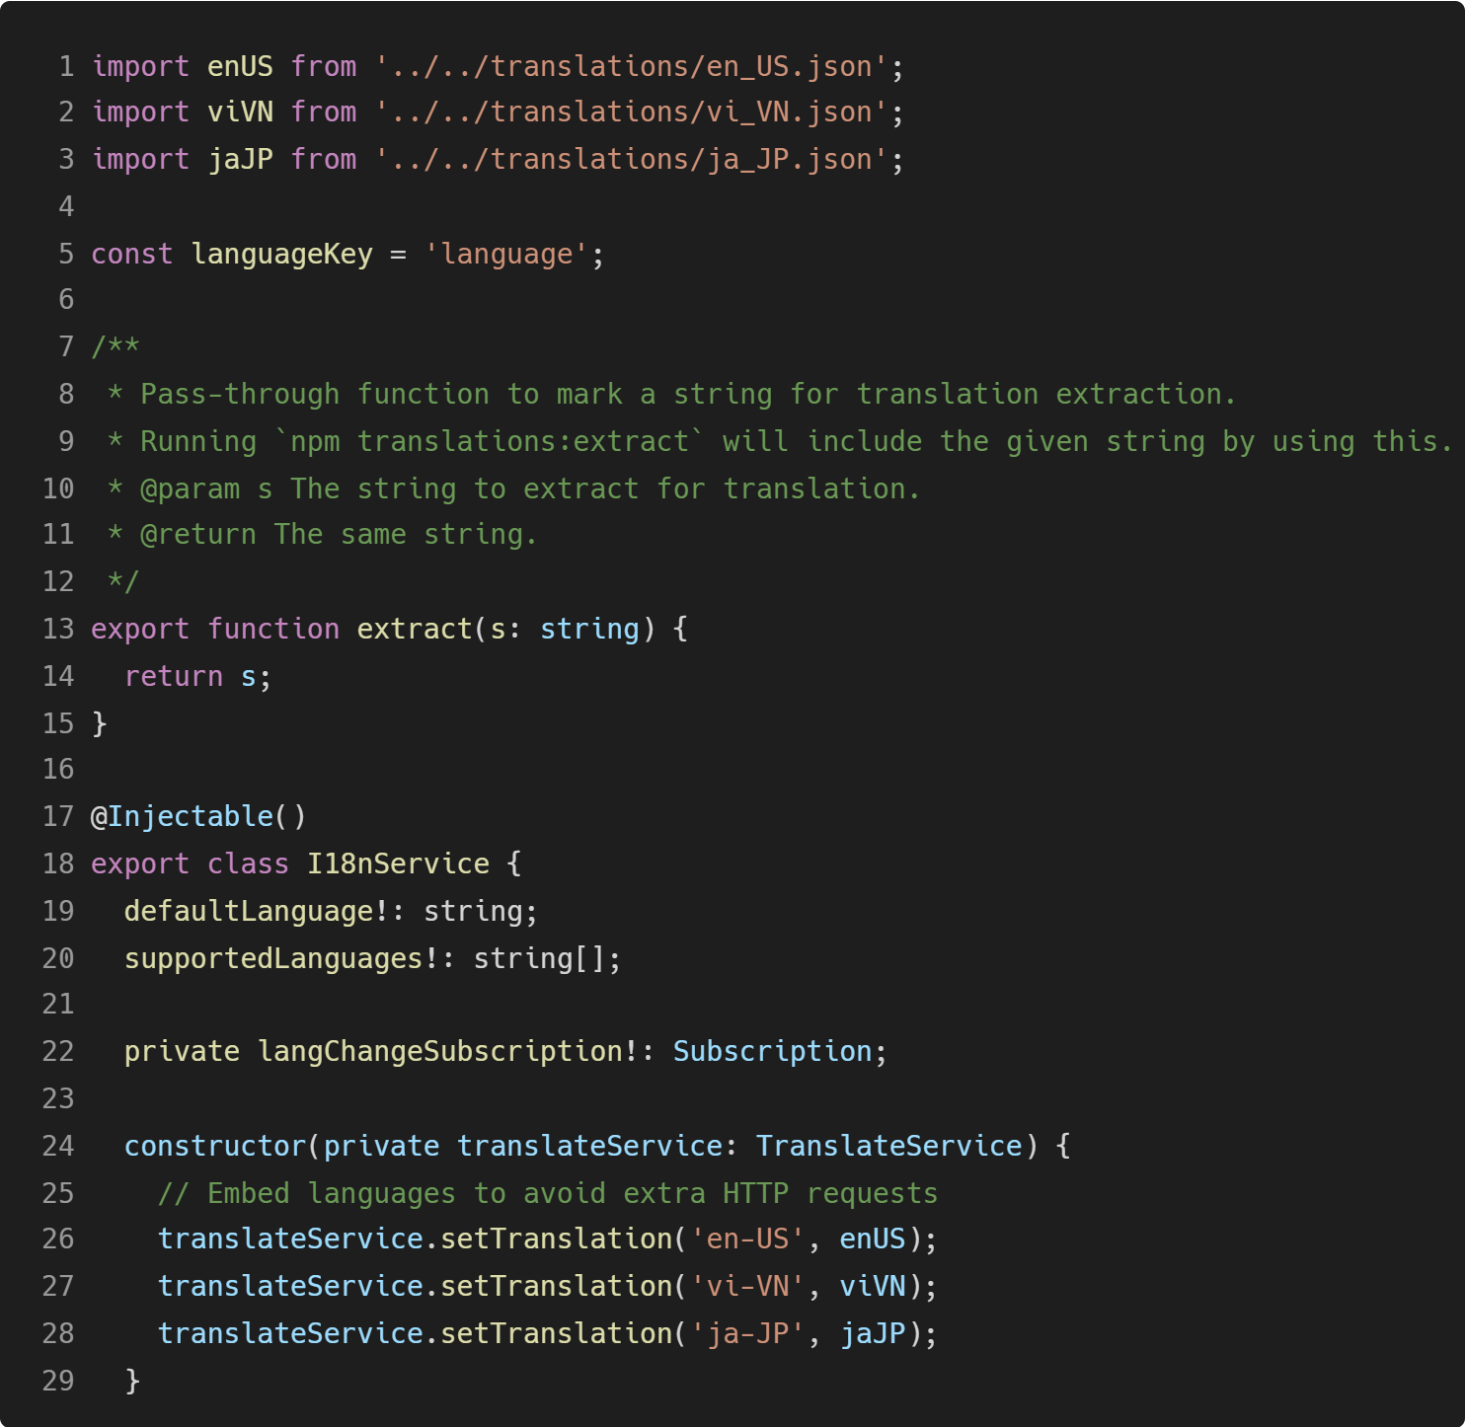  
  Add line 3 and 28 as above image
* Run “npm run i18n:extract”, then open /src/translations/ja_JP.json and change the data, something like this:  
  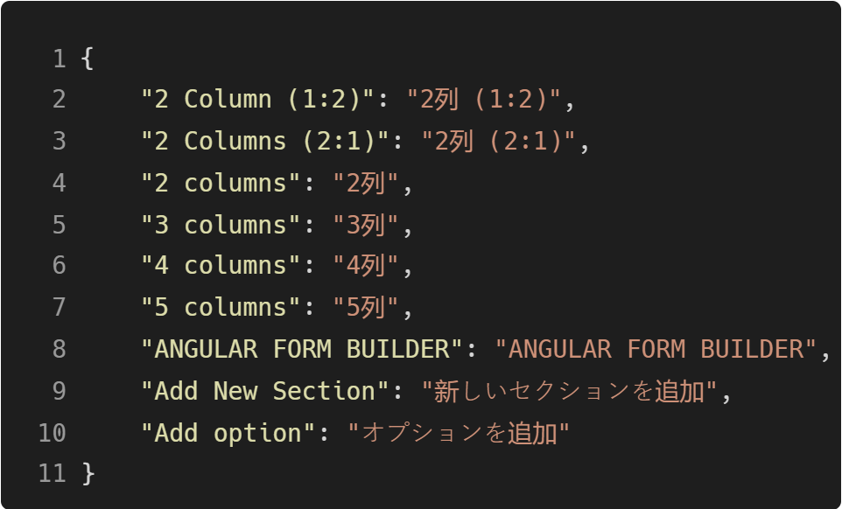

Once again, thank you so much for purchasing this script. As I said at the beginning, I'd be glad to help you if you have any questions relating to this script. No guarantees, but I'll do my best to assist.

***Nam Khanh Do***