**Description:**

This is a simple java standalone application program which can compress various files like image files, text files, audio files, dll files and exe files.

Here I have created simple GUI using JAVA SWING classes.

**System Requirement:**

This program can be run in any platform that installed with JRE (Java Runtime Environment).

**For Encoding**:

Here, I have created compress(InputStream,OutputStream) method in LZW_Implementation class.

In InputStream, I passed original parameter and output file with .lzw format is created.

**For Decoding:**

Here, I have created decompress(InputStream,OutputStream) method in LZW_Implementation class.

In Inputstream, I passed encoded file and output new file same as original file.

For **Compiling Program**:

1. Change Directory in shell command and go till MP_Project Folder
2. Type command ‘javac –d . LZW_Encoder_Decoder.java’ and enter

Or

1. Type Command ‘make’ and enter

For **Run Program:**

Type Command ‘java LZW_Encoder_Decoder’

Following screenshot is displayed to user:

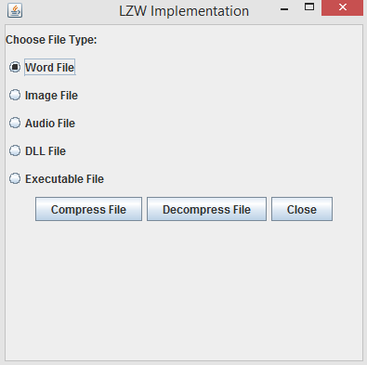

**Main.jpg**

**User Manual:**

Here, I have taken following file for compression and decompression:

Word File- Sample word file.doc

Image File- Sample image file.jpg

Audio File- Sample music file.mp3

DLL File- Sample dll file.dll

EXE File- Sample exe file.exe

User have to select radio button for compression any of the following types:

Word File, Image File, Audio File, DLL File or Exe File. (**Refer Main.jpg Screenshot**)

1. To Encode Files:

After selecting any radio button, user can click on compress button to compress files. After compressing file, Following Message box is displayed:

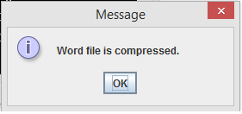

1. To Decode Files:

To decompress file, user have to select any radio button and click on decompress button. If File has already encoded then decompression will be done successfully and message box will be displayed as under:

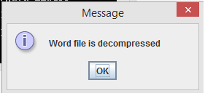

If File is not encoded earlier then no file is found for decompression. So following message will be displayed as under: 