A MINI PROJECT REPORT ON
QR CODE GENERATOR
(QR Code Generation Using Python with a Command Line and a Tkinter GUI)
Subject: Python Programming
Submitted by
Dax Patel
Enrollment No.: 12402080601023
Under the guidance of
Nayan Mali
Information Technology
A D Patel Institute of Technology
Academic Year 2026 – 27

Certificate
This is to certify that the mini project report entitled “QR Code Generator” is a bonafide record of the work carried out by Dax Patel (Enrollment No. 12402080601023), a student of Semester V, Department of Information Technology, A D Patel Institute of Technology, CVM University, Vallabh Vidyanagar, for the subject Python Programming during the academic year 2026 – 27.
The work has been completed under my guidance and supervision. To the best of my knowledge, the report has not been submitted to any other institute or university for the award of any degree, diploma or certificate.

Nayan Mali  Project Guide  Department of Information Technology | Head of Department  Department of Information Technology  A D Patel Institute of Technology
Date: ____________________
Place: Vallabh Vidyanagar

Acknowledgement
I would like to express my sincere gratitude to everyone who helped me in completing this mini project on the QR Code Generator.
First of all, I thank my guide, Nayan Mali, for his valuable guidance, constant encouragement and useful suggestions during every stage of the project. His feedback on the structure of the report and on the testing of the program helped me to improve the quality of my work.
I am also thankful to the Head of the Department of Information Technology and to all the faculty members of A D Patel Institute of Technology for providing the laboratory facilities and the learning environment in which this project could be carried out.
I thank the developers of the Python language and of the qrcode library, and the authors of the documentation that I used as references. Finally, I thank my classmates, friends and family for their support and motivation.
Dax Patel
Enrollment No.: 12402080601023

Abstract
A QR (Quick Response) code is a two-dimensional barcode that stores data such as a web address, a phone number or a short message in a pattern of black and white squares. A phone camera can read the pattern in a fraction of a second, which makes QR codes a convenient bridge between the printed world and the digital world. Drawing a QR code by hand is impractical, and many online generators show advertisements, need an internet connection or ask for personal details.
This project presents a QR Code Generator written in Python. It uses the qrcode library to create the code and the Tkinter toolkit to provide a small graphical window. When the program starts, a menu lets the user choose between a command-line mode and a graphical mode. In both modes the user types the text to be encoded and the program saves a PNG image of the QR code, using the highest error-correction level (H), a module size of 10 pixels and a border of 4 modules. The command-line mode saves a black code as cli_qr.png and the graphical mode saves a blue code as gui_qr.png. Empty input is rejected with a clear message.
The report describes the objectives, requirements, design, implementation and testing of the project. The complete source code is included, along with 12 test cases in which the saved images were read back with a QR decoder and compared with the original text. The project shows how a ready-made library, a menu and a graphical window can be combined into a small, practical tool.
Keywords: QR code, Python, qrcode library, Pillow, Tkinter, GUI, command line interface, error correction, PNG image.

Table of Contents
1. Introduction 7
2. Review of Existing Approaches 8
3. Problem Statement and Objectives 9
4. Scope and System Requirements 9
5. Technologies Used 10
6. System Design 11
7. Implementation 16
8. Testing and Results 18
9. Advantages and Limitations 19
10. Future Scope 20
11. Conclusion 20
References 20

List of Figures
Figure 1: QR code structure (version 3 example) 7
Figure 2: Steps performed by the qrcode library 12
Figure 3: Structure of the program 13
Figure 4: Level-0 data flow diagram 13
Figure 5: Flowchart of the program 14
Figure 6: Layout of the tkinter window 15
Figure 7: Sample QR codes produced for the text “https://www.example.com” 19
List of Tables
Table 1: Error correction levels of a QR code 9
Table 2: Comparison of QR code generation methods 9
Table 3: Functional requirements 10
Table 4: Hardware and software requirements 10
Table 5: Role of each technology 11
Table 6: Size and capacity of QR code versions (level H) 11
Table 7: Parameters used to create the QR code 12
Table 8: Functions of the program 15
Table 9: Test cases and results 18
Table 10: Output files of the two modes 19

1. Introduction

1.1 Overview
Today a QR code can be found on posters, bus tickets, restaurant tables, product packs, payment counters and visiting cards. A person points a phone at the square pattern and the phone opens a web page, joins a Wi-Fi network or shows a message. Behind each of these codes is a program that has converted some text into a pattern of modules and saved it as an image. This project builds such a program in Python.
The project is developed as a mini project for the Python Programming subject. It is intentionally small so that every line of code can be understood, yet it uses many basic ideas of the language: functions, conditions, user input, a third-party library, file output, global variables, a menu and a graphical user interface.

1.2 About QR Codes
A QR code stores data in a square grid of dark and light squares called modules. The size of the grid is described by its version, from version 1 (21 × 21 modules) to version 40 (177 × 177 modules); each version adds 4 modules to each side. A larger version can hold more data. A QR code contains the following parts, shown in Figure 1:
- Finder patterns: three large squares in the corners that let a scanner find the code and know how it is rotated.
- Timing patterns: alternating dark and light modules between the finder patterns that give the scanner the size of one module.
- Alignment pattern: a small square in larger versions (version 2 and above) that corrects distortion when the code is printed on a curved surface or photographed at an angle.
- Data and error-correction modules: the rest of the grid, which holds the encoded text and extra Reed–Solomon codewords that allow a damaged code to be read.
- Quiet zone: an empty border around the code; the specification asks for at least four modules.
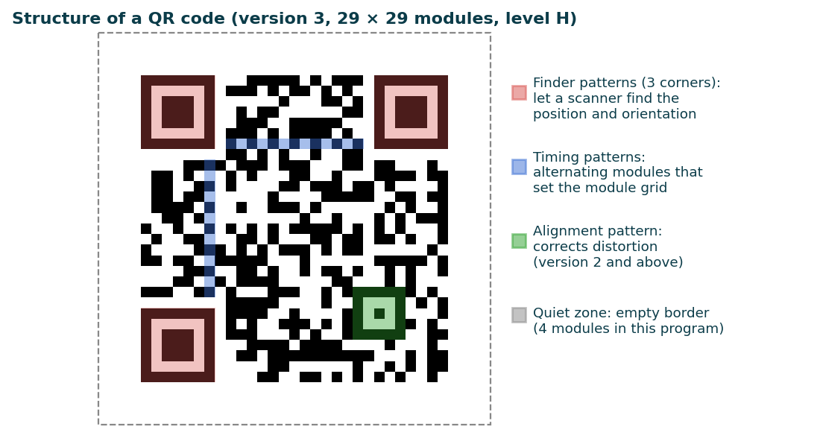
Figure 1: QR code structure (version 3 example)

1.3 Background of QR Codes
The QR code was invented in 1994 by Denso Wave, a company of the Toyota group, to track vehicle parts in factories faster than the ordinary barcode could. Unlike a barcode, which stores data in one direction, a QR code stores data in two directions and can therefore hold much more. The format is described in the international standard ISO/IEC 18004 and the code is free to use. With the arrival of smartphones with cameras, QR codes spread to advertising, ticketing, payments and many other areas.

1.4 Need for a QR Code Generator
Anyone who wants to share a link or a message as a QR code needs a generator. A program written by the user has several advantages over an online service: it works without an internet connection, it keeps the data on the user’s own computer, it shows no advertisements and its behaviour can be changed. It is also a good learning project, because it shows how a library is installed and used and how the same function can serve both a text interface and a graphical interface.

1.5 Organization of the Report
Chapter 2 reviews the existing ways of creating QR codes. Chapter 3 states the problem and the objectives. Chapter 4 defines the scope and the system requirements, and Chapter 5 describes the technologies used. Chapter 6 explains the system design including the parameters, the flowchart and the interface. Chapter 7 presents the implementation with the complete source code. Chapter 8 reports the testing and results. Chapters 9 to 11 discuss the advantages and limitations, the future scope and the conclusion.

2. Review of Existing Approaches

2.1 Online QR Code Generators
Many websites generate QR codes free of charge. Most of them are easy to use, but they need an internet connection, often show advertisements, and some ask the user to register or create “dynamic” codes that stop working when a subscription ends. The text typed by the user is also sent to the website’s server.

2.2 Mobile Applications and Desktop Software
Mobile applications and desktop programs can also create QR codes. They are convenient, but they must be installed, they are usually closed source, and many hide basic options such as the error-correction level or the colour behind a paid version.

2.3 Programming Libraries
Libraries are available for most languages. In Python the qrcode package, which uses the Pillow imaging library, creates a code with a few lines of code and allows the version, the error-correction level, the module size, the border and the colours to be chosen. This project uses it because it is simple, widely used and free.

2.4 Error Correction in QR Codes
A QR code carries extra Reed–Solomon data so that it can still be read when part of it is dirty, scratched or covered. There are four levels, shown in Table 1. A higher level recovers more damage but needs more modules, so the same text produces a larger code. The program uses the highest level, H, so that the codes remain readable even when printed small or partly damaged.
Table 1: Error correction levels of a QR code
Level | Name | Approximate share of data that can be restored
L | Low | 7%
M | Medium | 15%
Q | Quartile | 25%
H | High | 30%

2.5 Comparison with the Proposed System
Table 2: Comparison of QR code generation methods
Feature | Online generator | Mobile / desktop app | Proposed program
Needs internet | Yes | Sometimes | No
Installation | Not needed | Needed | Python and one library
Advertisements / tracking | Often present | Sometimes | None
Data stays on the device | No | Usually | Yes
Error-correction level | Often fixed | Often paid option | H (30%), can be changed in code
Easy to study and extend | No (closed) | No (closed) | Yes (small open code)

3. Problem Statement and Objectives

3.1 Problem Statement
Many people need to turn a link or a short message into a QR code, but they depend on websites that need internet access, show advertisements and receive the data that was typed. The problem is to design a simple program that accepts text from the user, converts it into a QR code that can be read reliably, and saves it as an image file, with both a command-line and a graphical way of using it.

3.2 Objectives
- To generate a QR code image from any text entered by the user.
- To use the highest error-correction level so that the code remains readable when damaged.
- To provide a command-line mode and a Tkinter graphical mode, chosen from a menu.
- To validate the input and show a helpful message when no data is entered.
- To save the result as a PNG image that can be printed or shared.
- To apply Python, a third-party library and a GUI toolkit together in a practical project.

4. Scope and System Requirements

4.1 Scope
The project covers a desktop program that converts one piece of text into one QR code image at a time. The user chooses the mode from a menu. The program runs completely on the user’s computer, so no data is sent anywhere. Reading (scanning) QR codes, batch generation, logos inside the code and special data formats such as Wi-Fi or contact cards are outside the scope of this version and are listed under future scope.

4.2 Functional Requirements
Table 3: Functional requirements
ID | Requirement
FR1 | The system shall show a menu with a command-line option and a graphical option and read the choice.
FR2 | The system shall display “Invalid choice!” for any choice other than 1 or 2.
FR3 | In command-line mode the system shall read the text from the keyboard, reject empty text and save the QR code as cli_qr.png.
FR4 | In graphical mode the system shall open a window with an entry field and a Generate QR button.
FR5 | When the button is clicked, the system shall reject an empty entry with an error box, otherwise save the QR code as gui_qr.png and show a success box.
FR6 | The system shall create the QR code with error-correction level H, a module size of 10 pixels and a border of 4 modules.

4.3 Non-Functional Requirements
- Usability: one question in the command-line mode, one field and one button in the graphical mode.
- Performance: the image must be saved instantly for ordinary text.
- Reliability: the saved code must decode to exactly the text that was entered.
- Portability: the program must run on Windows, Linux and macOS wherever Python 3 is installed.
- Privacy: the text is never sent over a network.
- Maintainability: the code is divided into five small functions.

4.4 System Requirements
The program is very light and runs on almost any computer. The requirements used for development and testing are given in Table 4.
Table 4: Hardware and software requirements
Component | Specification
Processor | Any modern processor (Intel Core i3 or equivalent and above)
RAM | 4 GB or more
Operating system | Windows, Linux or macOS
Code editor | Visual Studio Code (or any text editor)
Language | Python 3
Libraries | qrcode (with Pillow) installed with pip; tkinter (included with Python)

5. Technologies Used

5.1 Python
Python is a high-level language with a short and readable syntax. It is used here because the whole program can be written in about eighty lines and because a library for QR codes is available. Python reads the menu choice with input(), takes decisions with if statements and organises the program into functions.

5.2 The qrcode Library and Pillow
The qrcode package is installed with the command pip install "qrcode[pil]", which also installs Pillow. The class QRCode collects the settings and the data, the method make() calculates the code, and make_image() draws it with Pillow and returns an image object whose save() method writes the PNG file. The choice of module colours is made in make_image().

5.3 Tkinter
Tkinter is the standard graphical toolkit of Python and is installed with it. The program uses a window (Tk), a text label (Label), a one-line text field (Entry) and a push button (Button) arranged with the pack() method, and the messagebox module for the error and success boxes.

5.4 Development Tools
- Visual Studio Code was used to write the program.
- The Python interpreter was used to run and test the functions.
- The documentation of Python, Tkinter and the qrcode library was used as reference.

5.5 Role of Each Technology
Table 5: Role of each technology
Technology | Role in the project | Used in
Python 3 | Menu, input, decisions, functions | All functions
qrcode library | Builds the QR code matrix and image | generate_qr_cli(), generate_qr_gui()
Pillow | Draws and saves the PNG image | Inside the qrcode library
Tkinter | Window, label, entry, button, message boxes | start_gui(), generate_qr_gui()

6. System Design

6.1 Size and Capacity of QR Code Versions
The version of a QR code decides its size: the code has 4 × version + 17 modules on each side. The amount of text that fits depends on the version and on the error-correction level. Table 6 gives the capacity for text stored as bytes at level H; shorter text such as digits only can use a denser mode and fit more characters.
Table 6: Size and capacity of QR code versions (level H)
Version | Modules per side | Characters that fit (level H, byte mode)
1 | 21 × 21 | 7
2 | 25 × 25 | 14
3 | 29 × 29 | 24
4 | 33 × 33 | 34
5 | 37 × 37 | 44
40 | 177 × 177 | 1273

For example, the 23-character text https://www.example.com needs version 3 (29 × 29 modules) at level H, which gives an image of (29 + 2 × 4) × 10 = 370 pixels on each side.

6.2 Parameters Used to Create the QR Code
Both modes create the code with the same four parameters, listed in Table 7.
Table 7: Parameters used to create the QR code
Parameter | Value | Meaning
version | 1 | The smallest size to start with; with fit=True the library increases it when the text does not fit
error_correction | ERROR_CORRECT_H | Highest level: about 30% of the code can be restored
box_size | 10 | Each module is drawn as a square of 10 × 10 pixels
border | 4 | Quiet zone of 4 modules on every side (the minimum in the standard)
make(fit=True) | True | Chooses the smallest version that can hold the text
fill_color / back_color | black or blue / white | Colour of the modules and of the background

6.3 Generation Process
When make_image() is called, the library performs the steps shown in Figure 2: it chooses the smallest version that can hold the text, encodes the text into bits, adds the error-correction codewords, places the modules in the grid together with the finder, timing and alignment patterns, applies the mask pattern that gives the most readable result, and finally draws the grid as an image in which every module is 10 pixels wide and a border of 4 modules is added.
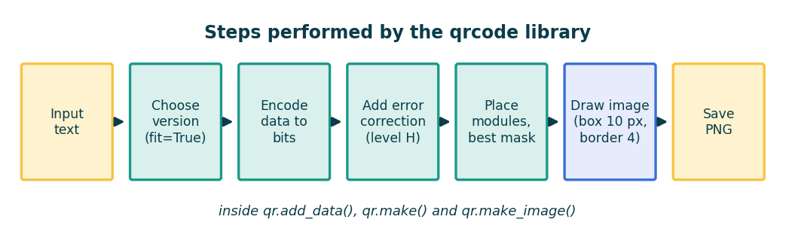
Figure 2: Steps performed by the qrcode library

6.4 System Architecture
The program is a single Python file with five functions, shown in Figure 3. The function main() shows the menu. Choice 1 calls generate_qr_cli(), and choice 2 calls start_gui(), which builds the window and connects the button to generate_qr_gui(). Both generating functions use the qrcode library and Pillow to produce the image.
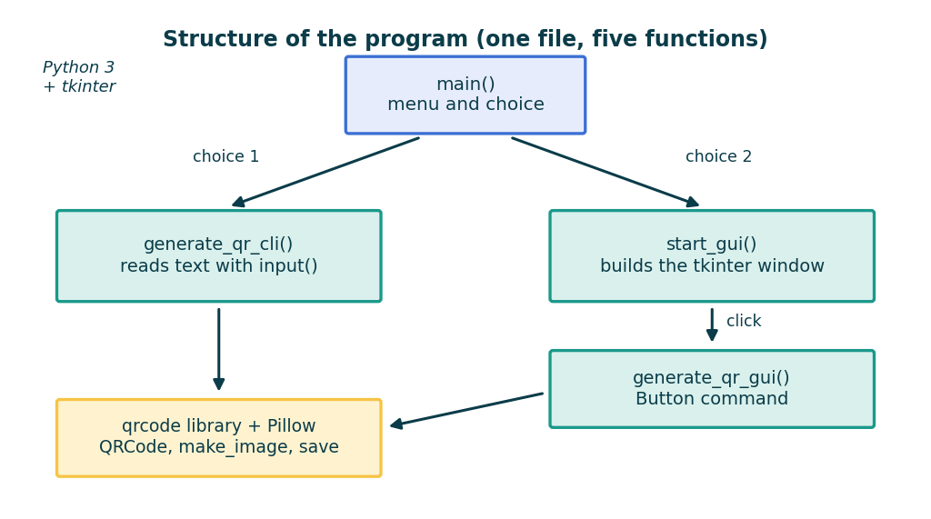
Figure 3: Structure of the program

6.5 Data Flow
At the highest level the system has one process. The user supplies the choice and the text; the process creates the QR code and the result is saved as a PNG file and announced to the user with a message. Figure 4 shows this as a level-0 data flow diagram.
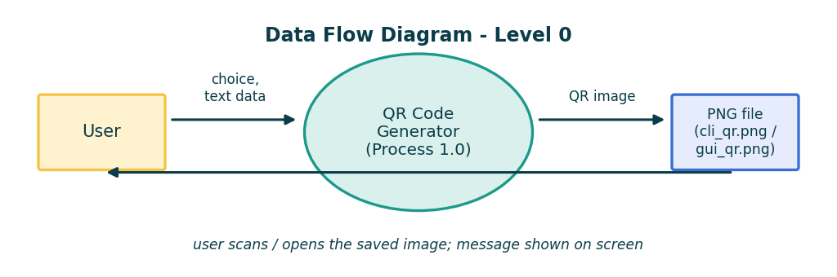
Figure 4: Level-0 data flow diagram

6.6 Algorithm
Command-line mode
- Show the menu and read the choice.
- If the choice is 1, read the text from the keyboard.
- If the text is empty, print “No data entered!” and stop.
- Create a QRCode object with version 1, level H, box size 10 and border 4.
- Add the text, call make(fit=True) and create the image in black on white.
- Save the image as cli_qr.png and print a confirmation.
Graphical mode
- If the choice is 2, create the window with a label, an entry field and the Generate QR button.
- Wait until the user clicks the button; then read the text of the entry field.
- If the field is empty, show an error box “Please enter some data” and stop.
- Create the QRCode object, add the text and call make(fit=True).
- Create the image in blue on white and save it as gui_qr.png.
- Show a success box “QR Code saved as gui_qr.png”.

6.7 Flowchart
The overall flow of the program is shown in Figure 5. Any menu choice other than 1 or 2 prints an error message and ends the program.
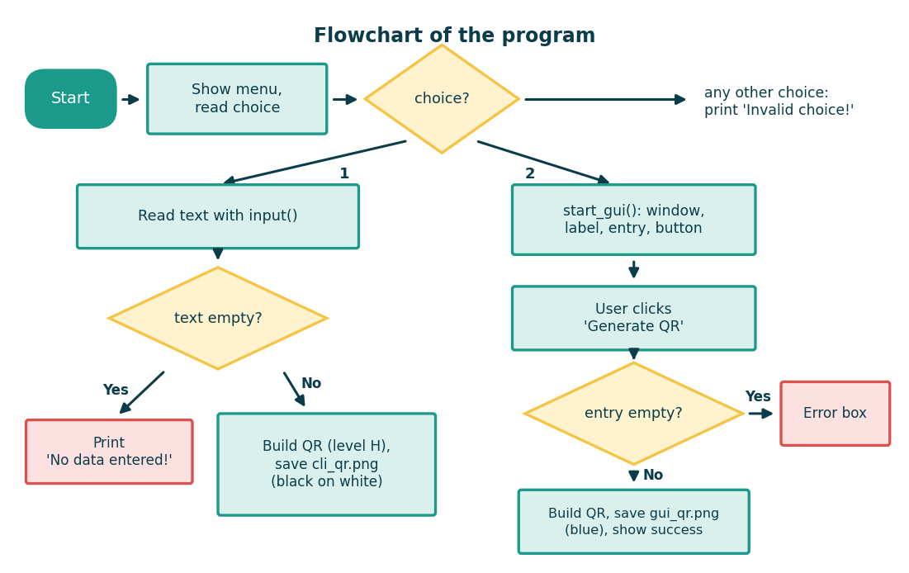
Figure 5: Flowchart of the program

6.8 User Interface Design
In the command-line mode the program prints the menu and asks one question, “Enter data for QR Code:”. The graphical mode, shown in Figure 6, is a small window of 300 × 150 pixels with the title “QR Code Generator”, a label, a text field of width 35 and a button. The interface is kept deliberately simple so that the user needs no instructions.
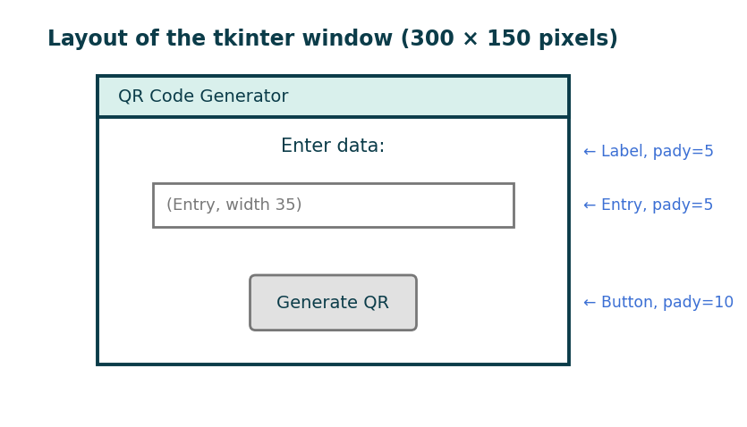
Figure 6: Layout of the tkinter window

6.9 Functions of the Program
Table 8: Functions of the program
Function | Purpose | Output
generate_qr_cli() | Reads text with input(), builds the code, saves it | cli_qr.png (black on white) and a message in the console
generate_qr_gui() | Reads the entry field, builds the code, saves it | gui_qr.png (blue on white) and a message box
start_gui() | Creates the window and widgets and starts the event loop | The window of Figure 6
main() | Shows the menu and calls the chosen mode | “Invalid choice!” for a wrong choice

7. Implementation
The project is a single file, qr_generator.py. Before running it, the library must be installed with pip install "qrcode[pil]". The complete code is given below in the order in which it appears in the file, followed by an explanation.

7.1 Imports
import qrcode
import tkinter as tk
from tkinter import messagebox

7.2 Command-Line Function
# ---------------- CLI FUNCTION ----------------
def generate_qr_cli():
data = input("Enter data for QR Code: ")
if not data:
print("No data entered!")
return

qr = qrcode.QRCode(
version=1,
error_correction=qrcode.constants.ERROR_CORRECT_H,
box_size=10,
border=4,
)

qr.add_data(data)
qr.make(fit=True)

img = qr.make_image(fill_color="black", back_color="white")
img.save("cli_qr.png")

print("QR Code generated and saved as cli_qr.png")

7.3 Graphical Function
# ---------------- GUI FUNCTION ----------------
def generate_qr_gui():
data = entry.get()
if data == "":
messagebox.showerror("Error", "Please enter some data")
return

qr = qrcode.QRCode(
version=1,
error_correction=qrcode.constants.ERROR_CORRECT_H,
box_size=10,
border=4,
)

qr.add_data(data)
qr.make(fit=True)

img = qr.make_image(fill_color="blue", back_color="white")
img.save("gui_qr.png")

messagebox.showinfo("Success", "QR Code saved as gui_qr.png")

7.4 Window Setup
# ---------------- GUI SETUP ----------------
def start_gui():
global entry
root = tk.Tk()
root.title("QR Code Generator")
root.geometry("300x150")

label = tk.Label(root, text="Enter data:")
label.pack(pady=5)

entry = tk.Entry(root, width=35)
entry.pack(pady=5)

btn = tk.Button(root, text="Generate QR", command=generate_qr_gui)
btn.pack(pady=10)

root.mainloop()

7.5 Main Menu
# ---------------- MAIN MENU ----------------
def main():
print("QR Code Generator")
print("1. Generate using CLI")
print("2. Generate using GUI")

choice = input("Enter your choice (1/2): ")

if choice == "1":
generate_qr_cli()
elif choice == "2":
start_gui()
else:
print("Invalid choice!")

if __name__ == "__main__":
main()

7.6 Explanation of the Code
- Imports: qrcode creates the code, tkinter (imported as tk) builds the window and messagebox shows the message boxes.
- generate_qr_cli(): input() reads the text; if not data is true for an empty string and stops the function with a message. QRCode(...) stores the four parameters of Table 7, add_data() stores the text, and make(fit=True) lets the library pick the smallest version that holds it.
- Image and colours: make_image(fill_color="black", back_color="white") draws the code; the graphical function uses blue modules, which makes the output of the two modes easy to tell apart. save() writes the PNG file in the folder from which the program was started.
- generate_qr_gui(): it is called when the button is clicked. It reads the text with entry.get(), shows an error box when the field is empty and otherwise saves gui_qr.png and shows a success box.
- Global variable: start_gui() declares entry as global so that the separate function generate_qr_gui() can read the entry field.
- start_gui(): it creates the window, sets its title and its size of 300 × 150, packs a label, an entry and a button with vertical padding, and calls mainloop(), which keeps the window open and waits for the user.
- main(): it prints the menu, reads the choice as text and compares it with “1” and “2”; anything else prints “Invalid choice!”. The line if __name__ == "__main__" makes the menu start only when the file is run directly.

7.7 How to Run the Project
- Install Python 3 and run pip install "qrcode[pil]" in a terminal.
- Save the code in a file named qr_generator.py.
- Open a terminal in the folder of the file and run python qr_generator.py.
- Type 1 for the command-line mode or 2 for the graphical mode.
- Enter the text and, in the graphical mode, click Generate QR.
- Open the saved PNG file, or scan it with a phone, to check the result.

8. Testing and Results

8.1 Testing Approach
The functions were tested with sample text, with empty input and with wrong menu choices. In every case the message shown by the program was compared with the expected message. For the cases that save an image, the PNG file was read back with a QR code decoder and the decoded text was compared with the text that had been entered; the colour of the modules and the size of the image were also checked. Table 9 lists the test cases.
Table 9: Test cases and results
No. | Test case | Input | Expected output | Actual output | Result
1 | CLI: URL as data | https://www.example.com | cli_qr.png created, message printed, QR decodes to the same text | file created; decoded 'https://www.example.com' | Pass
2 | CLI: empty input | (just Enter) | 'No data entered!' and no file | 'No data entered!'; no file | Pass
3 | CLI: plain text | Hello, World! 123 | QR decodes to the same text | decoded 'Hello, World! 123' | Pass
4 | CLI: longer text (fit=True) | 90-character sentence | version grows automatically, QR decodes to the same text | decoded correctly | Pass
5 | CLI: phone number | +91 9876543210 | QR decodes to the same text | decoded '+91 9876543210' | Pass
6 | GUI: URL as data | https://www.example.com | gui_qr.png created with blue modules, success box shown | file created; blue modules present; box: info | Pass
7 | GUI: empty entry | (empty field) | error box 'Please enter some data', no file | box: error 'Please enter some data'; no file | Pass
8 | GUI: plain text | QR Project | QR decodes to the same text | decoded 'QR Project' | Pass
9 | Menu: invalid choice | 3 | 'Invalid choice!' | 'Invalid choice!' | Pass
10 | Menu: non-numeric choice | abc | 'Invalid choice!' | 'Invalid choice!' | Pass
11 | Menu: option 2 opens the window | 2 | window titled 'QR Code Generator', 300x150, label, entry, button | title/size set; widgets created: Label, Entry, Button | Pass
12 | Error correction level H | cli_qr.png with a 6x6-module patch blanked in the centre | QR still decodes (up to ~30% damage recoverable) | decoded 'https://www.example.com' | Pass

8.2 Observations
All test cases produced the expected output. The codes decode to exactly the text that was entered, including text with punctuation, digits and a plus sign, and a longer sentence made the library move to a larger version automatically because of fit=True. Test 12 shows the benefit of level H: after a square of about 6 × 6 modules in the middle of the code was erased, the code was still read correctly. Empty input is rejected in both modes without creating a file, and wrong menu choices are handled by the final else branch.

8.3 Sample Output
Figure 7 shows the two files produced for the text https://www.example.com. Both are 370 × 370 pixels (version 3, 29 × 29 modules, box size 10, border 4) and differ only in the colour of the modules, as listed in Table 10.
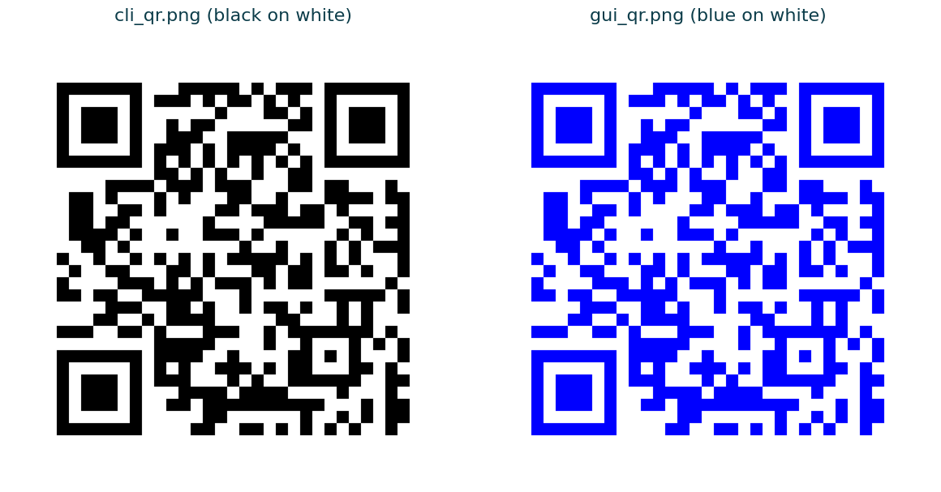
Figure 7: Sample QR codes produced for the text “https://www.example.com”
Table 10: Output files of the two modes
Property | Command-line mode | Graphical mode
Started by | Menu choice 1 | Menu choice 2, then the button
File saved | cli_qr.png | gui_qr.png
Module colour | Black | Blue
Background | White | White
Message on success | Printed in the console | Message box “Success”
Message when empty | “No data entered!” printed | Error box “Please enter some data”

8.4 Result
The final program asks for text, rejects empty input, creates a QR code with error-correction level H and saves it as a PNG image in either mode. The output meets all the functional requirements listed in Table 3.

9. Advantages and Limitations

9.1 Advantages
- Simple to use: one question, or one field and one button.
- Works offline and keeps the entered text on the user’s computer.
- High error correction (level H) keeps the codes readable even when damaged.
- Two ways of using the program from one file: command line and graphical window.
- Small, readable code that is easy to understand, modify and extend.
- The version is chosen automatically, so short and long text both work.

9.2 Limitations
- The code that builds the QR code is repeated in the two generating functions.
- If the text is too long for the largest QR code (about 1,200 characters at level H), the library raises an error that the program does not handle.
- The files cli_qr.png and gui_qr.png are overwritten each time, and the user cannot choose a file name or folder.
- The graphical mode does not display the QR code in the window and does not clear the entry field after saving.
- The colours, size and error-correction level are fixed in the code and cannot be changed by the user.
- Only text can be encoded; the program does not check that a link is valid, and it cannot read QR codes.

10. Future Scope
The program is complete for its purpose, but it can be extended in many useful directions:
- Move the common code into one function that takes the colour and the file name as parameters.
- Show the generated QR code inside the Tkinter window and add a Save As button.
- Let the user choose the colour, size and error-correction level.
- Handle errors such as text that is too long and show a friendly message.
- Add special formats such as Wi-Fi, e-mail, phone number and contact card.
- Add a logo in the centre of the code, batch generation from a file and a scanner that reads QR codes with the camera.

11. Conclusion
The QR Code Generator project meets its objectives of accepting text, creating a QR code with high error correction and saving it as an image, with both a command-line and a graphical way of use. It was built with Python, the qrcode library and Tkinter. Testing showed correct results for text of different kinds, for empty input and for wrong menu choices, and the saved codes decoded to exactly the entered text.
The project also gave practical experience of installing and using a third-party library, organising a program into functions, handling input and building a small graphical interface. With the enhancements listed above, it can grow into a more complete QR code tool.

References
[1] International Organization for Standardization, ISO/IEC 18004: Information technology – QR Code bar code symbology specification.
[2] Denso Wave, “QR Code”, https://www.qrcode.com/en/
[3] “qrcode”, Python QR Code image generator, Python Package Index. https://pypi.org/project/qrcode/
[4] Python Software Foundation, “tkinter – Python interface to Tcl/Tk”, Python documentation. https://docs.python.org/3/library/tkinter.html
[5] Pillow documentation, https://pillow.readthedocs.io/

