A Model of the Solar System

CS 480 - PA#07 Report

Jordan Andrieu, Deev Patel & Braeden Richards

October 17, 2018

**Contents**

Overview ……………………………………………………… 3

Extra Credit

Dependencies & Building

User Manual …………………………………………………... 6

IMGUI Menu & Movement

Keyboard Controls

*Zoom, Simulation Speed, Window Control*

Screenshots of Solar System

Technical Manual ……………………………………………. 13

Issues

Things We Could Have Done Differently

Recent Changes

**Overview**

This project is a simulation of our solar system. It includes the sun, all major planets (including Pluto), and many moons. In the case of the moons, only the major ones are rendered as some of the outer planets have too many to consider. The solar system adheres to all the required guidelines as set out in the project assignment rubric. We tried to make the solar system as accurate as possible by implementing realistic elliptical orbits, planet tilts, and rings. Notably, most of the movement controlling is done through the menu system.

**Extra Credit**

In addition to basic requirements, the project implements the following extra credit items.

* Live adjustment of simulation speed
  + Simulation can be made faster or slower with ‘f’ or ‘s’ keys respectively
* Configuration file
  + Located in “launch” folder
  + Controls all parameters of solar system including orbitals
* Proper Rings planets (besides Saturn)
  + Jupiter
  + Neptune
  + Uranus

**Dependencies & Building**

This project is built using cmake. To build and run the program, go to the project source directory (PA7) and run the following.

|  |
| --- |
| mkdir build cd build cmake .. make ./Solar_System |

The project was made with OpenGL 3.3, but it should work with most newer versions. In addition, the following external libraries are required. Note that everything was built and tested on Ubuntu 18.04. As such, all installation instructions are meant for Ubuntu 18.04.

* **Assimp** - Open Asset Import Library
  + More Info: <https://github.com/assimp/assimp/wiki>
  + Installation: sudo apt-get install libassimp-dev
  + Primary Usage: loading models of sun, planets, & moons
* **GLEW** - OpenGL Extension Wrangler Library
  + More Info: <http://glew.sourceforge.net/>
  + Installation: sudo apt-get install libglew-dev
* **GLM** - OpenGL Mathematics Library
  + More Info: <http://glm.g-truc.net/0.9.7/index.html>
  + Installation: sudo apt-get install libglm-dev
  + Primary Usage: math related with rendering and orbit mechanics
* **Magick++** - ImageMagick C++ API
  + More Info: <http://www.imagemagick.org/Magick%2B%2B/>
  + Installation: sudo apt-get install libmagick++-dev
  + Primary Usage: loading textures for sun, planets, & moons
* **SDL2** - Simple DirectMedia Layer
  + More Info: <https://wiki.libsdl.org/FrontPage>
  + Installation: sudo apt-get install libsdl2-dev
  + Primary Usage: window creation & user interactions

Note: One can install all the necessary dependencies at once.

|  |
| --- |
| sudo apt-get install libassimp-dev libglew-dev libglm-dev libmagick++-dev libsdl2-dev |

**User Manual**

**Menu & Movement**

There is an IMGUI menu that opens in a separate window by default. The menu window can be closed and opened by pressing the ‘m’ key. The menu plays a pivotal role in the movement capabilities of the project.

The top part of the menu gives the user the ability to manually change either the camera location or focus position. Simply type the desired values and hit update to go to the location. The menu also automatically updates the current camera position and focus point. This is useful when following a specific planet.

The bottom part of the menu gives the user the ability to follow any one of nine planets. By clicking on a planet name from the dropdown list, the simulation will follow the specified planet. When following a planet, the camera position and focus will automatically change as the planet orbits. You can also use the zoom keys (as defined in the “Keyboard Controls” section) to move closer or further away from the planet being followed. You can stop following a planet by clicking the “System” view or going to a specific location through the top half of the menu.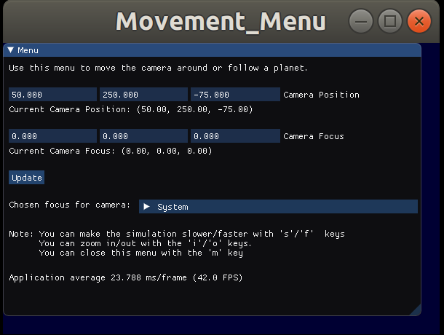

**Figure 1:** The IMGUI menu window as it appears on program startup.

**Keyboard Controls**

* Zooming
  + **i:** Zoom towards the focus point
  + **o:** Zoom away from the focus point
* Simulation Speed
  + **f:** Increase the speed of the simulation
  + **s:** Decrease the speed of the simulation
* Window Controls
  + **m:** open or close the IMGUI menu window
  + **ESC:** Close all windows and exit program

**Screenshots of Solar System**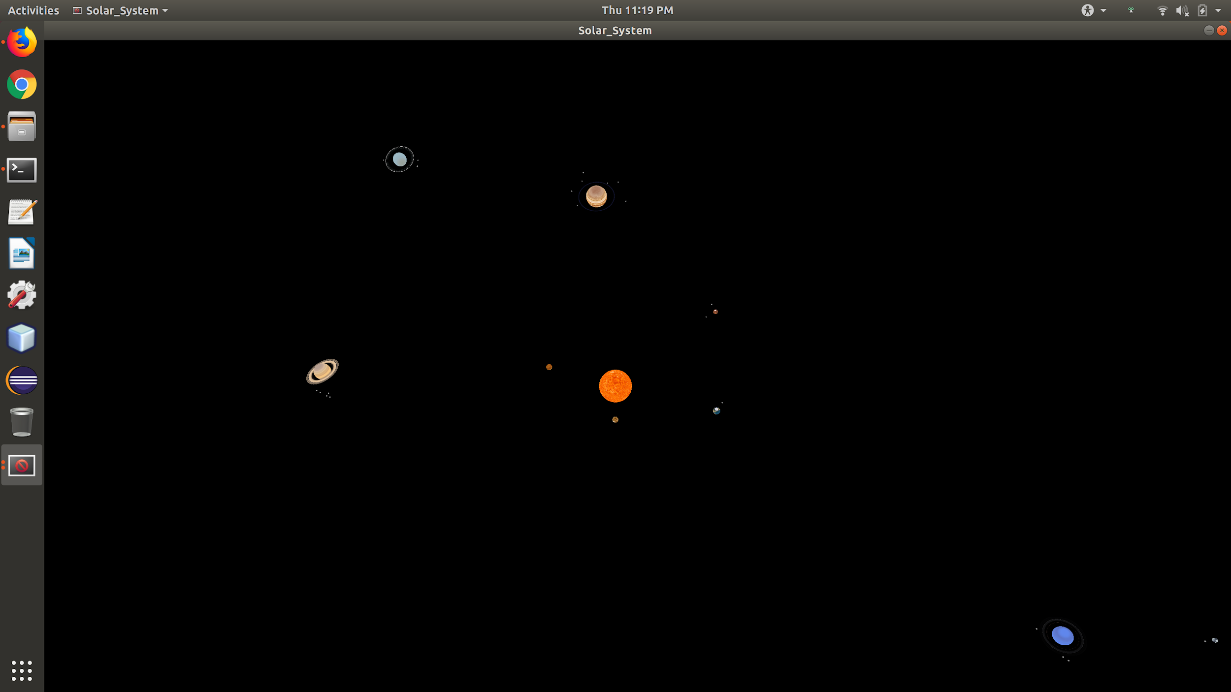

**Figure 2:** Default system view of the entire solar system.

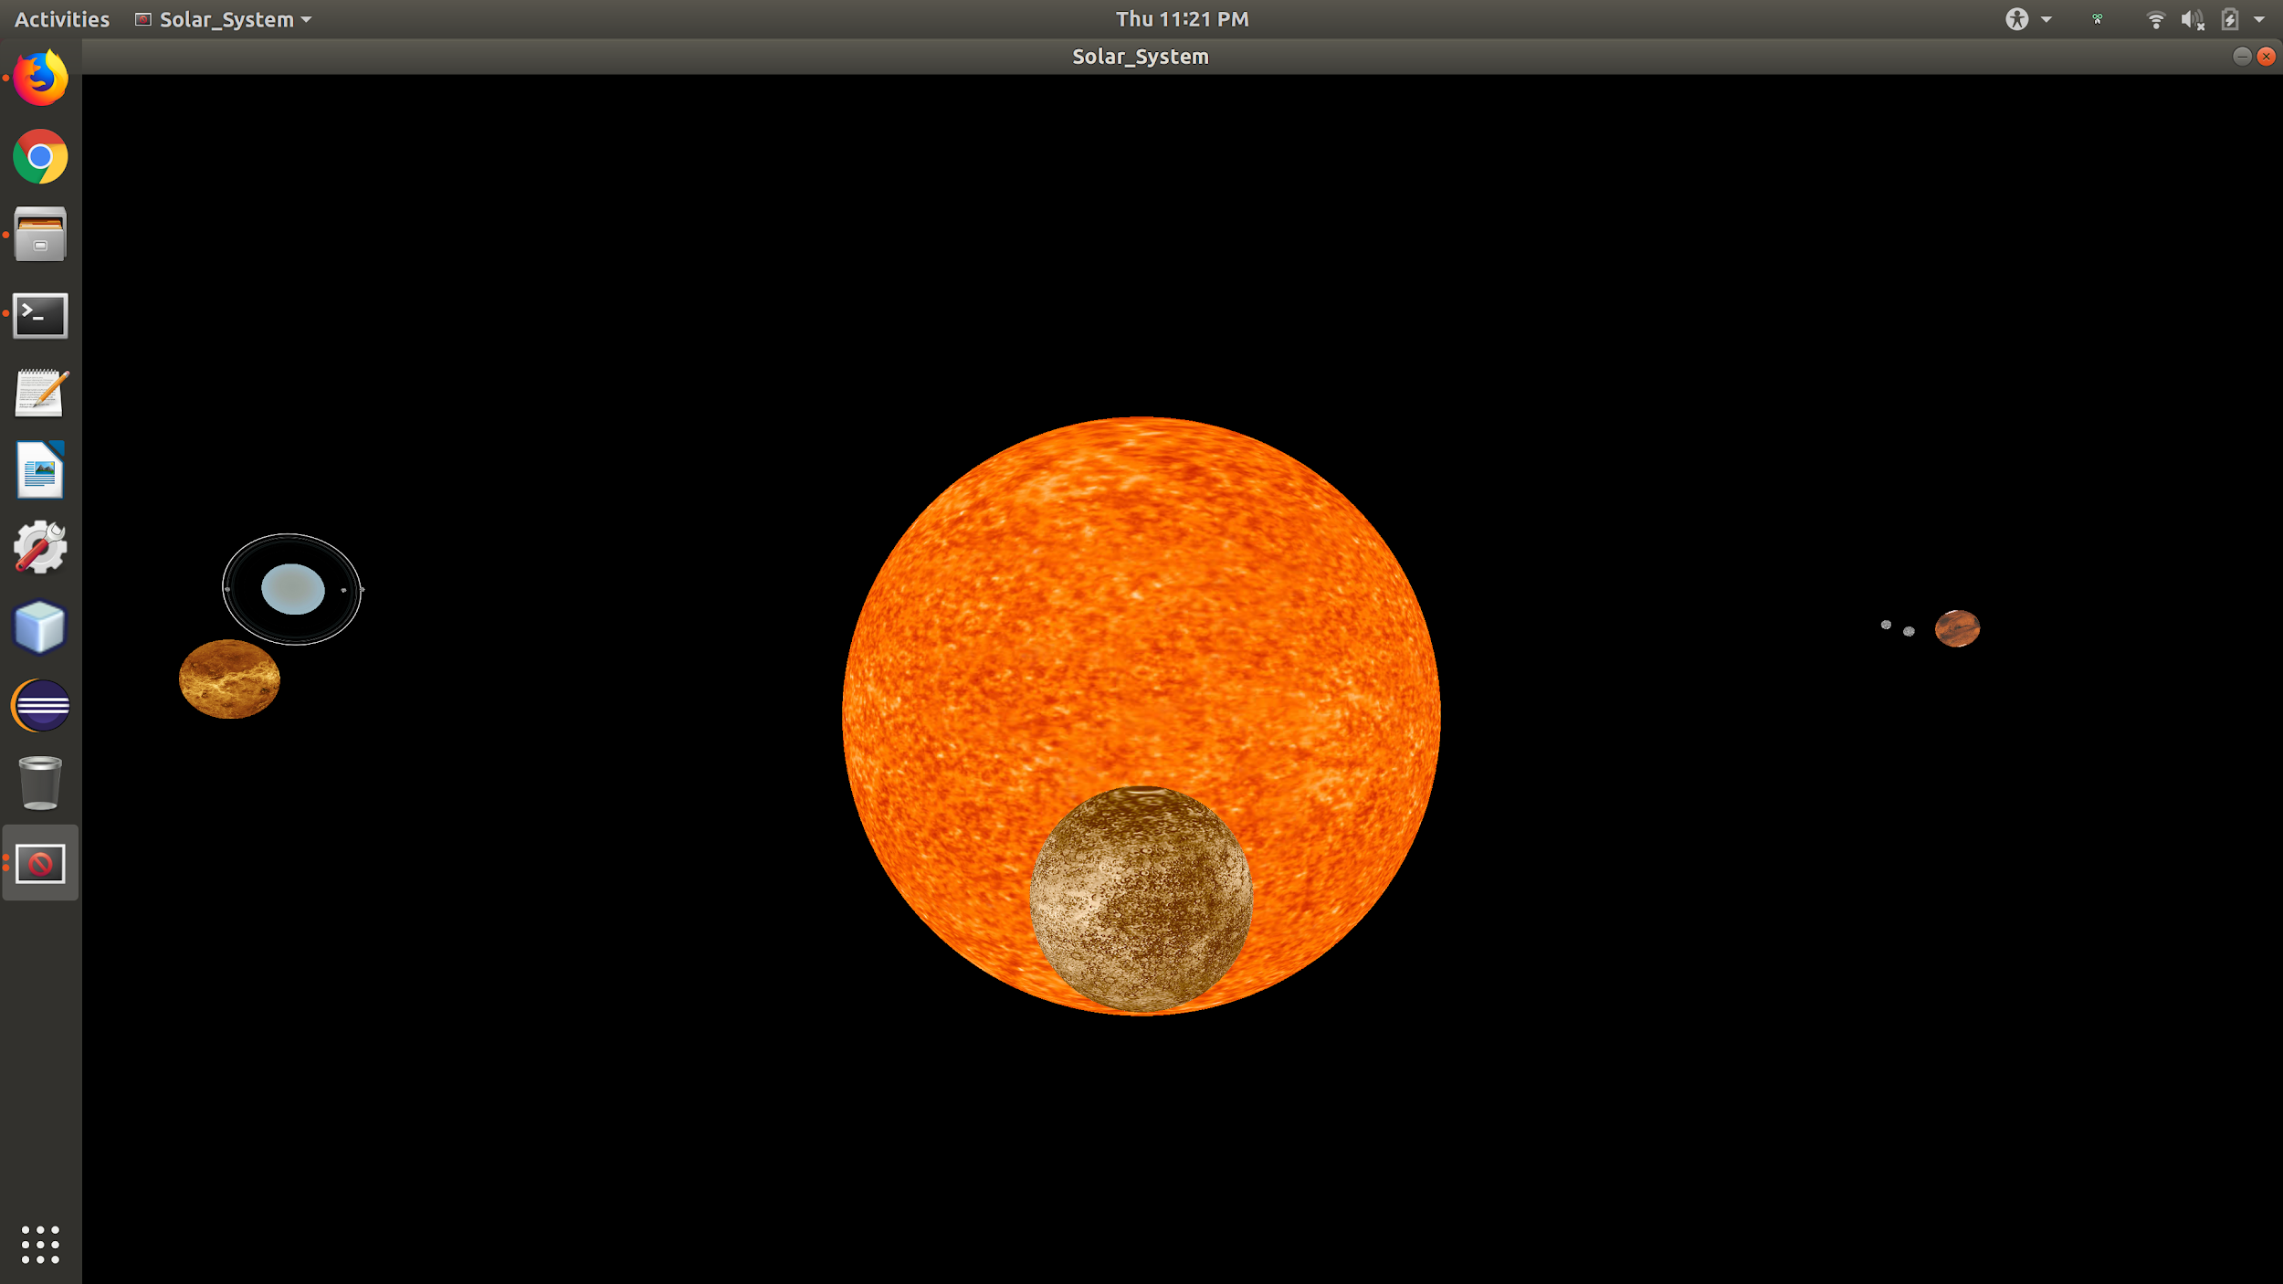

**Figure 3:** A view of the solar system from Mercury.

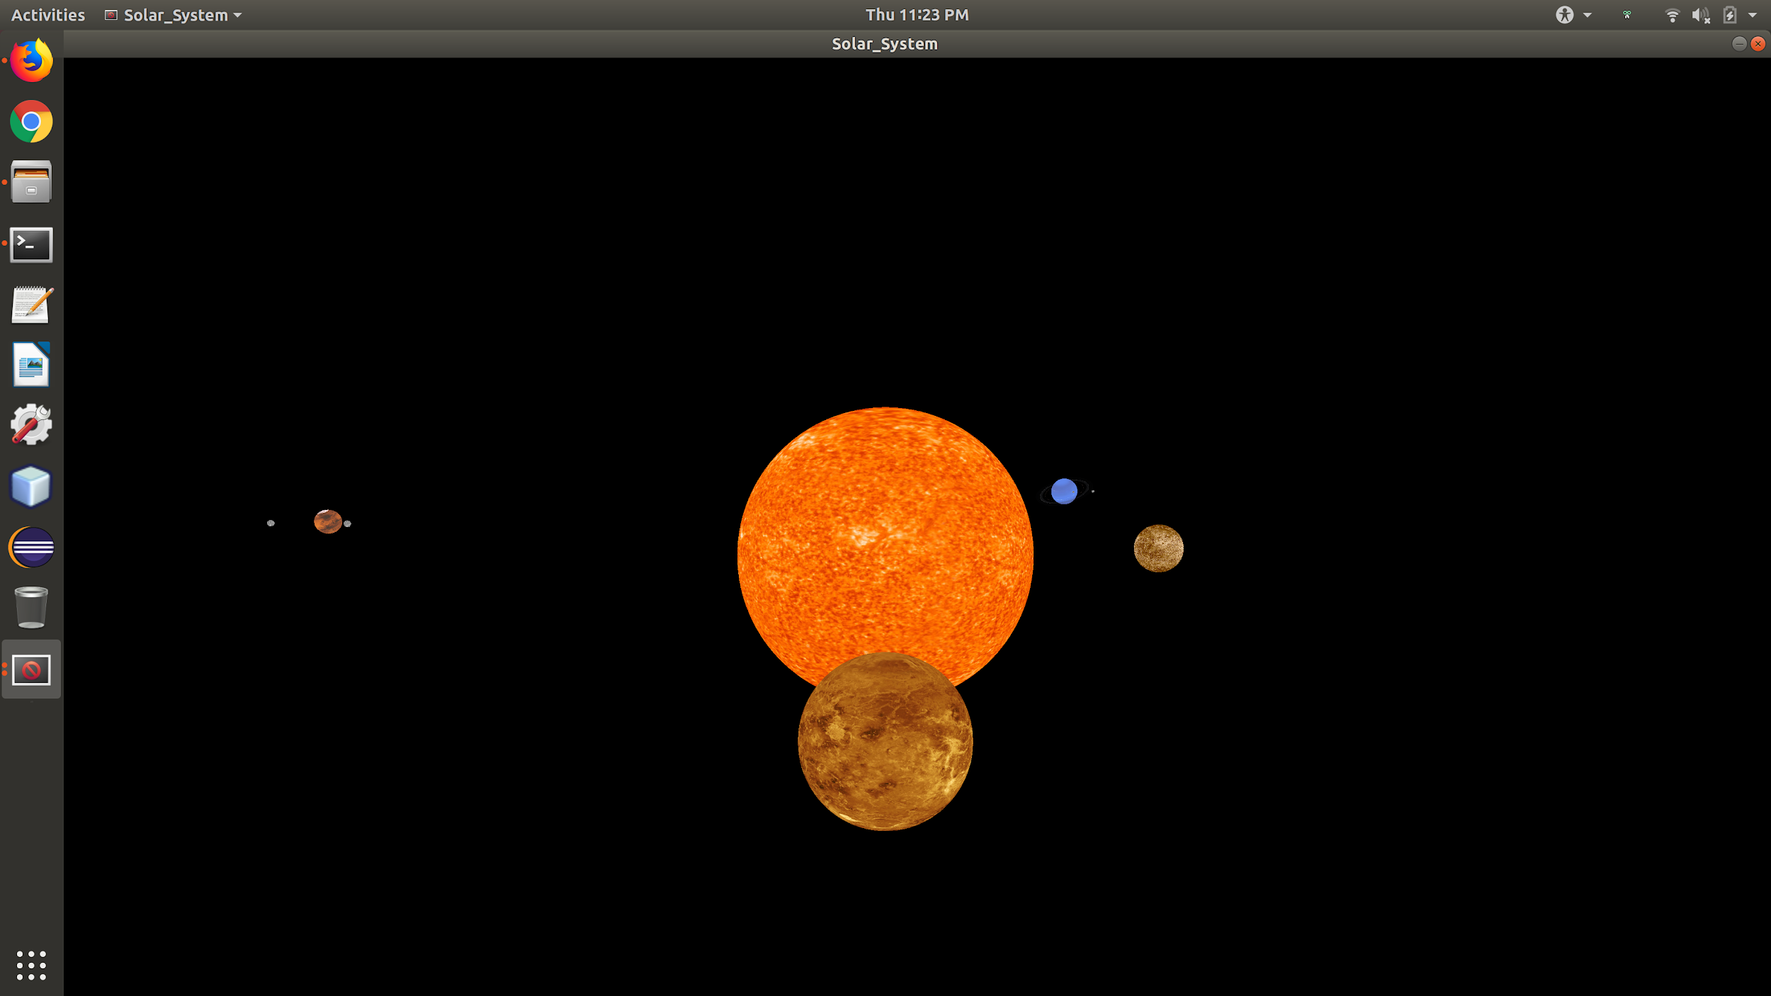

**Figure 4:** A view of the solar system from Venus.

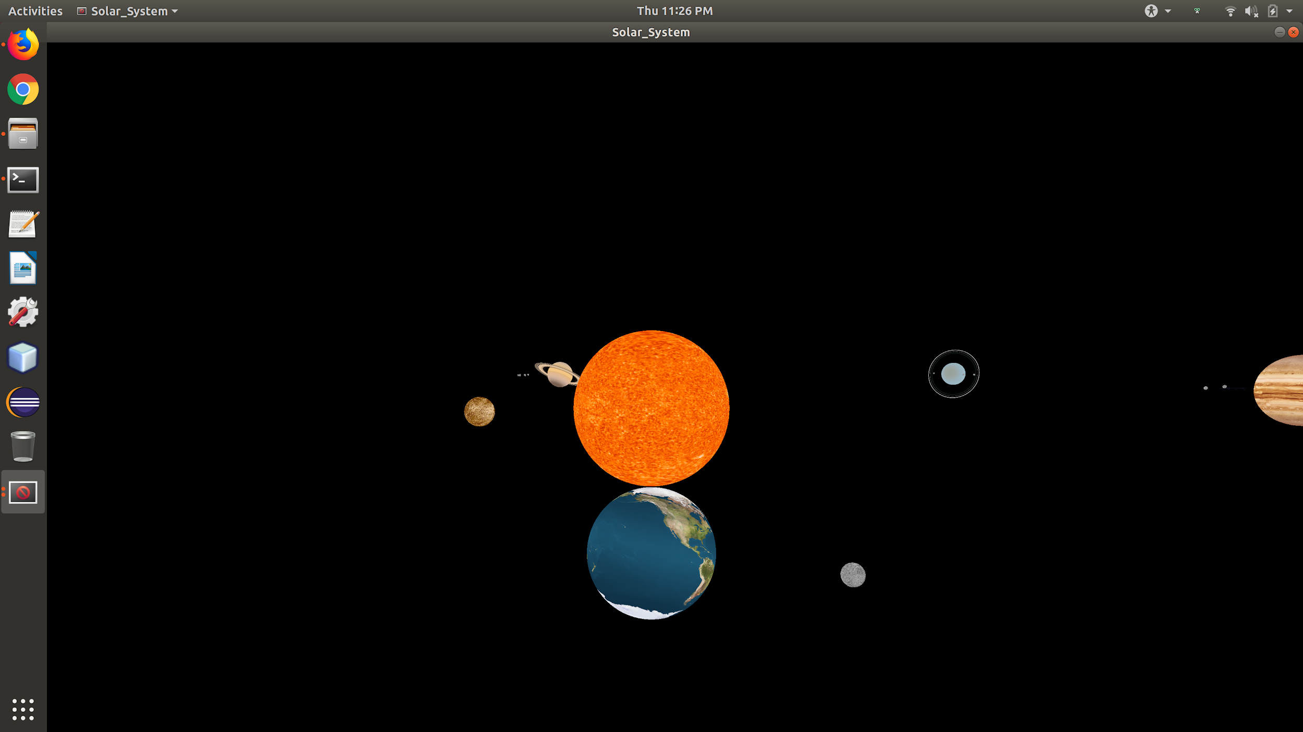

**Figure 5:** A view of the solar system from Earth.

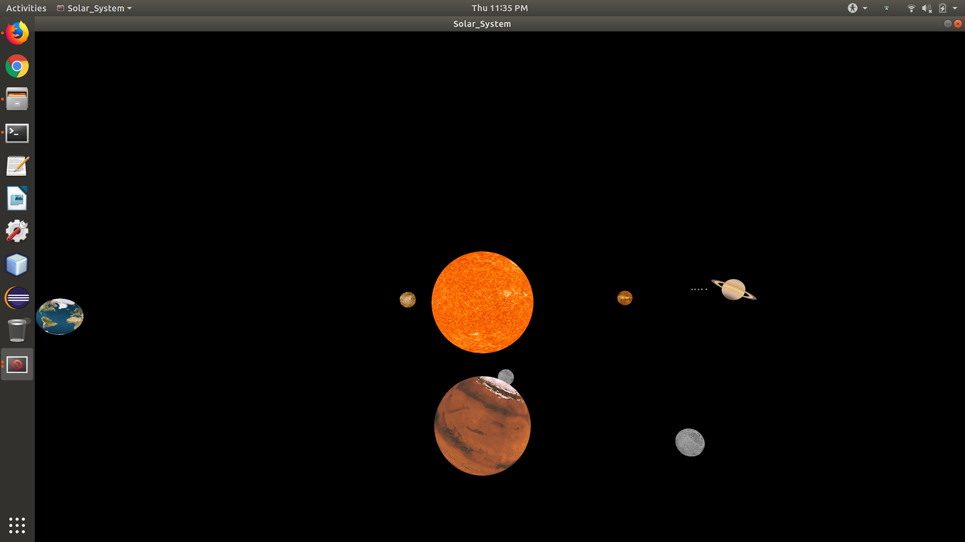

**Figure 6:** A view of the solar system from Mars.

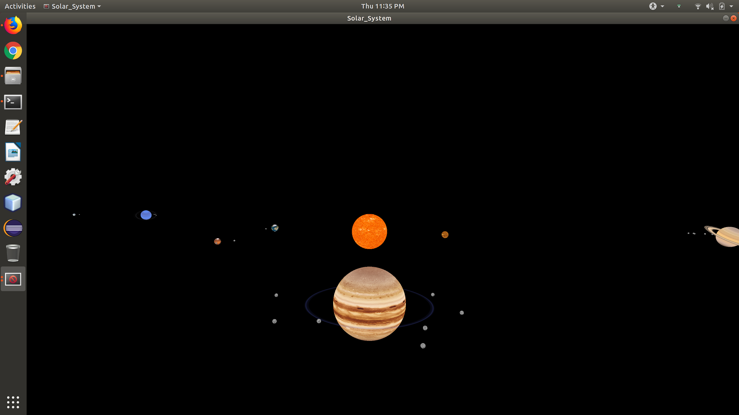

**Figure 7:** A view of the solar system from Jupiter.

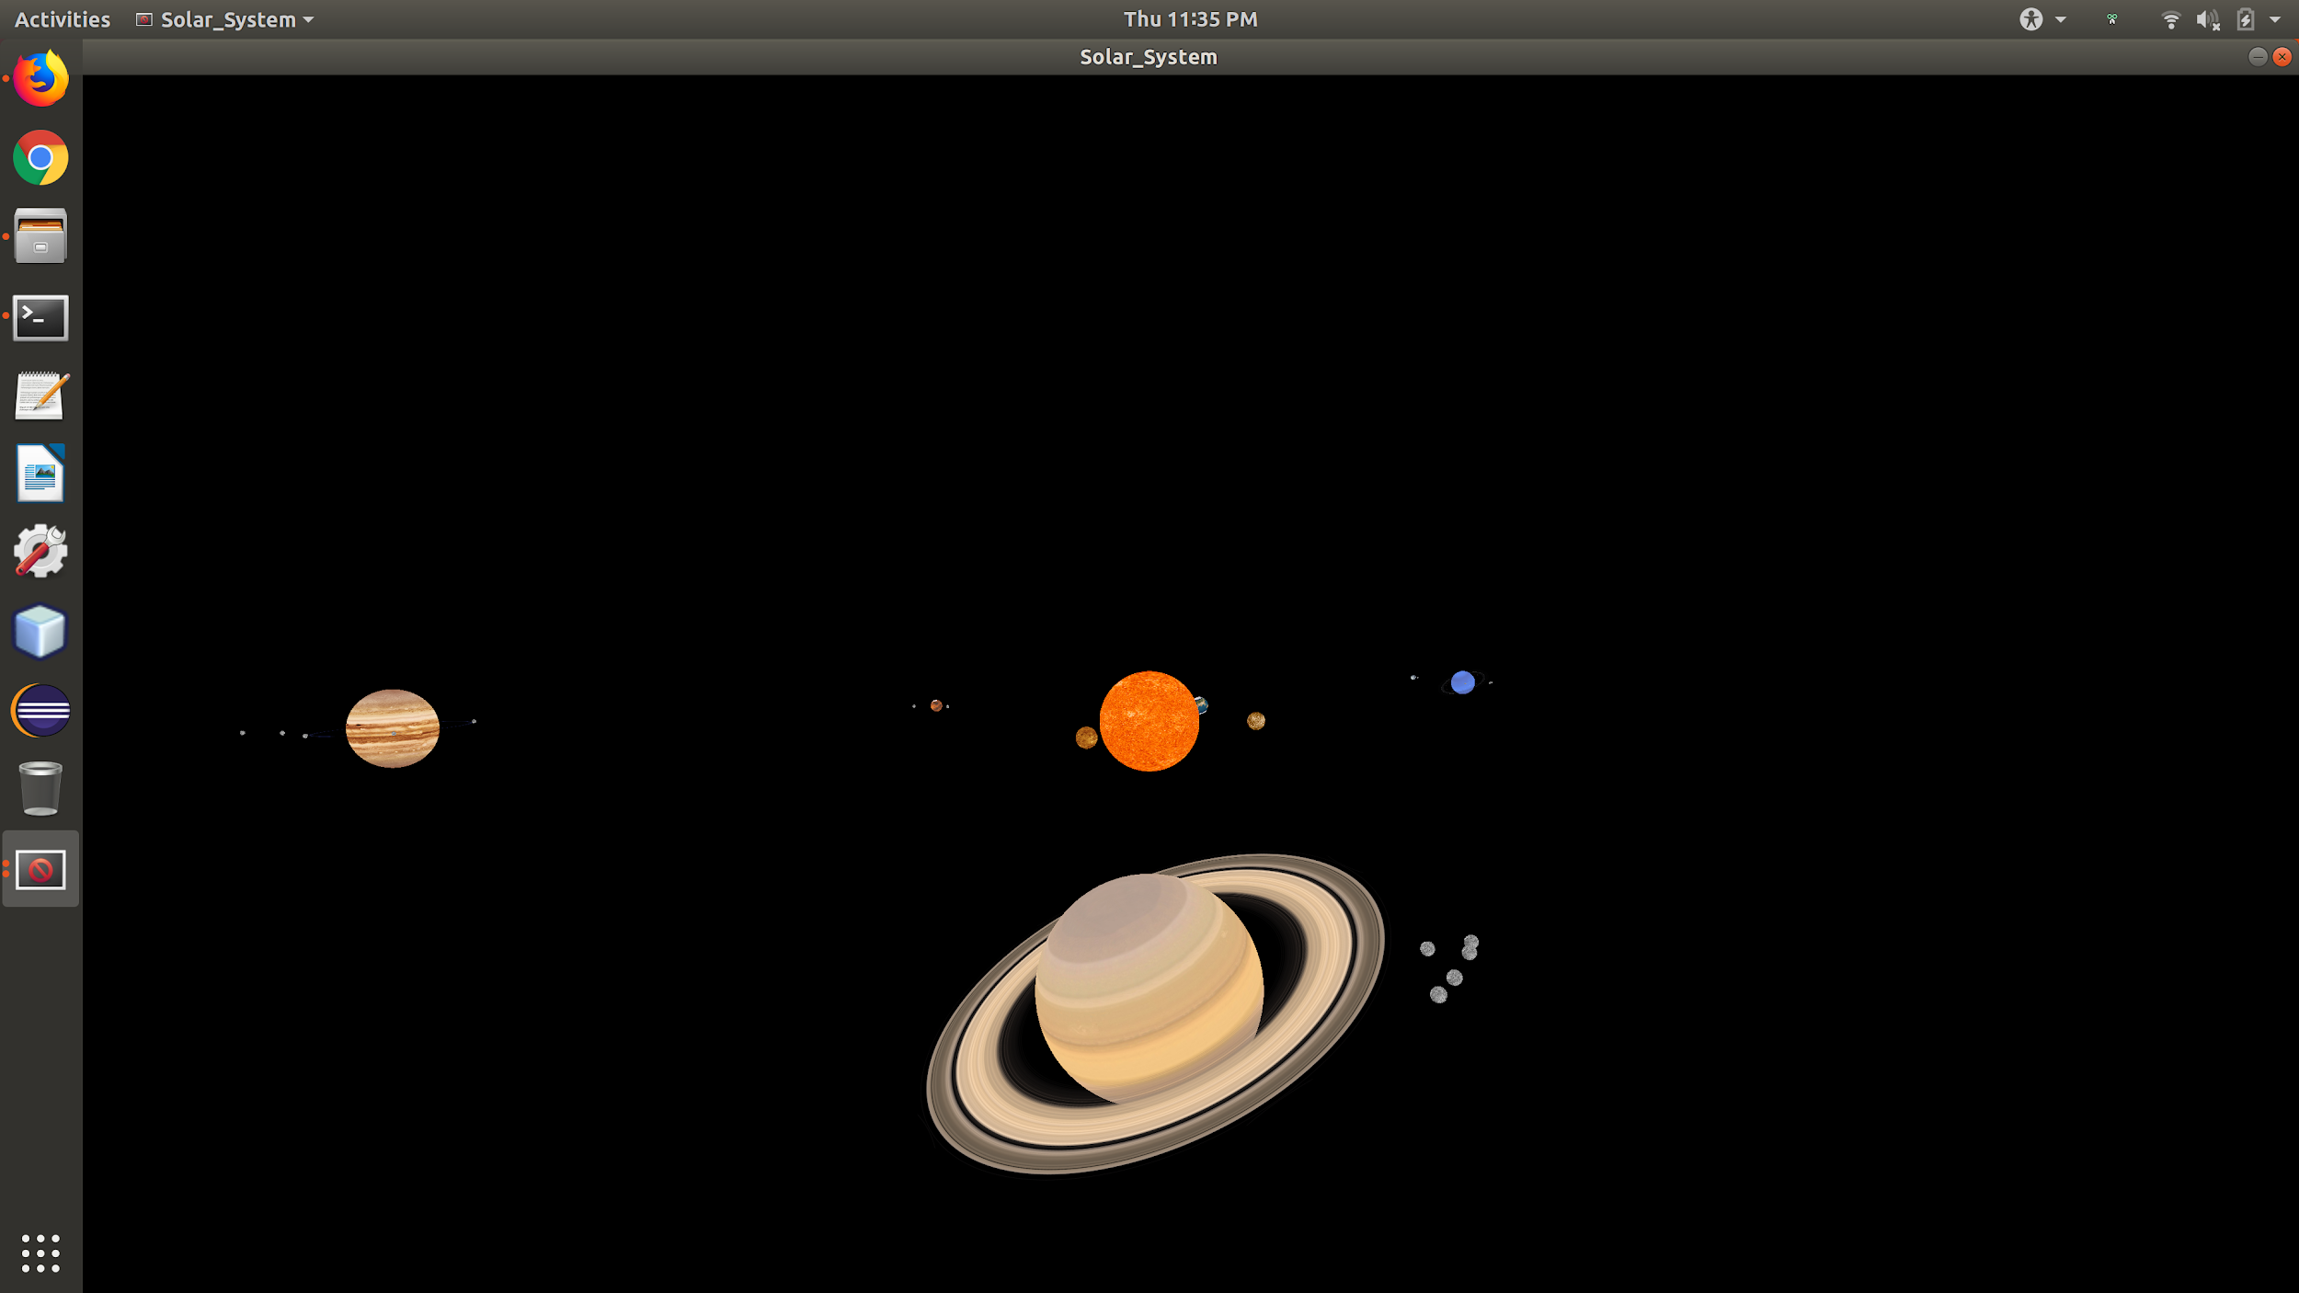

**Figure 8:** A view of the solar system from Saturn.

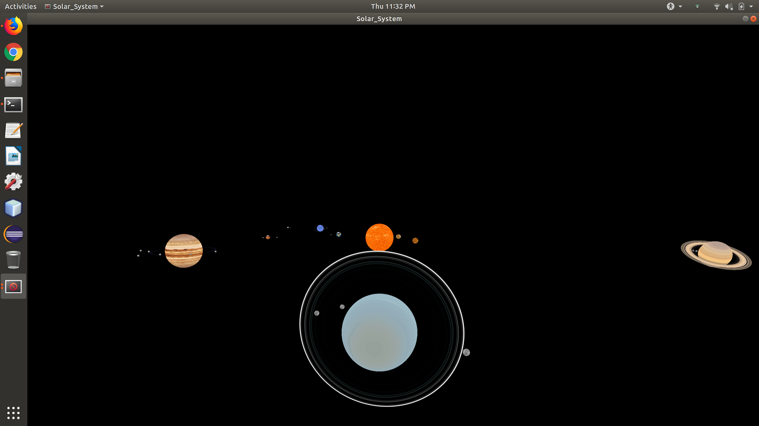

**Figure 9:** A view of the solar system from Uranus.

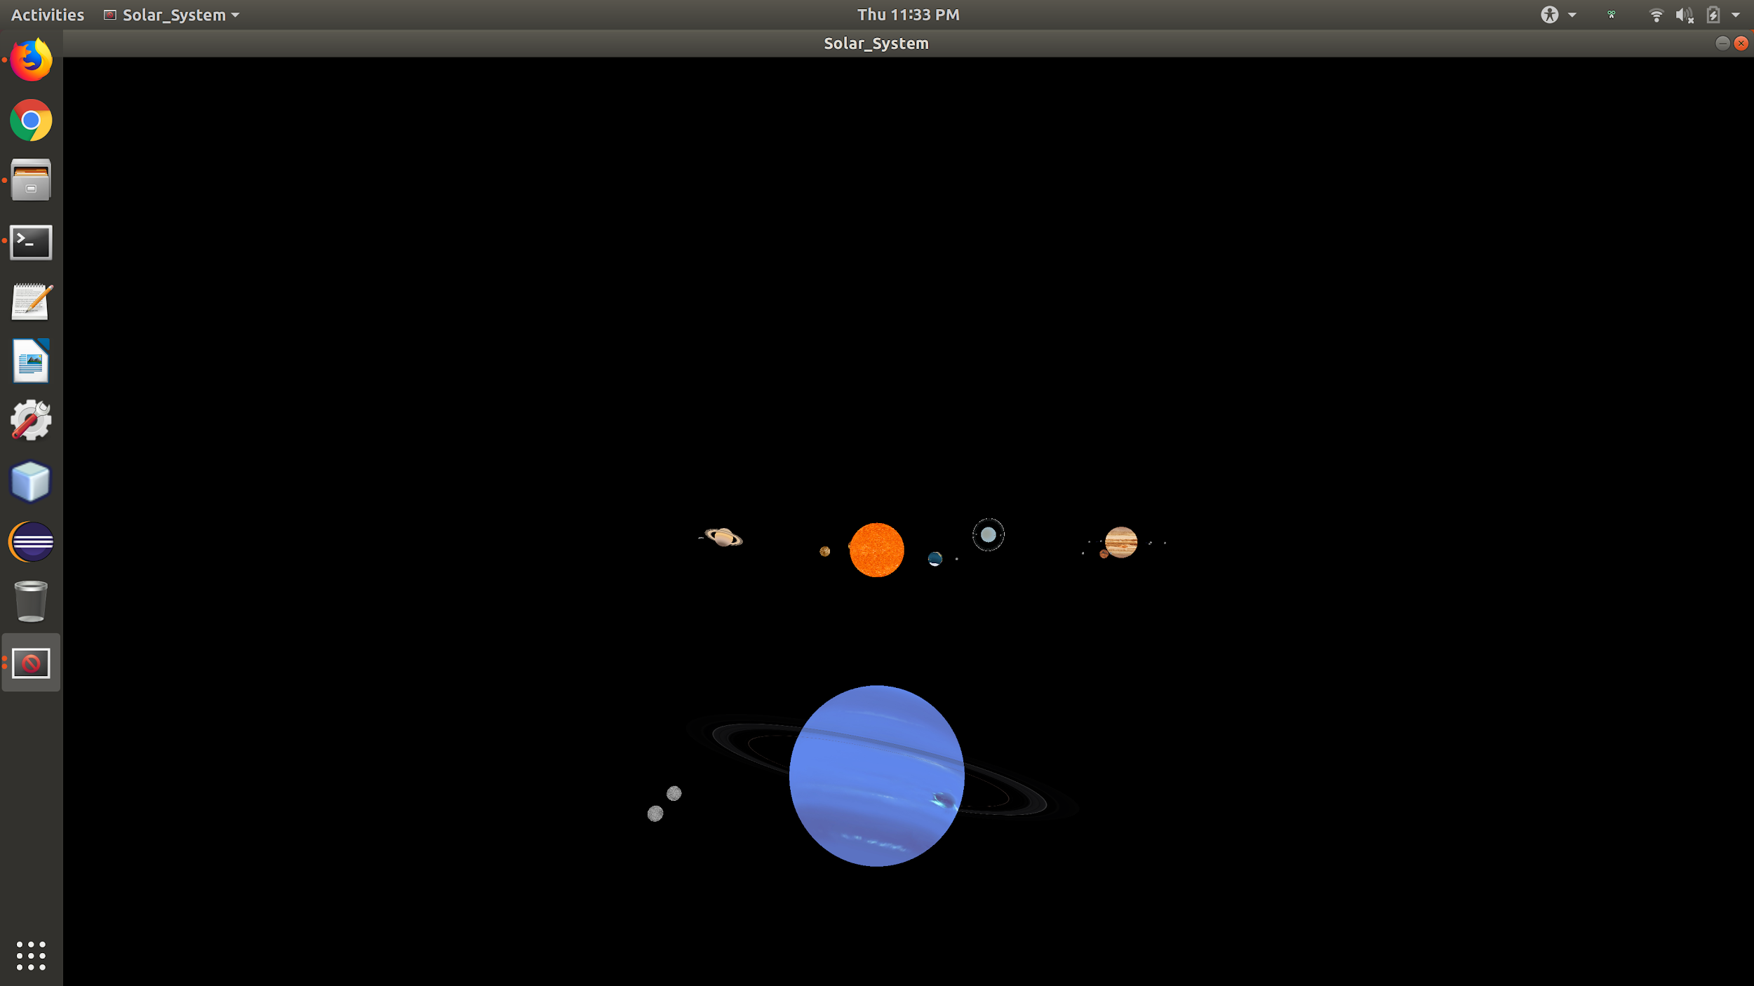

**Figure 10:** A view of the solar system from Neptune.

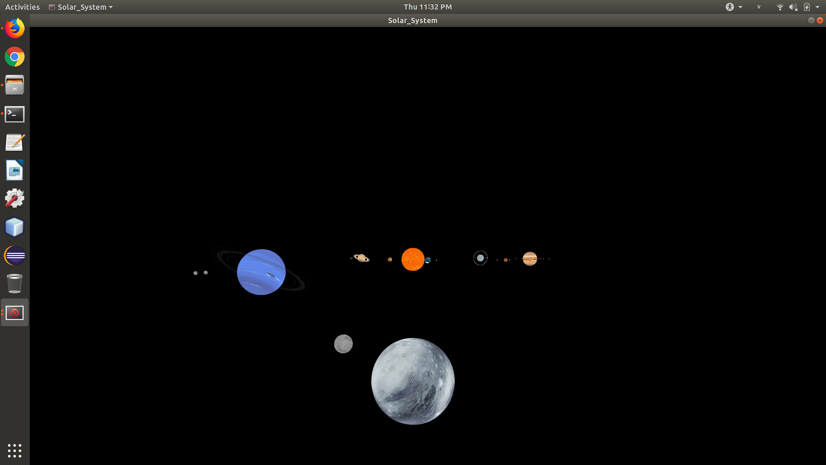

**Figure 11:** A view of the solar system from Pluto.

**Technical Manual**

**Issues**

The biggest problem was the fact that the libraries needed to run this project only seemed to work with Ubuntu 18.04. Due to this, team members who normally work on MacOS systems or Windows systems were unable to build the project. Specifically for the MacOS, the ASSIMP library was would not allow the project to build even though the library was correctly installed. This meant the group members with a Macbook and Windows laptop could only work on the project outside of school/activity hours since they needed to be either in the ECC or at their home desktop.

Another major problem came trying to create 3 dimensional movement for the camera (user) to freely move. Firstly, when moving the position of the camera, the team found they had to change camera focus at the same rate since otherwise the movement would not be linear and instead curve toward the focus point. However, when changing the focus point it became clear that it was difficult to view the planets accurately since the focus point would often be in front or behind the planet when trying to move to view it directly. Secondly, with how the program was designed it was difficult to add 3 dimensional movement without recreating a few larger sections of code. Due to this, the idea of true ‘free roam’ movement was scrapped for times sake. Instead, a planet based system was introduced that would seek to have the camera focus on individual planets as desired by the user.

**Things We Could Have Done Differently**

Currently the planets are stored in a vector of objects while their associated names are stored in another vector. This was a good choice as it allowed for easy rendering of the objects, however when it came to focusing on planets as well as a few other interactions in the program it may have been easier to use a map object to store the planets so they could be referenced by name. This would not have affected the end product but would have sped up some of the code creation.

Another thing that could be improved is the rendering order of the planets. Currently, they are rendered from close to far, which seemes fine at first but at times causes some planets to temporarily have derendered spots on them due to the rings of closer planets. To fix this, it would have been better to render the planets from far to close so they are not culled by closer partially transparent objects, such as the rings of some planets.

A final thing that we would have liked to add is a way to use lower quality models for planets further away. This would have reduced the computational load on the program while having minimal effect on the final product. The group even went as far as to generate low poly versions of each of the planets. These models can be found in the “objFiles” directory. However, the group never got around to finding an efficient way to calculate distances and switch between the models as necessary.

**Recent Changes**

Since Wednesday, a few minor changes were made to the project. The zoom controls were changed from the +/- key to the i/o keys. This way, the - key could be used in the menu when specifying a negative number without causing the solar system viewpoint to change. Another minor fix that was added had to deal with reinitializing the menu after it was closed via the m key. There had to be a minor fix for the menu class so that it opened again with the correct parameters. A few final changes had to deal with the orbital and rotation speeds of the planets. These were minor changes in the configuration file to make the solar system more accurate.