EXECUTIVE CASE STUDY
PREDICTIVE
MAINTENANCE
From rare-event prediction to governed maintenance decisions

Business question
Can routine machine operating conditions identify elevated failure risk early enough to support better maintenance decisions?

10,000  observations | 339  failures | 3.39%  failure prevalence | 7  model configurations

Evidence base: uploaded Jupyter notebook and recorded outputs. Analytical proof of concept; not a validated production control system.

EXECUTIVE DECISION
1. Executive summary
A concise view of the result, decision logic, and recommended enterprise path.
Recommendation
Use Random Forest as the leading pilot model and treat the decision threshold as a governed operating policy. At threshold 0.50 the model is highly precise; at 0.20 it detects more failures when the business prioritizes failure capture.

96.5%  precision @ 0.50 | 80.9%  recall @ 0.50 | 88.0%  F1 @ 0.50 | 89.1%  PR-AUC

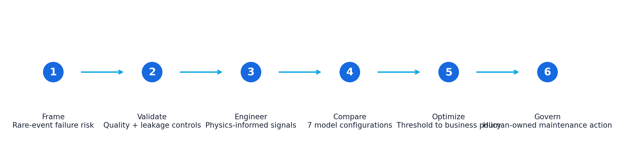

What leadership should take away
- Accuracy was intentionally not used as the primary success measure: a naive model reached 96.6% accuracy while detecting zero failures.
- Random Forest produced the strongest overall balance at the default operating point and remained superior to XGBoost under the 85%+ failure-detection scenario.
- The preferred threshold depends on the economics of downtime, inspection capacity, asset criticality, and acceptable false-alarm burden.
- The proof of concept supports a controlled shadow-mode pilot, not autonomous maintenance decisions.
DECISION CONTEXT
2. Why predictive maintenance is a business problem
The model is useful only if it improves decisions about uptime, maintenance capacity, and operational risk.

The operating challenge
Reactive maintenance exposes operations to unplanned downtime and downstream schedule disruption. Fixed preventive maintenance reduces some risk, but it can consume labor and parts on equipment that is not yet at elevated risk. Predictive maintenance adds a third option: prioritize attention using observed operating conditions.

The rare-event complication
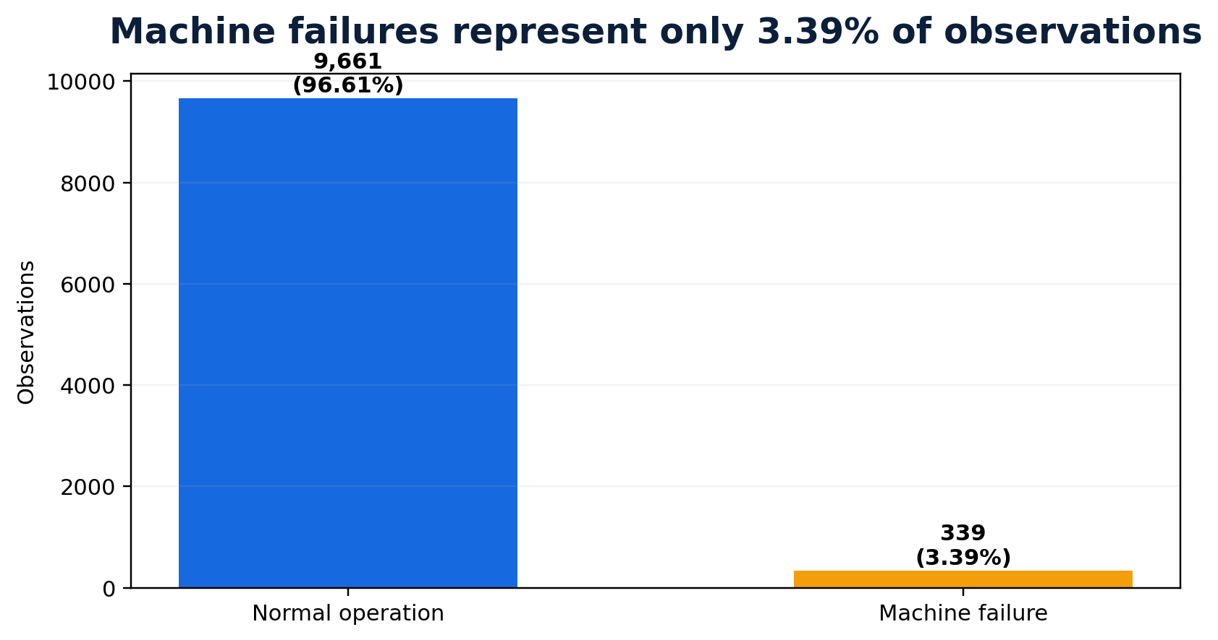
Why 96.6% accuracy can be useless
Because only 3.39% of observations are failures, predicting “normal” every time achieves 96.6% accuracy and 0% failure recall. The project therefore focused on precision, recall, F1, ROC-AUC and PR-AUC.

Business interpretation of the core metrics
Metric | Plain-English meaning | Decision relevance
Precision | Of all failure alerts, how many were truly failures? | Controls unnecessary inspection burden.
Recall | Of all actual failures, how many did we catch? | Controls missed-failure risk.
F1 | Balance between precision and recall. | Useful when both error types matter.
PR-AUC | Performance across precision-recall trade-offs. | Well suited to rare-event problems.
ROC-AUC | Ability to rank failures above normal states. | Useful for comparing discrimination across thresholds.

EVIDENCE FIRST
3. Data quality, leakage control, and operating signal discovery
The analysis established trust in the inputs before comparing algorithms.
0  missing values | 0  duplicate rows | 5  failure-mode flags excluded | 3  engineered operating signals

Observed operating differences
Signal | Normal | Failure | Observed pattern
Torque | 39.6 Nm mean | 50.2 Nm mean | Higher load in failure observations
Tool wear | 106.7 min mean | 143.8 min mean | More accumulated wear
Rotational speed | 1,507 rpm median | 1,365 rpm median | Lower median RPM in failures
Type L failure rate | - | 3.92% | Highest observed type-specific rate

Target leakage prevention
Critical modeling control
TWF, HDF, PWF, OSF and RNF were excluded from predictors because they directly describe failure outcomes. Including them would make the model look stronger than it could be in real use.

Feature engineering with operating meaning
- Temperature difference = process temperature - air temperature.
- Mechanical power = torque × angular velocity.
- Tool-wear load = tool wear × torque.
- Engineered signals were evaluated empirically rather than assumed to improve performance.
MODEL TOURNAMENT
4. How the model was selected
Seven configurations were compared under a consistent train/test split and metric framework.
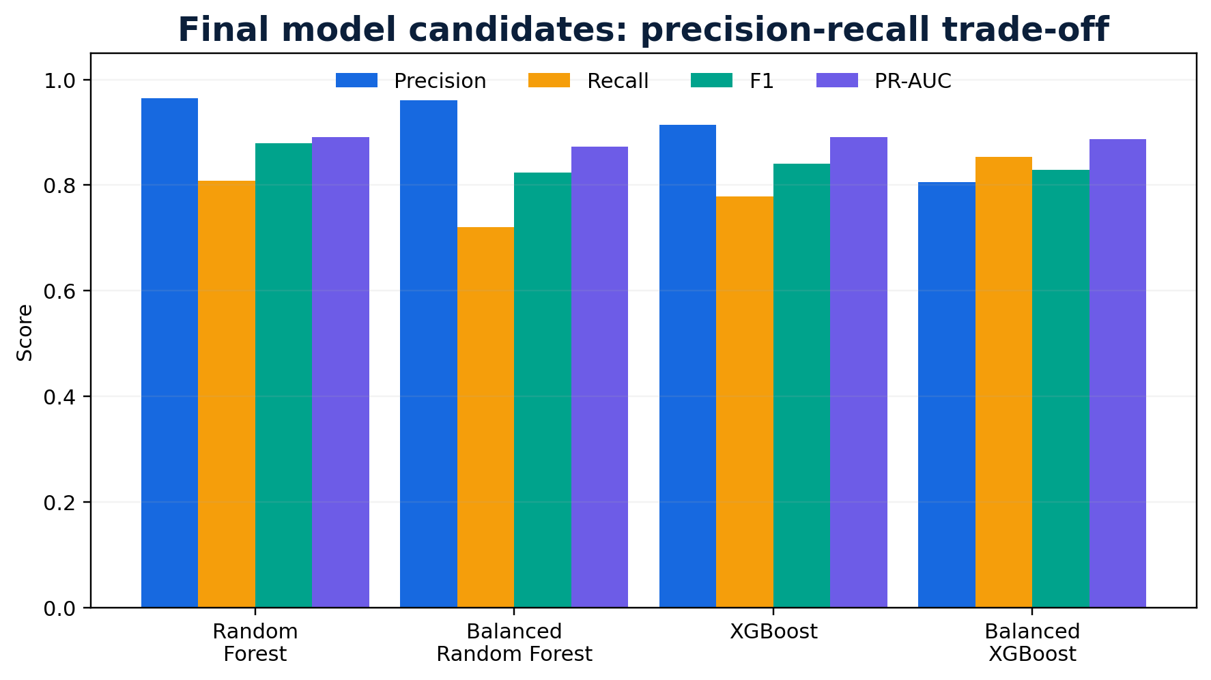
Model | Key result | Decision
Naive baseline | 96.6% accuracy; 0% recall | Reject accuracy as a primary KPI
Logistic Regression | 57.1% precision; 17.6% recall | Too conservative
Balanced Logistic | 88.2% recall; 17.9% precision | Too many false alerts
Random Forest | 96.5% precision; 80.9% recall; F1 88.0% | Leading candidate
Balanced RF | Recall fell to 72.1% | Balancing hurt performance
XGBoost | ROC-AUC 98.6%; PR-AUC 89.1% | Strong challenger
Balanced XGBoost | Recall 85.3%; precision 80.6% | Good high-recall option

Key lesson
Class imbalance techniques were tested model by model. Balancing materially improved Logistic Regression recall but reduced Random Forest performance. The project used evidence rather than a one-size-fits-all rule.

OPERATING POLICY
5. Threshold optimization: from probability to action
The same model can behave very differently depending on where the organization sets the alert threshold.
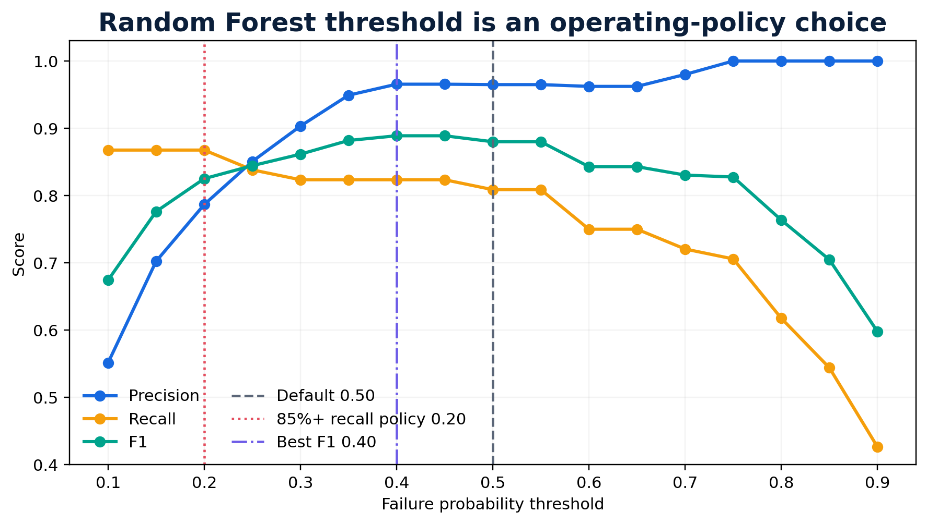
Policy | Threshold | Precision | Recall | F1 | Predicted failures
Best F1 | 0.40 | 96.6% | 82.4% | 88.9% | -
Default / high confidence | 0.50 | 96.5% | 80.9% | 88.0% | 57
85%+ recall policy | 0.20 | 78.7% | 86.8% | 82.5% | 75

When both Random Forest and XGBoost were required to detect at least 85% of failures, Random Forest reached 86.8% recall at 78.7% precision. XGBoost reached the same recall only at a lower threshold and precision fell to 66.3%. Random Forest therefore delivered the same failure capture with fewer unnecessary alerts.
Governance point
The 85% recall target used here is a case-study operating requirement, not an industry or regulatory standard. In production, the threshold should be approved against site-specific downtime cost, maintenance capacity and asset criticality.

EXPLAINABILITY
6. What is driving predicted risk?
Two importance methods were used to avoid relying on a single explanation technique.
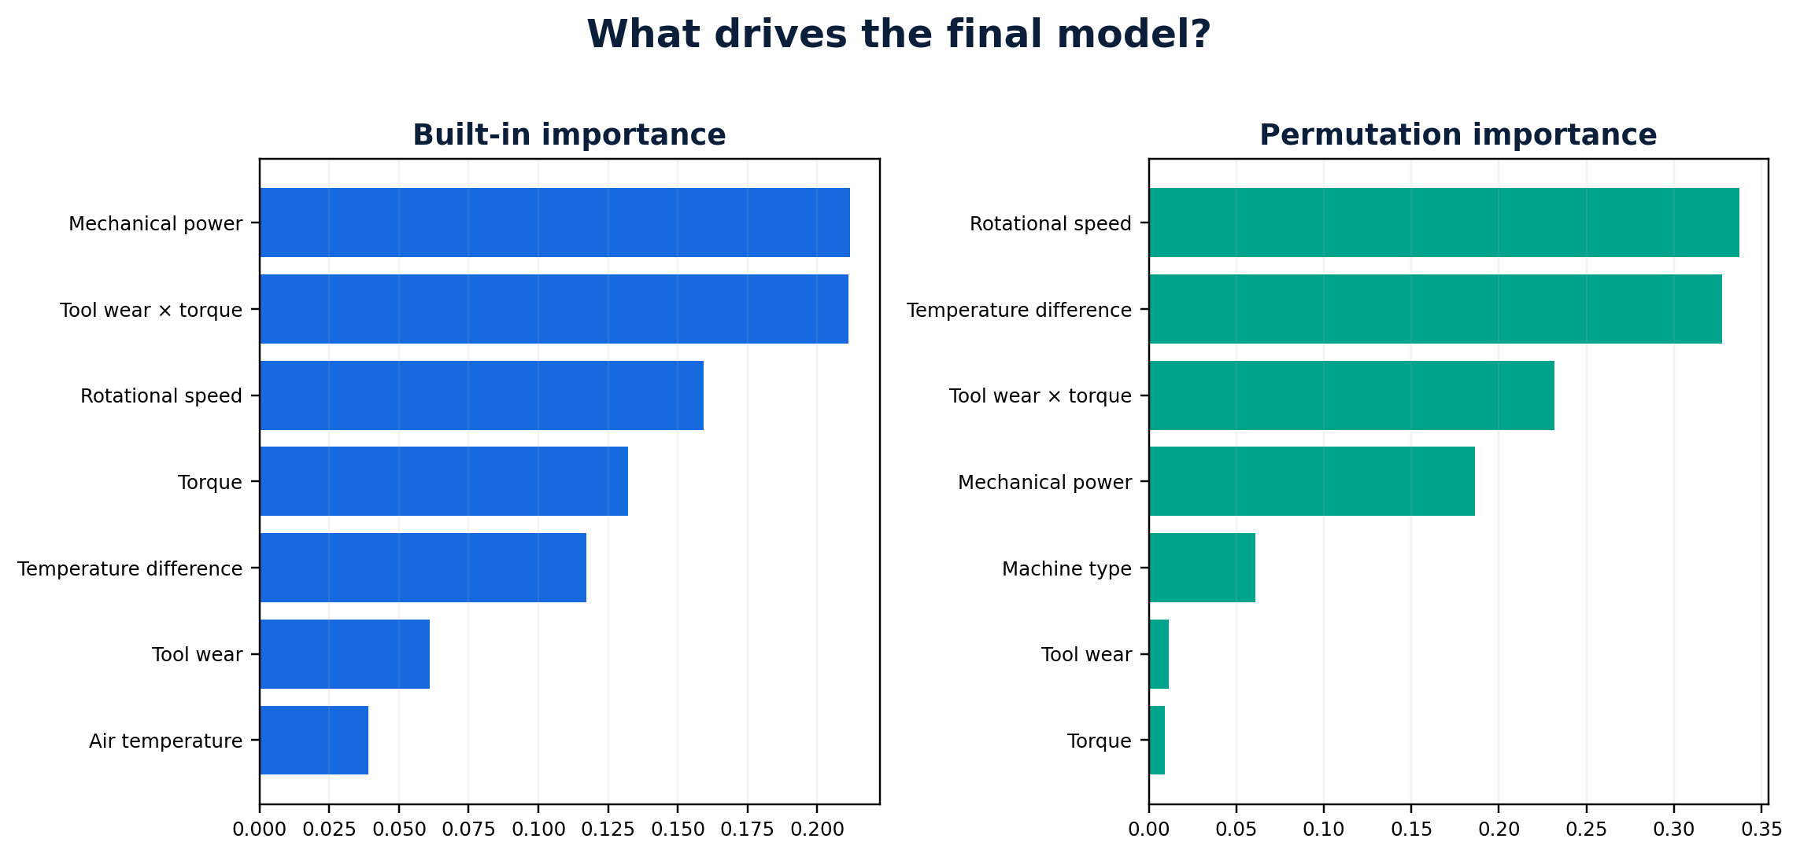

Interpretation
The final model relies most strongly on mechanical power, tool-wear load, rotational speed, torque and temperature difference. Permutation importance independently highlighted rotational speed, temperature difference and tool-wear load as high-impact variables.
Important boundary
Predictive importance is not proof of causation. A high-importance variable can be a root cause, a symptom, or a correlated operating condition. Engineering and maintenance investigation remains necessary.

Risk-to-action concept
Risk tier | Illustrative score | Decision support
Low | <20% | Continue normal operation
Moderate | 20%-49% | Increase monitoring / inspect context
High | 50%-74% | Schedule maintenance inspection
Critical | ≥75% | Immediate maintenance review

FINAL PERFORMANCE
7. What the selected model actually did
The confusion matrix translates abstract metrics into operational counts on the held-out test set.
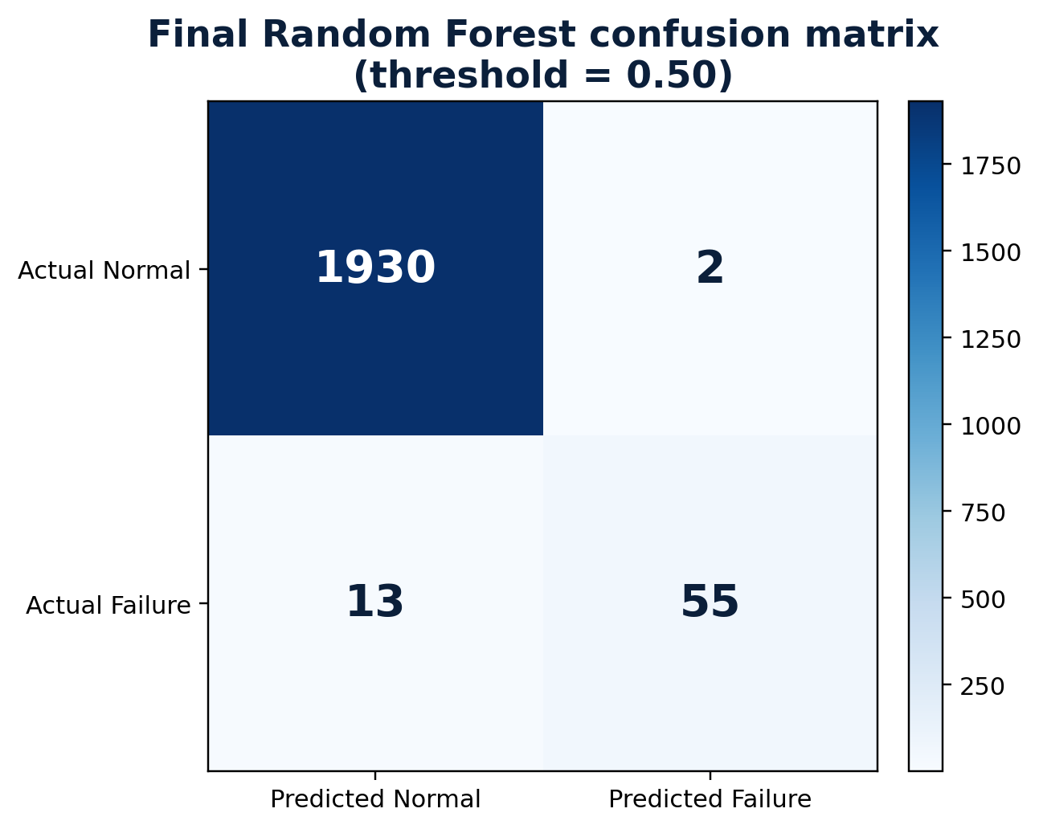
1,930  normal states correctly cleared | 55  failures correctly detected | 2  false alerts | 13  missed failures

At threshold 0.50, the final Random Forest correctly identified 55 of 68 failures while generating only two false alerts among 1,932 normal observations. This operating point favors confidence and maintenance efficiency. A lower threshold captures four additional failures but produces more false alerts.

Where value could appear
Value lever | Potential business effect
Unplanned downtime | Earlier identification of higher-risk operating states
Maintenance productivity | Prioritize inspections where risk is highest
Spare parts / planning | Improve readiness around elevated-risk assets
Quality & reliability | Create a traceable evidence stream linking operating state, intervention and outcome
Capital planning | Build evidence on recurring high-risk equipment and failure mechanisms

CONTROL MODEL
8. How this should operate in an enterprise
A prediction should enter a controlled process, not bypass it.
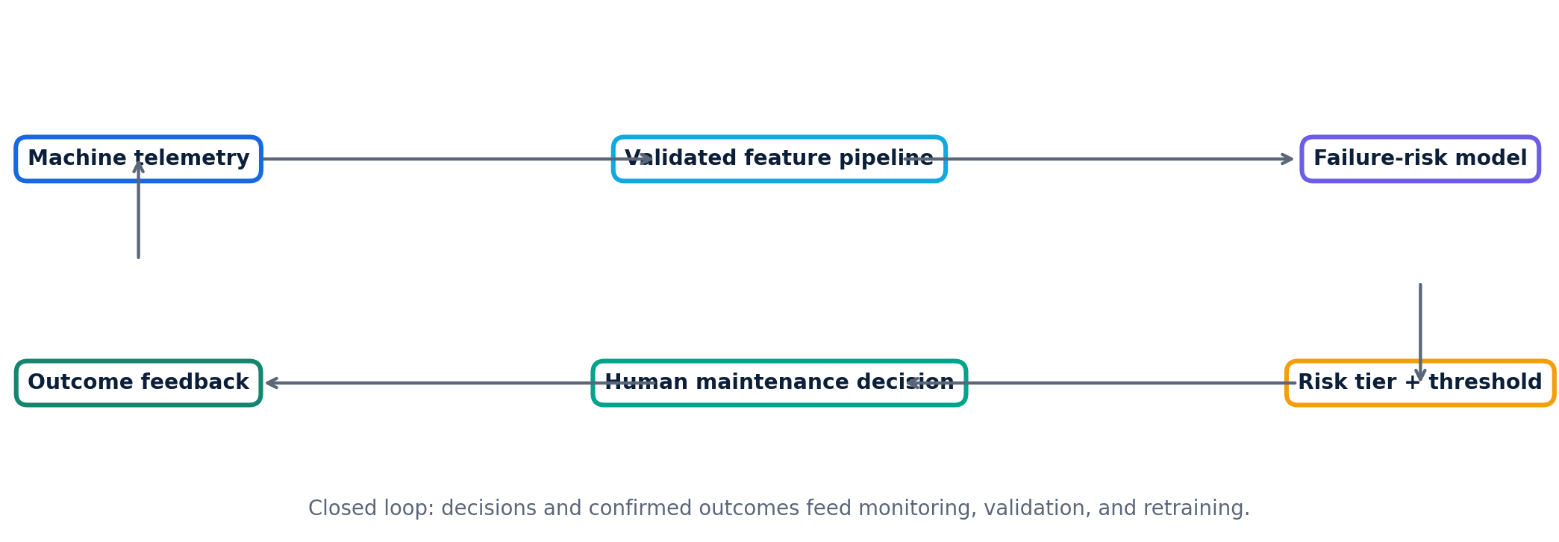

Minimum controls before production use
- Data integrity: equipment IDs, timestamps, sensor units, missingness, calibration status and source lineage must be controlled.
- Human-in-the-loop: model outputs should support, not replace, accountable maintenance and engineering decisions.
- Model governance: versioning, performance acceptance criteria, threshold history, approval and rollback should be documented.
- Monitoring: track drift, alert volume, false positives, missed failures and performance by asset/site/time period.
- Change control: retraining, feature changes and threshold changes should be assessed as controlled changes.
For regulated environments
If model output influences GMP decisions or validated equipment controls, intended use, validation, data integrity, auditability and change-control requirements must be defined before deployment. This proof of concept does not establish that validated state.

SCALE-UP PLAN
9. From proof of concept to enterprise pilot
Move in gates so business value and control maturity increase together.
Gate | Purpose | Evidence required
1. Historical validation | Replay real plant history | Representative asset data; confirmed outcomes; stable features
2. Shadow mode | Score live data without changing maintenance decisions | Alert quality, latency, drift, workflow fit
3. Limited pilot | Use recommendations on selected assets with human approval | Defined owners, action SOP, benefit and error tracking
4. Controlled scale | Expand assets/sites after acceptance criteria are met | Repeatable controls, monitoring, support model, audit trail
5. Sustain | Monitor and revalidate | Drift thresholds, periodic review, retraining/change control

Business case inputs still required
- Cost per hour of unplanned downtime by critical asset.
- Cost of inspection / planned intervention and maintenance capacity.
- Failure severity and secondary impact by asset class.
- Sensor/integration costs and data-quality remediation effort.
- Value of additional production availability and reduced emergency work.
DECISION MEMO
10. Conclusion and recommended next move
The model is promising; the next decision is whether the organization can validate it against real operations and economics.
Conclusion
Random Forest was selected because it delivered the strongest precision-recall balance at the default threshold and remained the better option when failure detection was increased to at least 85%. The project demonstrates a disciplined pathway from sensor data to a governed maintenance decision.

Recommended next actions
- Run a shadow-mode pilot on real telemetry for a representative set of critical assets.
- Link predictions to confirmed maintenance findings and actual failure outcomes.
- Quantify the economics of false alerts versus missed failures and approve an operating threshold.
- Validate performance by equipment type, site, operating regime and time period.
- Establish model ownership across operations, engineering, IT and quality before any decision automation.

Limitations
- The dataset is simulated/public and contains 339 failures; production performance may differ materially.
- Observations are operating snapshots rather than a true longitudinal degradation history for each machine.
- The test set comes from the same source distribution as training data and does not represent site-to-site transfer.
- Feature importance is predictive rather than causal.
- The selected thresholds are analytical operating examples, not validated safety or compliance limits.

