TECHNICAL MODEL & MLOPS REPORT
PREDICTIVE
MAINTENANCE
Reproducible model development, evaluation, explainability, and production-readiness design

Business question
Can routine machine operating conditions identify elevated failure risk early enough to support better maintenance decisions?

10,000  observations | 339  failures | 3.39%  failure prevalence | 7  model configurations

Evidence base: uploaded Jupyter notebook and recorded outputs. Analytical proof of concept; not a validated production control system.

TECHNICAL OVERVIEW
1. Analytical design and decision objectives
A reproducible account of how the machine-failure classifier was framed, built, challenged, selected, and prepared for controlled operational use.

Problem formulation
Binary classification target: Machine failure (1) versus normal operation (0). Predictors were limited to information that could plausibly be available before the failure outcome. The objective was not maximum accuracy; it was useful discrimination of a rare positive class with an explicit precision-recall trade-off.

Core technical decisions
Decision | Implementation | Reason
Leakage prevention | Exclude TWF/HDF/PWF/OSF/RNF and identifiers | Avoid outcome information and non-operational IDs
Split | 80/20 stratified train/test; random_state=42 | Preserve 3.39% failure prevalence
Preprocessing | One-hot encode Type; standardize numeric features in pipeline | Consistent train/test transformations and no preprocessing leakage
Metrics | Precision, recall, F1, ROC-AUC, PR-AUC | Rare-event evaluation
Candidates | Dummy, Logistic Regression, Random Forest, XGBoost + imbalance variants | Compare linear, bagging and boosting approaches
Selection | Model + threshold evaluated separately | Separate ranking quality from operational decision policy

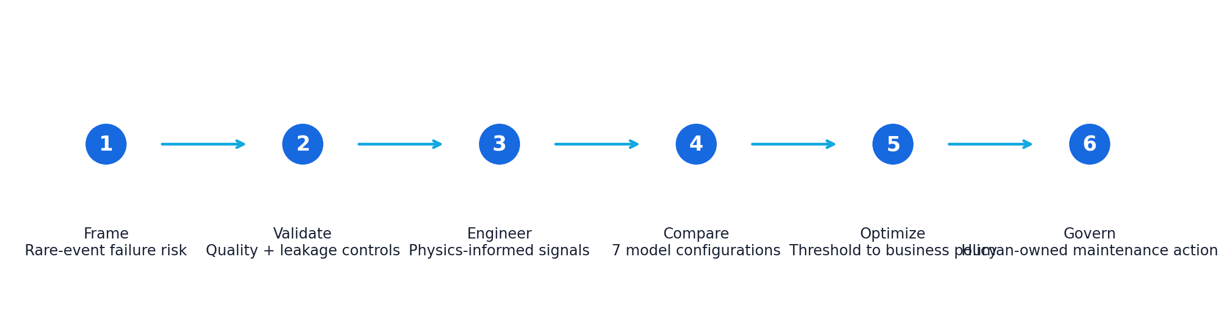
DATASET
2. Data structure and quality assessment
The source contained 10,000 observations and 14 variables spanning identifiers, machine type, operating measurements, target, and failure-mode flags.
Variable group | Variables | Treatment
Identifiers | UDI, Product ID | Excluded from model
Categorical | Type | One-hot encoded
Raw numeric | Air temp, process temp, rotational speed, torque, tool wear | Retained
Target | Machine failure | Binary target
Failure flags | TWF, HDF, PWF, OSF, RNF | Excluded as potential leakage

10,000  rows | 14  source columns | 339  failure rows | 3.39%  positive class

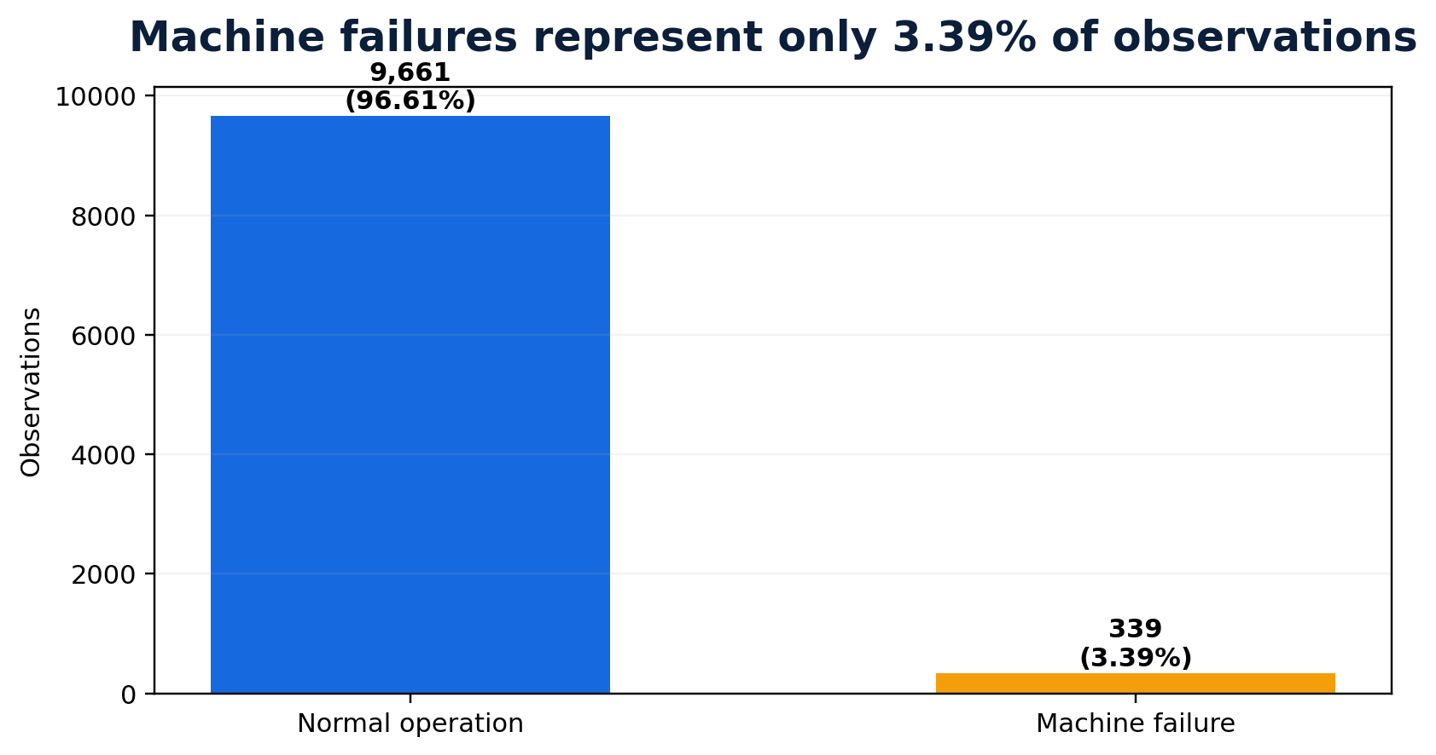

Quality checks
- No missing values were identified.
- No completely duplicated rows were identified.
- Machine type distribution: L=6,000; M=2,997; H=1,003.
- Failure-mode counts were reviewed to understand label structure before excluding them from predictors.
EDA
3. Exploratory analysis and operating hypotheses
EDA was used to generate testable feature hypotheses, not to prove causation.
Feature | Normal mean/median | Failure mean/median | Technical observation
Air temperature | 299.97 K mean | 300.89 K mean | Small aggregate shift
Process temperature | 310.00 K mean | 310.29 K mean | Small aggregate shift
Rotational speed | 1,507 rpm median | 1,365 rpm median | Large median shift / nonlinear behavior likely
Torque | 39.63 Nm mean | 50.17 Nm mean | Strong load separation
Tool wear | 107 min median | 165 min median | Strong wear separation

Machine type failure rate
Type | Observations | Failures | Failure rate
H | 1,003 | 21 | 2.09%
L | 6,000 | 235 | 3.92%
M | 2,997 | 83 | 2.77%

Interpretation discipline
Observed associations informed modeling and feature engineering, but were not treated as root-cause findings. Nonlinear interactions were expected, motivating tree-based models.

FEATURE ENGINEERING
4. Physics-informed feature construction
Three derived variables were added to represent thermal state, mechanical work, and wear under load.
Feature | Definition | Rationale
Temperature difference | Process temperature - air temperature | Represents thermal gap / heat-dissipation context
Angular velocity | RPM × 2π / 60 | Converts rotational speed to rad/s
Mechanical power | Torque × angular velocity | Combines torque and rotational speed into work rate
Tool-wear load | Tool wear × torque | Interaction of accumulated wear and load

The final modeling feature set included Type, five raw operating variables, temperature difference, mechanical power and tool-wear load. The usefulness of engineered features was assessed within model performance rather than assumed a priori.

Pipeline design
A Scikit-learn ColumnTransformer handled categorical and numerical preprocessing, and each estimator was placed in a Pipeline. This ensured preprocessing was fit on training data only and consistently reused for inference.
BASELINE
5. Baseline and linear-model experiments
The baseline established why rare-event metrics matter and how class weighting changes the decision surface.
Model | Accuracy | Precision | Recall | F1 | ROC-AUC | PR-AUC
Naive Baseline | 0.966 | 0.000 | 0.000 | 0.000 | 0.500 | 0.034
Logistic Regression | 0.968 | 0.571 | 0.176 | 0.270 | 0.926 | 0.464
Balanced Logistic Regression | 0.858 | 0.179 | 0.882 | 0.298 | 0.939 | 0.430

Interpretation
- Dummy majority classifier: 96.6% accuracy but zero true failures detected.
- Standard Logistic Regression: reasonable precision but only 17.6% recall, indicating a conservative boundary.
- Balanced Logistic Regression: recall increased to 88.2%, but precision dropped to 17.9%, creating a very high false-alert burden.
Technical lesson
Class weighting can move the decision boundary substantially. A higher recall value is not automatically better if precision collapses and the operational false-positive cost becomes unacceptable.

TREE MODELS
6. Random Forest experiments
Bagged decision trees were evaluated to capture nonlinear interactions without imposing a linear decision boundary.
Configuration | Accuracy | Precision | Recall | F1 | ROC-AUC | PR-AUC
Random Forest | .992 | .965 | .809 | .880 | .973 | .891
Balanced Random Forest | .990 | .961 | .721 | .824 | .971 | .873

Decision
The standard Random Forest became the leading candidate. Class weighting reduced recall and PR-AUC, so the balanced variant was rejected. This result demonstrated that imbalance handling needed to be empirical rather than formulaic.

Random Forest strengths for this problem
- Captures nonlinear thresholds and feature interactions.
- Robust to mixed feature scales after pipeline preprocessing.
- Provides probability estimates for threshold optimization.
- Offers global importance measures that can be cross-checked with permutation importance.
BOOSTING CHALLENGER
7. XGBoost experiments and hyperparameter rationale
Gradient boosting was used as the primary challenger because it is strong on structured tabular data and optimizes sequential residual errors.
Parameter | Value | Role
n_estimators | 300 | Number of boosting trees
learning_rate | 0.05 | Contribution of each new tree
max_depth | 4 | Limits tree complexity
subsample | 0.8 | Row sampling to reduce overfit
colsample_bytree | 0.8 | Feature sampling per tree
objective | binary:logistic | Binary probability model
eval_metric | logloss | Probability-quality loss during training
random_state | 42 | Reproducibility

Configuration | Precision | Recall | F1 | ROC-AUC | PR-AUC
XGBoost | .914 | .779 | .841 | .986 | .891
Balanced XGBoost | .806 | .853 | .829 | .983 | .887

XGBoost achieved the highest ROC-AUC (0.986) and tied Random Forest on PR-AUC (0.891), indicating excellent ranking ability. However, Random Forest delivered a better default precision-recall balance and higher F1.
MODEL COMPARISON
8. Selection across metrics
Model ranking quality and classification performance at a specific threshold were evaluated separately.
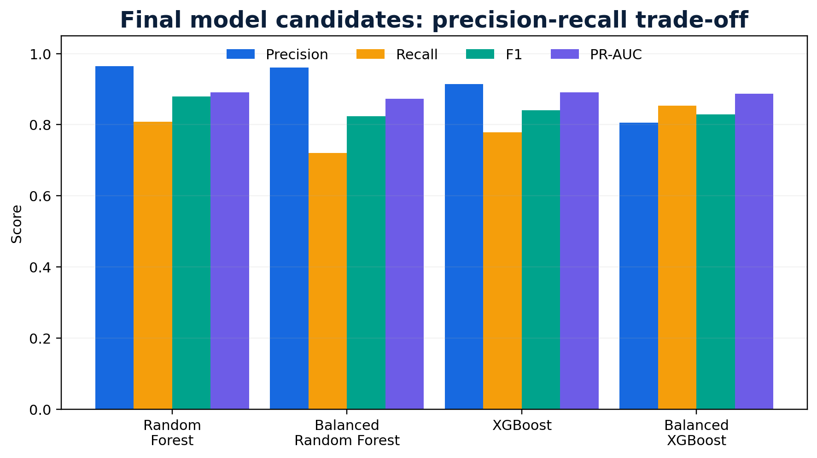
Selection criterion | Random Forest | XGBoost | Technical conclusion
Default F1 | .880 | .841 | Random Forest
Default precision | .965 | .914 | Random Forest
Default recall | .809 | .779 | Random Forest
ROC-AUC | .973 | .986 | XGBoost
PR-AUC | .891 | .891 | Tie
85%+ recall precision | .787 | .663 | Random Forest

Selection rationale
XGBoost ranked observations extremely well, but Random Forest produced the better operational classifier at both the default threshold and the high-recall business constraint.

THRESHOLD ANALYSIS
9. Probability threshold optimization
Threshold optimization separated model training from the business decision rule.
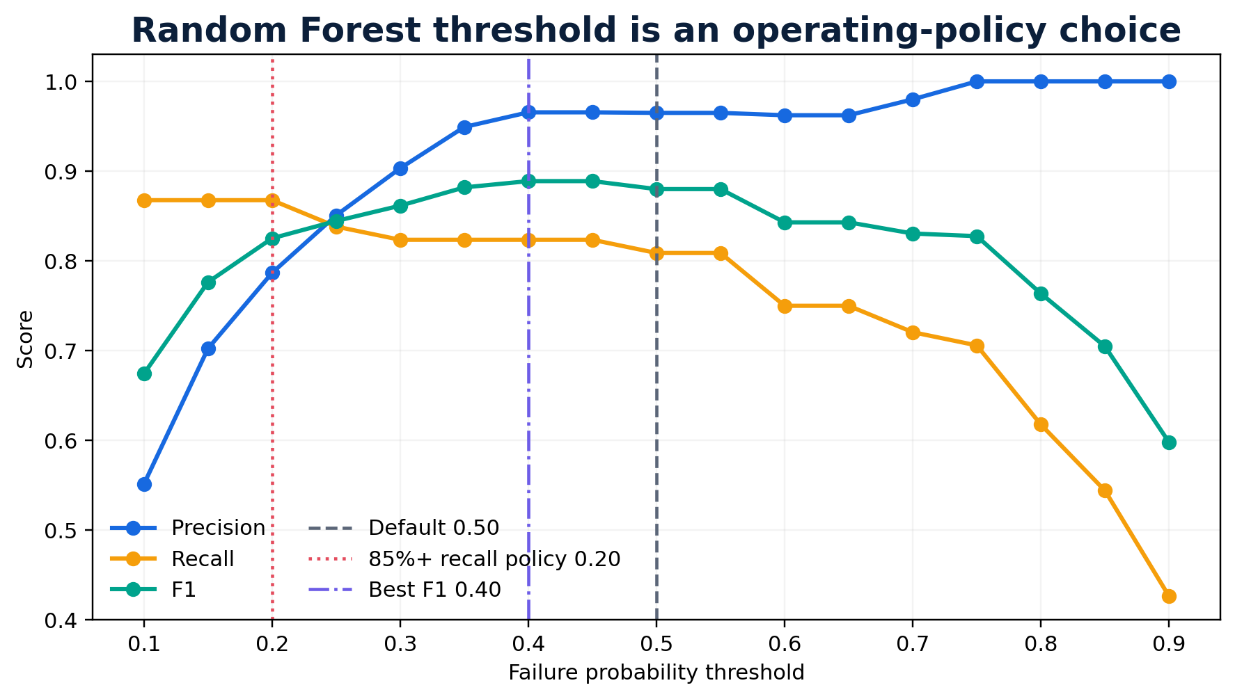
Threshold | Precision | Recall | F1 | Use case
0.20 | 78.7% | 86.8% | 82.5% | Failure-detection-first policy
0.40 | 96.6% | 82.4% | 88.9% | Best F1 in evaluated grid
0.50 | 96.5% | 80.9% | 88.0% | Default high-confidence policy

For the business-oriented requirement of at least 85% recall, Random Forest achieved 86.8% recall at threshold 0.20 with 78.7% precision. XGBoost reached 86.8% recall at threshold 0.10 but precision fell to 66.3%.
Validation caution
The threshold grid was evaluated on the held-out test set. In a production-quality workflow, threshold selection should be tuned on validation data or cross-validation and the final test set reserved for one-time unbiased evaluation.

EXPLAINABILITY
10. Global model interpretation
Two complementary importance methods were used to understand which predictors the final model relied upon.
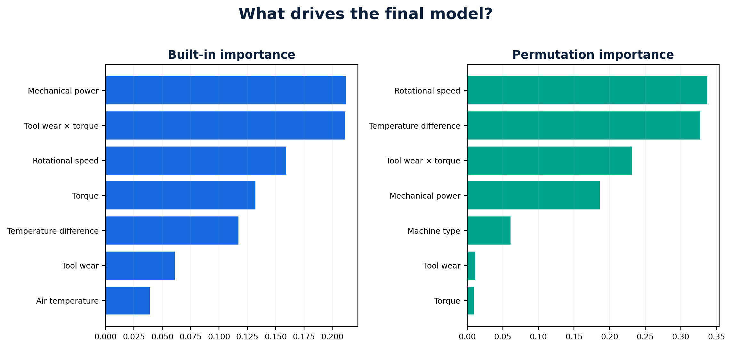

Built-in tree importance
Mechanical power and tool-wear load were the largest built-in importance contributors, followed by rotational speed, torque and temperature difference.

Permutation importance
Randomly shuffling individual features produced the largest F1 degradation for rotational speed, temperature difference and tool-wear load. Process temperature had approximately zero/slightly negative permutation importance in this test set, suggesting limited incremental value after accounting for correlated variables.
Correlation caveat
Importance can be split across correlated raw and engineered variables. Global importance describes predictive dependence, not causality or a safe operating limit.

FINAL EVALUATION
11. Hold-out test performance and error profile
The final Random Forest pipeline was evaluated at threshold 0.50.
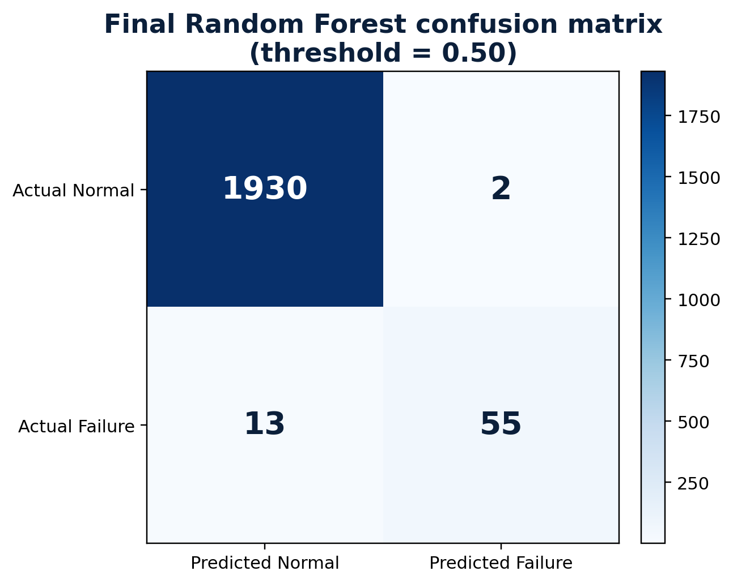
0.992  accuracy | 0.965  precision | 0.809  recall | 0.880  F1 | 0.973  ROC-AUC | 0.891  PR-AUC

Confusion matrix counts: TN=1,930; FP=2; FN=13; TP=55. The default operating point is precision-oriented: only two false alerts occurred, while 13 of 68 failures were missed.

Alternative operating point
At threshold 0.20, recall increased to 86.8% and predicted failures increased from 57 to 75. This higher-recall configuration should only be selected after quantifying the maintenance burden and economic value of the additional captured failures.
MODEL ARTIFACT
12. Reproducibility and inference design
The final preprocessing-plus-model pipeline was serialized as a single reusable artifact.

Saved artifact
The notebook saved the Random Forest pipeline to predictive_maintenance_random_forest.pkl using joblib. Reloading the artifact reproduced approximately 99.25% accuracy on the same held-out test data.

Why the pipeline artifact matters
- One-hot encoding and numeric scaling travel with the estimator.
- New observations receive the exact transformations used during model training.
- The artifact can be versioned and tested as a single inference unit.

Production metadata to add
Metadata | Purpose
Model version / Git commit | Reproducibility and rollback
Training dataset version | Lineage
Feature schema version | Input compatibility
Threshold version | Decision-policy traceability
Training date + metrics | Performance history
Approval state / owner | Governance

PRODUCTION ARCHITECTURE
13. Recommended MLOps extension
The notebook is sufficient for proof of concept; production use requires data, software, model, and governance controls.
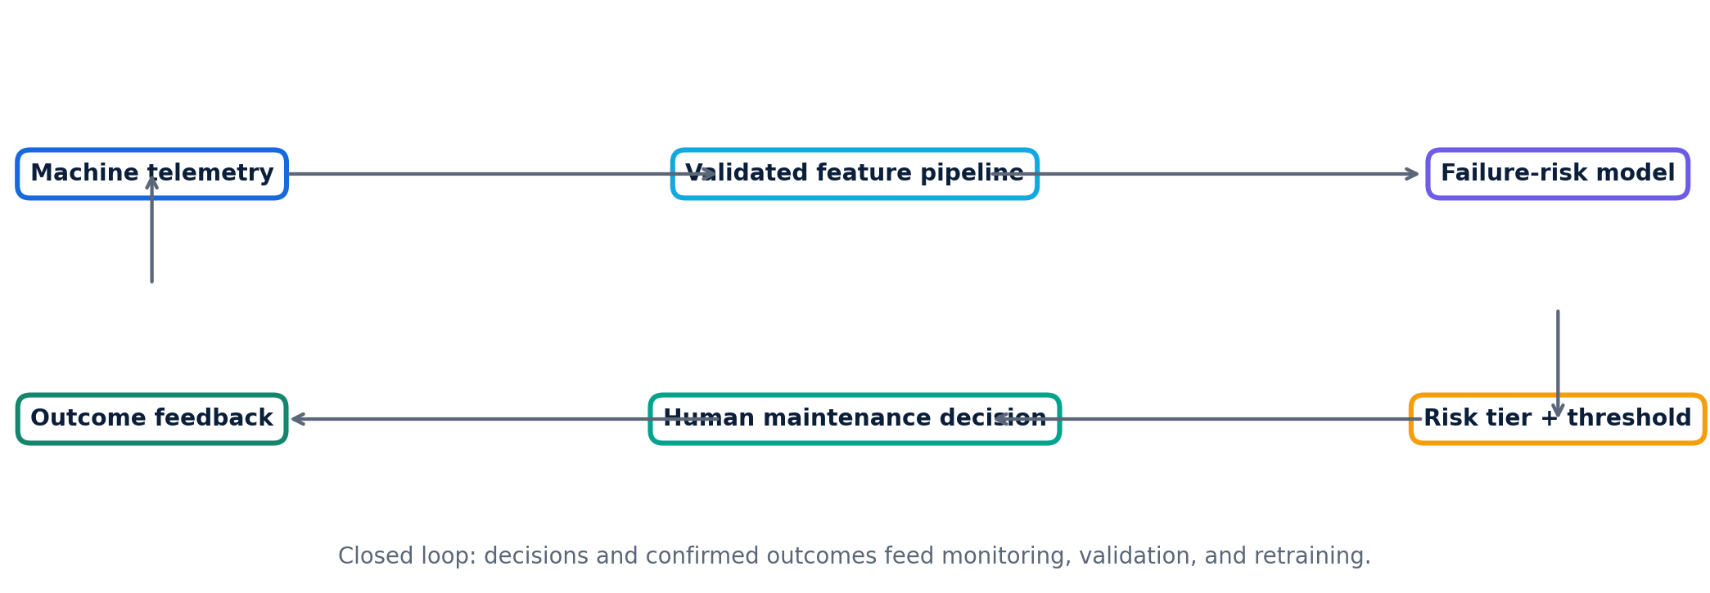
Layer | Recommended capability
Data ingestion | Historian / PLC / sensor ingestion with timestamp and asset identity controls
Validation | Schema, range, missingness, unit and sensor-quality tests
Feature pipeline | Versioned feature transformations with train/inference parity
Model serving | Batch or API scoring with versioned model + threshold
Decision integration | CMMS/work-order or monitoring dashboard with human approval
Monitoring | Input drift, prediction drift, alert rate, outcome metrics, latency
Retraining | Governed trigger, validation gates and rollback

VALIDATION AND MONITORING
14. Enterprise acceptance criteria
A technically strong model is not production-ready until performance remains stable under real operating conditions.

Recommended validation tests
- Time-based holdout to test future generalization.
- Asset-level or site-level holdout to test transferability.
- Cross-validation within training data for hyperparameter and threshold tuning.
- Calibration analysis to verify whether predicted probabilities reflect observed risk.
- Stress tests for missing sensors, out-of-range values, new machine types and distribution shifts.
- Subgroup metrics by asset type, line, site, shift and operating regime.

Monitoring metrics
Category | Examples
Data quality | Missingness, range violations, stale sensors, schema drift
Drift | PSI/KS or distribution change by critical feature
Prediction behavior | Alert rate, score distribution, threshold crossings
Outcome performance | Precision, recall, F1, PR-AUC when labels mature
Operational | Inspection volume, confirmed faults, avoided downtime, latency
Governance | Model version, threshold changes, retraining approvals, rollback events

LIMITATIONS
15. Technical limitations and future improvements
The proof of concept is strong enough to justify further validation, but not to support unrestricted deployment.
- Simulated/public dataset: real plant data may contain different noise, failure mechanisms, maintenance practices and sensor quality.
- Only 339 failures: rare-event estimates can be sensitive to sample composition.
- Snapshot observations: no true machine-level degradation sequence or time-to-failure target.
- Same-source train/test split: does not demonstrate generalization across sites, assets or time.
- Threshold optimization touched the held-out test set: future work should use validation data/cross-validation for threshold selection.
- No probability calibration study was performed.
- No hyperparameter search or nested validation was performed; XGBoost parameters were reasonable starting values, not proven optima.
- Feature importance does not establish root cause.

High-value future improvements
- Collect longitudinal telemetry and maintenance-event history to model time-to-failure and degradation trends.
- Add rolling statistics, rate-of-change and vibration/current/pressure features when real time-series data is available.
- Use cross-validated hyperparameter optimization and probability calibration.
- Evaluate cost-sensitive objective functions using real downtime and inspection costs.
- Add SHAP or local explanations for individual high-risk predictions.
- Implement experiment tracking/model registry, drift monitoring, CI/CD testing, and controlled retraining.
Final technical conclusion
Random Forest was selected because it delivered the strongest operational precision-recall balance, not because it dominated every metric. XGBoost had the best ROC-AUC, but Random Forest converted ranking quality into a better decision policy under both default and 85%+ recall scenarios.

