University Model

Pavani Bendi

Pranav Shailesh Adhav

Dhaval Minesh Patel

Main purpose of university model application is to observe performance of the overall university and keep track of the various factor affecting its performance. The factors include student’s performance, faculty’s performance and alumni’s performance. Overall rank is calculated for each entity based on data gathered like student’s grades, faculty’s performance using students review and tracking alumni’s current job will give us score for each entity which will be displayed through dashboard to University Admin.

1. Our application includes different login pages for each entity student, alumni, faculty and main admin.
2. Admins have various options like he can add new colleges, department, courses and faculty he can view rankings of each of these entities based on the factors mentioned previously.
3. Students have various options like add/drop course, they can view courses they have opted for particular semester, they can review courses as well as faculty through which department can improve their courses, they can observe dashboard where they are able to compare courses according to their job interests and review of faculties.
4. Faculty have options of viewing courses they selected, and they can view assigned seats as well as student registered for courses moreover, they can grade students based on their performance and view feedback for his course to improve his coursework.

UML Class Diagram:

Sequence Diagram:

Sequence diagram depicts the navigation of different entities like admin, faculty and student for using our application this will help us gaining performance matrix we required to compare and maintain universities performance.

Snapshots of Our application:

1. Student login page:

1. Student Landing Page:

1. Faculty Landing Page:

1. Admin Landing Page:

1. Alumni Landing Page:

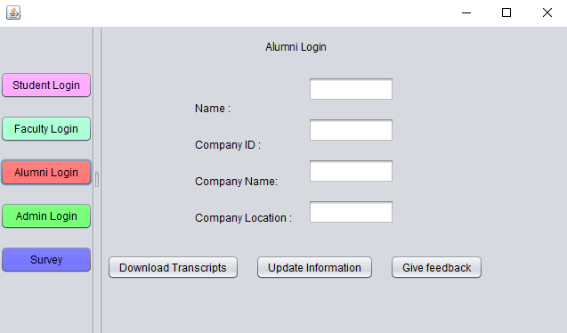

1. Dashboard Options:

1. Reports for Reference:

