Assignment 01: Interface Analysis

Name: Dhruv Patel
PRN: 1032233160 (roll no : 55)
Critical Analysis of an Interface

Interfaces Selected

Website 1: Chemist Warehouse (chemistwarehouse.com.au)
This is the online storefront for Australia's largest discount pharmacy chain. It sells prescription medicines, vitamins, cosmetics, baby care, and general health/beauty products, backed by 500+ physical stores.
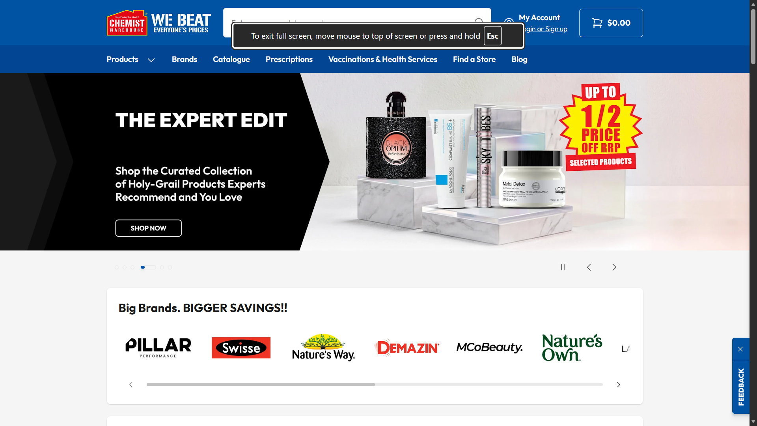

Website 2: Zeno Health (zeno.health)
Zeno is an omnichannel Indian pharmacy built around affordable generic medicines. It runs 180+ stores across Mumbai and Pune plus micro-franchisees in West Bengal, and says it serves over 25 lakh customers.

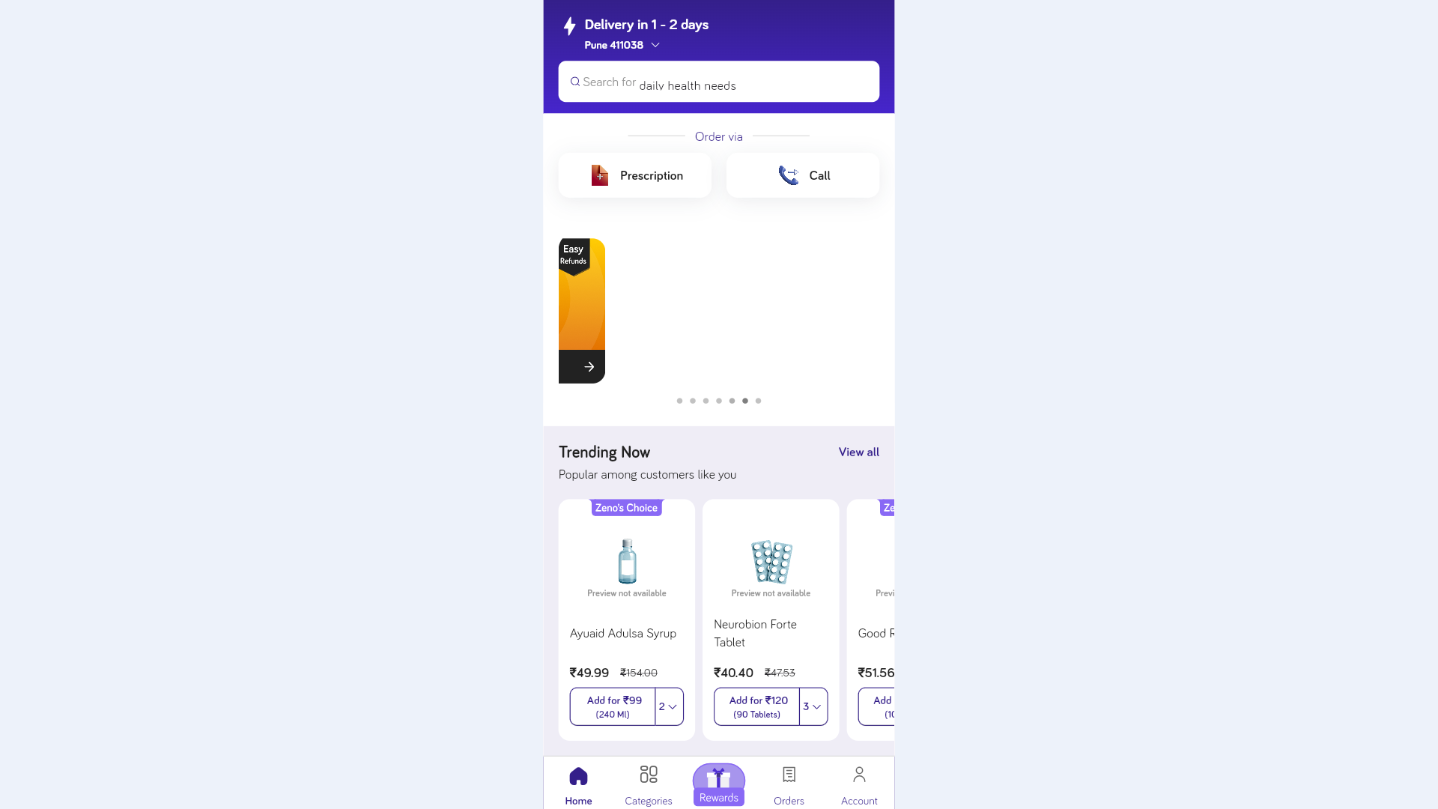

Why these were selected
One of them is international while other is a start-up(2021) from pune .As instructed i considered multiple categories for observation.

Critical Analysis - 18 Parameters

Chemist Warehouse
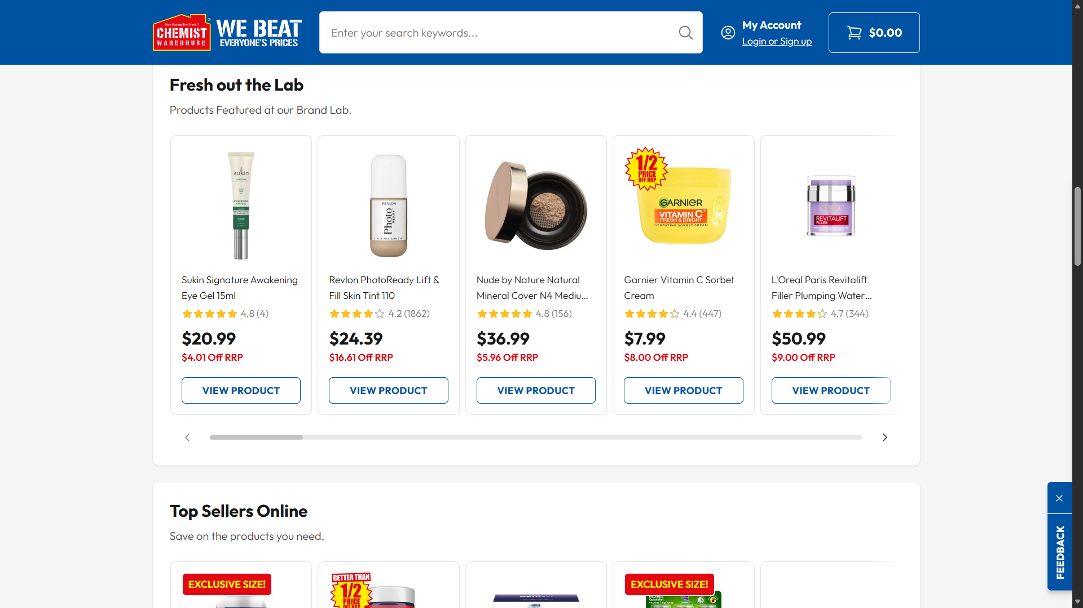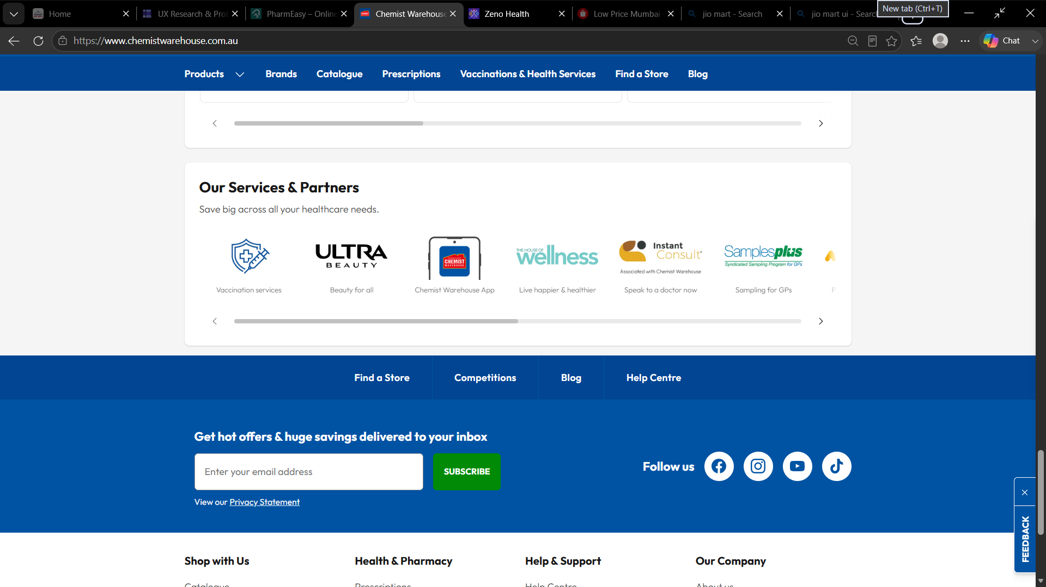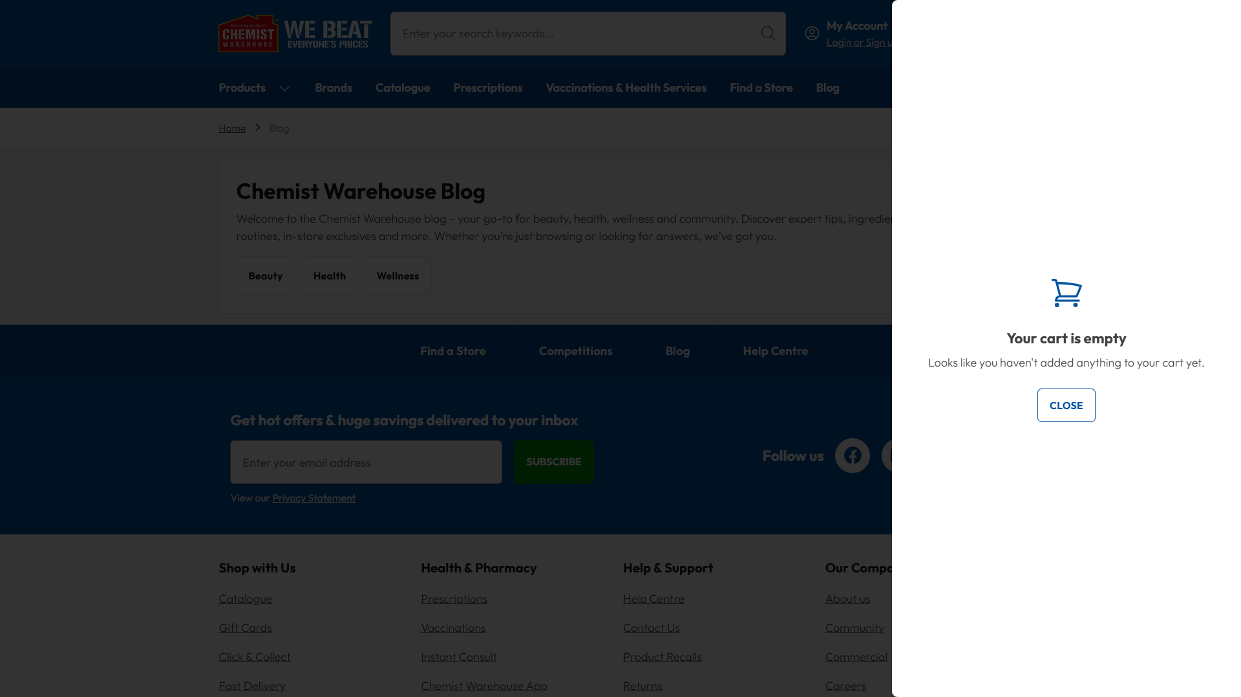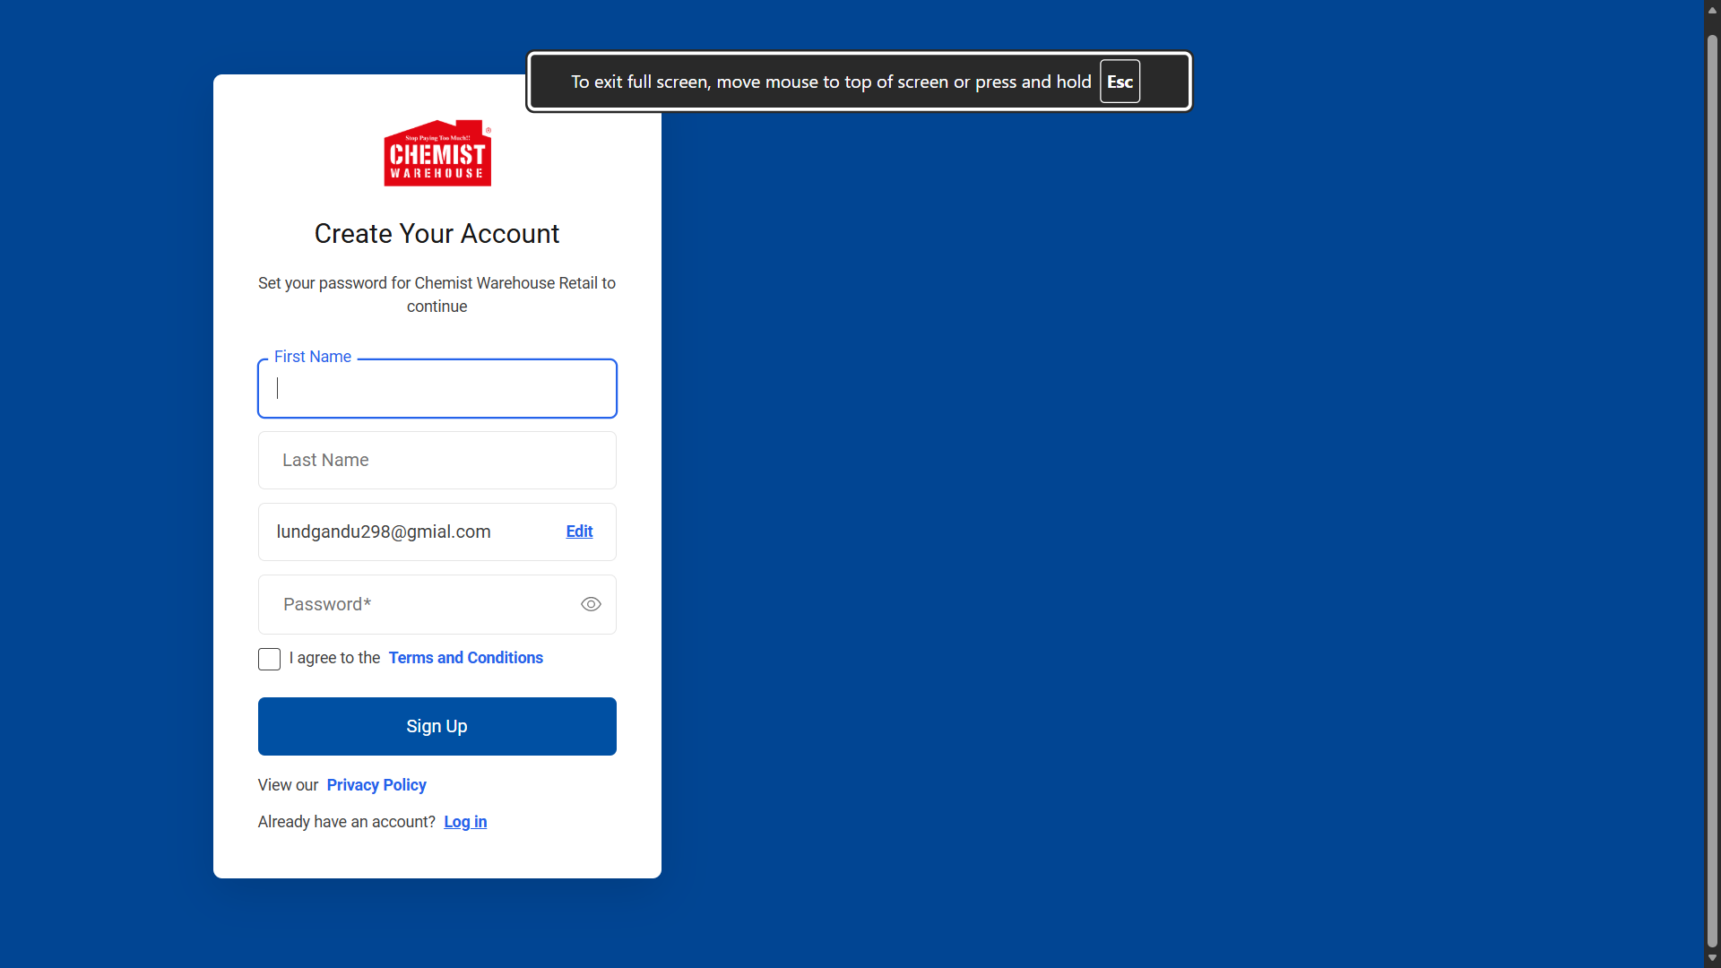
1. Learnability. Chemist Warehouse sticks to familiar e-commerce conventions - logo top-left, search bar top-center, cart top-right - so a first-time visitor doesn't need to learn anything new. That said, the homepage itself is packed: brand carousels, category tiles, blog articles, and service tiles are all stacked on top of each other, which can overwhelm someone who's just trying to figure out where to start. A shorter, guided first-time path, something like a quick "What are you shopping for today?" prompt, would take some of that learning curve away.
2. Usability. Once you find them, the core actions - search, add to cart, checkout - are simple enough. The problem is that the homepage leans hard on promotional content (catalogues, brand banners) ahead of task-oriented navigation, so users end up scrolling past a lot of non-essential material before they reach actual product categories. Giving category navigation and search more visual weight, and treating promotions as secondary, would fix a lot of this.
3. Consistency. Fonts, the red/white brand palette, and the tile-based product cards stay consistent across the site. Where it slips is in mixing "Marketplace" (online-only) items with "BAU" (core catalogue) products without any visual distinction, which can leave users unsure about stock availability or delivery timing. A simple badge - "Ships from partner seller," for instance - would make that distinction obvious at a glance.
4. Use of Metaphors. Nothing to complain about here. The cart icon, account icon, and search magnifying glass are all standard retail metaphors that don't need explaining. This is one of the site's clear strengths, and honestly there isn't much room for improvement.
5. Navigation Structure. A persistent top navigation bar and clear category tiles ("Skincare," "Vitamins & Supplements," etc.) make it easy to move sideways across departments. The catch is that with 500+ stores and thousands of SKUs, the category depth isn't visible from the homepage - you have to click into a category before subcategories even appear. A mega-menu that shows subcategories on hover would let users skip that extra step entirely.
6. Visual Hierarchy. Section headers like "Shop Popular Categories" and "Online Only Offers" do a decent job separating content blocks. But because so many sections use similarly sized tiles and banners, nothing really stands out as the "start here" element - the eye has too many competing, equal-weight things to look at. Making one primary call-to-action, like search or "shop by category," visually louder than the promotional tiles would help a lot.
7. Accessibility. Product and banner images do carry alt text, which is a good baseline. The concern is the heavy reliance on colour - red banners, red pricing - to signal importance, which can be hard for colour-blind users to pick out from the rest of the page. Pairing those colour cues with icons or text labels (a "SALE" badge, not just red background) would close that gap.
8. Responsiveness. The tile grid does adapt reasonably well to smaller screens. But the content-heavy sections - blog carousel, brand banners - take a while to become usable on mobile simply because of how much scrolling is involved. Lazy-loading or collapsing the non-critical sections (blog, brand carousel) below the fold on mobile would let the important shopping actions load first.
9. Efficiency of Interaction. Search sits at the top of every page, so a frequent shopper can skip navigation entirely if they want to. What's missing is any shortcut for returning customers - someone reordering the same vitamin every month gets no "reorder" or "recently viewed" option. Adding a "Buy Again" or order-history shortcut for logged-in users would solve this directly.
10. Feedback and System Status. The cart total ("$0.00") is always on screen, which gives constant status awareness. On the homepage, though, there's no visible confirmation when an item is actually added to the cart beyond the badge updating - a first-time user could easily miss it. A brief "Added to cart" toast near the action itself would make this much clearer.
11. Error Prevention and Recovery. Clear pricing disclaimers (the RRP explanation, for example) help avoid price-related disputes. But for prescription medicines specifically, the homepage gives no early warning about what happens if you search for a prescription-only item without a script - you only find that out deep into the flow. A short note near prescription-category entry points, explaining the upload requirement upfront, would save users the wasted browsing time.
12. Aesthetic and Minimalist Design. Individual tiles and cards are clean and have decent white space. The homepage as a whole, though, is anything but minimalist - it reads more like a catalogue than a focused shopping tool. Trimming the number of homepage sections, and moving seasonal or blog content to a separate "Discover" tab, would help it feel less crowded.
13. Content Readability. Font sizes and contrast on the product tiles are perfectly legible. The footer, on the other hand, is dense with small, paragraph-heavy legal/RRP text that's easy to skip - even when it actually matters for pricing. Pulling the key legal points into plain, larger text with a "read full policy" link would make that information much harder to miss.
14. Search and Discoverability. There's a dedicated, always-visible search bar that supports direct product lookup. Category-based browsing is slower, though - it takes homepage → category → subcategory → product, several clicks in total. Search-as-you-type suggestions with product and category previews would shortcut that path considerably.
15. Performance Perception. The page structure suggests server-rendered content, which should mean a reasonably fast initial load. Heavy imagery across banners and blog sections can slow down perceived load speed, though, especially on weaker connections. Lazy-loading below-the-fold images and sticking to compressed formats consistently would help.
16. Trust and Credibility. This is a genuine strength - the established brand name, clear legal pages (returns, privacy, scam alerts), and a dedicated "Product Recalls" and "Scam Warning" page are unusually transparent for a pharmacy site. There isn't a major problem to flag here. If anything, moving trust badges like "secure checkout" or "pharmacist-verified" closer to the actual purchase point, rather than leaving them in the footer, would reinforce that trust right when it matters most.
17. Personalization. An account/login system exists, so personalised order history and preferences are technically possible. In practice, though, the homepage looks generic and promotional whether or not you're logged in. Showing personalised sections - "Based on your last order," refill reminders - for logged-in users would make that account system feel worth using.
18. User Satisfaction. The wide product range, competitive pricing messaging, and multiple fulfilment options (click & collect, fast delivery) all add up to a satisfying end-to-end experience. But the sheer density of the homepage can trigger decision fatigue before the user has even started their actual task. A simplified "quick shop" mode, or just a stronger default focus on search and navigation over merchandising, would help.

Zeno Health
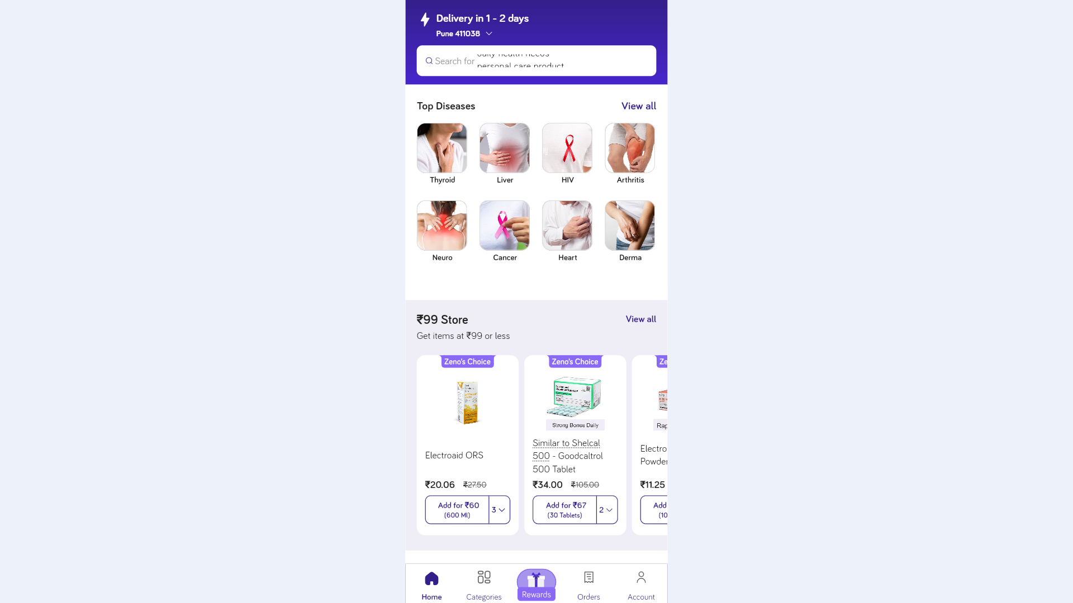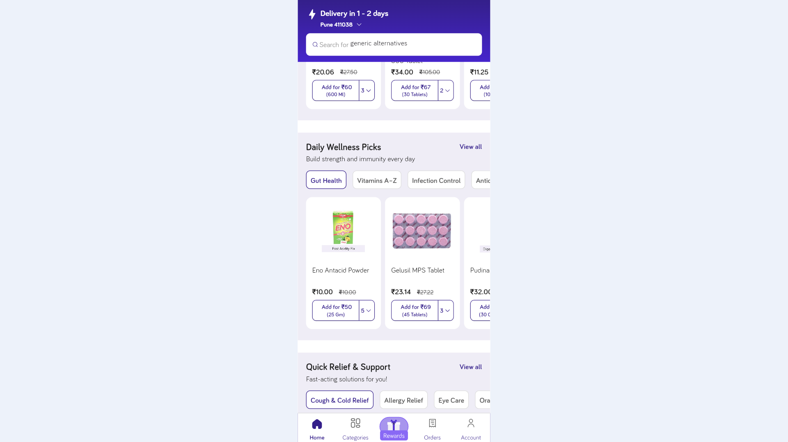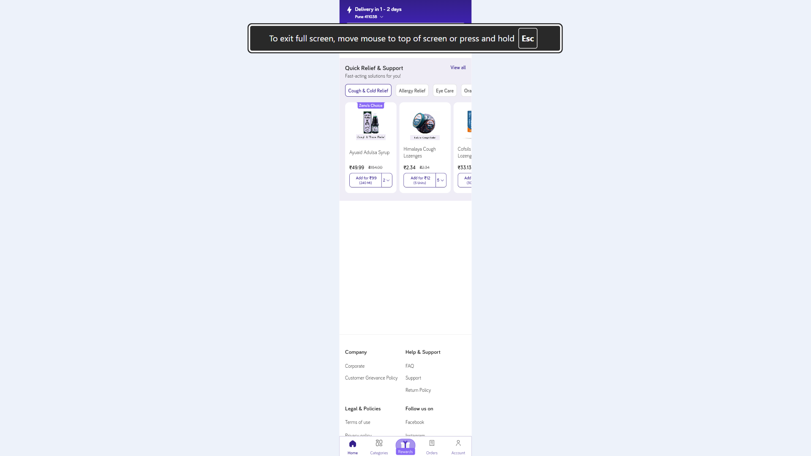

1. Learnability. Zeno's core message - affordable generic medicines - comes through clearly in its marketing copy ("Quality medicines at the lowest prices & fastest delivery"), so the value proposition is easy to grasp. The bigger issue is that the website is a heavily JavaScript-rendered single-page application, meaning almost no content shows up until the scripts fully execute. On a slow network, that can look like a blank or broken page with zero explanation. A lightweight loading skeleton or spinner with a short status message would go a long way toward reassuring first-time users that the page is working, not broken.
2. Usability. The task model itself is simple - search a medicine, order it, save money - and easy to understand. But because most content depends on client-side JavaScript, basic usability (even just viewing product info) hinges entirely on the scripts succeeding. If they don't, the user is left with nothing at all. Rendering critical content like search and categories earlier, or server-side, would stop usability from being so fully dependent on JS.
3. Consistency. Based on app store listings and marketing material, the app and website appear to share the same visual identity and messaging, which is good for cross-platform consistency. User reviews, though, mention occasional app crashes and inconsistent substitute recommendations - so while the experience looks the same every time, it doesn't always behave the same way. Investing in stability testing would help consistency hold up functionally, not just visually.
4. Use of Metaphors. Standard pharmacy/e-commerce metaphors - cart, search, categories - are in use, which keeps the learning curve low. There isn't quite enough visible page content to judge deeper metaphor choices, like the prescription-upload iconography, from the website alone. Given that Zeno explicitly targets users with lower digital literacy, it's worth making sure something like "prescription upload" uses a universally recognisable icon (a camera or upload symbol) instead of relying on text alone.
5. Navigation Structure. The core navigation - medicines, wellness, offers - is simpler than Chemist Warehouse's, which in principle should make it feel less overwhelming. But because the homepage is client-rendered with barely any crawlable structure, there's no visible hierarchy to actually evaluate, which hints that some navigation might be buried behind JS-only interactions that aren't discoverable without clicking around first. A persistent, always-visible top-level menu that doesn't depend on full page hydration would fix that.
6. Visual Hierarchy. Official app screenshots suggest a clean, promotion-forward layout with pricing and savings callouts up front, which suits a price-sensitive audience well. This is hard to verify directly, though, since a JS-only render is itself a hierarchy problem - search engines and slower devices effectively "see" nothing until the scripts finish running. It would be worth confirming, on a throttled connection, that the savings message really is the first thing users see rather than the last.
7. Accessibility. Zeno's own product description positions it for less tech-savvy and older users, so accessibility is at least a stated goal. That makes it more concerning that a fully JavaScript-rendered site with no fallback content is a real risk here - screen readers, low-end Android devices, and poor networks (all common in Zeno's Tier-1/2 India market) could easily land on an unusable blank page. Adding server-side rendering, or at least a no-JS fallback message, matters more here than it would for most sites, precisely because it's the target audience most likely to hit that failure.
8. Responsiveness. Zeno is primarily an app-first product, and the app's mobile responsiveness is generally well reviewed. The website's responsiveness is harder to judge without full script execution, and if it mirrors the app-first priority, it may end up being treated as a secondary, less cared-for experience. It would be better to treat the website as a first-class responsive surface in its own right, not just a landing page pointing people to the app.
9. Efficiency of Interaction. Reviews mention a repeat-purchase discount program (up to 20% off), which rewards efficient, repeat behaviour. On the flip side, one review specifically called out slow or unfulfilled customer support - for example, replacing a short-shelf-life medicine - which breaks efficiency right at the post-purchase stage. Self-service order-issue reporting built into the interface, rather than relying only on a helpline, would help close that gap.
10. Feedback and System Status. Delivery tracking is a stated feature, which gives users some visibility into their order status. App reviews mentioning crashes are a much bigger problem, though - a crash is the most severe kind of feedback failure, since the system communicates nothing at all when it breaks. Graceful error states ("Something went wrong, please retry") instead of a hard crash would make failures far less jarring.
11. Error Prevention and Recovery. "Easy returns & immediate refunds" is advertised as a feature, supporting recovery after a wrong order. But a user review describes a case where a promised replacement for short-shelf-life medicine simply wasn't delivered, meaning that promise isn't always kept in practice. Making the returns/replacement process trackable in-app, with visible status updates, would be more reliable than depending on manual follow-up.
12. Aesthetic and Minimalist Design. A narrower product focus - generic medicines plus wellness - naturally lends itself to a simpler, less cluttered interface than a full-range retailer like Chemist Warehouse. This is hard to fully verify without rendered content, but marketing screenshots suggest a fairly promotion-heavy home screen, similar to other Indian e-commerce apps. Keeping the medicine search bar as the single most dominant element - ahead of banners and offers - would keep the focus on the core task.
13. Content Readability. Marketing copy is simple and comfortable with a Hindi-English mix, which fits the target audience's language habits well, based on reviews and promotions. In-app typography and contrast are harder to assess directly from the available data. Given the stated older/less tech-savvy user base, it's worth explicitly verifying that text contrast and font size meet accessibility minimums.
14. Search and Discoverability. Medicine search with substitute/generic recommendations is the core feature, and it's well reviewed by users ("good substitute recommendations"). Search quality itself is hard to evaluate from the raw, JS-rendered website, and generic-medicine search is inherently trickier than branded search, since users often don't know the generic name of what they were prescribed. Letting users search by uploading a photo of the prescription or the branded medicine name, and auto-matching to the generic equivalent, would directly support the core value proposition here.
15. Performance Perception. Fast, roughly 50-minute delivery is a strong, clearly promoted value proposition for the app. The website itself, though, being entirely JS-rendered with no visible initial content, is likely to feel slow and "blank" on first load - a poor performance perception regardless of how fast the actual delivery is. Optimising first-contentful-paint on the website specifically matters here, since perceived site speed and perceived delivery speed both feed into the same trust equation.
16. Trust and Credibility. Claims of WHO-GMP-certified sourcing, pharmacist consultations, and transparent generic-vs-branded education all help build credibility in a category many users are naturally sceptical of. That credibility takes a hit from mixed app-store reviews - an unhelpful helpline, unresolved replacement promises - which undercut what the marketing claims. Making certifications and sourcing information visible directly on the website, not just in app descriptions, and closing the gap between support promises and actual support delivery, would help a lot.
17. Personalization. Order history and repeat-purchase discounts suggest some personalisation already exists for returning customers. There aren't any visible personalisation signals on the base website itself, though that's again limited by the JS rendering. Surfacing personalised refill reminders prominently would be especially valuable given how much of the customer base is likely managing chronic medication.
18. User Satisfaction. A strong stated value proposition (up to 80% savings) and largely positive reviews around delivery speed and substitute suggestions support decent satisfaction overall. Negative reviews cluster specifically around support responsiveness and order-issue resolution, so satisfaction really breaks down at the "something went wrong" moment. Fixing the post-purchase support loop should be the priority, since that's exactly where the reviewed dissatisfaction concentrates.

Major UI/UX Problems

Chemist Warehouse
- The homepage is merchandising-heavy, which buries core navigation and search under promotional content.
- There's no early guidance for prescription-required products - users only find this out deep into the flow.
- Marketplace items and core-catalogue items aren't clearly differentiated, which risks confusing users about delivery or availability.

Zeno Health
- The website relies almost entirely on client-side JavaScript rendering, so users on slow networks or older devices - a segment Zeno explicitly serves - may just see a blank screen with no feedback.
- There's a gap between what's marketed (immediate refunds, 24/7 support) and what reviewers actually experience (unresolved replacements, an unhelpful helpline).
- The app-first design bias leaves the website feeling like a secondary, less-polished experience.

Suggested Improvements
Area | Chemist Warehouse | Zeno Health
Homepage priority | Elevate search/category navigation above promotions | Add a fast-loading skeleton screen / SSR fallback
Clarity | Differentiate marketplace vs. core stock visually | Clarify the prescription-upload and generic-matching flow
Trust | Surface trust badges closer to checkout | Close the gap between support promises and delivery
Personalization | Add "buy again" / refill shortcuts | Highlight refill reminders for chronic patients
Performance | Lazy-load heavy images | Optimise first paint of the website specifically

Shneiderman's 8 Golden Rules
1. Strive for consistency. Chemist Warehouse keeps a consistent red/white visual identity throughout, but mixes "Marketplace" and core-catalogue items without a consistent visual cue. Zeno looks visually consistent across its app and marketing, but functional consistency is weaker according to reviews - occasional crashes mean the interface looks the same every time without always behaving the same way.
2. Seek universal usability. Chemist Warehouse serves a broad Australian audience reasonably well with familiar retail patterns. Zeno explicitly targets less tech-savvy and older users, but its JS-only website undermines that goal, since it can fail silently on low-end devices - exactly the users it says it wants to include.
3. Offer informative feedback. Chemist Warehouse gives constant visible feedback through the cart total, though it lacks a clear "added to cart" confirmation. Zeno's feedback is weakest at failure points - app crashes and unresolved support tickets mean the system sometimes gives no feedback at all when something goes wrong.
4. Design dialogs to yield closure. Neither homepage shows the full checkout flow on its own, but Chemist Warehouse's clear returns/shipping policy pages suggest a well-defined end-to-end process. Zeno's "immediate refund" promise not always being honoured, per reviews, means the task doesn't always reach a real sense of closure for the user.
5. Prevent errors. Chemist Warehouse avoids pricing confusion with a detailed, if dense, disclaimer system. Zeno's generic-medicine matching is itself a kind of error prevention - it helps users avoid buying the wrong or overpriced branded drug - but the website going blank on slow connections is an unprevented error state in its own right.
6. Permit easy reversal of actions. Both sites advertise returns policies. Chemist Warehouse's is detailed and linked directly from the footer. Zeno advertises "easy returns & immediate refunds," but real-world reviews suggest reversal isn't always smooth in practice.
7. Keep users in control. Chemist Warehouse's dense homepage can make users feel steered by promotions rather than in control of their own path. Zeno's app-first approach may leave website users feeling like second-class users compared to app users, which chips away at their sense of control over how they shop.
8. Reduce short-term memory load. Chemist Warehouse's persistent search bar and visible cart total do a good job of reducing memory load. Zeno's lack of visible content on first load forces users to remember what they intended to search for once the page finally becomes interactive - unnecessary extra cognitive load.

Conclusion
Both Chemist Warehouse and Zeno Health deliver on their core promise of accessible, affordable pharmacy shopping, but their UI/UX weaknesses show up in different places. Chemist Warehouse's problem is homepage density - too much merchandising competes with the simple task of finding and buying a product. Zeno Health's problem is more technical and structural: a JavaScript-dependent website that risks shutting out the low-bandwidth, less tech-savvy users it says it wants to serve, on top of a gap between what it promises and what reviewers say they actually experience. For both, a stronger interface would come down to the same underlying principle: put the user's core task - find the medicine, trust the source, complete the purchase, get help if something goes wrong - ahead of everything else on the screen.

