

Functional Safety Concept Lane Assistance

**Document Version: [Version]**

**Template Version 1.0, Released on 2017-06-21**



# Document history

**[Instructions: Fill in the date, version and description fields. You can fill out the Editor field with your name if you want to do so. Keep track of your editing as if this were a real world project.**

**For example, if this were your first draft or first submission, you might say version 1.0. If this is a second submission attempt, then you'd add a second line with a new date and version 2.0]**

|  |  |  |  |
| --- | --- | --- | --- |
| Date | Version | Editor | Description |
| 16-05-2018 | 1.0 | Disha Patel | Initial Submission |
|  |  |  |  |
|  |  |  |  |
|  |  |  |  |
|  |  |  |  |

# Table of Contents

**[Instructions: We have provided a table of contents. If you change the document structure, please update the table of contents accordingly. The table of contents should show each section of the document and page numbers or links. Most word processors can do this for you. In** [**Google Docs**](https://support.google.com/docs/answer/116338?co=GENIE.Platform%3DDesktop&hl=en)**, you can use headings for each section and then go to Insert > Table of Contents.** [**Microsoft Word**](https://support.microsoft.com/en-us/help/285059/how-to-create-a-table-of-contents-by-marking-text-in-word) **has similar capabilities]**

Document history

Table of Contents

Purpose of the Functional Safety Concept

Inputs to the Functional Safety Analysis

Safety goals from the Hazard Analysis and Risk Assessment

Preliminary Architecture

Description of architecture elements

Functional Safety Concept

Functional Safety Analysis

Functional Safety Requirements

Refinement of the System Architecture

Allocation of Functional Safety Requirements to Architecture Elements

Warning and Degradation Concept

# Purpose of the Functional Safety Concept

**[Instructions: Answer what is the purpose of a functional safety concept?]**

The purpose of functional safety is to avoid accidents by reducing risk to acceptable levels.

# Inputs to the Functional Safety Concept

## Safety goals from the Hazard Analysis and Risk Assessment

**[Instructions:**

**REQUIRED:**

**Provide the lane departure warning and lane keeping assistance safety goals as discussed in the lessons and derived in the hazard analysis and risk assessment.**

**OPTIONAL:**

**If you expanded the hazard analysis and risk assessment to include other safety goals, include them here.**

**]**

|  |  |
| --- | --- |
| **ID** | **Safety Goal** |
| Safety_Goal_01 | For the lane departure warning function, the oscillating steering torque from the function shall be limited. S3 x E3 x C3 = ASIL C |
| Safety_Goal_02 | The lane keeping assistance function should be time limited and the additional steering torque should end after a mentioned time interval so the system for autonomous driving is not misused by the driver. = ASIL B |

## Preliminary Architecture

**[Instructions: Provide a preliminary architecture for the lane assistance item. Hint: See Lesson 3: Item Definition]**

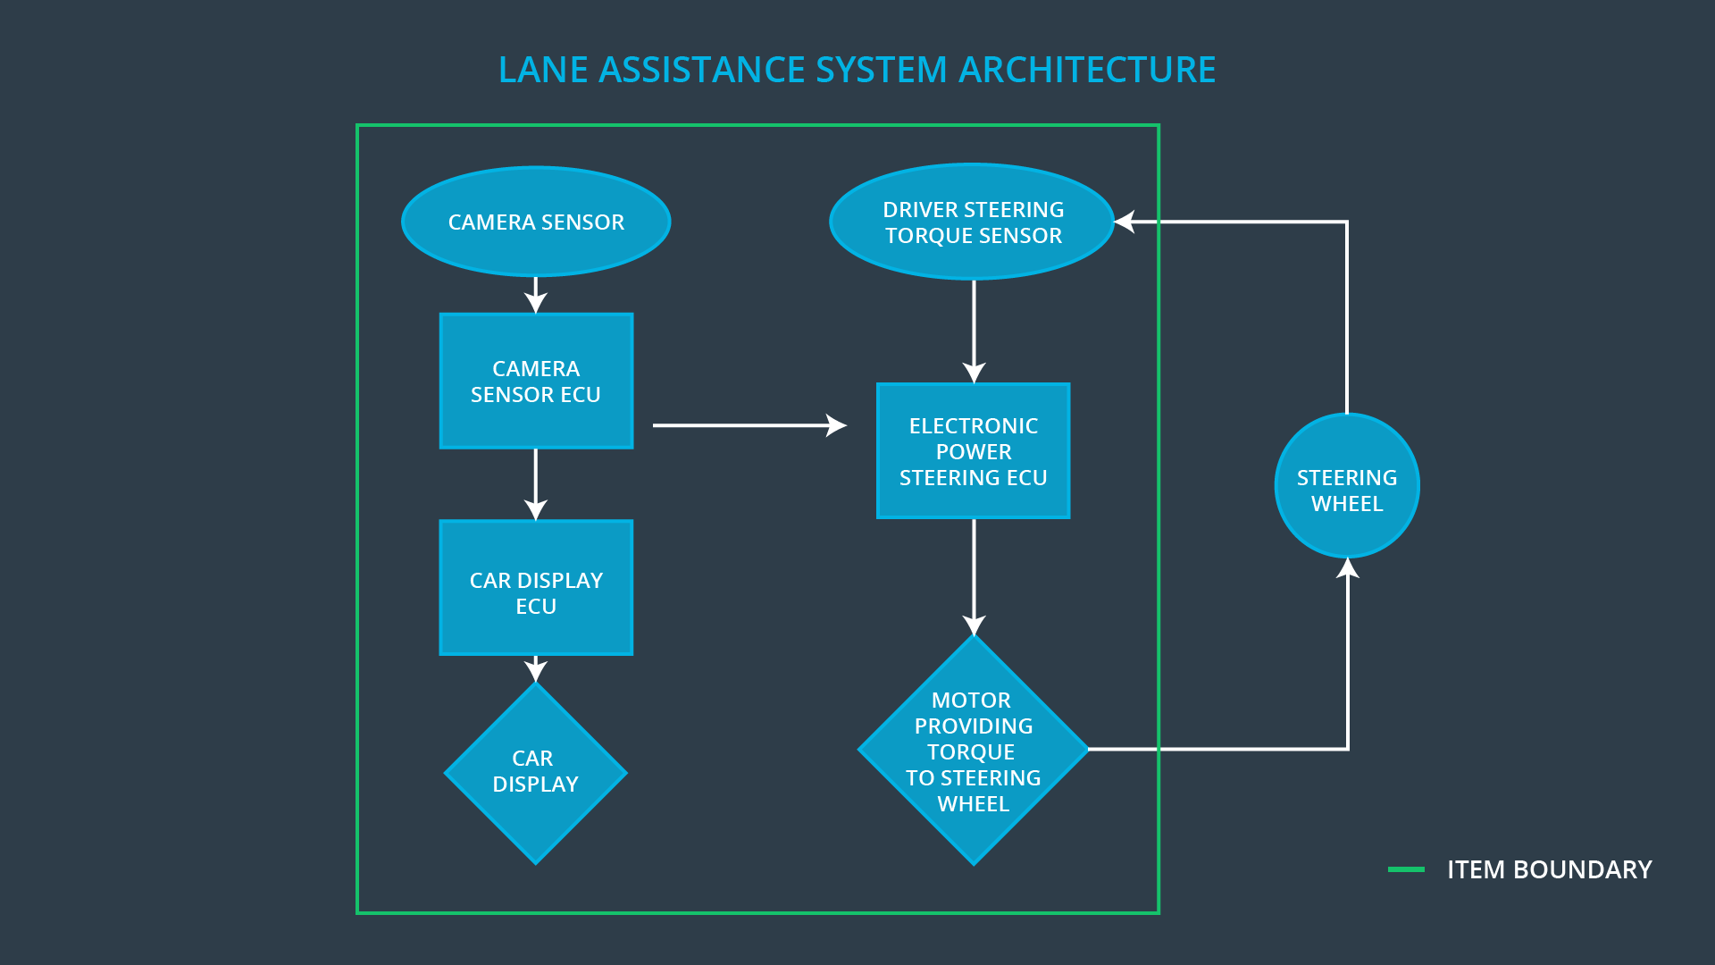

### Description of architecture elements

**[Instructions: Provide a description for each of the item elements; what is each element's purpose in the lane assistance item? ]**

|  |  |
| --- | --- |
| **Element** | **Description** |
| Camera Sensor | To provide the images captured from camera to the camera Sensor ECU. |
| Camera Sensor ECU | Images will be analyzed and will calculate the car position and detect the lane lines. |
| Car Display | It will display warning to the driver. |
| Car Display ECU | It will show the lane departure and lane keeping assistance warning status, by controlling the car display component. |
| Driver Steering Torque Sensor | It will be measuring the steering torque which will be applied by the driver to the steering wheel. |
| Electronic Power Steering ECU | It will process the inputs from Driver steering torque sensor, Camera Sensor ECU and request the required torque which will be applied by the motor. |
| Motor | It will apply the torque received from Electronic Power Steering ECU and apply it to the steering wheel. |

# Functional Safety Concept

The functional safety concept consists of:

* Functional safety analysis
* Functional safety requirements
* Functional safety architecture
* Warning and degradation concept

## Functional Safety Analysis

**[Instructions: Fill in the functional safety analysis table below.]**

|  |  |  |  |
| --- | --- | --- | --- |
| **Malfunction ID** | **Main Function of the Item Related to Safety Goal Violations** | **Guidewords (NO, WRONG, EARLY, LATE, MORE, LESS)** | **Resulting Malfunction** |
| Malfunction_01 | Lane Departure Warning (LDW) function shall apply an oscillating steering torque to provide the driver a haptic feedback | MORE | The oscillating amplitude is too high. |
| Malfunction_02 | Lane Departure Warning (LDW) function shall apply an oscillating steering torque to provide the driver a haptic feedback | MORE | The oscillating frequency is too high. |
| Malfunction_03 | Lane Keeping Assistance (LKA) function shall apply the steering torque when active in order to stay in ego lane | NO | the lane departure oscillating torque amplitude is below Max_Torque_Amplitude |

## Functional Safety Requirements

**[Instructions: Fill in the functional safety requirements for the lane departure warning ]**

Lane Departure Warning (LDW) Requirements:

|  |  |  |  |  |
| --- | --- | --- | --- | --- |
| **ID** | **Functional Safety Requirement** | **ASIL** | **Fault Tolerant Time Interval** | **Safe State** |
| Functional  Safety  Requirement  01-01 | the lane departure oscillating torque amplitude is below Max_Torque_Amplitude | C | 50 ms | Turn off the functionality or system |
| Functional  Safety  Requirement  01-02 | the lane departure oscillating torque frequency is below Max_Torque_Frequency | C | 50 ms | Turn off the functionality or system |

Lane Departure Warning (LDW) Verification and Validation Acceptance Criteria:

|  |  |  |
| --- | --- | --- |
| **ID** | **Validation Acceptance**  **Criteria and Method** | **Verification Acceptance**  **Criteria and Method** |
| Functional  Safety  Requirement  01-01 | Validating the Max_Torque_Amplitude and check if it is low which will not cause the steering loss. | To verify that the system goes turn off when the Max_Torque_Amplitude is exceeded. |
| Functional  Safety  Requirement  01-02 | Validating the Max_Torque_Frequency and check if it is low which will not cause the steering loss. | To verify that the system goes turn off when the Max_Torque_Frequency is exceeded. |

**[Instructions: Fill in the functional safety requirements for the lane keeping assistance]**

Lane Keeping Assistance (LKA) Requirements:

|  |  |  |  |  |
| --- | --- | --- | --- | --- |
| **ID** | **Functional Safety Requirement** | **ASIL** | **Fault Tolerant Time Interval** | **Safe State** |
| Functional  Safety  Requirement  02-01 | Lane keeping assistance function shall be time limited and the additional steering torque shall end after a given timer interval so that the driver cannot misuse the system for autonomous driving | B | 500 ms | Turn the system off |

Lane Keeping Assistance (LKA) Verification and Validation Acceptance Criteria:

|  |  |  |
| --- | --- | --- |
| **ID** | **Validation Acceptance**  **Criteria and Method** | **Verification Acceptance**  **Criteria and Method** |
| Functional  Safety  Requirement  02-01 | The max_duration chosen really did dissuade drivers from taking their hands off the wheel | The system really does turn off if the lane keeping assistance every exceeded max_duration. |

## Refinement of the System Architecture

**[Instructions: Include the refined system architecture. Hint: The refined system architecture should include the system architecture from the end of the functional safety lesson including all of the ASIL labels.]**

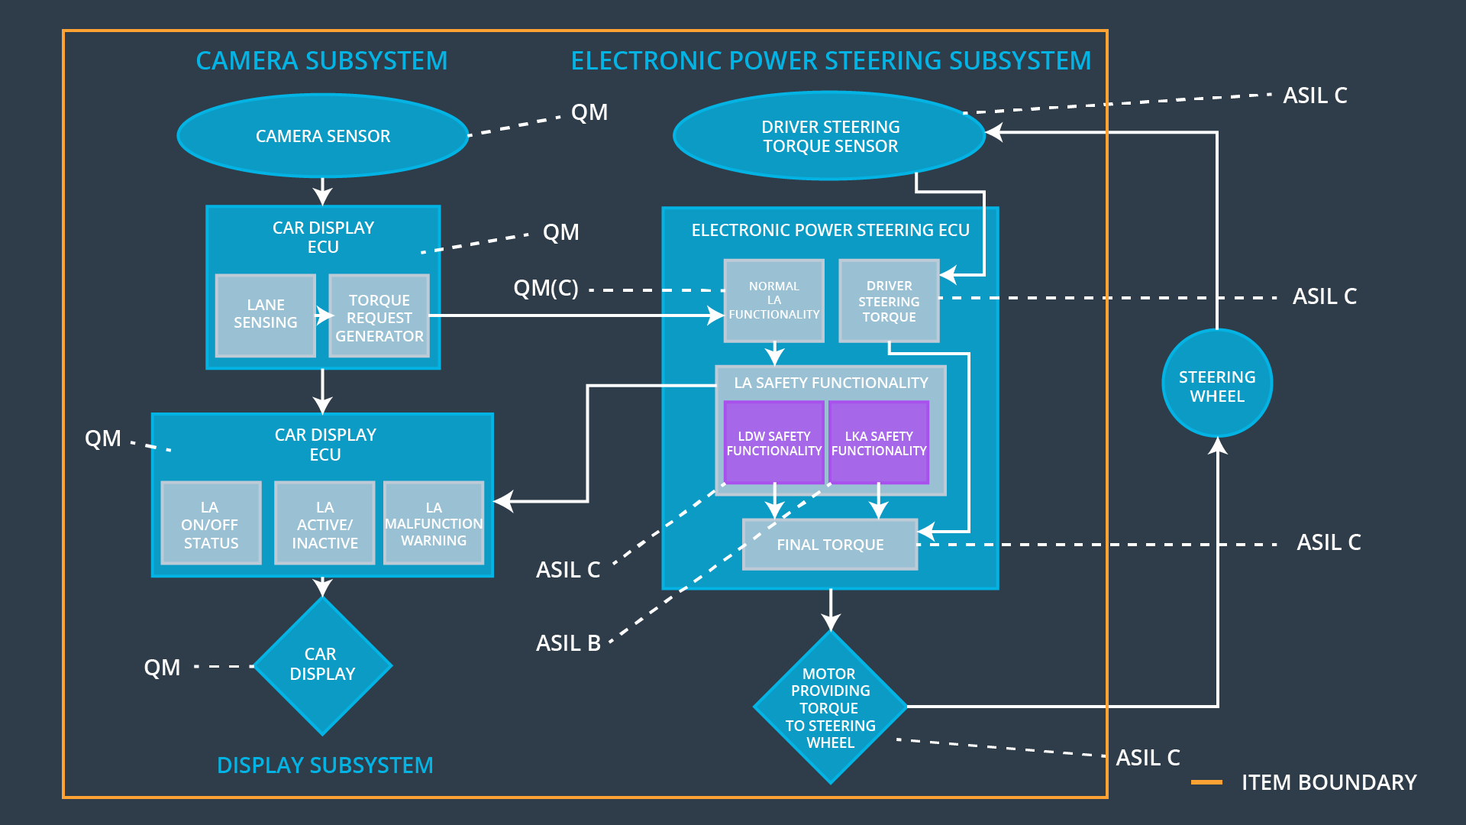

## Allocation of Functional Safety Requirements to Architecture Elements

**[Instructions: Mark which element or elements are responsible for meeting the functional safety requirement. Hint: Only one ECU is responsible for meeting all of the requirements.]**

|  |  |  |  |  |
| --- | --- | --- | --- | --- |
| **ID** | **Functional Safety Requirement** | **Electronic Power Steering ECU** | **Camera ECU** | **Car Display ECU** |
| Functional  Safety  Requirement  01-01 | The electronic power steering ECU should be ensuring that the lane departure oscillating torque frequency is below Max_Torque_Frequency | **x** |  |  |
| Functional  Safety  Requirement  01-02 | The electronic power steering ECU should be ensuring that the lane departure oscillating torque Amplitude is below Max_Torque_Amplitude | **x** |  |  |
| Functional  Safety  Requirement  02-01 | The electronic power steering ECU should be ensuring that the lane keeping torque is applied for less than the Max_Duration. | **x** |  |  |

## Warning and Degradation Concept

**[Instructions: Fill in the warning and degradation concept.]**

WDC-01 is for Lane Departure Warning function

WDC-02 is for Lane Keeping assistance function

|  |  |  |  |  |
| --- | --- | --- | --- | --- |
| **ID** | **Degradation Mode** | **Trigger for Degradation Mode** | **Safe State invoked?** | **Driver Warning** |
| WDC-01 | Turn off the functionality | Malfunction_01  Malfunction_02 | Yes | a warning light on the dashboard |
| WDC-02 | Turn off the functionality | Malfunction_03 | Yes | a warning light on the dashboard |