QUE 1:= Create a new database called InstaClone in MySQL Workbench, then create a table named Users with columns: user_id (INT, primary key), username (VARCHAR), email (VARCHAR), and followers_count (INT).
CREATE DATABASE InstaClone;

USE InstaClone;

CREATE TABLE Users (
user_id INT PRIMARY KEY,
username VARCHAR(100),
email VARCHAR(150),
followers_count INT
);

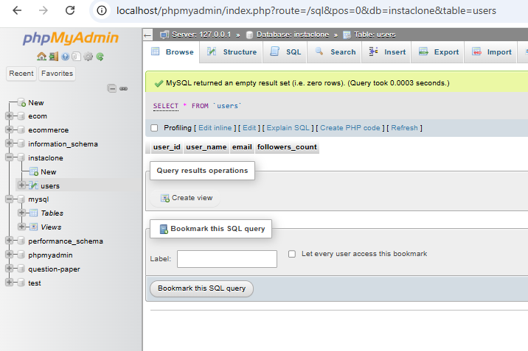

QUE 2: Insert 3 sample users into the Users table you created, using realistic Instagram-style usernames and follower counts.

INSERT INTO users(user_id,user_name,email,followers_count)
VALUES
(1, 'diya_3006', 'diya@gmail.com', 500),
(2, 'dia_123', 'd@gmail.com', 1200),
(3, 'official_nisarg', 'omi@gmail.com', 2500);

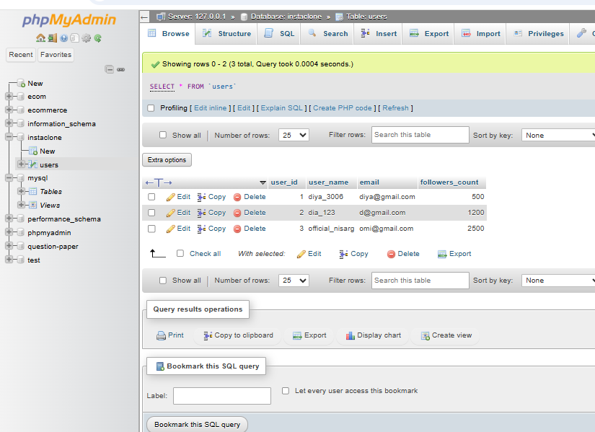

Que 3: Create another table in the InstaClone database called Posts with columns: post_id (INT, primary key), user_id (INT), caption (VARCHAR), and post_date (DATE). Add a foreign key from Posts.user_id to Users.user_id to establish a relationship.

CREATE TABLE Posts (
post_id INT PRIMARY KEY,
user_id INT,
caption VARCHAR(255),
post_date DATE,
FOREIGN KEY (user_id) REFERENCES Users(user_id)
);
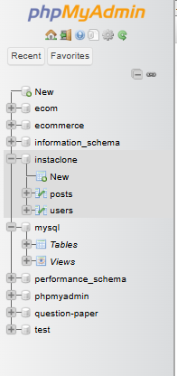

Que 4: 1. MySQL
MySQL is an open-source relational database management system. It is commonly used in websites and web applications. It is popular for storing user information, products, and orders.

2. PostgreSQL
PostgreSQL is an open-source relational database system. It is commonly used in complex web applications and data analysis. It supports advanced queries and provides reliable data management.

3. Oracle
Oracle is a commercial database management system. It is commonly used by large companies, banks, and enterprise systems. It provides advanced security and handles large amounts of data.

4. SQLite
SQLite is a lightweight database that stores data in a local file. It is commonly used in mobile apps and desktop applications. It does not require a separate database server.

