Que 1: Create a SQL query using GROUP BY to show the total number of orders placed by each user in an 'orders' table, displaying user_id and order_count.
SELECT user_id, COUNT(*) AS order_count
FROM orders
GROUP BY user_id;
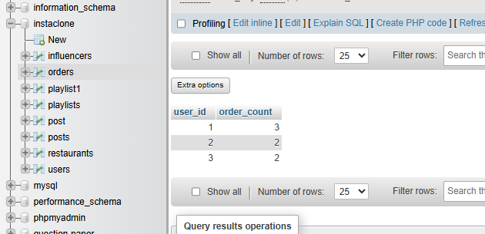

Que 2: Write a SQL query to display the names of restaurants from a 'restaurants' table that have received an average rating above 4.0, using GROUP BY and HAVING.
SELECT name, AVG(rating) AS average_rating
FROM restaurants
GROUP BY name
HAVING AVG(rating) > 4.0;
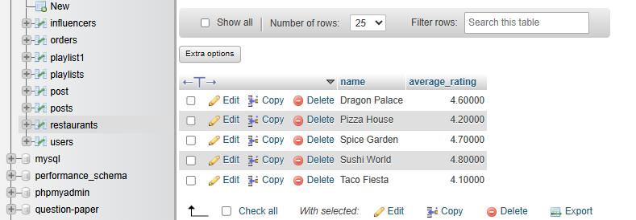
Que 3:
Suppose you have a 'payments' table with columns user_id, amount, and payment_date. Write a subquery to find user_ids who have made a single payment above ₹2000 in any transaction.
CREATE TABLE payments (
payment_id INT PRIMARY KEY AUTO_INCREMENT,
user_id INT,
amount DECIMAL(10,2),
payment_date DATE
);

INSERT INTO payments (user_id, amount, payment_date)
VALUES
(1, 1500, '2026-10-01'),
(1, 2500, '2026-10-02'),
(2, 1800, '2026-10-03'),
(3, 3000, '2026-10-04'),
(4, 500, '2026-10-05');

SELECT user_id
FROM payments
WHERE user_id IN (
SELECT user_id
FROM payments
WHERE amount > 2000
);

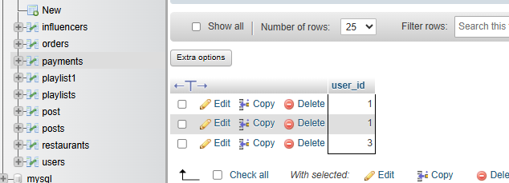
Que 4: Using a nested subquery, display the names of movies from a 'movies' table that have a higher average rating than the overall average rating of all movies.<br><br><em><strong>Hint:</strong> Use a subquery to calculate the overall average rating, then compare each movie's average rating against it in the main query.</em>
CREATE TABLE movies (
movie_id INT PRIMARY KEY AUTO_INCREMENT,
movie_name VARCHAR(100),
rating DECIMAL(3,1)
);

INSERT INTO movies (movie_name, rating)
VALUES
('Movie A', 8.5),
('Movie B', 6.0),
('Movie C', 9.0),
('Movie D', 7.0),
('Movie E', 8.0);

SELECT movie_name
FROM movies
WHERE rating > (
SELECT AVG(rating)
FROM movies
);


