Que 1: Create a table called Restaurant with columns: id, name, location, and cuisine. Apply NOT NULL constraint to name and location, and make id the PRIMARY KEY.
CREATE TABLE Restaurant2 (
id INT PRIMARY KEY,
name VARCHAR(100) NOT NULL,
location VARCHAR(100) NOT NULL,
cuisine VARCHAR(50)
);
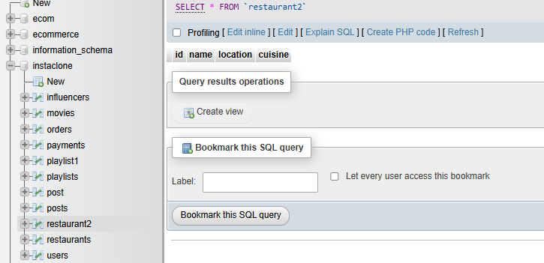

Que 2: Create a table called FoodOrder with columns: order_id, restaurant_id, user_id, and order_total. Set order_id as PRIMARY KEY, and add a FOREIGN KEY constraint on restaurant_id referencing Restaurant(id).

CREATE TABLE FoodOrder (
order_id INT PRIMARY KEY,
restaurant_id INT,
user_id INT,
order_total DECIMAL(10,2),
FOREIGN KEY (restaurant_id) REFERENCES restaurants(id)
);
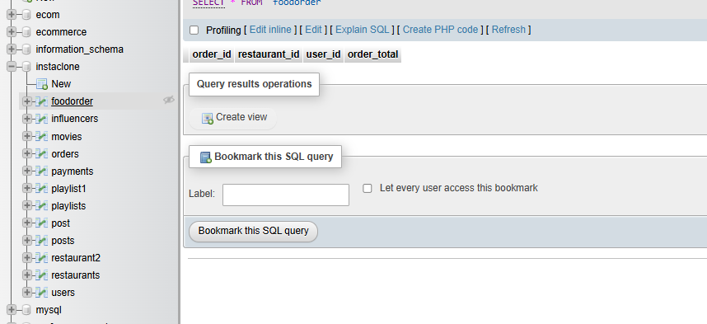

Que 3:
Insert 6 rows into a table called SpotifyUser with columns: user_id, username, email, and subscription_type. Ensure that username is UNIQUE and email is NOT NULL.<br><br><em><strong>Hint:</strong> Use the UNIQUE and NOT NULL constraints when creating the table.</em>

CREATE TABLE SpotifyUser (
user_id INT PRIMARY KEY,
username VARCHAR(100) UNIQUE,
email VARCHAR(100) NOT NULL,
subscription_type VARCHAR(50)
);
INSERT INTO SpotifyUser
(user_id, username, email, subscription_type)
VALUES
(1, 'diya_music', 'diya@gmail.com', 'Premium'),
(2, 'nisarg_beats', 'nisarg@gmail.com', 'Free'),
(3, 'priya_songs', 'priya@gmail.com', 'Premium'),
(4, 'rahul_music', 'rahul@gmail.com', 'Free'),
(5, 'neha_tunes', 'neha@gmail.com', 'Student'),
(6, 'jay_playlist', 'jay@gmail.com', 'Premium');

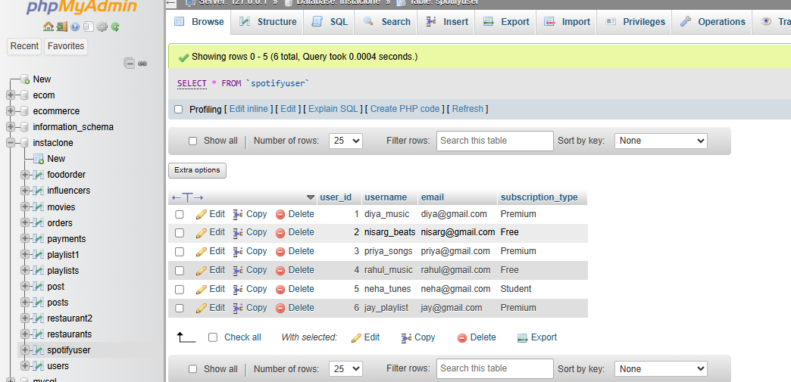

Que 4 : Create a VIEW named TopSpendersView that shows usernames and order_total from a FoodOrder table where order_total is greater than 1000.

CREATE VIEW TopSpendersView AS
SELECT SpotifyUser.username, FoodOrder.order_total
FROM FoodOrder
INNER JOIN SpotifyUser
ON FoodOrder.user_id = SpotifyUser.user_id
WHERE FoodOrder.order_total > 1000;
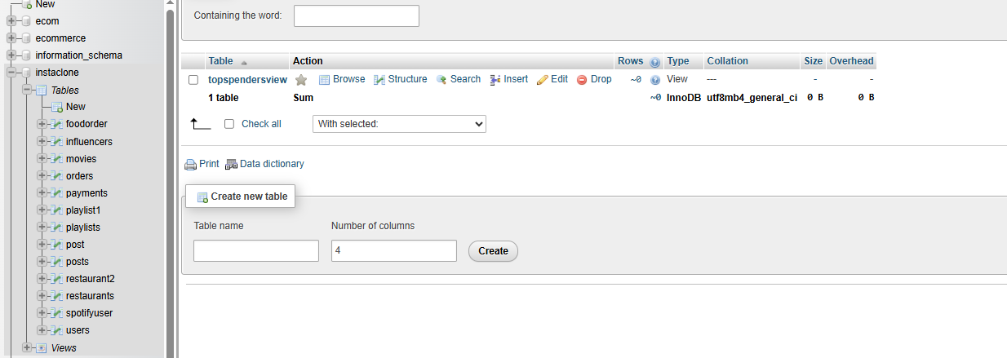

Que 5 :
Write a SQL query to list all users from the TopSpendersView who have spent more than 2000, sorted by order_total descending.<br><br><em><strong>Constraint:</strong> Only use the TopSpendersView for your query, not the original FoodOrder table.</em>

SELECT username, order_total
FROM TopSpendersView
WHERE order_total > 2000
ORDER BY order_total DESC;
