Que1 :
Write a PL/SQL block that declares two variables: one for a user's name (VARCHAR2) and one for their age (NUMBER). Assign values and print both using DBMS_OUTPUT.PUT_LINE.

Ans:
DECLARE
message varchar2(100):= 'Hello, World!';
name varchar2(100):='Diya Patel';
age int :=25;
BEGIN
dbms_output.put_line(name);
dbms_output.put_line(age);

END;
/

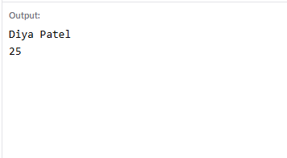

2.
Create a PL/SQL block that uses an IF statement to check if a given order amount is above 500. If yes, print 'Eligible for free delivery', else print 'Delivery charges apply'.

Ans:
DECLARE
amount float:=3500;
BEGIN

if amount>500 then
dbms_output.put_line('eligible');
else
dbms_output.put_line('not eligible');
end if;
END;
/

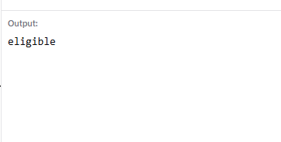

Que 3 : Write a PL/SQL block that uses a simple LOOP to print the numbers 1 to 5 using DBMS_OUTPUT.PUT_LINE.<br><br><em><strong>Hint:</strong> Use a counter variable and EXIT WHEN condition inside the loop.</em>

SET SERVEROUTPUT ON;

DECLARE
i NUMBER := 1;
BEGIN
LOOP
DBMS_OUTPUT.PUT_LINE(i);
i := i + 1;

EXIT WHEN i > 5;
END LOOP;
END;
/

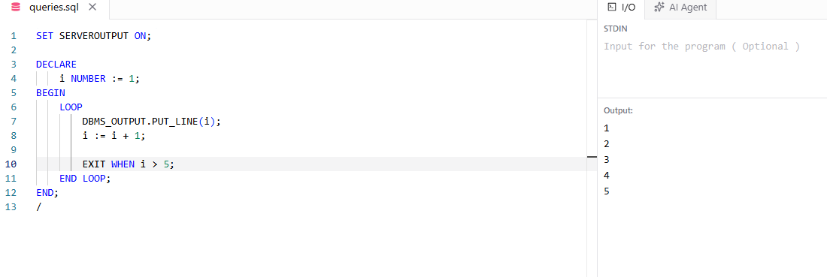

Que 4 :
Declare a cursor in PL/SQL to select all product names from a table called PRODUCTS. Fetch each product name and print it using DBMS_OUTPUT.PUT_LINE.<br><br><em><strong>Hint:</strong> Assume the PRODUCTS table has a column PRODUCT_NAME.</em>
DELIMITER //

CREATE PROCEDURE getPnameByRow()
BEGIN
DECLARE cpid INT;
DECLARE cname VARCHAR(100);
DECLARE done INT DEFAULT 0;

DECLARE productcursor CURSOR FOR
SELECT pid, pname FROM product;

DECLARE CONTINUE HANDLER FOR NOT FOUND
SET done = 1;

OPEN productcursor;

ploop: LOOP
FETCH productcursor INTO cpid, cname;

IF done = 1 THEN
LEAVE ploop;
END IF;

SELECT cpid AS Product_ID, cname AS Product_Name;

END LOOP;

CLOSE productcursor;
END //

DELIMITER ;

