ASSIGNMENT -1 (FUNDAMENTALS)

**1. What is testing?**

* In simple word, testing is the process.
* Testing is the process of evaluating a system or its component(s) with the intent to find that whether satisfied the specified requirement or not.
* Software testing is a process to identify correctness, completeness, and quality of developed computer software.
* This activity results in the actual, expected and difference between their results.

**2. What is SDLC?**

* SDLC is a structure imposed on the development of a software product that means the process for planning, implementation, documentation, testing, maintenance, support and deployment.
* There are number of different development models.
* A Software Development Life Cycle is essential a series of steps or phases, that provide a model for development and life cycle management of an application or piece of software.

**3. Write SDLC phases with basic introduction?**

* There are six phases in SDLC.

1. **Requirement gathering;**

* Features
* Usage scenarios
* Plan for change
* Build constant feedback into the project.
* User and Business needs change during the project.
* **There are three problems arises;**

1. Lack of clarity: It is hard to identify all languages.
2. Requirement confusion: Functional and Non Functional requirements both are available so it is confusion which method are used.
3. Requirement amalgamation: several different requirements may be expressed together**.**
4. **Analysis phase;**

* The analysis phase means the requirement of the system, independent of how these requirements will be accomplished.
* This phase starts with the requirement document delivered by the requirement phase and maps the requirement into architecture.
* It is represent the “what” phase.

1. **Design phase**

* Critical priority analysis
* Implementation plan
* The architecture team also converts the typical scenario to test plan.
* This requirement document must guide this decision process.

1. **Implementation phase;**

* Critical error removal
* The implementation phase deals with issues of quality, libraries, performance, baselines and debugging.
* This phase is the construct a solution of software.

1. **Testing phase;**

* Simply tested quality level is very important. Many companies have not learned that quality is important and deliver more claimed functionality but at a lower quality level. So, In this phase is testing the software quality level and easily to explain missing features.
* Updating all analysis, design, and user documentation.

1. **Maintenance phase;**

* It is the process of changing a system after it has been deployed.

1. **Corrective maintenance:** Identifying and repairing defects.
2. **Adaptive maintenance:** Adapting the existing solution to the new platforms.
3. **Perfective maintenance:** Improve the quality level and remove the defect.

**4. Write SDLC phases with basic introduction?**

* There are three parts of phases,(1) Verification phase, (2)Code phase, (3)Validation phase

1. **Verification phase;**
2. **Business Requirement:** This is the first phase in the development cycle where the product owner and developer are Understand from the customer requirement. This phase involves detailed communication with the customer to understand his expectations and exact requirement. Furthermore, the acceptance test design planning is done in this phase.
3. **System Requirement:** once you have clear and detailed requirement and it’s time to design the complete system. System design are understand and detailing computer hardware. System test plan is developed based on the system design.
4. **Technical Specification:** Usually more than one technical approach is based on the technical and financial feasibility the final decision is taken. System design is broken down into further modules and taking up different functionality. This is also known by High Level Design. Technical designer is plan the integration testing.
5. **Program specification:** In this phase understand and detailed internal design for all the system modules is specified. This is also called by Low Level Design.It is important to design other architecture model and other external systems. It is plan done for first step of validation phase.
6. **Code phase:** The best programming language is decided based on the system and architectural requirement. The coding is worked coding guideline and standards. It is optimized for best performance before the final build is checked into the stored.
7. **Validation phase;**
8. **Unit testing:** Unit test are executed on the code during this validation phases. Unit testing is the testing at code level and help to remove bugs in early stage however all defects cannot be uncovered by unit testing.
9. **Integration testing:** This testing id associated with technical specification. Integration test are performed by coexistence and communication of internal modules within the system**.**
10. **System testing:** It is associated directly system design phase. System test check the all functions and communication of the system under development with external systems.
11. **Acceptance testing:** Acceptance testing is associated with the business requirement analysis phase and involves testing the product in user environment. It also discovers the non-functional issues such as load and performance defect in the actual user environment and test uncover the compatibility issues**.**

**5. Write agile manifesto principal?**

* There are four agile manifesto,(1) Individual interaction

(2) Working software

(3) Responding to change

(4) Customer collaboration

**6. What is agile methodology?**

* Agile SDLC model is a combination of iterative and incremental process models with focus on process adaptability and customer satisfaction by rapid delivery of working software product.
* These builds are provided in iterations.
* Agile Methods break the product into small incremental builds.

**7. Write phases of spiral model?**

* **There are four phases in spiral model;**

1. **Planning Phase:** Determination of objectives, alternatives and constraints.
2. **Risk Analysis:** Analysis of alternativesand identification /resolution of risks.
3. **Engineering:** Development of the ‘next level product.’
4. **Customer Evaluation:** Assessment of the results of engineering.

**8. Explain working methodology of agile model and also write pros and cons?**

* **PROS :**
* Is a very realistic approach to software development.
* Promotes team work and cross training.
* Functionality can be developed rapidly and demonstrated.
* Little and no planning needed easy to manage gives flexibility and developers.
* Resource requirement are minimum.
* Suitable for fixed or changing requirement.
* **CONS:**
* Not suitable for handling complex dependencies.
* More risk of sustainability, maintainability, extensibility.
* Depends heavily on customer interaction, so if customer is not clear, team can be driven in the wrong direction.
* An overall plan, an agile leader and agile PM practice is a must without which it will not work.
* It is new team member are challenging due to lack of documentation use case.

**9. What is SRS?**

* A software requirement specification is a complete detail of the behavior for system to be developed.
* It includes a set of use cases that all of the all detailed interactions that the users will have with the software.
* There are three types of Requirement,(1)Customer Requirement

(2)Functional Requirement

(3)Non-Functional Requirement

**10. What is OOPS?**

* OOPS full name is object-oriented programming system.
* OOPS means identifying objects and assigning responsibilities to these objects.
* An object is a just like black boxes.
* The internal details are hidden.

**11. Write basic concepts of OOPS?**

* There are six basic concepts of OOPS:(1)Object

(2)Class

(3)Encapsulation

(4)Inheritance

(5)Polymorphism

(6)Abstraction

**12. What is object?**

* Object is an instance of a particular class.
* An object has the responsibility to know and the responsibility to do.
* This is a basic unit of object oriented programming.

**13. What is class?**

* Class means collection of data member and member function with its behavior.
* Example: Fan is a data member but the user turn on switch then fan is running. So this is a called member function.

**14. What is Encapsulation?**

* Encapsulation is a wrapping up of data into single unit i.e. data hiding in a small level.
* Encapsulate in plain English means to enclose or be enclosed in or as if in a capsule. In java, a class is the capsule (or unit).

**15. What is Inheritance?**

* Inheritance means Properties of parent class extends into child class.
* It is a main purpose of reusability, extensibility.
* There are five types:(1)Single: <child>

(2)Multi level: <parent to child>

(3)Hierarchical: <grandfather to parent then parent to child>

(4)Multiple: java does not support directly.

(5)Hybrid: java does not support directly**.**

**16. What is polymorphism?**

* It is an ability to take one name having many forms.
* There two types of polymorphism:(1) Method of overloading [compile time]

(2)Method of overriding [run time]

**17. Draw use case on online shopping product using payment gateway.**

* 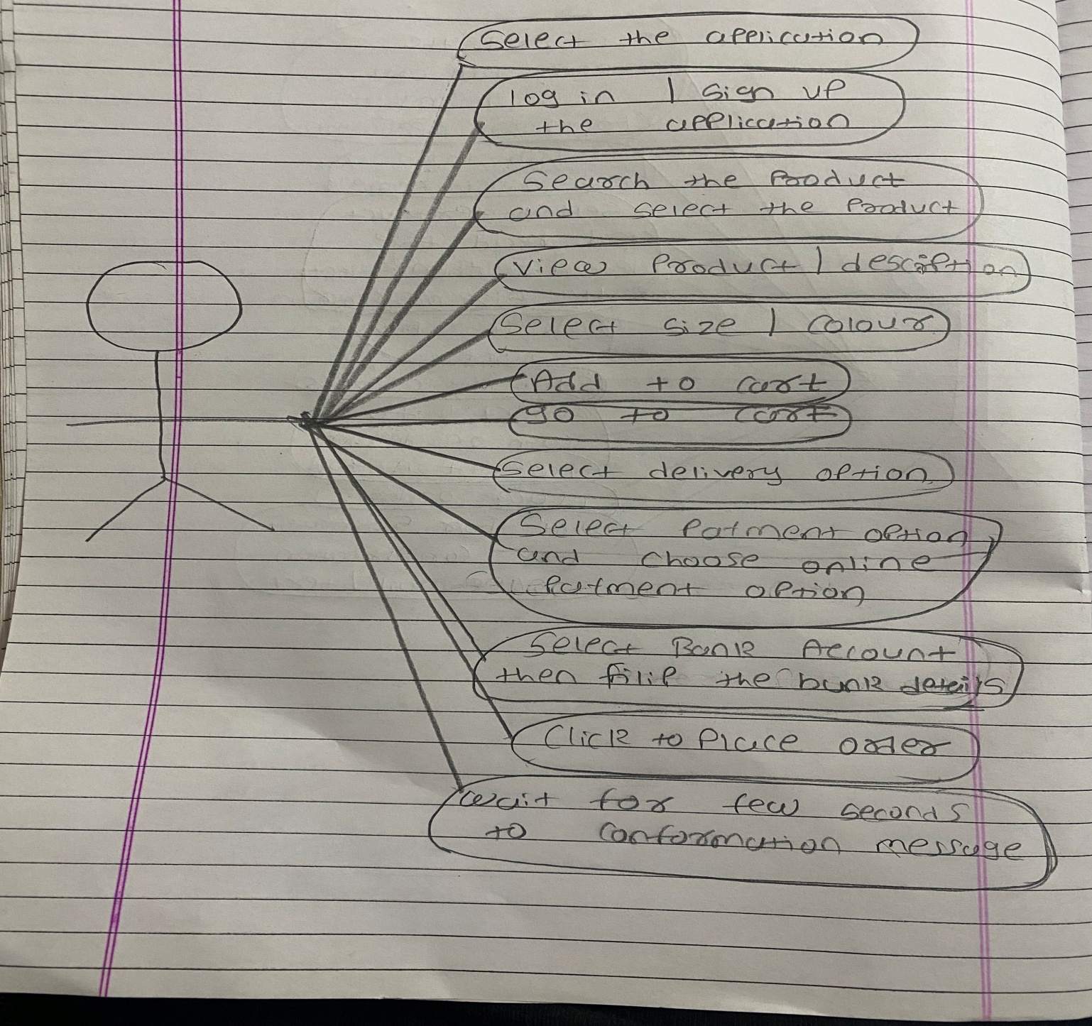

**18. Draw use case on online book shopping.**

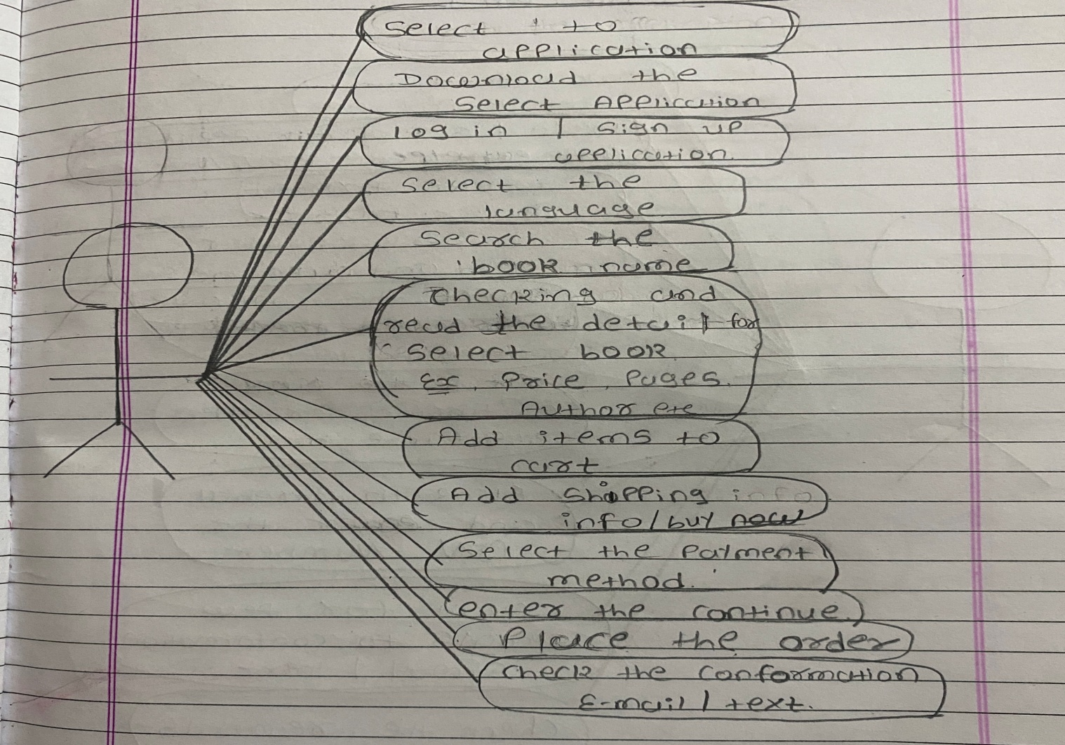

**19. Draw use case on online bill payment system. [Goggle pay]**

* 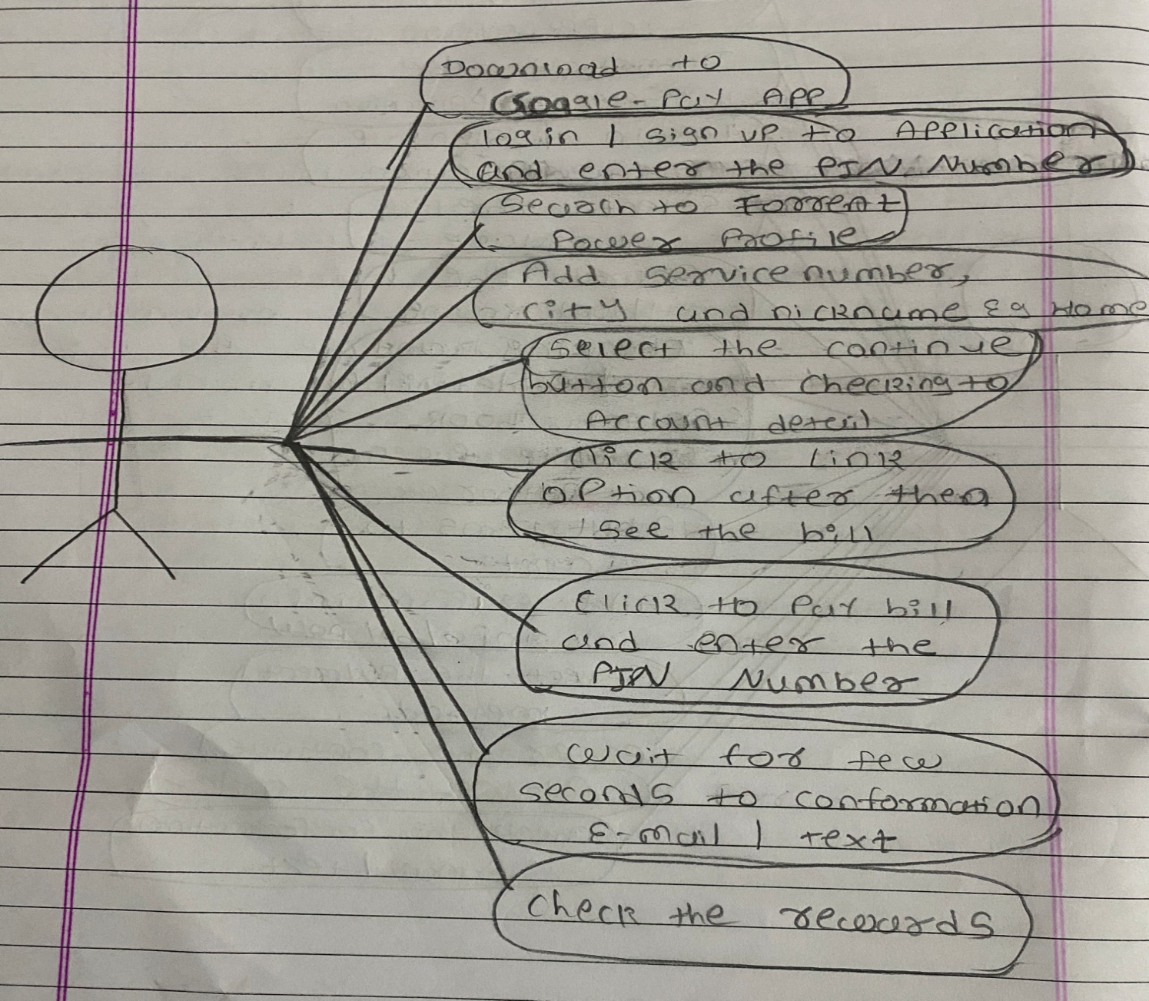

**20. Draw use case on online shopping product using cash on delivery.**

* 