SIT323/SIT737- Cloud Native Application Development

5.1P: Containerisation of a simple web application using Docker

GitHub Link:

1. Install Docker

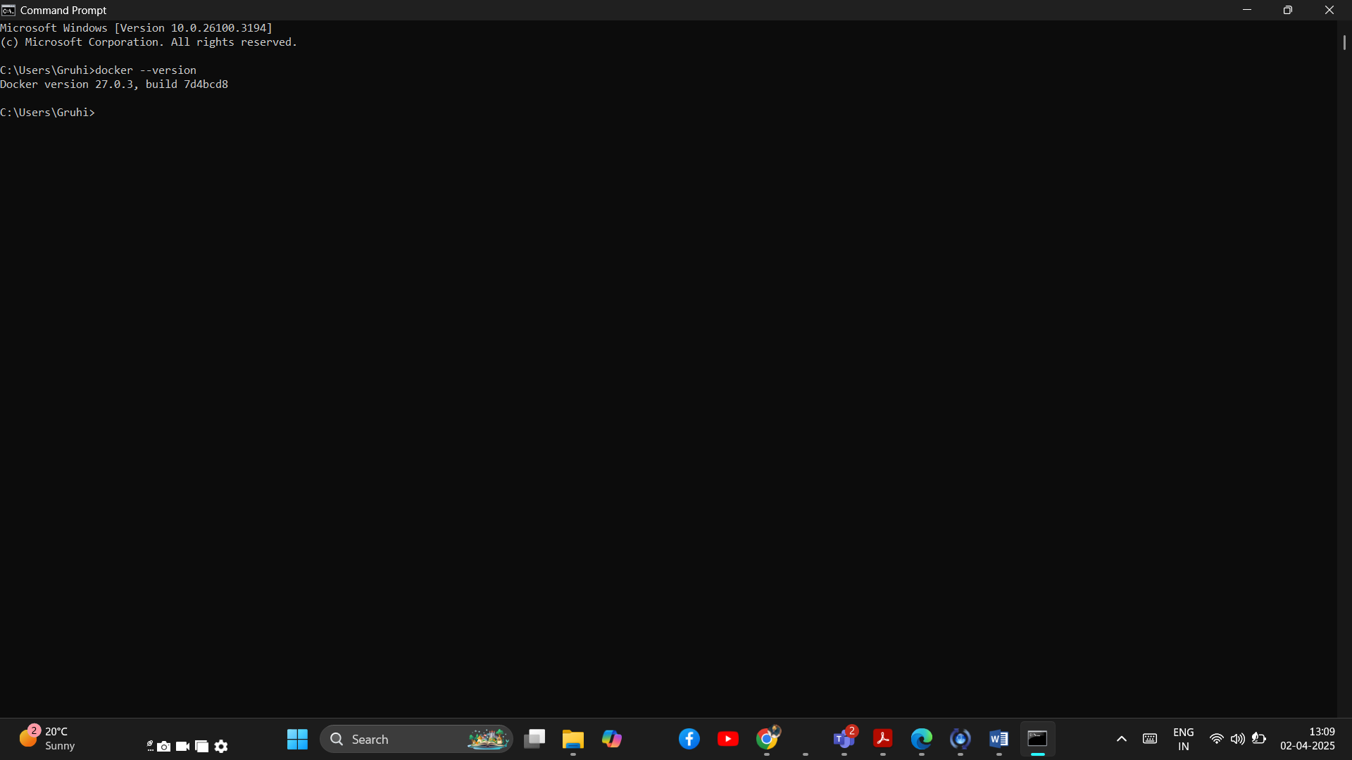

2. Clone the sample web application.

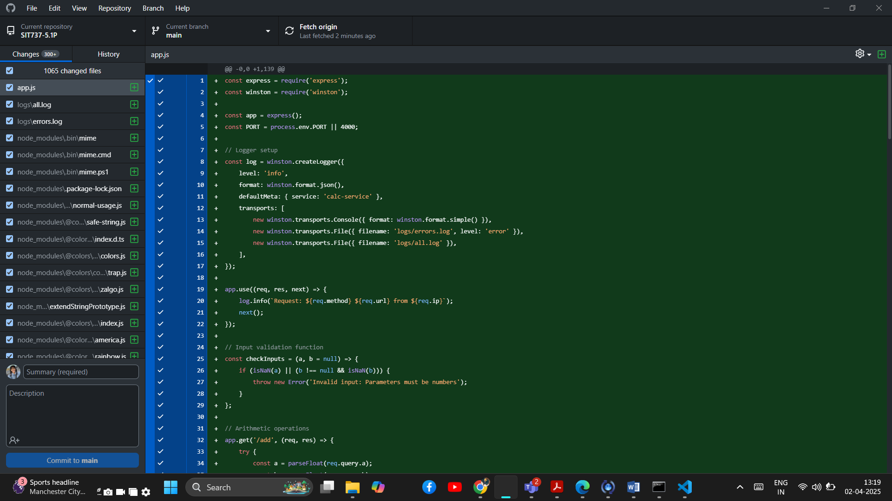

3. Create a Dockerfile

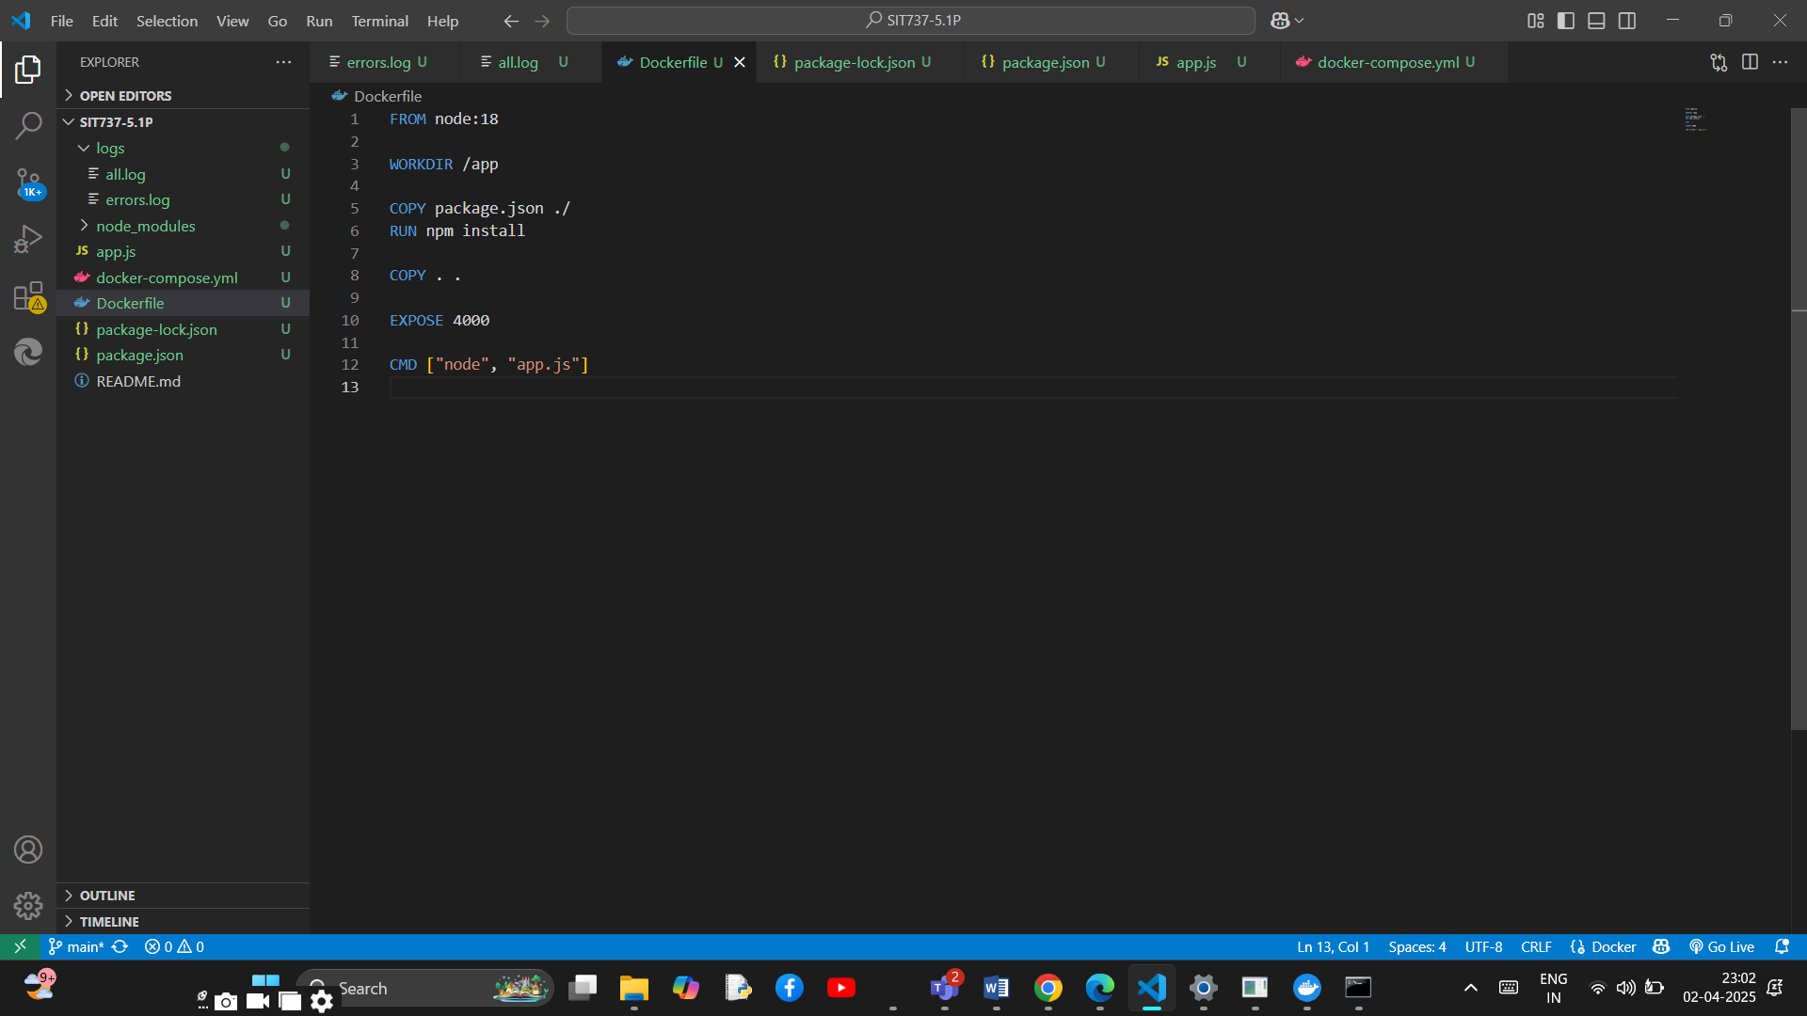

4. Build the Docker image

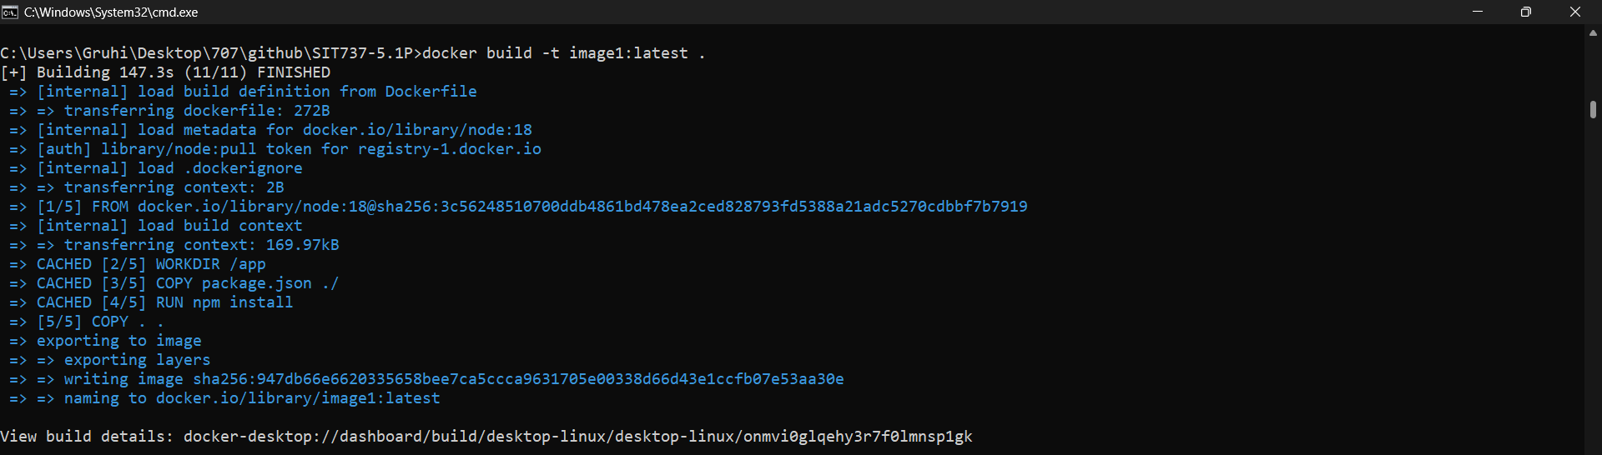

5. Create a Docker Compose file

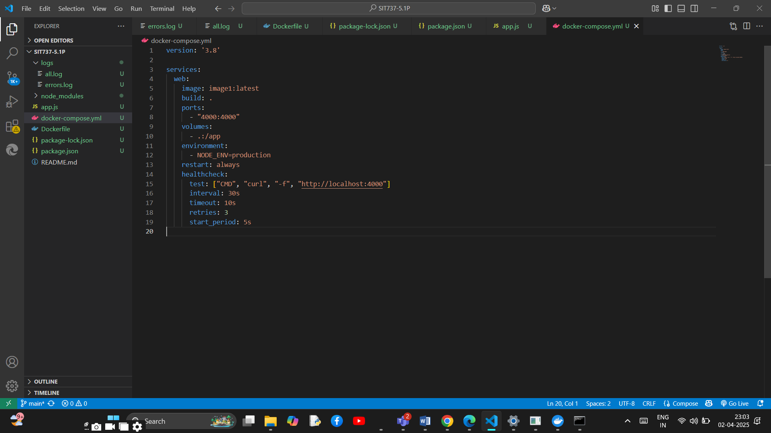

6. Start the Docker Compose environment

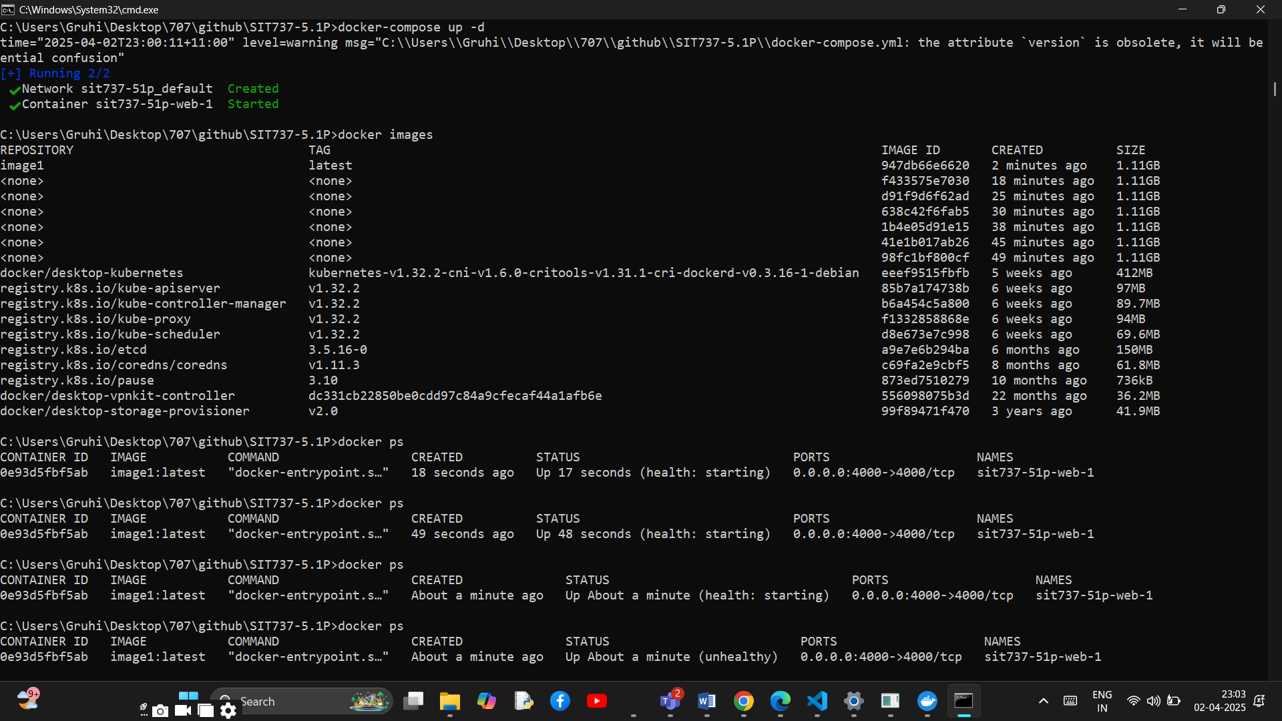

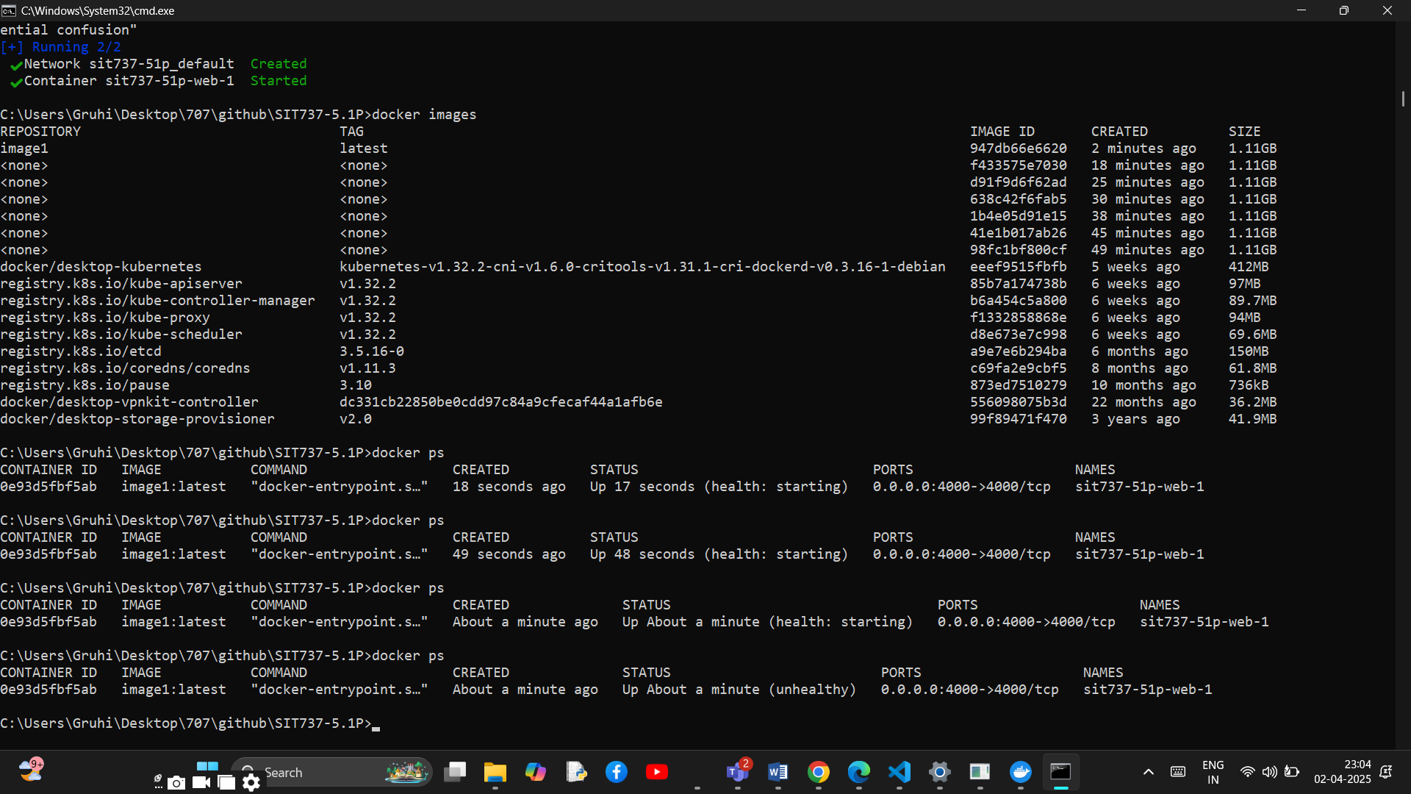

7. Test the application

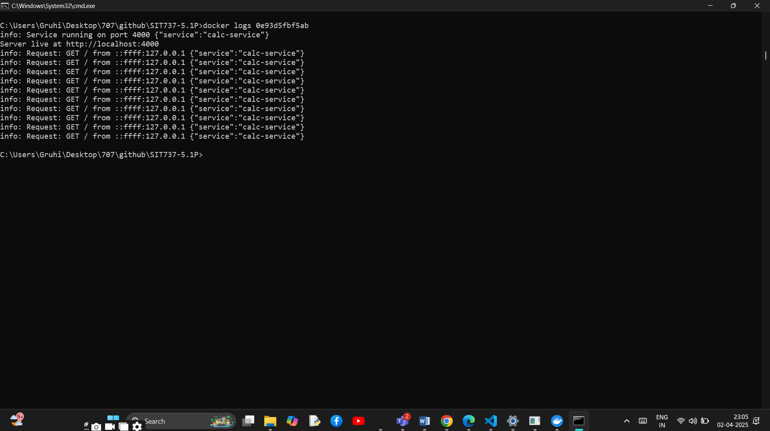

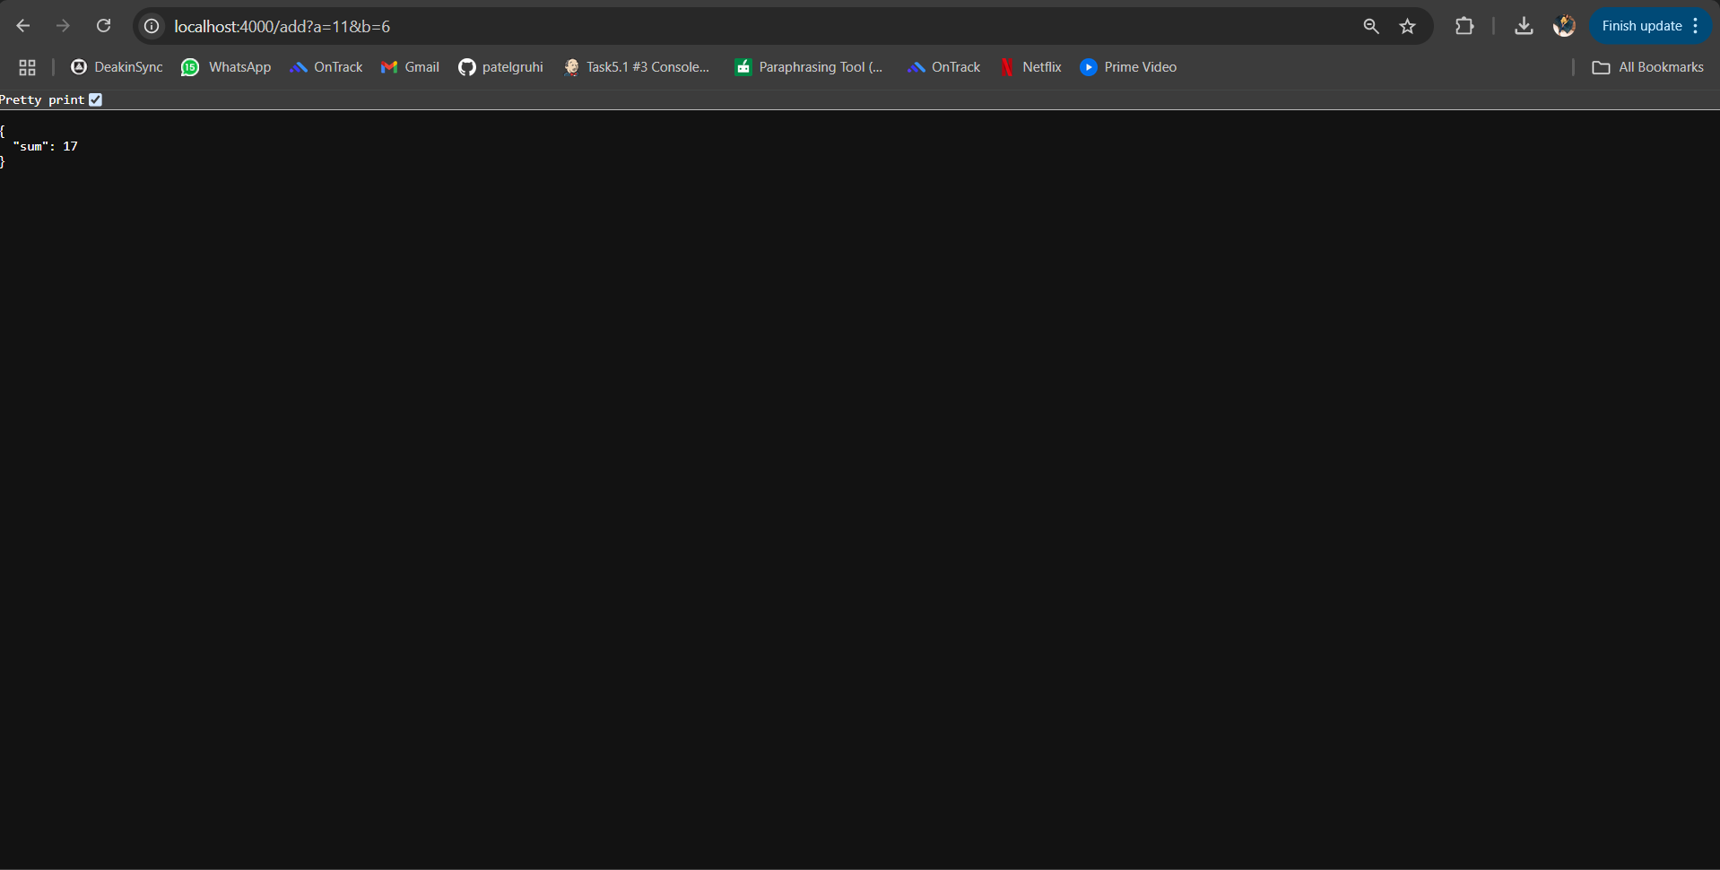

8. Push the Docker image to a registry

