### Solving analytical queries on Redshift Cluster

Here, you have to write the query used for solving the question and the screenshots of the table which is outputted after the query is run on the AWS Redshift Query editor UI.

1. **Top 10 ATMs where most transactions are in the ’inactive’ state**

<Query>

SELECT

a.atm_number,

a.atm_manufacturer,

l.location,

count(f.trans_id) as total_transaction_count,

SUM(CASE WHEN f.atm_status = 'Inactive'

THEN 1

ELSE 0

END) as inactive_count,

(inactive_count/total_transaction_count)*100 as inactive_count_percent

FROM

etl_atm_data.DIM_ATM as a,

etl_atm_data.FACT_ATM_TRANS as f,

etl_atm_data.DIM_LOCATION as l

WHERE

a.atm_id = f.atm_id AND a.atm_location_id = l.location_id

GROUP BY

a.atm_number,

a.atm_manufacturer,

l.location

ORDER BY

inactive_count DESC

LIMIT 10;

<Screenshot of the resultant table>

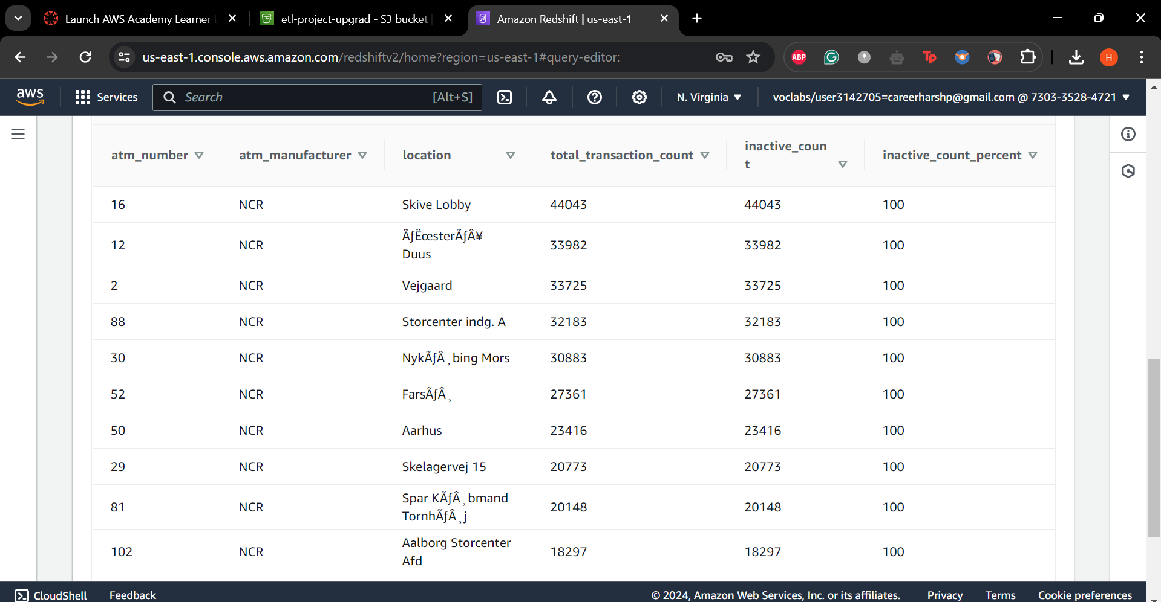

1. **Number of ATM failures corresponding to the different weather conditions recorded at the time of the transactions**

<Query>

WITH failed_atm AS

(SELECT

weather_main,

count(trans_id) as total_transaction_count,

SUM(CASE WHEN atm_status = 'Inactive'

THEN 1

ELSE 0

END) as inactive_count

FROM

etl_atm_data.FACT_ATM_TRANS

WHERE

weather_main != ' '

GROUP BY

weather_main)

SELECT *,

ROUND(CAST(inactive_count AS numeric(10,2))/ total_transaction_count*100,2) AS inactive_count_percent

FROM

failed_atm

ORDER BY

inactive_count_percent DESC;

<Screenshot of the resultant table>

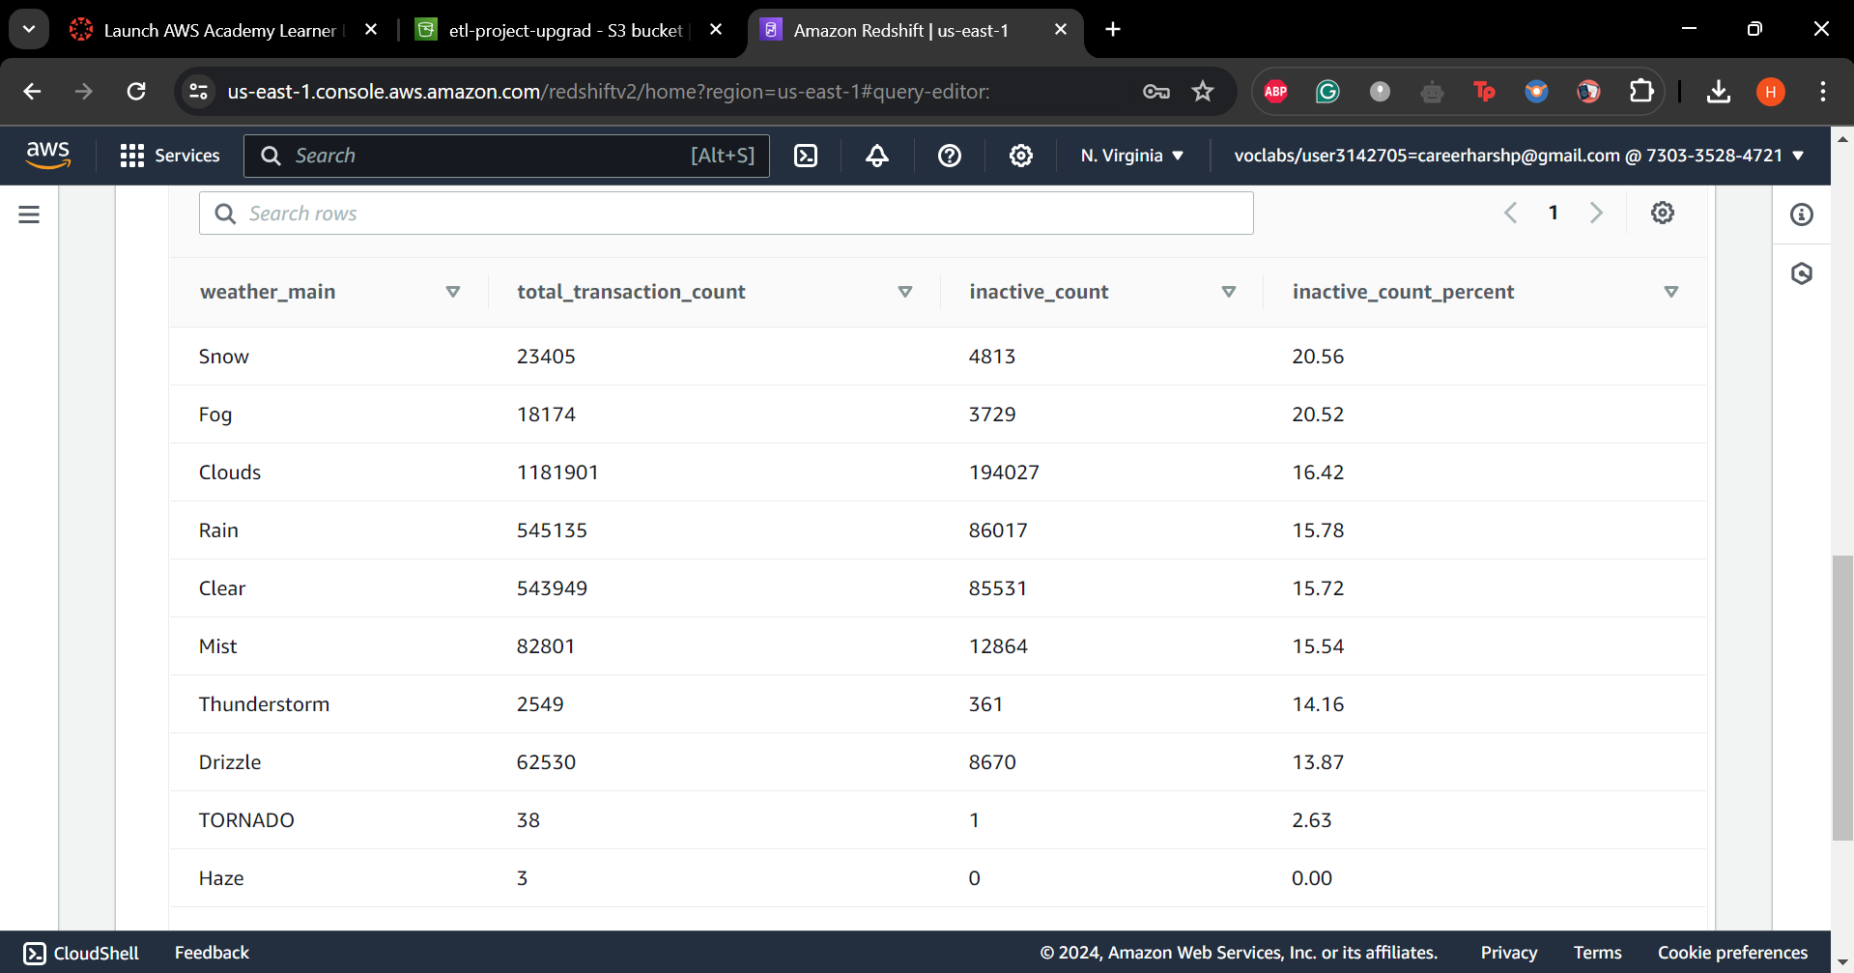

1. **Top 10 ATMs with the most number of transactions throughout the year**

<Query>

SELECT

a.atm_number,

a.atm_manufacturer,

l.location,

count(f.trans_id) as total_transaction_count

FROM

etl_atm_data.DIM_ATM as a,

etl_atm_data.FACT_ATM_TRANS as f,

etl_atm_data.DIM_LOCATION as l

WHERE

a.atm_id = f.atm_id AND a.atm_location_id = l.location_id

GROUP BY

a.atm_number,

a.atm_manufacturer,

l.location

ORDER BY

total_transaction_count DESC

LIMIT 10;

<Screenshot of the resultant table>

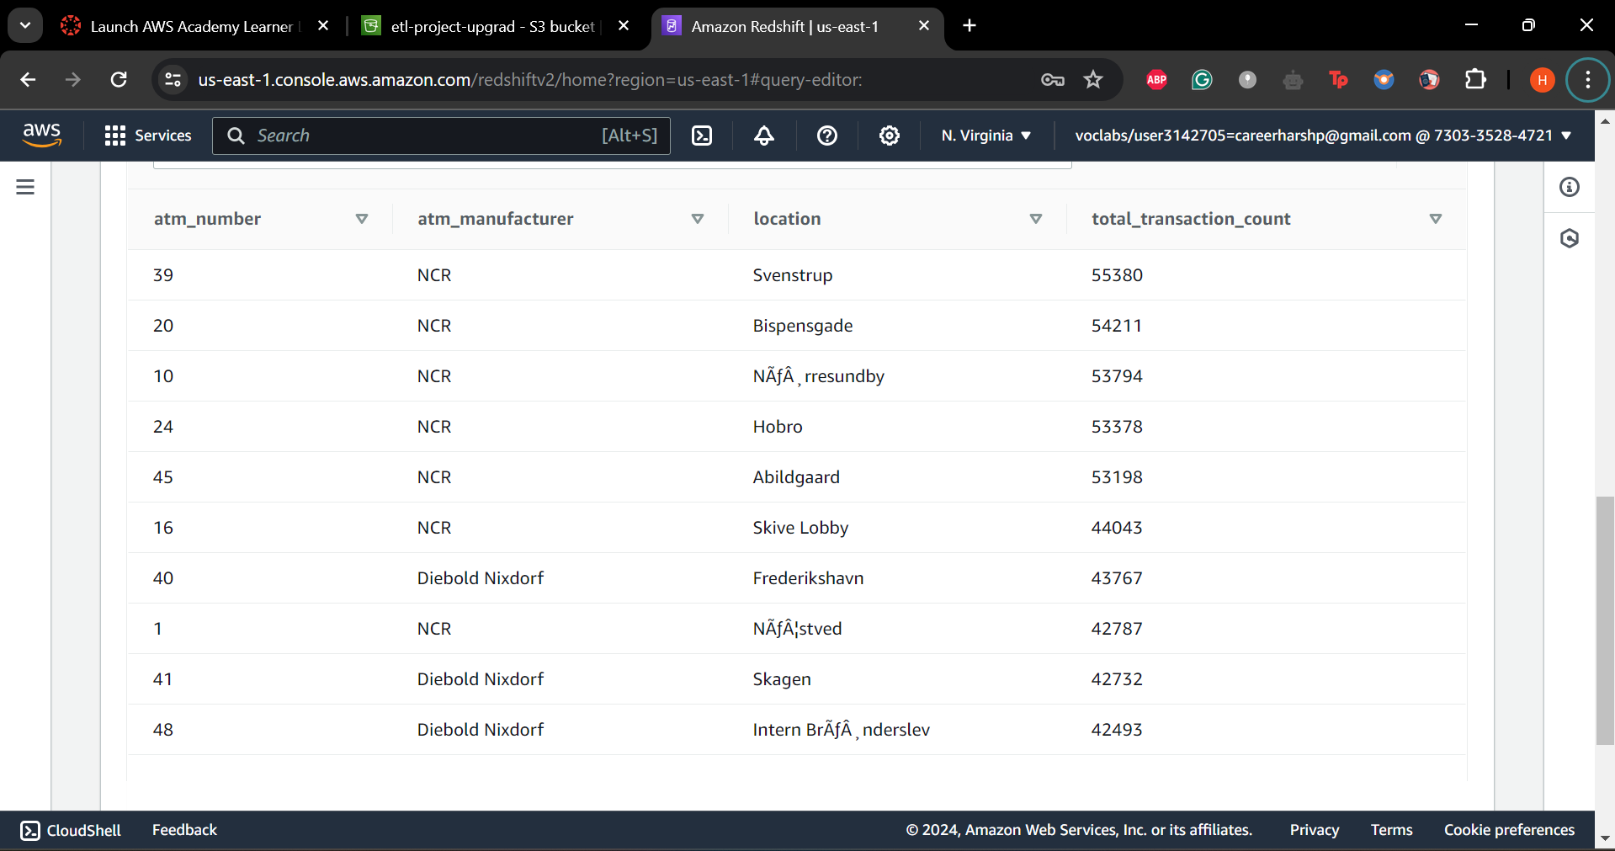

1. **Number of overall ATM transactions going inactive per month for each month**

<Query>

WITH failed_atm_monthly AS (

SELECT

d.year,

d.month,

count(f.trans_id) as total_transaction_count,

SUM(CASE WHEN f.atm_status = 'Inactive'

THEN 1

ELSE 0

END) as inactive_count

FROM

etl_atm_data.FACT_ATM_TRANS as f,

etl_atm_data.DIM_DATE as d

WHERE

f.date_id = d.date_id

GROUP BY

d.year,

d.month)

SELECT *,

ROUND(CAST(inactive_count AS numeric(10,2))/ total_transaction_count*100,2) AS inactive_count_percent

FROM

failed_atm_monthly

ORDER BY

month;

<Screenshot of the resultant table>

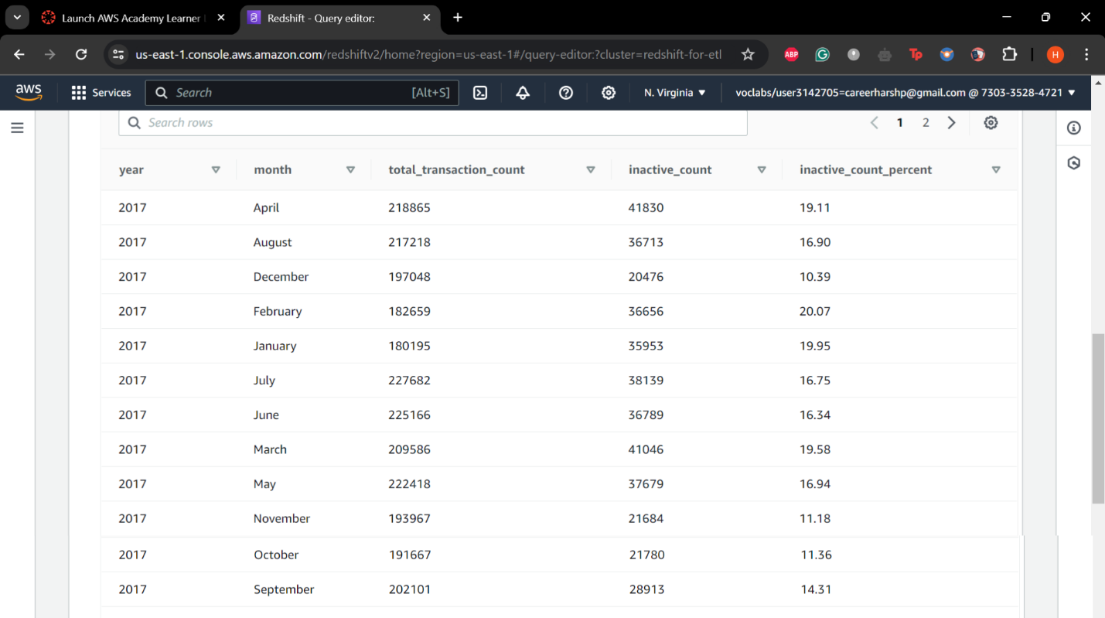

1. **Top 10 ATMs with the highest total withdrawn amount throughout the year**

<Query>

<Screenshot of the resultant table>

1. **Number of failed ATM transactions across various card types**

<Query>

<Screenshot of the resultant table>

1. **Number of transactions happening on an ATM on weekdays and on weekends throughout the year. Order this by the ATM_number, ATM_manufacturer, location, weekend_flag and then total_transaction_count**

<Query>

<Screenshot of the resultant table>

1. **Most active day in each ATMs from location "Vejgaard"**

<Query>

<Screenshot of the resultant table>