### Solving analytical queries on Redshift Cluster

1. **Top 10 ATMs with the highest total amount withdrawn throughout the year**

SELECT

a.atm_number,

a.atm_manufacturer,

l.location,

SUM(f.transaction_amount) as total_amount_withdrawn

FROM

etl_atm_data.DIM_ATM as a,

etl_atm_data.FACT_ATM_TRANS as f,

etl_atm_data.DIM_LOCATION as l

WHERE

a.atm_id = f.atm_id

AND a.atm_location_id = l.location_id

GROUP BY

a.atm_number,

a.atm_manufacturer,

l.location

ORDER BY

total_amount_withdrawn DESC

LIMIT 10;

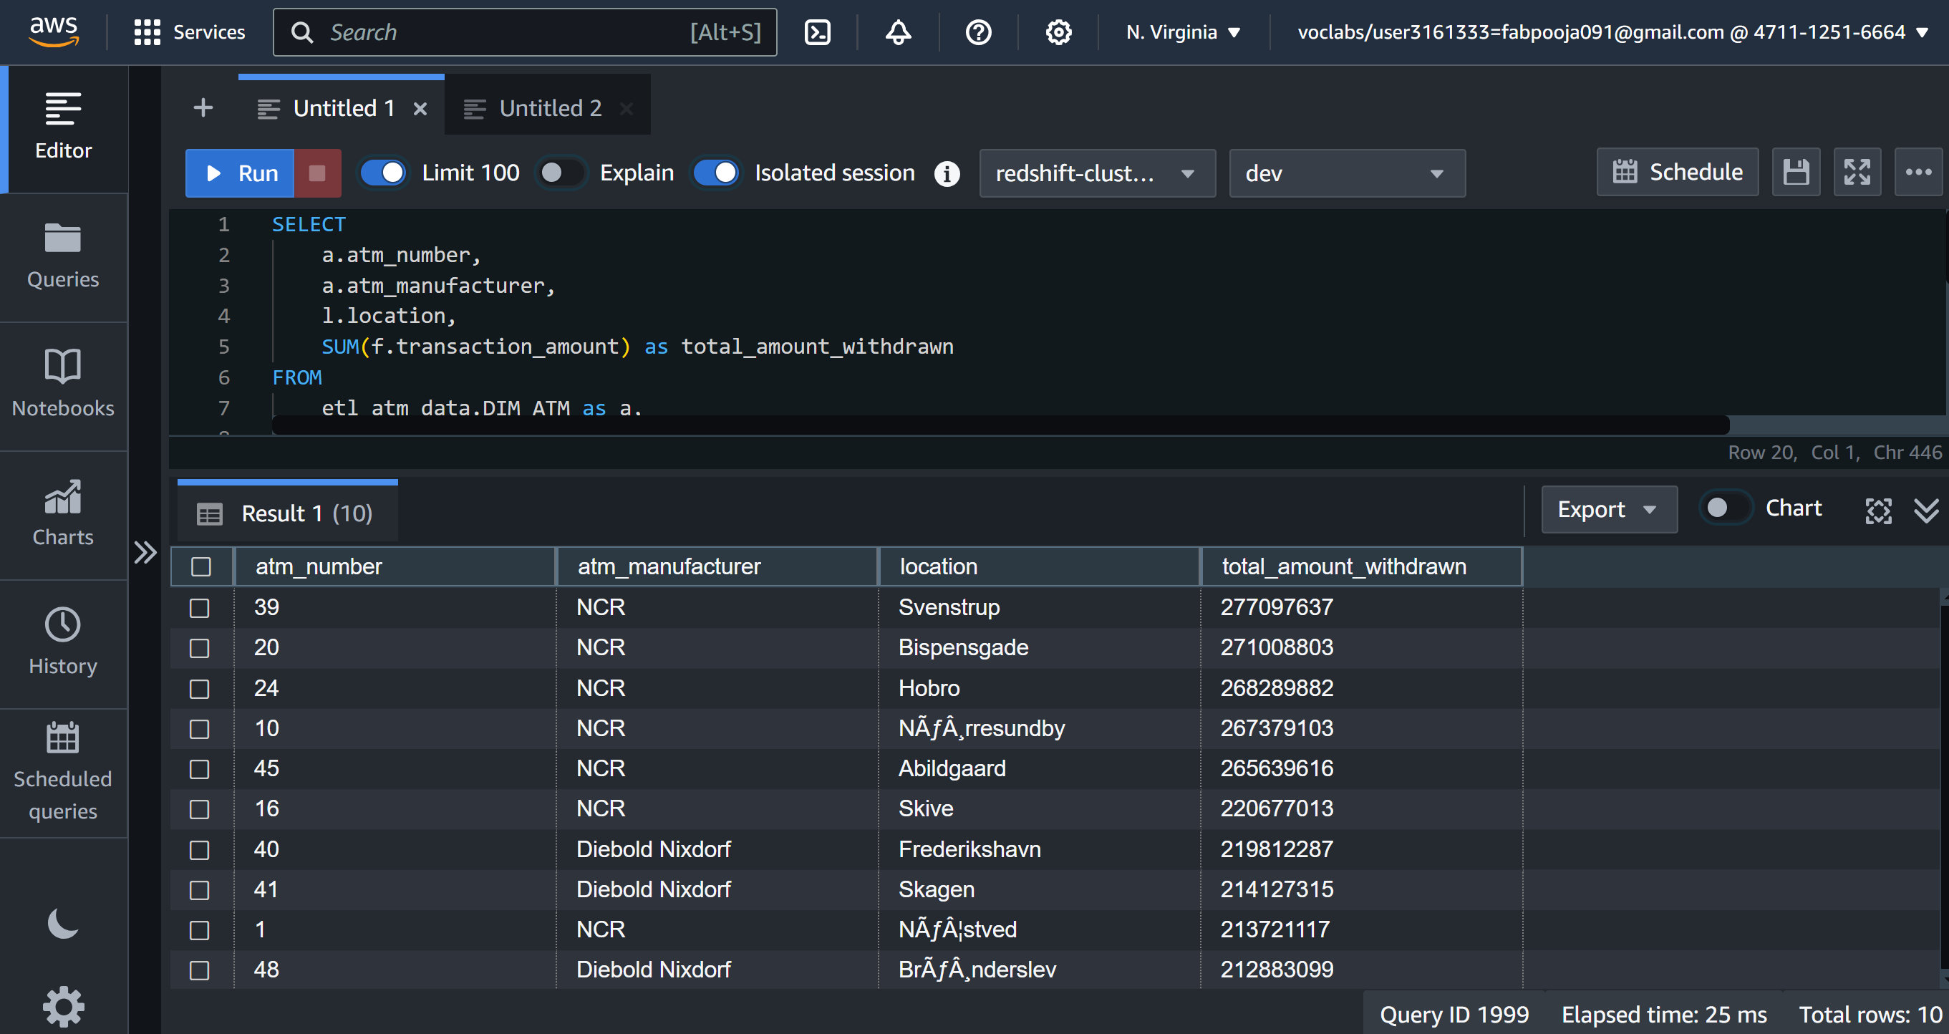

1. **Number of failed ATM transactions across various card types**

Query

SELECT ct.card_type,

COUNT(trans_id) as total_transaction_count,

SUM(case when atm_status = 'Inactive' then 1 else 0 end) as inactive_count

FROM etl_atm_data.fact_atm_trans f, etl_atm_data.dim_card_type ct

WHERE f.card_type_id = ct.card_type_id

GROUP BY ct.card_type;

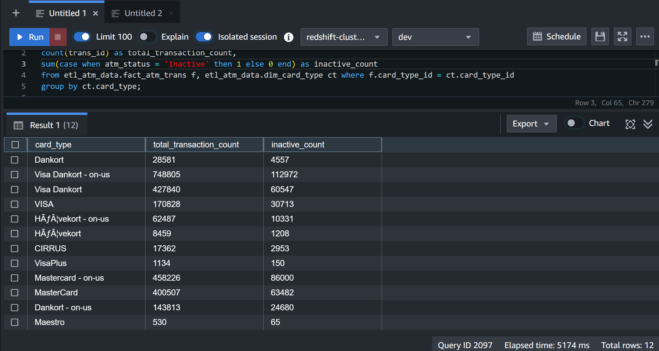

1. **Top 10 records with the number of transactions ordered by the ATM_number, ATM_manufacturer, location, weekend_flag and then total_transaction_count, on weekdays and on weekends throughout the year**

Query

SELECT

a.atm_number,

a.atm_manufacturer,

l.location,

CASE

WHEN d.weekday IN ('Saturday', 'Sunday') THEN 1

ELSE 0

END AS weekend_flag,

COUNT(f.trans_id) AS total_transaction_count

FROM

etl_atm_data.fact_atm_trans f

JOIN

etl_atm_data.dim_atm a ON f.atm_id = a.atm_id

JOIN

etl_atm_data.dim_location l ON a.atm_location_id = l.location_id

JOIN

etl_atm_data.dim_date d ON f.date_id = d.date_id

GROUP BY

a.atm_number,

a.atm_manufacturer,

l.location,

weekend_flag

ORDER BY

a.atm_number,

a.atm_manufacturer,

l.location,

weekend_flag,

total_transaction_count DESC

LIMIT 10;

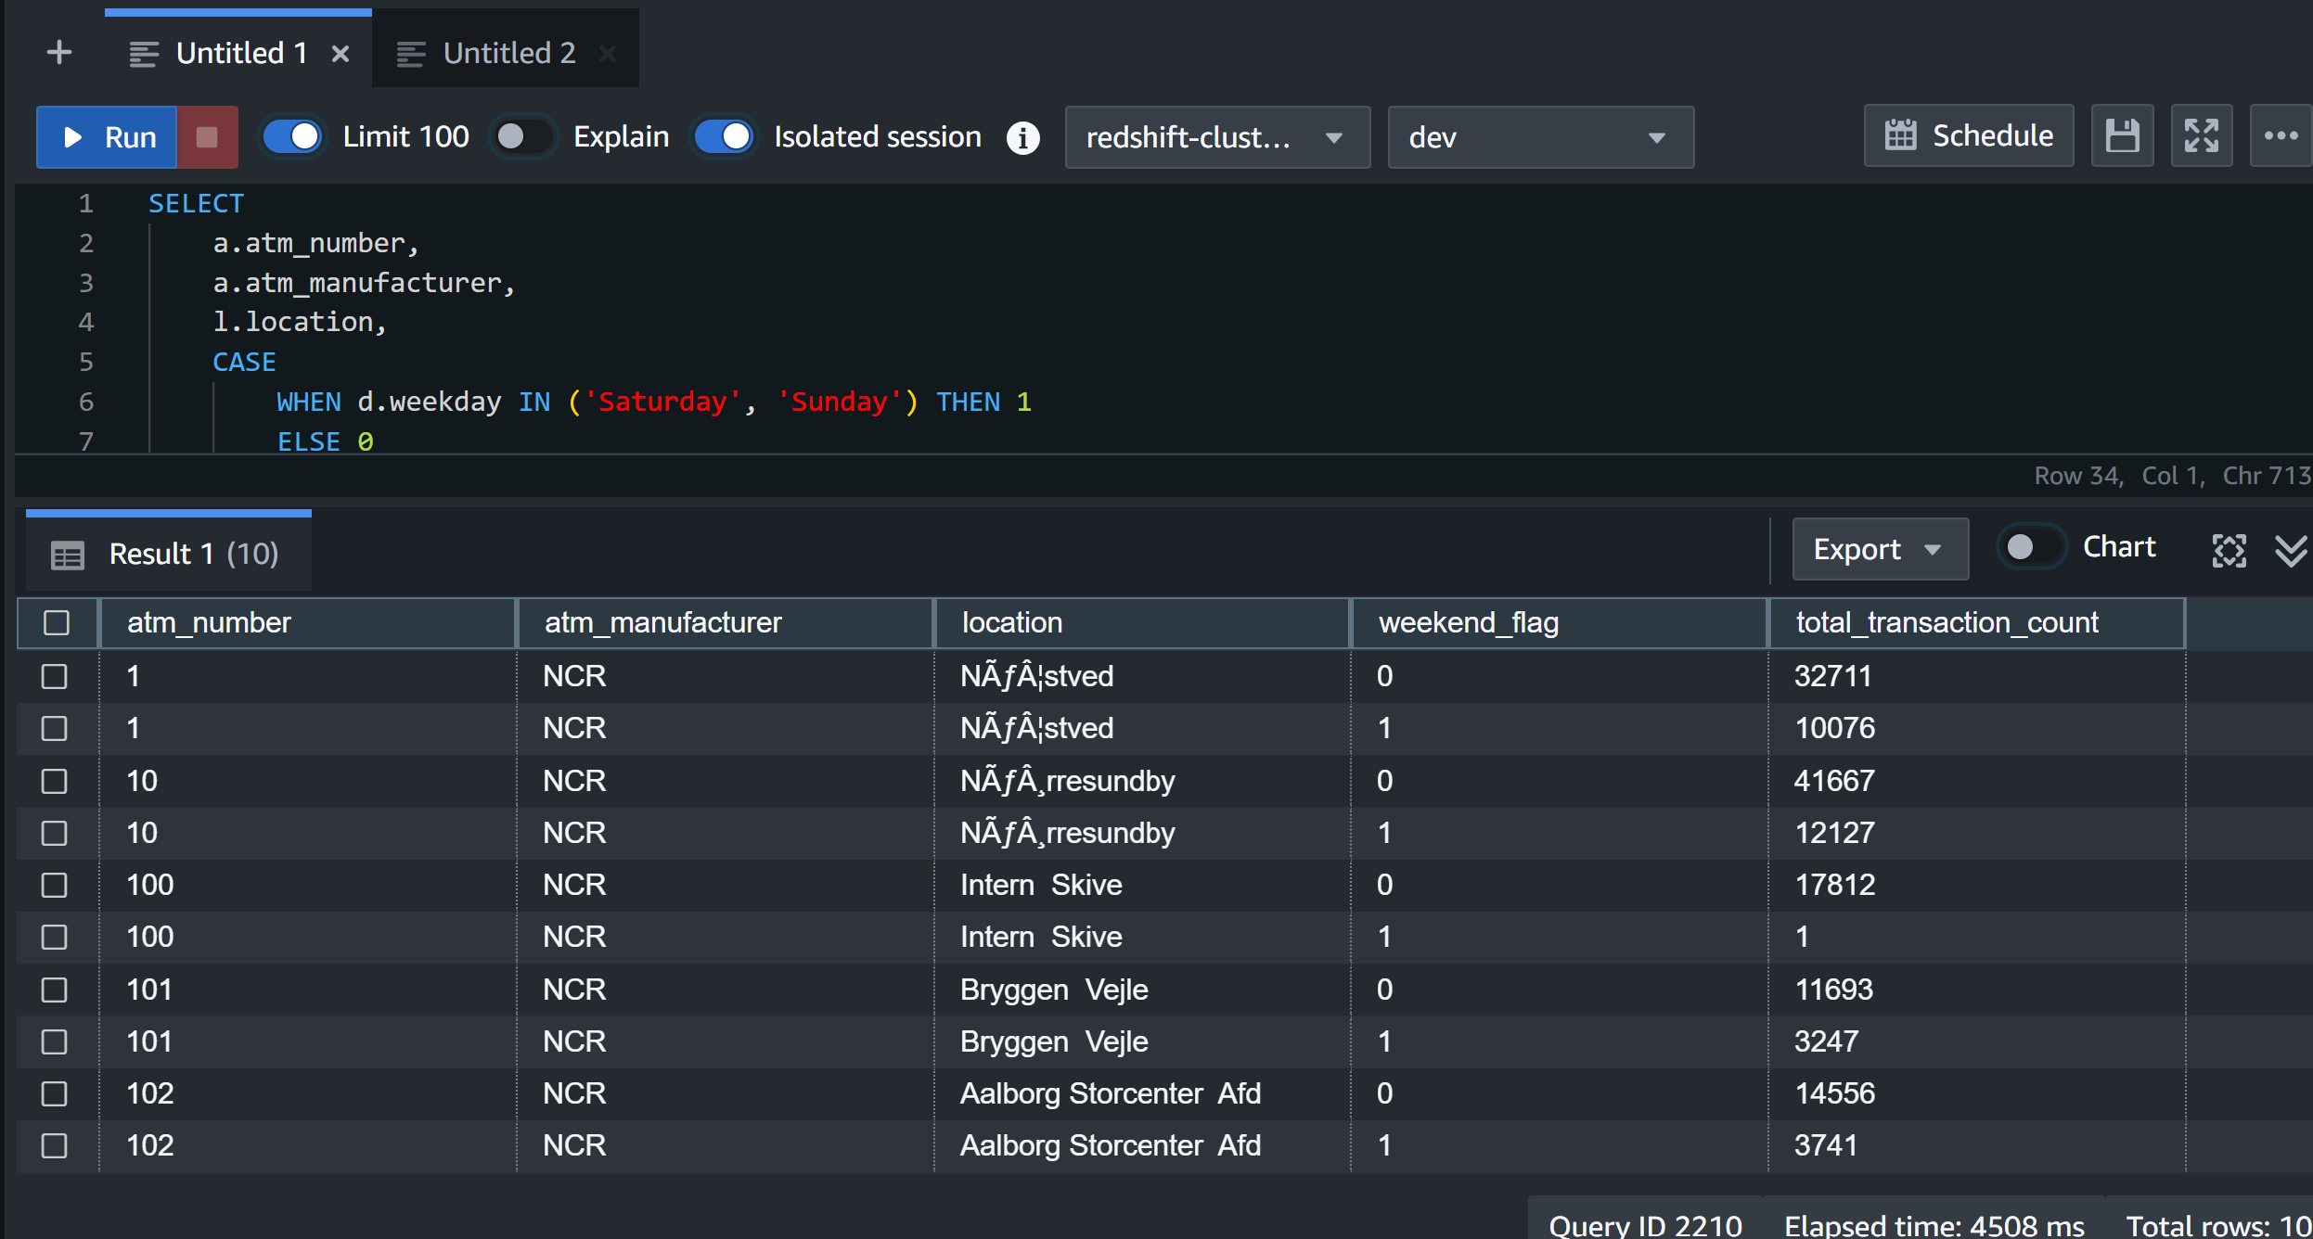

1. **Most active day in each ATMs from location "Vejgaard"**

Query

WITH daily_transactions AS (

SELECT

a.atm_number,

a.atm_manufacturer,

l.location,

d.weekday,

COUNT(f.trans_id) AS transaction_count

FROM

etl_atm_data.fact_atm_trans f

INNER JOIN

etl_atm_data.dim_atm a ON f.atm_id = a.atm_id

INNER JOIN

etl_atm_data.dim_location l ON a.atm_location_id = l.location_id

INNER JOIN

etl_atm_data.dim_date d ON f.date_id = d.date_id

WHERE

l.location = 'Vejgaard'

GROUP BY

a.atm_number,

a.atm_manufacturer,

l.location,

d.weekday

),

ranked_transactions AS (

SELECT

*,

ROW_NUMBER() OVER (PARTITION BY atm_number ORDER BY transaction_count DESC) AS rank

FROM

daily_transactions

)

SELECT

atm_number,

atm_manufacturer,

location,

weekday,

transaction_count

FROM

ranked_transactions

WHERE

rank = 1;

