### Creation of a Redshift Cluster

**Screenshots of the configuration of the Redshift cluster that you have created:**

<Screenshot of the type of machine used along with number of nodes>

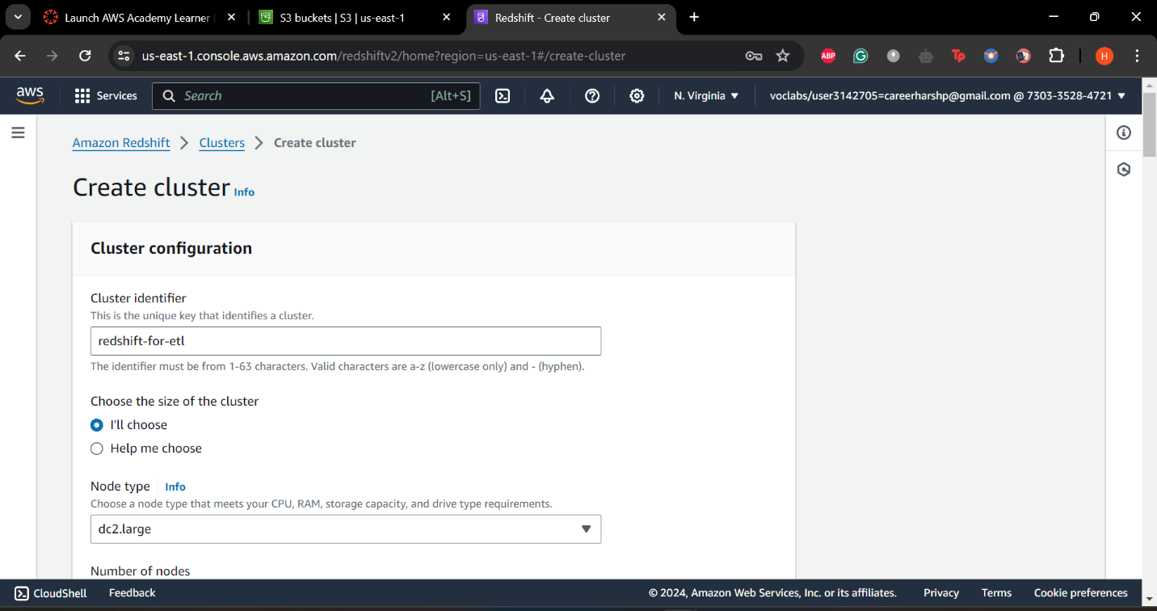

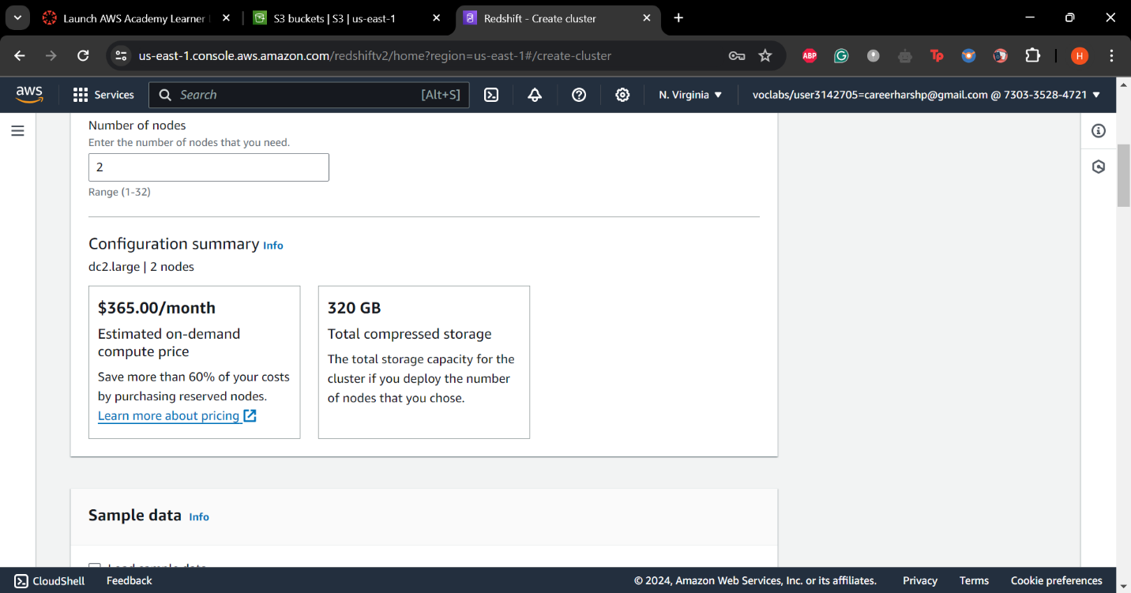

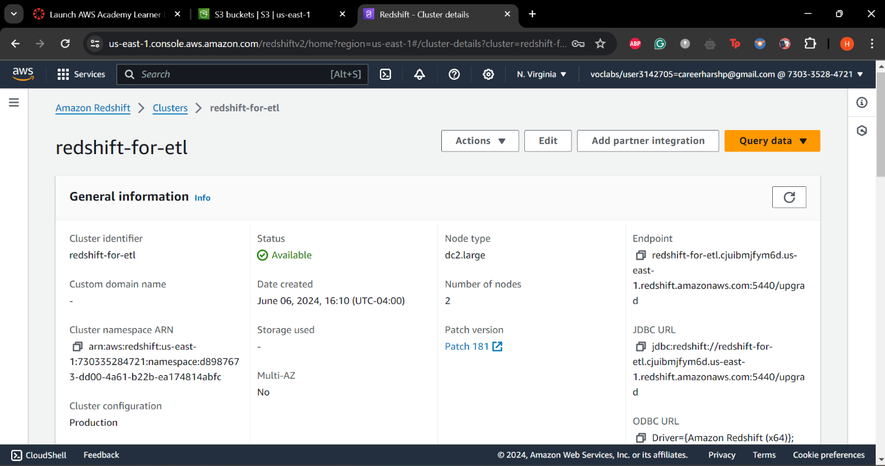

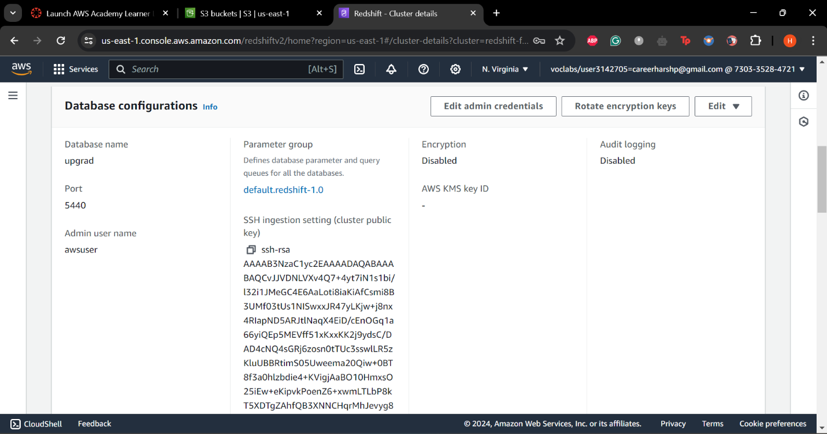

### Setting up a database in the Redshift cluster and running queries to create the dimension and fact tables

**Queries to create the various dimension and fact tables with appropriate primary and foreign keys:**

<Queries>

create schema etl_atm_data;

create table if not exists etl_atm_data.DIM_LOCATION(

location_id int not null sortkey distkey,

location varchar(50),

streetname varchar(255),

street_number int,

zipcode int,

lat decimal(10,3),

lon decimal(10,3),

PRIMARY KEY(location_id)

);

create table if not exists etl_atm_data.DIM_ATM(

atm_id int not null distkey sortkey,

atm_number varchar(20),

atm_manufacturer varchar(50),

atm_location_id int,

PRIMARY KEY(atm_id),

FOREIGN KEY(atm_location_id) REFERENCES etl_atm_data.DIM_LOCATION(location_id)

);

create table if not exists etl_atm_data.DIM_DATE(

date_id int not null distkey sortkey,

full_date_time timestamp,

year int,

month varchar(20),

day int,

hour int,

weekday varchar(20),

PRIMARY KEY(date_id)

);

create table if not exists etl_atm_data.DIM_CARD_TYPE(

card_type_id int not null distkey sortkey,

card_type varchar(30),

PRIMARY KEY(card_type_id)

);

create table if not exists etl_atm_data.FACT_ATM_TRANS(

trans_id bigint not null distkey sortkey,

atm_id int,

weather_loc_id int,

date_id int,

card_type_id int,

atm_status varchar(20),

currency varchar(10),

service varchar(20),

transaction_amount int,

message_code varchar(255),

message_text varchar(255),

rain_3h decimal(10,3),

clouds_all int,

weather_id int,

weather_main varchar(50),

weather_description varchar(255),

PRIMARY KEY(trans_id),

FOREIGN KEY(weather_loc_id) REFERENCES etl_atm_data.DIM_LOCATION(location_id),

FOREIGN KEY(atm_id) REFERENCES etl_atm_data.DIM_ATM(atm_id),

FOREIGN KEY(date_id) REFERENCES etl_atm_data.DIM_DATE(date_id),

FOREIGN KEY(card_type_id) REFERENCES etl_atm_data.DIM_CARD_TYPE(card_type_id)

);

### Loading data into a Redshift cluster from Amazon S3 bucket

**Queries to copy the data from S3 buckets to the Redshift cluster in the appropriate tables**

<Queries>

copy etl_atm_data.DIM_LOCATION from 's3://etl-project-upgrad/dim_location/part-00000-4497a930-8930-45db-93a5-705c7d58d299-c000.csv' iam_role 'arn:aws:iam::730335284721:role/myRedshiftRole' delimiter ',' region 'us-east-1' CSV;

copy etl_atm_data.DIM_ATM from 's3://etl-project-upgrad/dim_atm/part-00000-dc0c784f-40a6-4330-a08d-553d23e030a5-c000.csv' iam_role 'arn:aws:iam::730335284721:role/myRedshiftRole' delimiter ',' region 'us-east-1' CSV;

copy etl_atm_data.DIM_DATE from 's3://etl-project-upgrad/dim_date/part-00000-339f7738-7b0f-47ba-8fed-c81f7c1579e2-c000.csv' iam_role 'arn:aws:iam::730335284721:role/myRedshiftRole' delimiter ',' region 'us-east-1' CSV timeformat 'auto';

copy etl_atm_data.DIM_CARD_TYPE from 's3://etl-project-upgrad/dim_card_type/part-00000-666ce7dc-4bc4-4312-99db-c75d5c570b8f-c000.csv' iam_role 'arn:aws:iam::730335284721:role/myRedshiftRole' delimiter ',' region 'us-east-1' CSV;

copy etl_atm_data.FACT_ATM_TRANS from 's3://etl-project-upgrad/fact_atm_trans/part-00000-f625ca03-24bb-4275-9a39-fb54a1eeb281-c000.csv' iam_role 'arn:aws:iam::730335284721:role/myRedshiftRole' delimiter ',' region 'us-east-1' CSV;