Introduction

Aim of the Project
The QuickMeds Medicine Warehouse and Local Store Management System is a web-based application designed to centralize and streamline medicine inventory management and sales. The main warehouse (managed by the super admin) handles bulk inventory and tracks transactions with local stores. Each local store (managed by sub-admins) can order medicines, manage its inventory, and track sales, both online and offline. The system ensures secure, role-based access, enabling efficient collaboration between the main warehouse and local branches.
The primary goals include:
- Centralized tracking of medicine inventory for the main warehouse.
- Role-based management for super admin, sub-admins, and employees.
- Real-time synchronization of orders and sales across all branches.
- Enhanced revenue tracking and reporting capabilities for better decision-making.

Project Scope
The QuickMeds Medicine Warehouse and Local Store Management System focuses on streamlining operations between a central warehouse and distributed local stores. It ensures efficient inventory management, sales tracking, and revenue monitoring for different user roles.
In-Scope Features:
- Super Admins: Manage central inventory by adding, updating, and removing medicines, approving or rejecting sub-admin orders, tracking revenue, and maintaining sales logs.
- Sub Admins: Access the main warehouse inventory, place medicine orders, manage local store inventory, set prices with margins, record offline sales, and generate revenue reports.
- Employees: Record offline transactions, update the central database, and ensure data synchronization for accurate sales tracking.
Out-of-Scope Features:
- Payment gateway integration (the current scope focuses on inventory and sales management).
- Advanced analytics and machine learning-based sales predictions (may be included in future phases).

Project Objective
The objectives of this project are to:
- Centralize Inventory Management: Provide a system for the super admin to manage and monitor the entire medicine inventory efficiently.
- Enable Local Store Operations: Allow sub-admins to access the main inventory, place orders, and track sales performance.
- Facilitate Offline Sales Recording: Equip employees with tools to record offline transactions, ensuring a complete sales record in the database.
- Revenue Reporting: Generate detailed revenue and sales reports for super admins to track the performance of each local store.
- Ensure Security and Access Control: Implement role-based authentication to restrict and streamline access for super admins, sub-admins, and employees.
- Support Franchise Orders: Allow franchises (admins) to place orders for required medicines directly from the central inventory system.
The system aims to improve operational efficiency, minimize manual errors, and enhance collaboration between the main warehouse and local stores.

Project Modules
The system is divided into the following key modules:
1. Authentication Module:
2. User Management Module
3. Inventory Management Module
4. Order Management Module
5. Sales Management Module
6. Revenue Tracking & Reports Module
7. Notifications & Alerts Module
8. Invoice & Billing Module
9. Customer Management Module (For Sub-Admins & Employees)
10. Dashboard & Analytics Module

Project basic requirements

Hardware
Component | Specification | Justification
Processor | Server: Quad-Core or higher | Handles multiple API requests and backend processes efficiently.
 | Client: Dual-Core or higher | For frontend operations and dashboard use
RAM | Server: 16 GB or higher | Multitasking and database performance.
 | Client: 4 GB or higher | Supports web app usage
Storage | Server: 500 GB SSD | For faster speeds and reduced latency.
 | Client: 256 GB HDD/SSD | For browser cache, files, and local app support.
Display | Client: 1366 × 768 resolution | For proper layout and interface visibility.
Network | Server: ≥ 50 Mbps high-speed connection | Ensures stable communication and low-latency access for all connected clients.

Software
Software/Tool | Description
React.js (Frontend) | For a responsive and user-friendly interface.
Node.js with Express.js (Backend) | For API handling.
MongoDB (Database) | For data storage and retrieval.
JSON Web Tokens (JWT) | For authentication and secure access control.
Visual Studio Code | Integrated Development Environment (IDE)
Git & Github | Version control software
OS | Server: Ubuntu Server 20.04 LTS, Client: Windows 10, macOS, or Linux

Analysis, Design Methodology and Implementation Strategy

Literature review
- Pharmeasy
Link: https://www.pharmeasy.in
Pharmeasy offers a loyalty program called Pharmeasy Plus, which provides:
- 5% Extra PharmEasy Credits on medicines and healthcare products (capped at ₹200 per order).
- Free Delivery for orders above ₹499.
- Discounts on lab tests, including 50% Extra PharmEasy Credits on the first test and 10% Extra Credits on subsequent tests.
While these features enhance customer engagement, the platform lacks centralized inventory management, advanced role-based access control (RBAC), offline sales tracking, and dynamic revenue reporting. These shortcomings make it less suitable for multi-location businesses or warehouse management.
- NetMeds
Link: https://www.netmeds.com
NetMeds offers a premium membership called NetMeds First, with features such as:
- 2% NMS Cashback on prescription medicines (up to ₹100 per order).
- Free Delivery for orders above ₹99 for prepaid and COD payments, with a COD limit of ₹5000.
- 10% Discount on lab tests and packages.
- Free Doctor Consultations (3 for 6-month members, 6 for 12-month members).
Despite these customer-friendly features, NetMeds lacks offline sales tracking, comprehensive inventory management, scalability for multi-location operations, and detailed revenue reporting
- DavaIndia
Link: https://www.davaindia.in
DavaIndia, part of Zota Healthcare Ltd., is India's largest private generic pharmacy retail chain. It aims to revolutionize the Indian healthcare landscape by offering high-quality generic medicines at significantly lower costs compared to branded medicines. DavaIndia's approach has earned it recognition, including the TIMES ICON 2019 award from the Times of India Group.
- 1mg
Link: https://www.1mg.com
1mg’s Care Plan provides benefits such as:
- Auto-applied discounts on prescription medicines for orders up to ₹15,000.
- Free Delivery for up to 20 orders applicable for orders above ₹249.
- Additional rewards through NeuCoins, redeemable across TataNeu services.
While the Care Plan is designed for customer convenience, 1mg does not support centralized inventory management, RBAC, offline sales integration, or dynamic revenue tracking, limiting its applicability for business-oriented operations.

Project Feasibility Study
1. Technical Feasibility
The project is technically feasible due to the availability of modern frameworks like React.js, Node.js, and MongoDB, which simplify development and deployment. Role-based access control ensures secure system operations.
2. Market Feasibility
There is a growing demand for automated inventory and sales management systems in the healthcare industry. Local pharmacies benefit from a platform that bridges the gap between warehouses and local stores.
3. Financial Feasibility
Development Costs: Estimated at $5,000–$10,000, covering server setup, development, and testing. Revenue Generation: Potential revenue sources include subscription-based access for sub-admins and inventory restocking fees.
4. Operational Feasibility
Sub-admins and staff require basic training to use the system. Regular system maintenance ensures smooth operation.

Project Timeline chart
Task | Duration | Start Date | End Date | Assigned Member(s)
Requirement Gathering | 1 Week | Jan 20, 2025 | Jan 27, 2025 | Entire Team
System Design | 1.5 Weeks | Jan 28, 2025 | Feb 7, 2025 | Siddhant
Frontend Development | 2.5 Weeks | Feb 8, 2025 | Feb 25, 2025 | Het
Backend Development | 2.5 Weeks | Feb 8, 2025 | Feb 25, 2025 | Rahul
Database Setup & Testing | 1.5 Weeks | Feb 26, 2025 | Mar 7, 2025 | Het & Siddhant
Integration & Testing | 2 Weeks | Mar 8, 2025 | Mar 21, 2025 | Entire Team
Deployment & Documentation | 1 Week | Mar 22, 2025 | Mar 28, 2025 | Entire Team

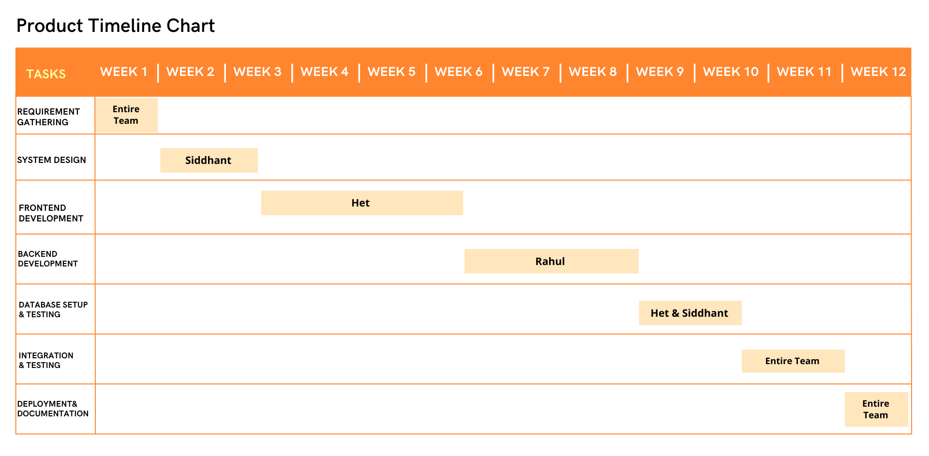
Table 1: Timeline of project milestones

Figure 1: Visual representation of the project timeline

Detailed Modules Description
The system is divided into the following key modules:
1. Authentication Module:
Purpose: Handles user registration, login, and access control.
Features:
- User Registration (Super Admin, Sub Admin, Employee).
- Secure Login with authentication mechanisms.
- Role-based access control (Super Admin, Sub Admin, Employee).
- Password reset and recovery.
Example Use Case: A sub-admin registers an account, logs in, and accesses the dashboard to place orders.
2. User Management Module
Purpose: Allows the super admin to manage users and their roles.
Features:
- Add, update, or remove users (sub-admins, employees).
- Assign roles and permissions.
- View user activity logs.
Example Use Case: The super admin adds a new sub-admin for a newly opened local store and assigns them permissions.
3. Inventory Management Module
Purpose: Manages medicine stock, availability, and updates in the warehouse and local stores.
Features:
- Add, update, and delete medicines from inventory.
- Track stock levels in the warehouse and sub-admin stores.
- Receive notifications for low stock alerts.
- Categorize medicines by type, brand, and expiry date.
Example Use Case: The super admin updates inventory by adding 500 new units of a painkiller to the warehouse stock.
4. Order Management Module
Purpose: Handles order placement, approval, and tracking.
Features:
- Sub-admins place orders for medicines from the warehouse.
- Super admin approves or rejects orders.
- Track order status (pending, approved, dispatched, delivered).
- Generate invoices for orders.
Example Use Case: A sub-admin places an order for 200 units of a medicine, which is approved by the super admin and then dispatched.
5. Sales Management Module
Purpose: Tracks sales transactions (both online and offline).
Features:
- Employees record offline sales data.
- Sub-admins track online sales.
- Synchronize sales data with the central database.
Example Use Case: An employee enters an offline sale of 10 units of a medicine purchased by a customer.
6. Revenue Tracking & Reports Module
Purpose: Generates financial reports and tracks revenue trends.
Features:
- Calculate total revenue from sales.
- Generate revenue reports (daily, weekly, monthly).
- Identify top-selling products and best-performing stores.
Example Use Case: The super admin generates a monthly revenue report to analyze store performance.
7. Notifications & Alerts Module
Purpose: Provides real-time updates on orders, stock, and sales.
Features:
- Notify sub-admins when stock is low.
- Alert super admins when an order is placed.
- Notify employees when an order is approved.
Example Use Case: A sub-admin receives a notification that their stock of a specific medicine is running low.
8. Invoice & Billing Module
Purpose: Generates and manages invoices for purchases and sales.
Features:
- Generate invoices for orders placed.
- Provide downloadable and printable invoices.
- Track pending and completed payments.
Example Use Case: A sub-admin downloads an invoice for a recent order placed with the warehouse.
9. Customer Management Module (For Sub-Admins & Employees)
Purpose: Tracks customer purchases and preferences.
Features:
- Maintain customer purchase history.
- Provide customer insights based on past purchases.
- Apply personalized discounts and loyalty programs.
Example Use Case: A sub-admin checks a customer's purchase history and offers a discount on their next purchase.
10. Dashboard & Analytics Module
Purpose: Provides an overview of key metrics for super admins and sub-admins.
Features:
- Visual representation of sales and revenue.
- Track inventory status in real time.
- Display recent order activities.
Example Use Case: The super admin views a dashboard showing real-time sales data and stock availability.

Project SRS

Use Case Diagrams
Use case diagrams are a common way to communicate the major functions of a software system. A use case diagram at its simplest is a representation of a user's interaction with the system that shows the relationship between the user and the different use cases in which the user is involved. A use case diagram can identify the different types of users of a system and the different use cases and will often be accompanied by other types of diagrams as well.
Use cases are nothing but the system functionalities written in an organized manner. Now another thing which is relevant to the use cases are the actors. Actors can be defined as something that interacts with the system.
So in brief, the purposes of use case diagrams can be as follows:
- Used to gather requirements of a system.
- Used to get an outside view of a system.
- Identify external and internal factors influencing the system.
- Show the interacting among the requirements are actors.
Symbols used in Use Case diagram:
 | Use Case |  | Include
 | Association |  | Extend
 | Actor |  | Dependency
 | System |  | Generalization

Use Case Diagram of the System:
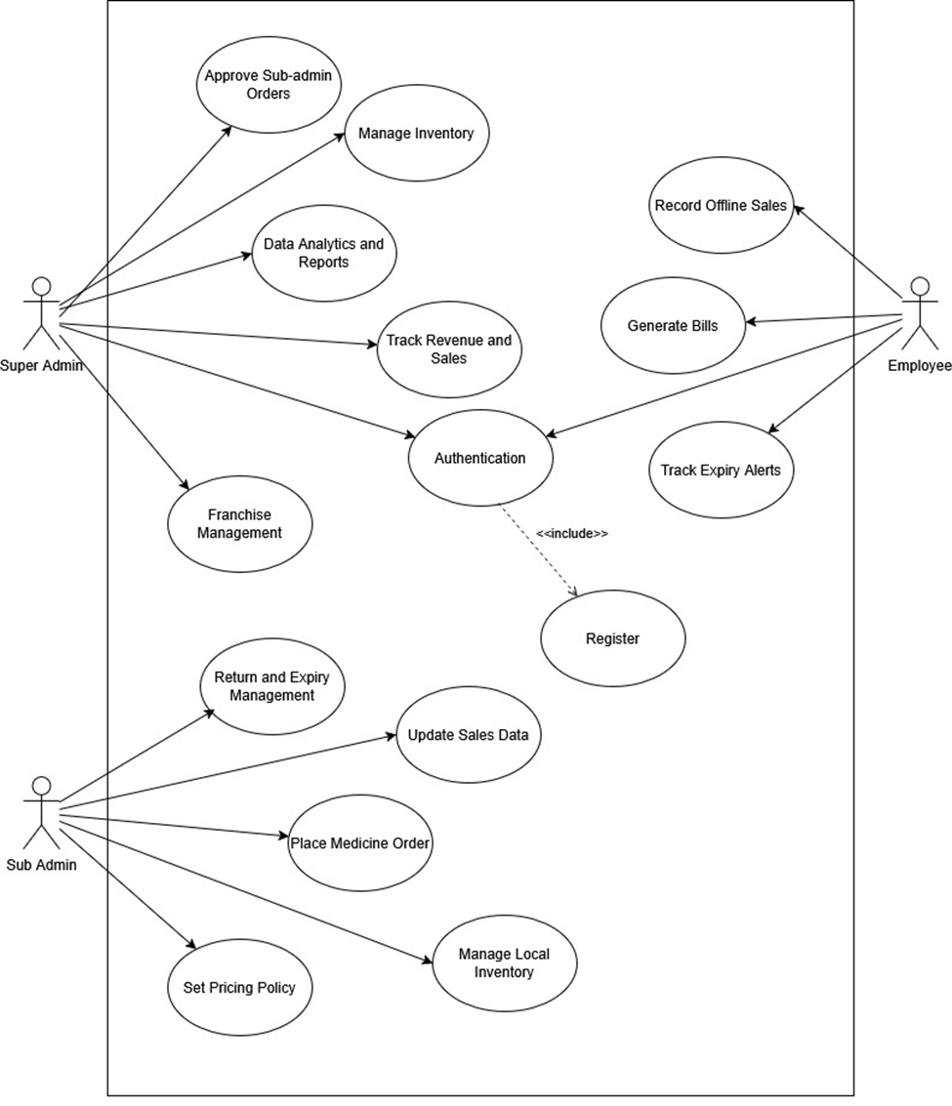

Figure 2: Use Case Diagram

Data Flow Diagrams
DFD provides the functional overview of a system. The graphical representation easily overcomes any gap between ’user and system analyst’ and ‘analyst and system designer’ in understanding a system. Starting from an overview of the system it explores detailed design of a system through a hierarchy. DFD shows the external entities from which data flows into the process and also the other flows of data within a system. It also includes the transformations of data flow by the process and the data stores to read or write a data.
Symbols used in Data Flow diagram:
Process | 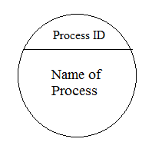 | or | 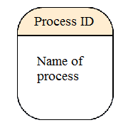
Data store | 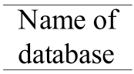 | or | 
Data flow | 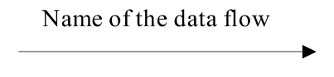
External entity | 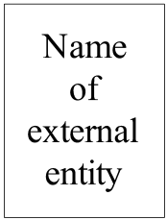
Data Flow Diagram of the System:
Context level DFD (level 0):
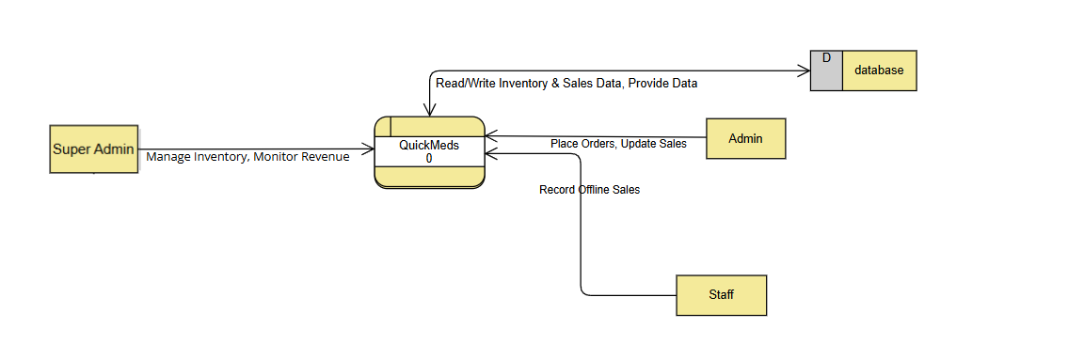

Figure 3.1: Data Flow Diagram
Level 1 DFD:
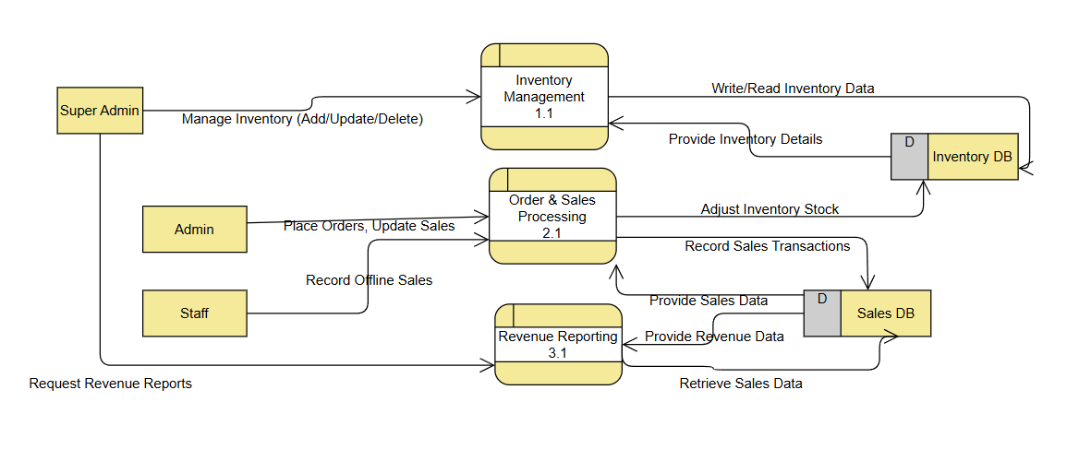

Figure 3.2: Data Flow Diagram

Level 2 DFD: 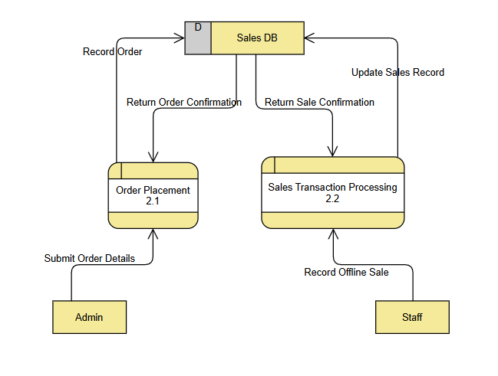

Figure 3.3: Data Flow Diagram

Activity Diagram
An activity denotes a particular action taken in the logical flow of control. This could simply be invocation of a mathematical function, alter an object's properties and so on. An activity is represented with a rounded rectangle, as shown in figure. A label inside the rectangle identifies the corresponding activity.
There are two special types of activity nodes: initial and final. They are represented with a filled circle, and a filled in circle with a border respectively. Initial node represents the starting point of a flow in an activity diagram. There could be multiple initial nodes, which mean that invoking that particular activity diagram would initiate multiple flows. A final node represents the end point of all activities. Like an initial node, there could be multiple final nodes. Any transition reaching a final node would stop all activities. A flow is represented with a directed arrow. A decision node, represented with a diamond, is a point where a single flow enters and two or more flows leave. This is represented with a diamond shape, with two or more flows entering, and a single flow leaving out. Fork is a point where parallel activities begin. A join is depicted with a black bar, with multiple input flows, but a single output flow. Physically it represents the synchronization of all concurrent activities.
Symbols used in Activity diagram:
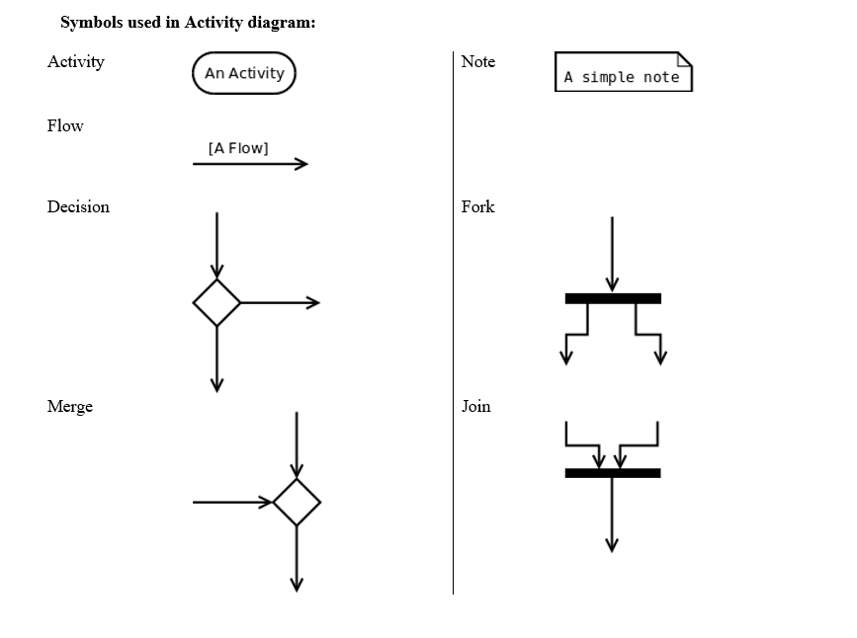
Activity Diagram of the System
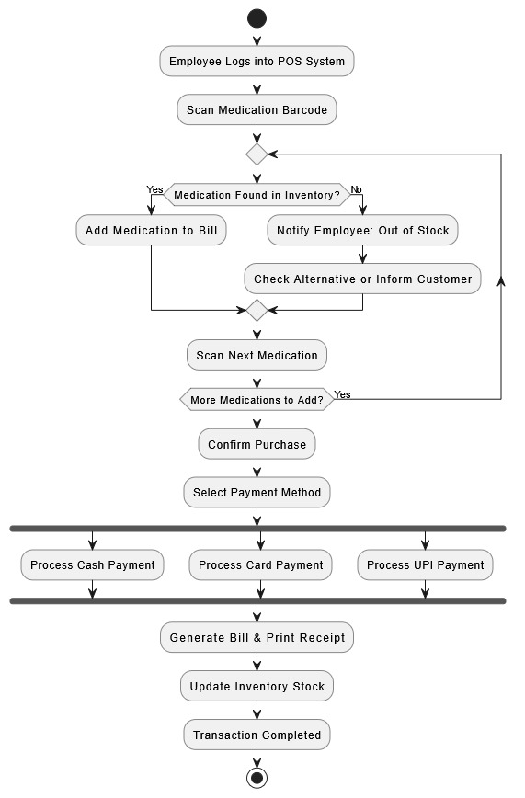
Staff (Employee)
Figure 4.1: Activity Diagrams (Staff)
Admin
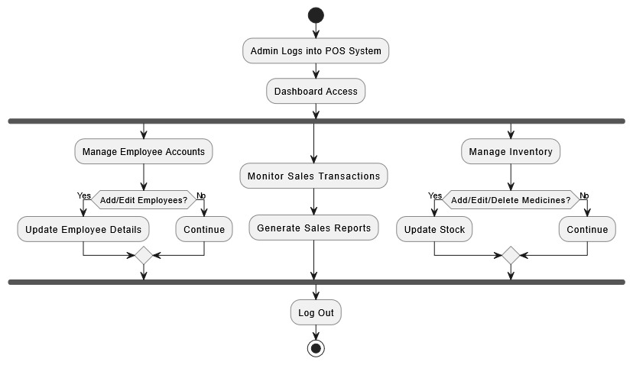

Figure 4.2: Activity Diagram (Admin)

Super Admin

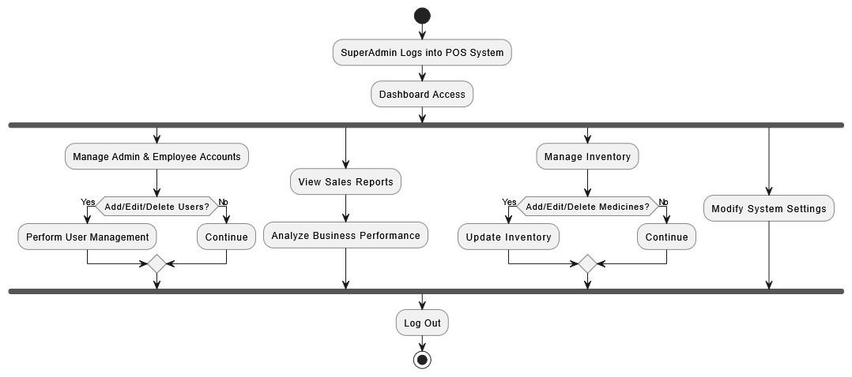 Figure 4.3: Activity Diagrams (Super Admin)

Event Trace Diagram
Event Trace Diagram represents the behavioural aspects of a system. Event Trace Diagram shows the interactions between the objects by means of passing messages from one object to another with respect to time in a system.
Event Trace Diagram contains the objects of a system and their life-line bar and the messages passing between them. Objects appear at the top portion of Event Trace Diagram . Object is shown in a rectangle box. Name of object precedes a colon ‘:’ and the class name, from which the object is instantiated. The whole string is underlined and appears in a rectangle box. A down-ward vertical line from object-box is shown as the life-line of the object. A rectangle bar on life-line indicates that it is active at that point of time. Messages are shown as an arrow from the life-line of sender object to the life-line of receiver object and labelled with the message name.
Symbols used in Event Trace Diagram :
Object | 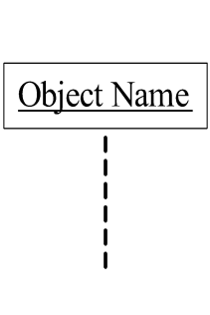
Life line bar | 
Call message | 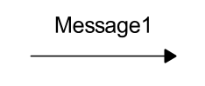
Return message | 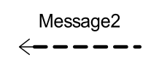

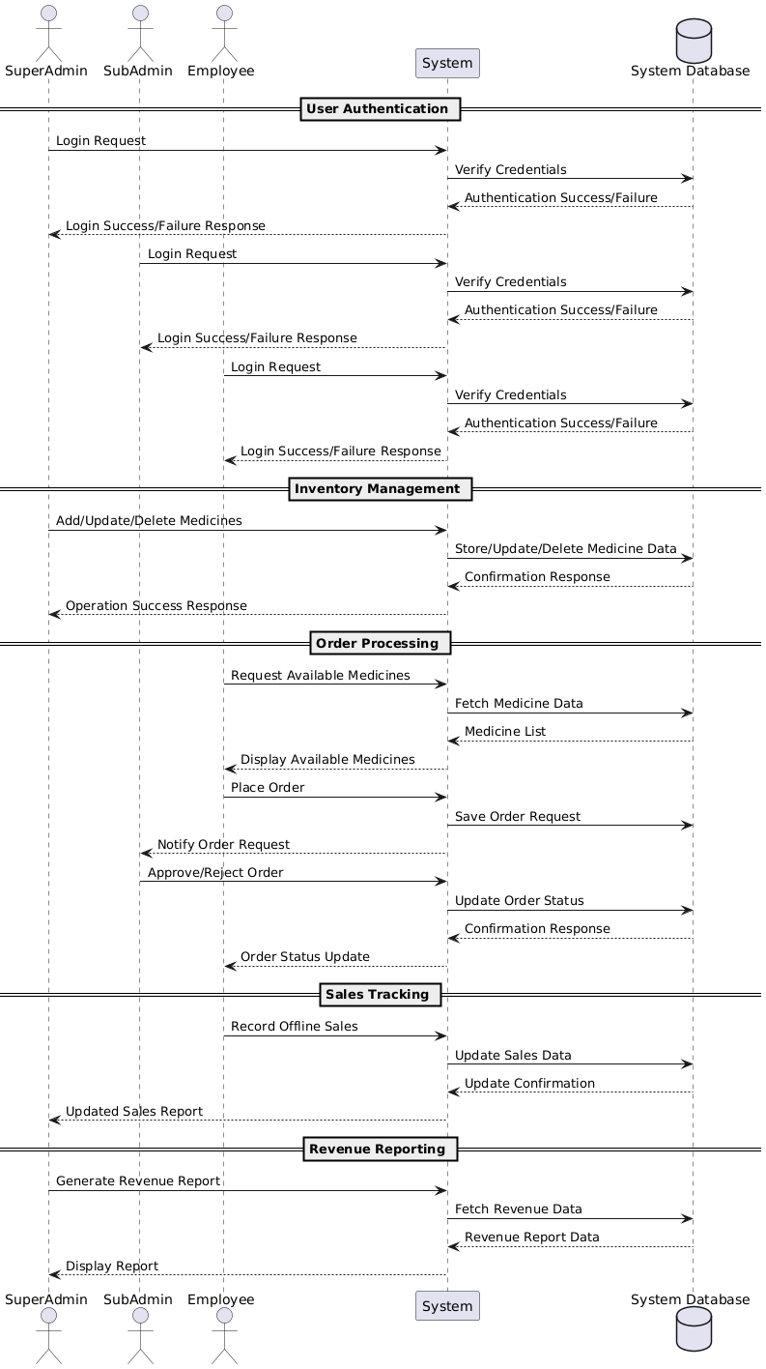
Event Trace Diagram of the System:

Figure 5: Event Trace Diagram

Class diagram
The class diagram is the main building block of object-oriented modelling. It is used both for general conceptual modelling of the systematics of the application, and for detailed modelling translating the models into programming code. Class diagrams can also be used for data modeling. The classes in a class diagram represent both the main elements, interactions in the application, and the classes to be programmed.
In the diagram, classes are represented with boxes that contain three compartments:
- The top compartment contains the name of the class. It is printed in bold and centered, and the first letter is capitalized.
- The middle compartment contains the attributes of the class. They are left-aligned and the first letter is lowercase.
- The bottom compartment contains the operations the class can execute. They are also left aligned and the first letter is lowercase.
In the design of a system, a number of classes are identified and grouped together in a class diagram that helps to determine the static relations between them. With detailed modelling, the classes of the conceptual design are often split into a number of subclasses.
Symbols used in Class diagram:
Class
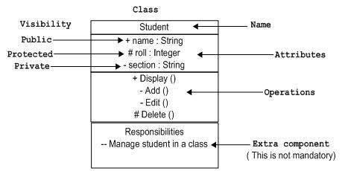

Aggregation | Composition

Association Inheritance
Multiplicity in Aggregation,  Composition, or Association | Abstract Class

Class Diagram of the System:
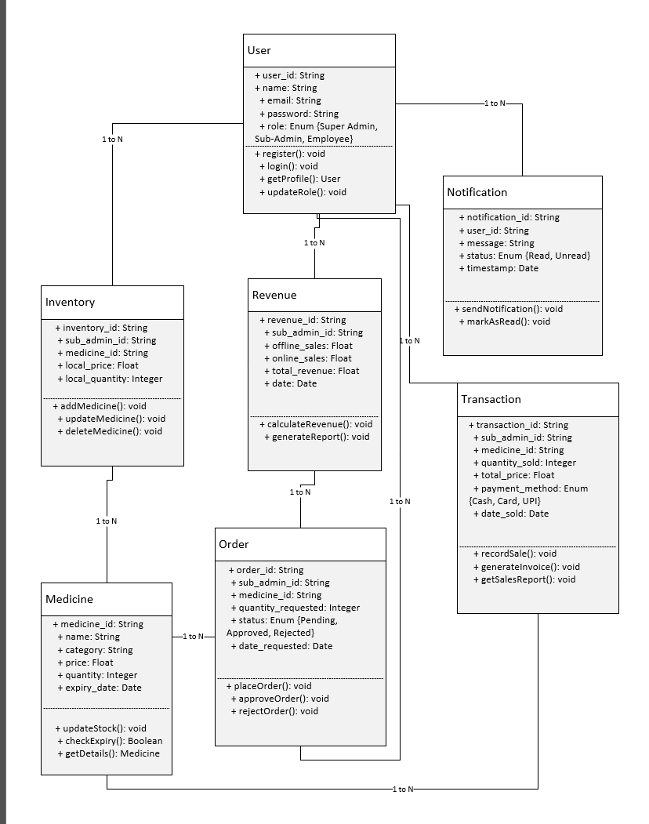
Figure 6: Class Diagram

Database design and Normalization

Collection Name: users
Description: Stores details of the users in the system.
Primary Key: user_id
Sr. No. | Name | Description
1 | id | Unique identifier for each user
2 | first_name | First name of the user
3 | last_name | Last name of the user
4 | role | Type of user (Admin/Superadmin/Employee)
5 | email | Email address of the user
6 | password | Encrypted password
7 | city | City of user
8 | phone | Contact number of the user
9 | store_name | Store name of belonging user
Table 1: User Table

Collection name: customers
Description: Stores details of customers.
Sr. No. | Name | Description
1 | id | Unique identifier for each user
2 | name | Name of the customer
3 | Phone | Contact number of the customer
4 | address | Address of the customer
5 | email | Email Address of the customer
6 | store | Store at which customer had signup
7 | created_by
  Employee ID that created the customer account
8 | created_at
  Timestamp when the customer account was created
9 | updated_at | Timestamp when customer details were last updated
Table 2: Customer Collection

Collection name: products.pharmacies
Description: Total medicines categorized in pharmacy collection.
Sr. No. | Name | Description
1 | id | Unique identifier for each pharmacy product
2 | tradeName | Trade name of the pharmacy product
3 | genericName | Generated name of the pharmacy product
4 | category | Category of the pharmacy product
5 | company | Manufacturing Company of the pharmacy product
6 | stock | Available stock of the pharmacy product
7 | packType | Pack type of the pharmacy product
8 | unitMrp | MRP of the pharmacy product
9 | addedBy | Updated user of Pharmacy product
10 | addedToDbAt | Timestamp of adding the product
Table 3: Pharmacies Collection

Collection Name: products.non-pharmacies
Description: Total medicines categorized in non-pharmacy collection.
Sr. No. | Name | Description
1 | id | Unique identifier for each pharmacy product
2 | tradeName | Trade name of the pharmacy product
3 | genericName | Generated name of the pharmacy product
4 | category | Category of the pharmacy product
5 | company | Manufacturing Company of the pharmacy product
6 | stock | Available stock of the pharmacy product
7 | packType | Pack type of the pharmacy product
8 | unitMrp | MRP of the pharmacy product
9 | addedBy | Updated user of Pharmacy product
10 | addedToDbAt | Timestamp of adding the product
Table 4: Non pharmacies Collection

Table Name: unittypes
Description: Stores the unit type of the product.
Sr. No. | Name | Description
1 | id | Unique identifier for each session
2 | SN | References user_table(user_id)
3 | Name | Timestamp for when the session started
4 | Description | Description of the unit type
5 | Creator | User who created the unit type record
6 | CreatedAt | Date and time when the unit type was created
7 | UpdatedBy | User who last updated the unit type
8 | UpdatedAt | Date and time of the last update
Table 5: Session Collection

Table Name: companies
Description: Medicine manufacturing companies added in the collection
Sr. No. | Name | Description
1 | Id | Unique identifier for an company
2 | SN | Serial number of the company
3 | Name | Name of the company
4 | Phone | Contact phone number of the company
5 | Website | Company website URL
6 | Email | Contact email of the company
7 | Address | Physical address of the company
8 | Creator | User who created the company record
9 | CreatedAt | Date and time when the record was created
10 | UpdatedBy | User who last updated the record
11 | UpdatedAt | Date and time of the last update
Table 6: Companies Collection

Table Name: orders.pharmacy
Description: Sent pharmacy orders from the Admins of the system to the Superadmin
Sr. No. | Name | Description
1 | Id | Unique identifier for the order
2 | items | List of pharmacy products requested in the order
3 | requestedBy | ID of the user who requested the order
4 | status | Status of the order (e.g., “approved”, “pending”, “rejected”)
5 | note | Optional notes regarding the order
6 | requestedAt | Timestamp when the order was requested
7 | approvedAt | Timestamp when the order was approved
8 | approvedBy | User who approved the order
Table 7: Pharmacy Collection

Table Name: orders.nonpharmacy
Description: Sent non-pharmacy orders from the Admins of the system to the Superadmin
Sr. No. | Name | Description
1 | Id | Unique identifier for the order
2 | items | List of non-pharmacy products requested in the order
3 | requestedBy | ID of the user who requested the order
4 | status | Status of the order (e.g., “approved”, “pending”, “rejected”)
5 | note | Optional notes regarding the order
6 | requestedAt | Timestamp when the order was requested
7 | approvedAt | Timestamp when the order was approved
8 | approvedBy | User who approved the order
Table 8: Pharmacy Collection

Template Design
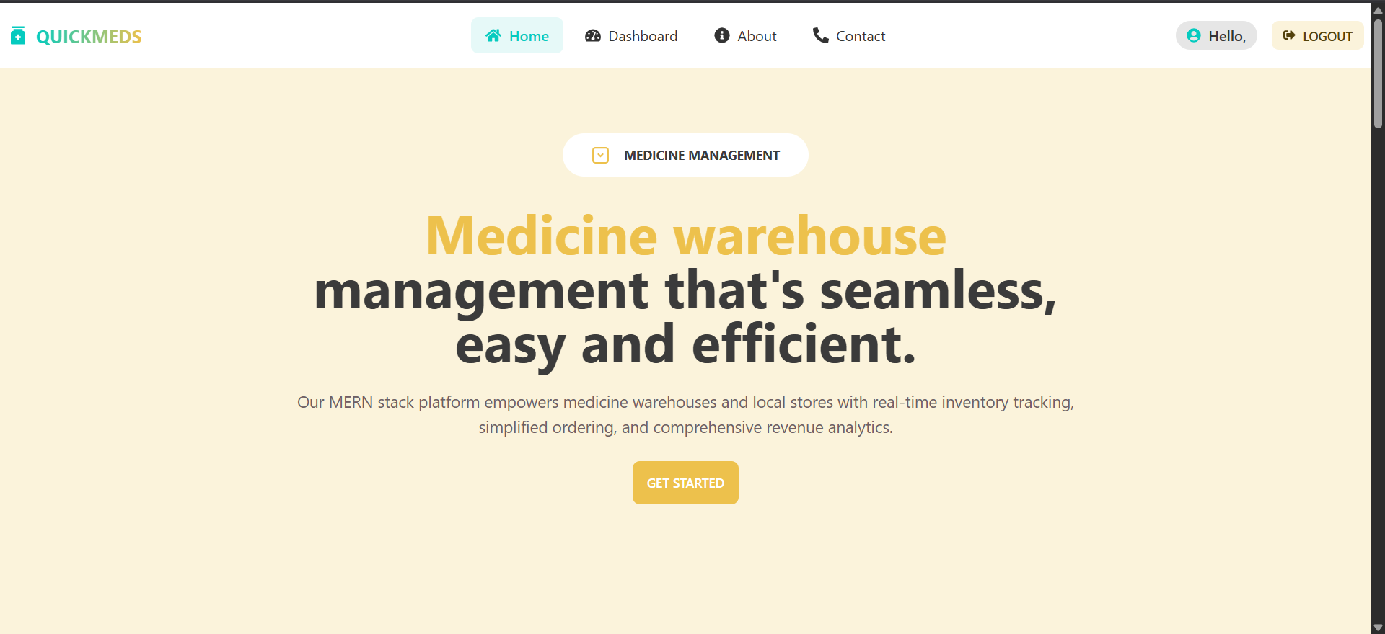
Figure 7.1 Home Page Snapshot
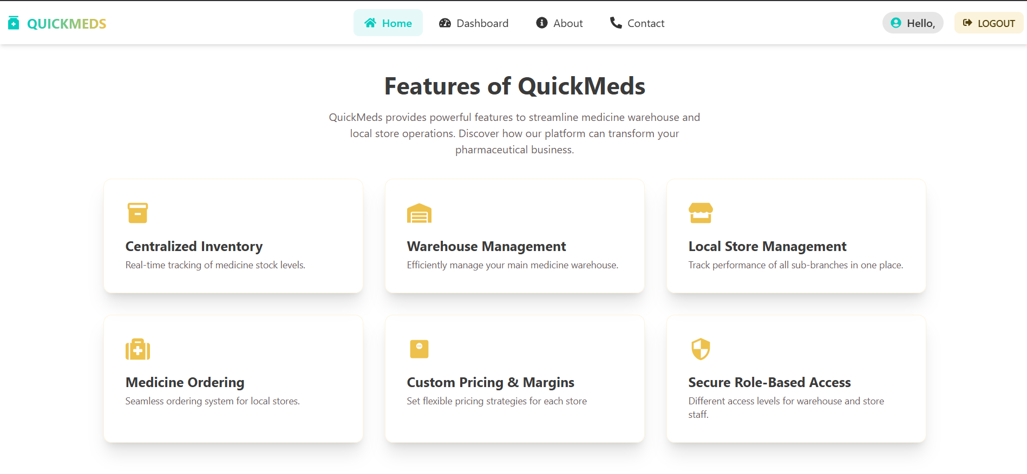
Figure 7.2 Home Page Snapshot

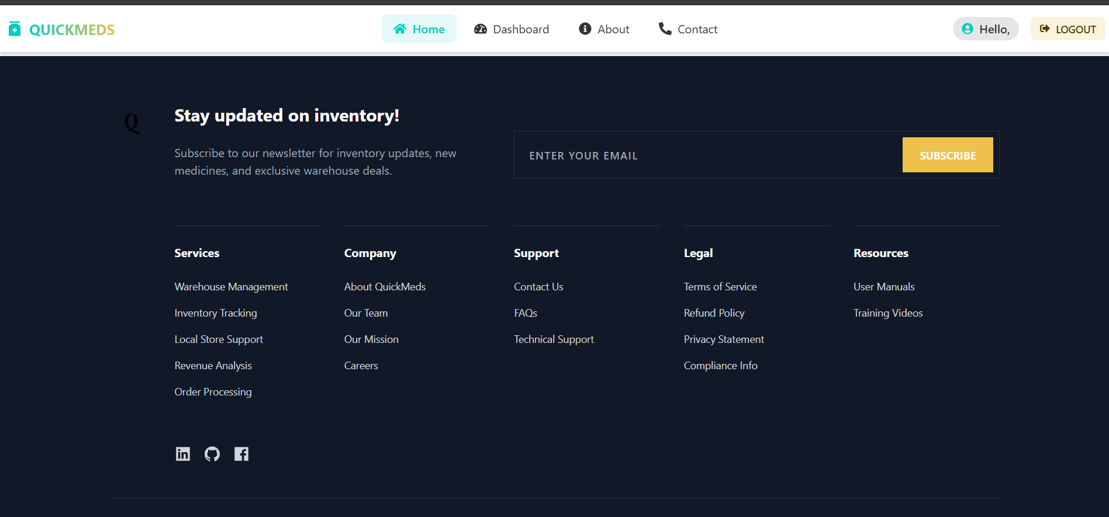
Figure 7.3 Home Page Snapshot

Implementation and Testing

Software and Tools
- Visual Studio Code (VSCode):
Used as the primary source code editor for writing and managing the frontend and backend code efficiently with extensions and integrated terminal support.
- MERN Stack:
A full-stack JavaScript framework used for building the QuickMeds application:
- MongoDB: NoSQL database for storing pharmacy products and user data.
- Express.js: Web framework for handling server-side logic and routing.
- React.js: Frontend library for building the user interface.
- Node.js: Backend runtime environment for executing JavaScript on the server side..

User Interface and Snapshot

Authentication Module:

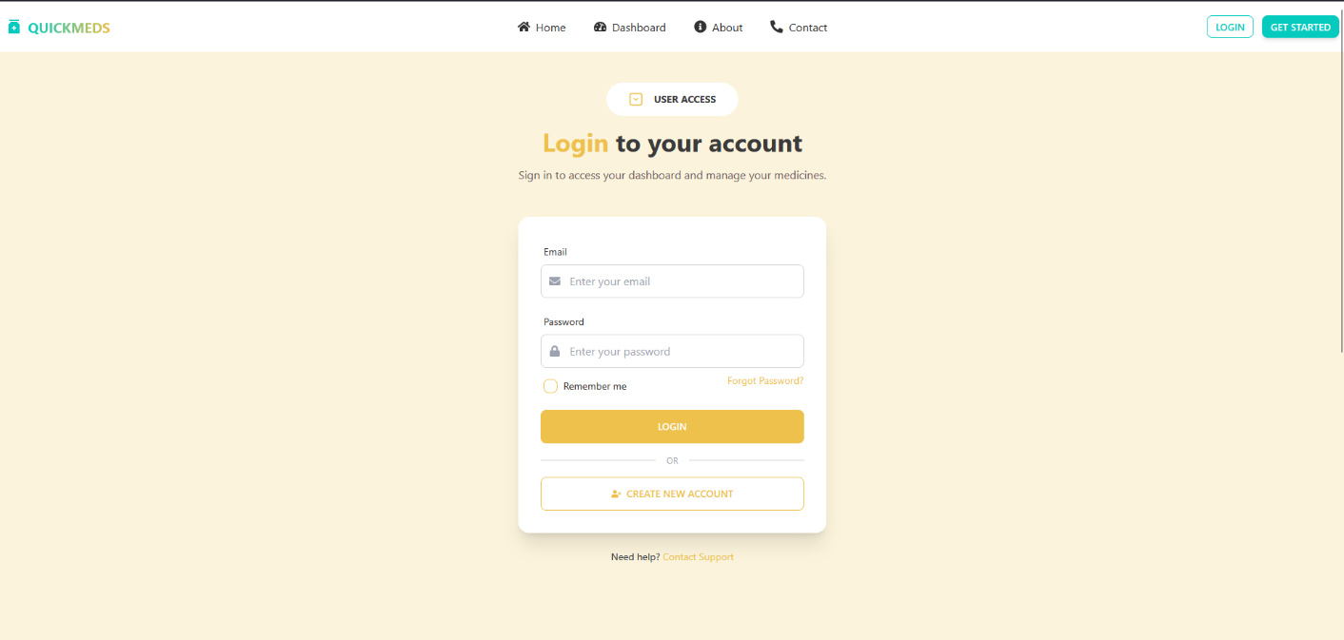
Figure 8. Login Page

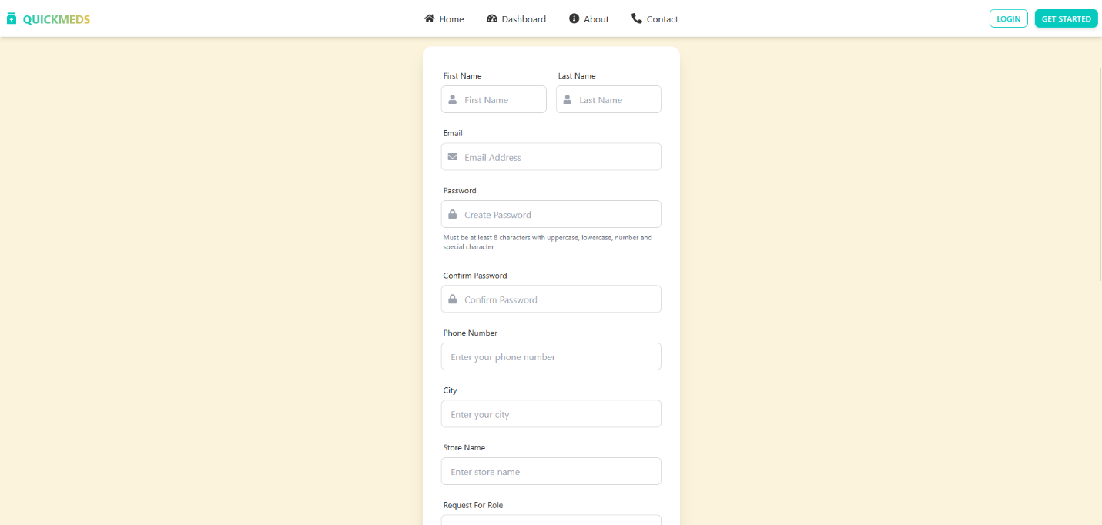
Figure 9. Register Page
Purpose:
This module ensures secure and role-specific access to the QuickMeds platform. It facilitates the registration and login process for different user types, ensuring that only authorized personnel can access the system and its features. The authentication flow is designed to maintain data confidentiality, system integrity, and user accountability.
Key Features:
- User Registration: Enables creation of accounts for Super Admins, Sub Admins (local store managers), and Employees. Includes input validation and duplicate checks.
- Secure Login: Users must provide valid credentials to access their account. Passwords are encrypted using hashing algorithms (e.g., bcrypt ).
- Role-Based Access Control (RBAC): Users can only access the modules and data relevant to their role. For example, a Sub Admin cannot access Super Admin functions.
- Password Recovery: Implements OTP/email-based password reset functionality.

User Management Module:

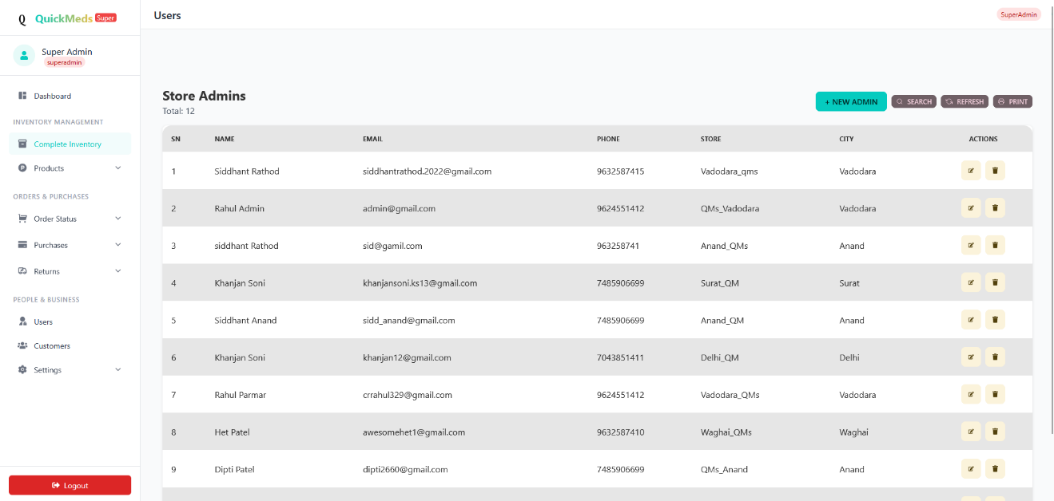
Figure 10. List of Admin Tab (Logged-in user- Superadmin)

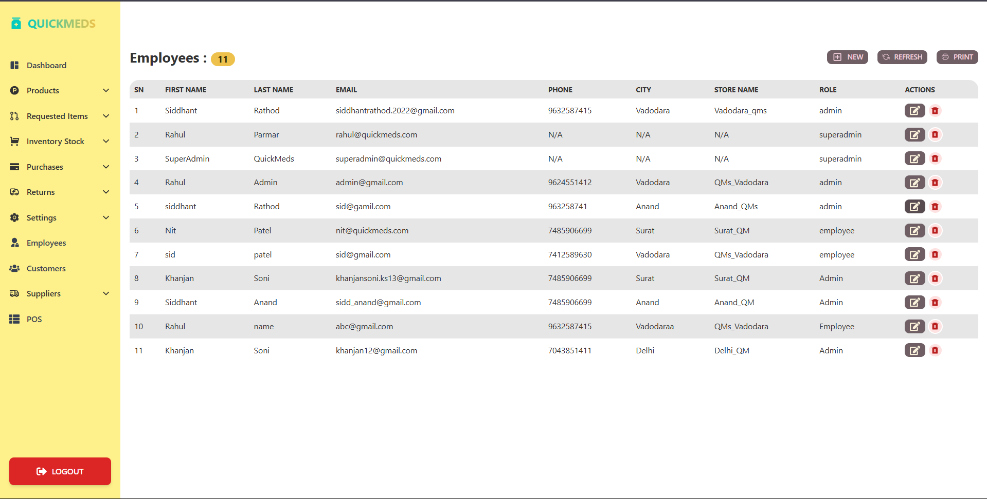
Figure 11. List of Employees Tab (Logged-in user- Admin)
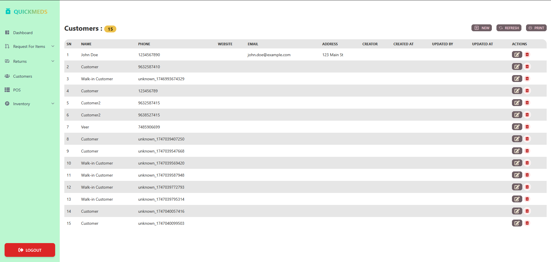

Figure 12. List of Customer Tab (Logged-in user- Employee)
Purpose:
This module allows the Super Admin, Admin and Employee to manage the platform’s user hierarchy and ensure organizational efficiency. It provides full visibility and control over user accounts and their roles, enabling dynamic assignment and revocation of permissions as per business needs.
Key Features:
- Add/Remove Users: The Super Admin, Admin and Employee can create new users or remove inactive/unnecessary accounts.
- Edit User Information: Allows updating of user details such as contact information, assigned store, or role.
- Role and Permission Management: Grants or restricts access to certain modules based on role, supporting scalability as new users or roles are introduced.
- Activity Logging: Monitors and records actions taken by users, such as logins, inventory updates, or order submissions, aiding in audit and security tracking.

Inventory Management Module:

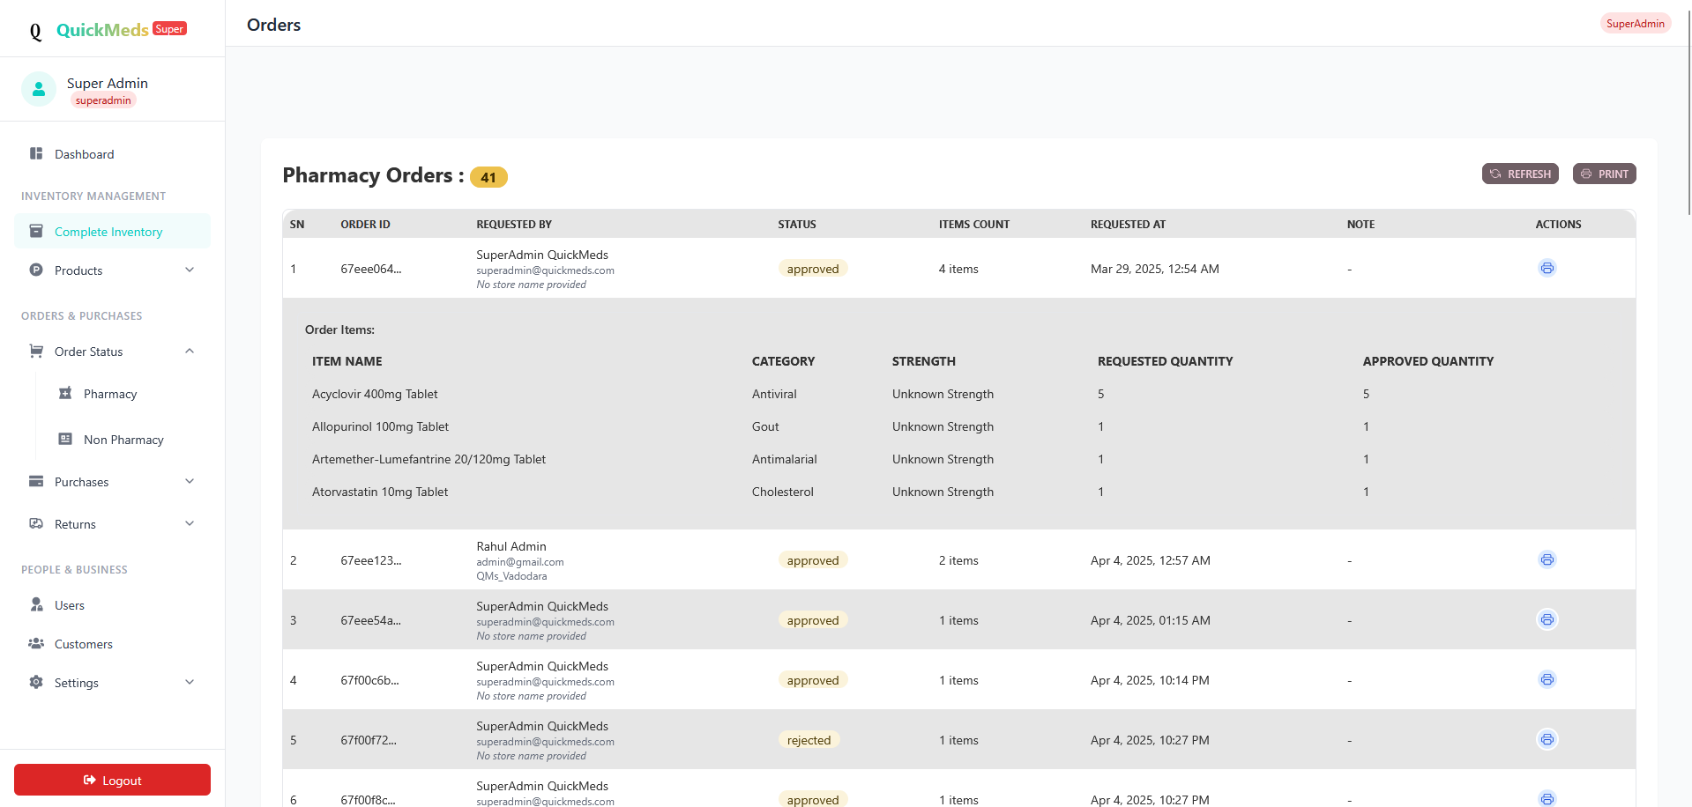 Figure 13. Screenshot of Inventory
Purpose:
This core module is responsible for real-time tracking and management of medicine stock across both central warehouses and decentralized local stores. It ensures that medicine availability, expiration, and categorization are well-maintained, enabling uninterrupted order fulfilment.
Key Features:
- Inventory CRUD Operations: Admins can Create, Read, Update, and Delete medicine entries in the database.
- Stock Monitoring: Tracks real-time quantity of each medicine in both the central warehouse and individual stores.
- Import/Export Functionality: Allows bulk inventory uploads via CSV/JSON files for efficient inventory population.

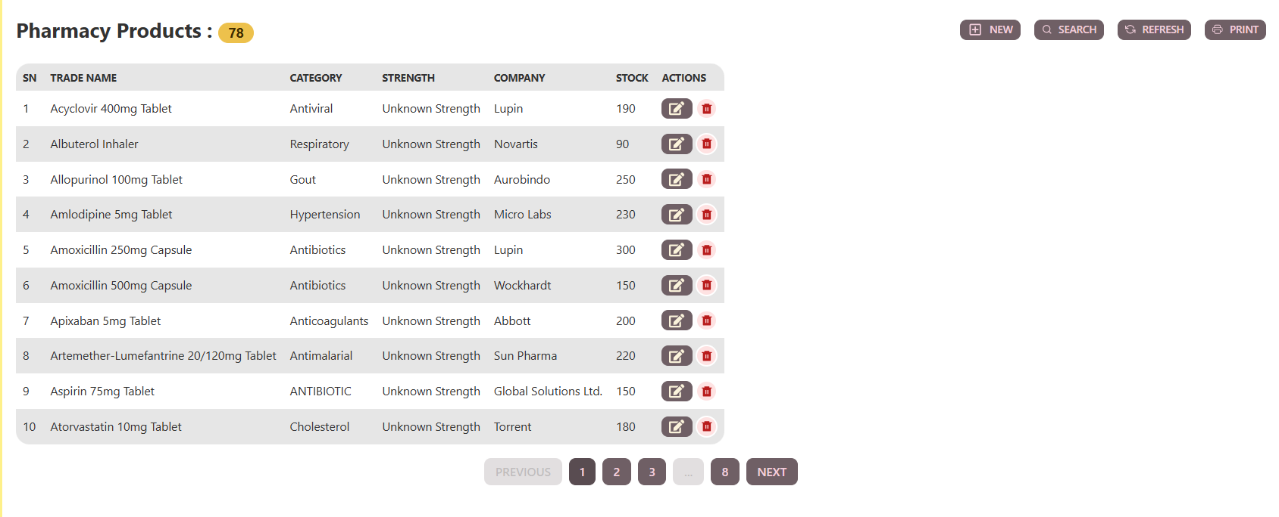

Figure 14. Screenshot of Pharmacy Products List
Purpose:
The Order Management Module facilitates the end-to-end ordering workflow between local stores (Sub Admins) and the central warehouse (Super Admin). It ensures smooth coordination of order placement, approval, dispatch, and delivery with tracking capabilities for transparency.
Key Features:
- Order Creation: Sub Admins can create medicine requisition orders from their store dashboard based on current stock needs.
- Approval Workflow: Orders placed by Sub Admins must be reviewed and approved/rejected by the Super Admin based on stock availability and business rules.
- Order Tracking: Orders move through clearly defined statuses — Pending, Approved, Rejected, Dispatched, Delivered.
- Invoice Generation: Automatically generates invoices based on order quantity and rates. Invoices are downloadable for recordkeeping.

Order Management Module

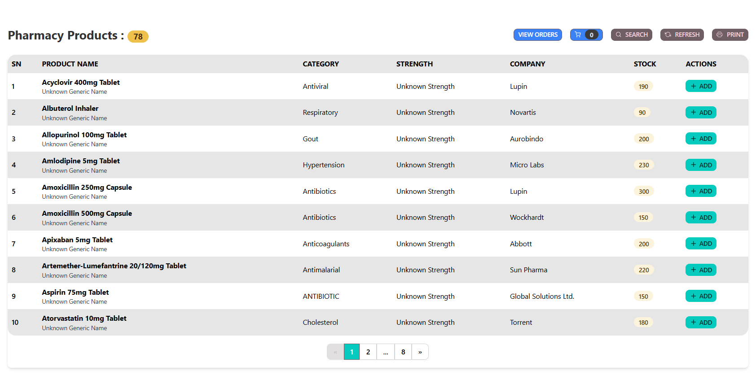 Figure 15. Order Management Page - Admin
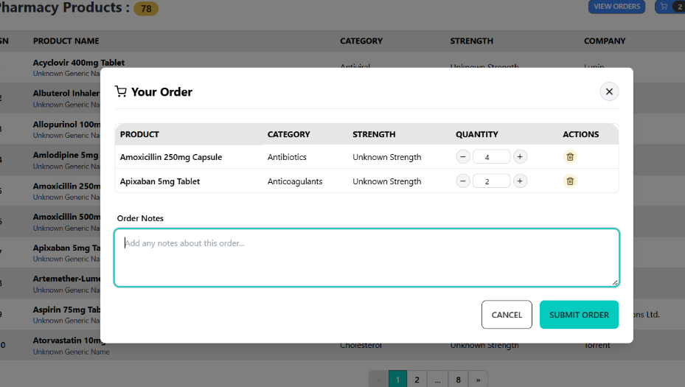
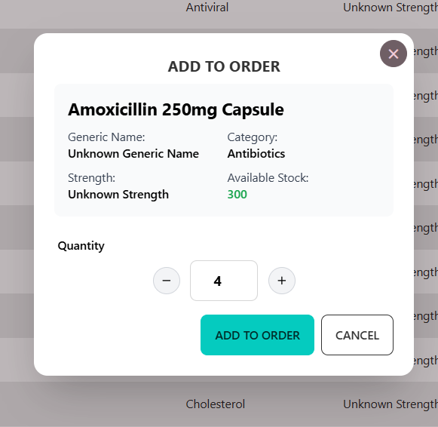

Figure 16. (i) & (ii) Order Handling - Admin
Purpose:
The Order Management Module facilitates the end-to-end ordering workflow between local stores (Sub Admins) and the central warehouse (Super Admin). It ensures smooth coordination of order placement, approval, dispatch, and delivery with tracking capabilities for transparency.
Key Features:
- Order Creation: Sub Admins can create medicine requisition orders from their store dashboard based on current stock needs.
- Approval Workflow: Orders placed by Sub Admins must be reviewed and approved/rejected by the Super Admin based on stock availability and business rules.
- Order Tracking: Orders move through clearly defined statuses — Pending, Approved, Rejected, Dispatched, Delivered.
- Invoice Generation: Automatically generates invoices based on order quantity and rates. Invoices are downloadable for recordkeeping.
Request for Products by Admin:
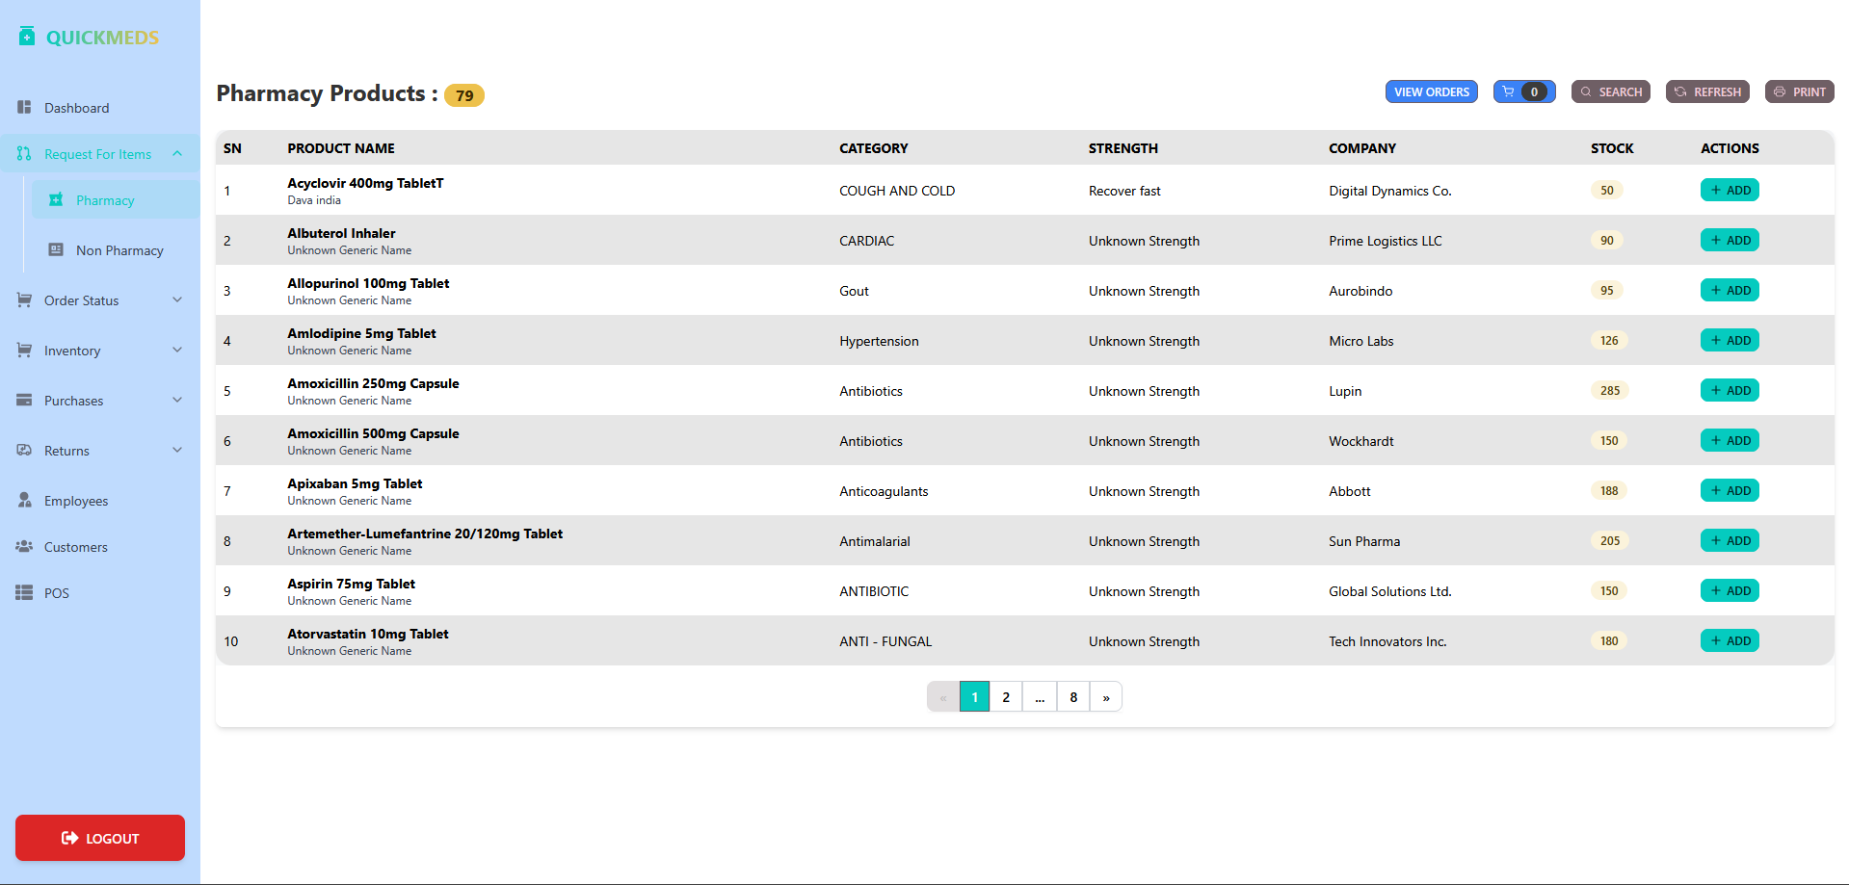

Figure 17. Admin Product Request
Purpose:
To allow sub-admins or store managers to view available pharmacy products and request required medicines from the central warehouse efficiently.
Key Features:
- Displays detailed product information including stock count and supplier.
- Provides "+ ADD" button for easy item selection and order placement.
- Real-time stock visibility ensures informed decision-making.
- Search, refresh, and print options improve usability and data handling.
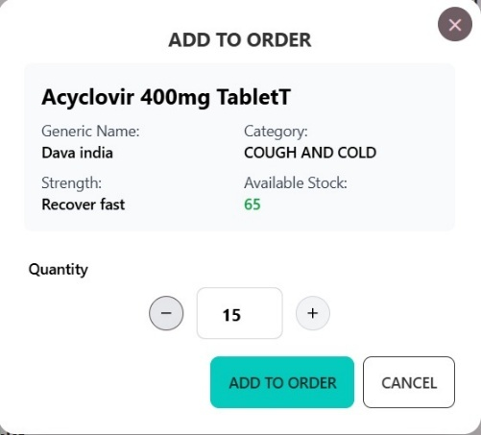
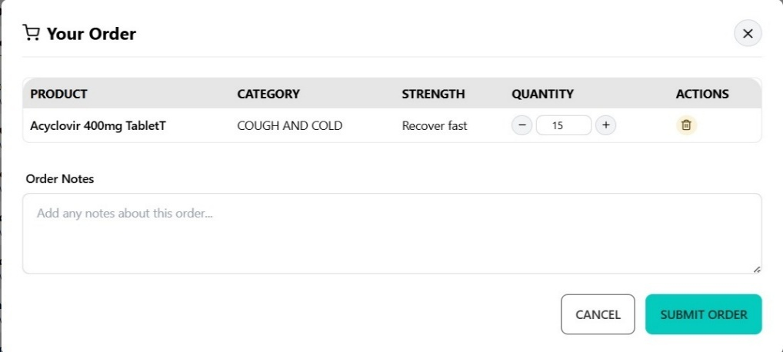
- Filtered view enables sub-admins to manage medicine procurement accurately.

Figure 18. Add & Submit Order - Admin

Approval for Products by Subadmin:
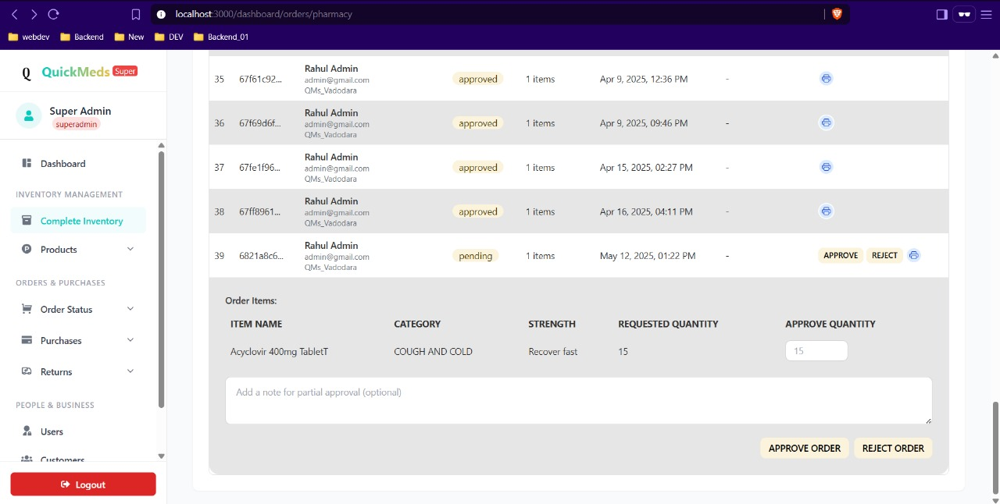

Figure 19. Superadmin Order Approval/Rejection
Purpose:
To give the Superadmin centralized control over all incoming medicine orders from local stores, allowing them to approve, reject, or dispatch orders based on stock availability and operational requirements.
Key Features:
- Order Request List: Displays pending orders with item details and requesting sub-admin info.
- Approval/Reject Controls: Superadmin can approve or decline requests with a single click.
- Stock Validation: Ensures order is only processed if stock is available in the central warehouse.
- Status Tracking: Orders are moved through statuses like Pending → Approved → Dispatched.
- Invoice Generation: Approved orders can be linked to automatic invoice creation.
- Notifications: Sub-admins are notified in real-time about approval or rejection decisions.
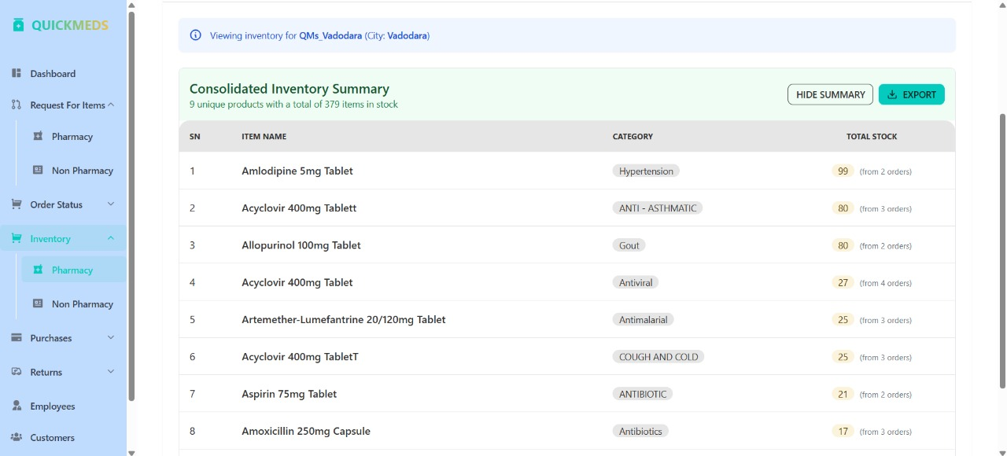

Figure 20. Admin Inventory

Purpose:
To give the Super Admin and Sub Admins centralized and real-time visibility over the medicine stock across the central warehouse and local stores, enabling efficient stock management, categorization, reordering, and stock level monitoring to prevent shortages or overstocking.
Key Features:
- Inventory Summary View: Shows total unique products and current stock quantity for the selected store.
- Itemized Stock Table: Displays item name, category, and total stock available, along with order contribution details.
- Category Labels: Medicines are tagged by category (e.g., Antibiotics, Antiviral) to simplify sorting and filtering.
- Store-Specific Inventory: Allows viewing inventory data filtered by individual store or location (e.g., Vadodara).
- Stock Tracking from Orders: Shows how many orders contributed to the current stock for transparency.

POS:
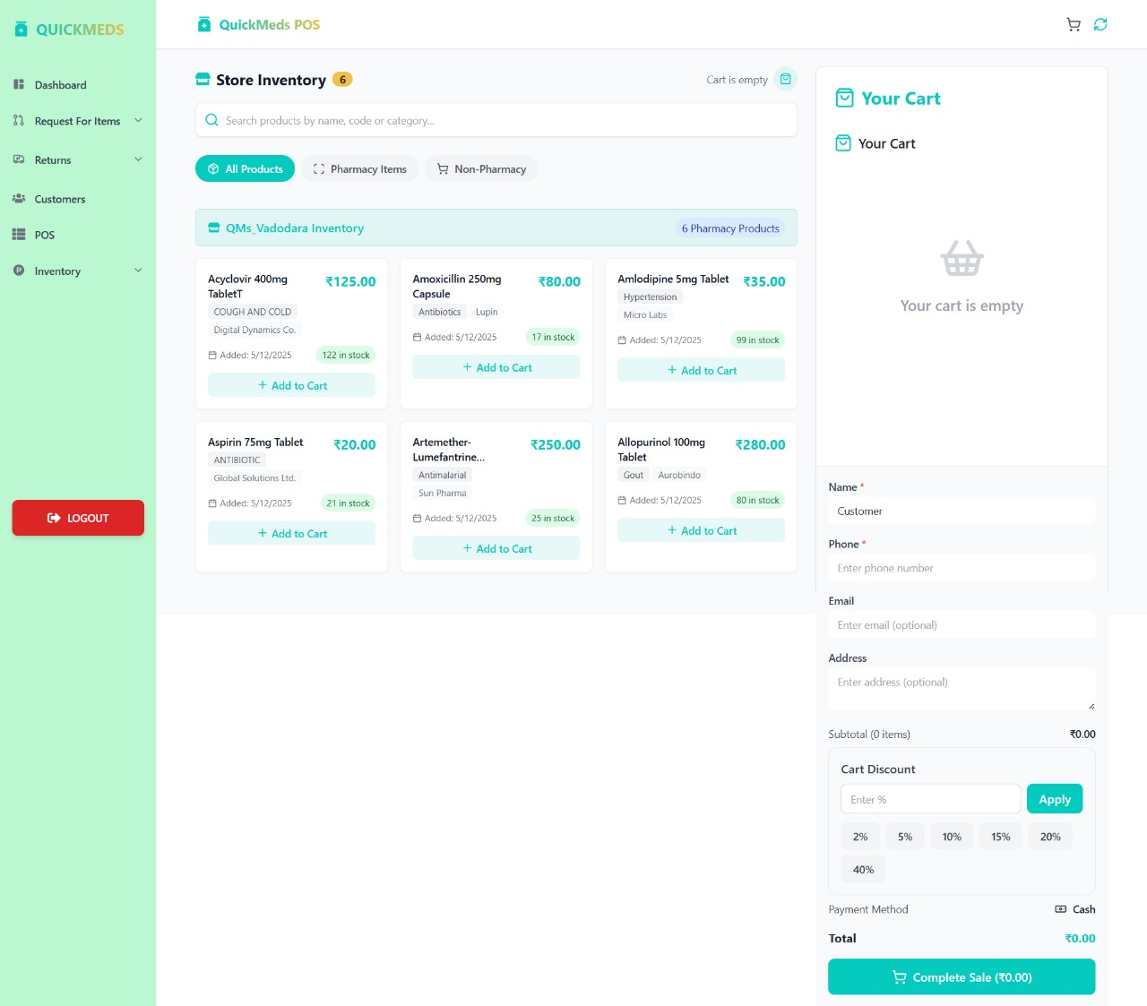

Figure 21. Point Of Sale (POS) - Employee
Purpose:
The POS system enables sub-admins and employees to efficiently process sales transactions, manage customer purchases, and ensure real-time stock updates, especially for offline purchases in local medical stores.
Key Features:
- Quick billing with automated price and tax calculations.
- Real-time inventory updates after each sale.
- Customer management with purchase history tracking.
- Support for discounts, offers, and loyalty programs.
- Printable and downloadable invoices for each transaction.
- Role-based access to ensure secure and accountable usage.
Order Successful:
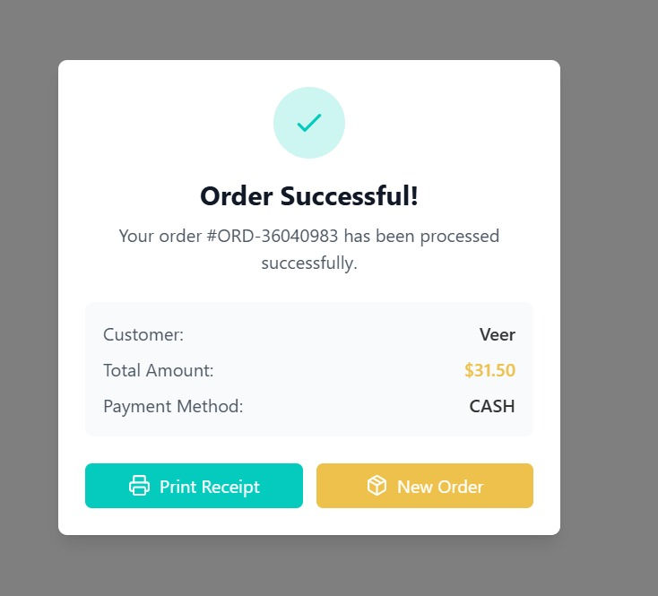

Figure 22. Order SuccessFull
Purpose:
To confirm successful transaction completion and provide employees with quick options to print a receipt or initiate a new sale.
Key Features:
- Displays order summary with key transaction details.
- Allows immediate receipt printing.
- Supports quick transition to new order entry.
- Enhances user efficiency during high customer flow.
- Visually indicates success for clear user feedback.

Bill Generation:
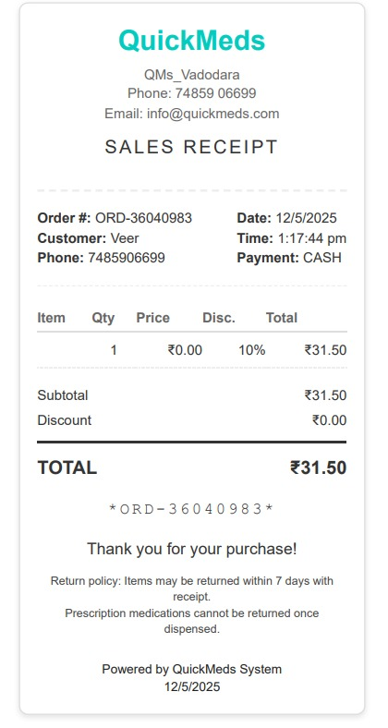

Figure 23. Bill
Purpose:
To confirm successful transaction completion and provide employees with quick options to print a receipt or initiate a new sale.
Key Features:
- Displays order summary with key transaction details.
- Allows immediate receipt printing.
- Supports quick transition to new order entry.
- Enhances user efficiency during high customer flow.
- Visually indicates success for clear user feedback.

Testing using Use Cases

Authentication Module
Test Case ID | Scenario | Test Steps / Data | Expected Result
TC_AUTH_01 | Register with blank fields | Email: -Password: - | Prompt: "Please fill all fields"
TC_AUTH_02 | Register with existing email | Email already in DB | Prompt: "Email already registered"
TC_AUTH_03 | Register with new user role | Role: Sub-Admin Valid email/pass | Successful registration, redirect to dashboard
TC_AUTH_04 | Login with invalid credentials | Wrong email/pass | Error: "Invalid credentials"
TC_AUTH_05 | Login with correct credentials | Valid email/pass | Redirect to user’s dashboard
TC_AUTH_06 | Password reset | Email exists in DB | Password reset link sent
TC_AUTH_07 | 2FA Enabled Login | Enter OTP after login | Access granted after verification

Table 3.1 Testing Report - Authentication

User Management Module
Test Case ID | Scenario | Test Steps / Data | Expected Result
TC_UM_01 | Add a new Sub Admin | Name, Email, Role: Sub Admin | Sub Admin added successfully
TC_UM_02 | Update Employee details | Change name, email | Updated in system
TC_UM_03 | Delete user account | User ID provided | User removed from DB

Table 3.2 Testing Report – User Management

Inventory Management Module
Test Case ID | Scenario | Test Steps / Data | Expected Result
TC_INV_01 | Add new medicine | Name: Paracetamol, Qty: 500 | Medicine added to warehouse
TC_INV_02 | Update existing stock | Increase qty by 200 | Updated quantity shown
TC_INV_03 | Delete expired medicine | Select expired batch | Removed from inventory

Table 3.3 Testing Report – Inventory Management

Order Management Module
Test Case ID | Scenario | Test Steps / Data | Expected Result
TC_ORD_01 | Place new order | Sub Admin → 200 units | Order request created
TC_ORD_02 | Approve order | Super Admin → approve | Status: Approved
TC_ORD_03 | Track order status | ID: ORD001 | Status flow shown

Table 3.4 Testing Report – Order Management

Conclusion and Future work

Conclusion
The QuickMeds Centralized Medicine Management System has been conceptualized, analyzed, and designed to address the operational challenges of managing inventory, orders, and sales across a network of local medical stores and a central warehouse. The system incorporates role-based access control for Super Admins, Sub Admins, and Employees, ensuring secure and efficient collaboration. Each module — including inventory management, order processing, sales tracking, and revenue reporting — has been tailored to meet the specific functional needs of a decentralized yet connected pharmacy ecosystem. By digitizing and automating critical processes such as stock updates, offline sales entries, and real-time notifications, QuickMeds aims to improve operational accuracy, enhance productivity, and support data-driven decision-making.
The project followed a systematic approach starting from requirement gathering, system design, implementation, and testing. Comprehensive testing based on use cases validated the reliability of the system modules. Overall, the project successfully meets its intended objectives of providing an integrated platform that facilitates streamlined medicine distribution and sales management.

Future work
While the current version of QuickMeds addresses the foundational needs of inventory and sales management, several enhancements can be explored in future iterations:
- Payment Gateway Integration: Future versions can include online payment modules for facilitating real-time customer payments and reconciling financial transactions.
- Mobile Application Support: Developing a cross-platform mobile app would allow Sub Admins and Employees to manage tasks conveniently on the go.
- Machine Learning for Demand Forecasting: Implementing predictive analytics can help in forecasting medicine demand, reducing wastage, and optimizing stock levels.
- Customer Feedback and Ratings: A module for capturing customer feedback on medicines or service quality can help improve customer satisfaction and store performance.
- Integration with Health Records: Future versions may integrate electronic health records (EHR) to allow personalized medicine suggestions based on prescription history.
- Multi-language Interface: Adding support for regional languages would improve accessibility for users across different geographies.
These enhancements would further elevate QuickMeds into a full-scale pharmacy management platform, supporting greater scalability, intelligent decision-making, and user engagement.

References
- PharmEasy – https://www.pharmeasy.in
An online pharmacy offering medicine delivery, lab tests, and healthcare products across India.
- NetMeds – https://www.netmeds.com
A digital pharmacy platform providing prescription medicines, wellness products, and health consultations.
- DavaIndia – https://www.davaindia.in
A generic pharmacy retail chain focused on affordable healthcare through high-quality generic medicines.
- 1mg – https://www.1mg.com
A digital health platform offering medicine delivery, lab tests, doctor consultations, and health plans.

