* Create a New .NET Core Project

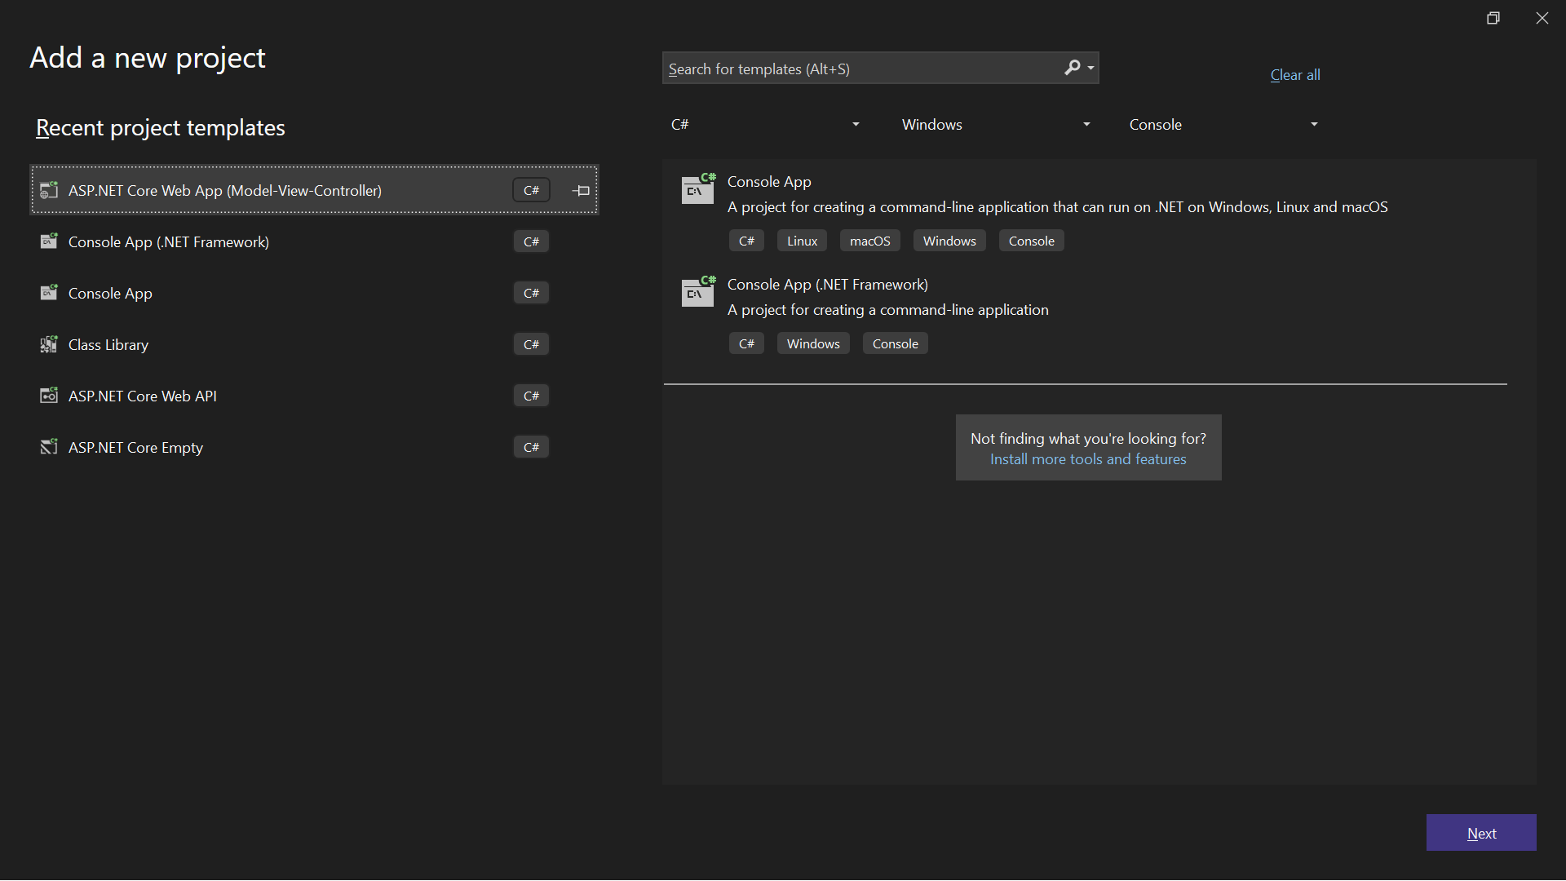

* Install Rotativa.AspNetCore NuGet Package

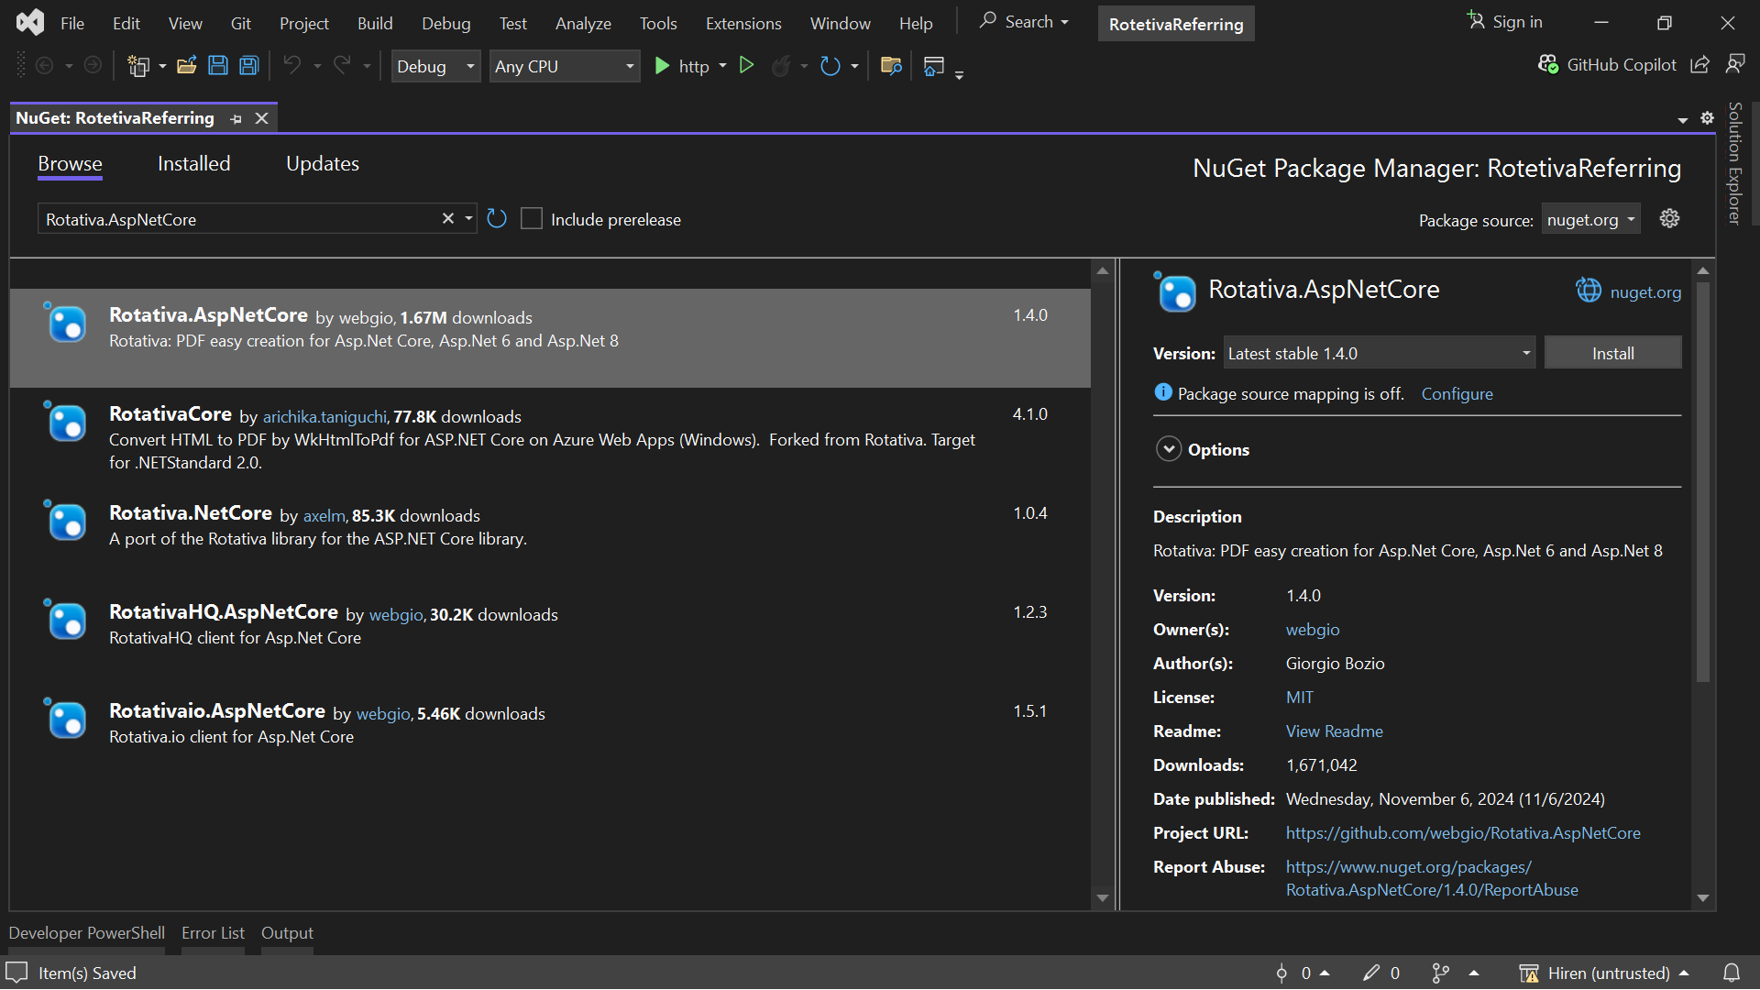

* Based on the GitHub repository link:
* <https://github.com/webgio/Rotativa/tree/master/Rotativa/Rotativa>
* Copy the 4 files from that directory and create a "Rotativa" folder in wwwroot at your project.
* Then, paste the 4 files inside the folder, as shown in the image below.

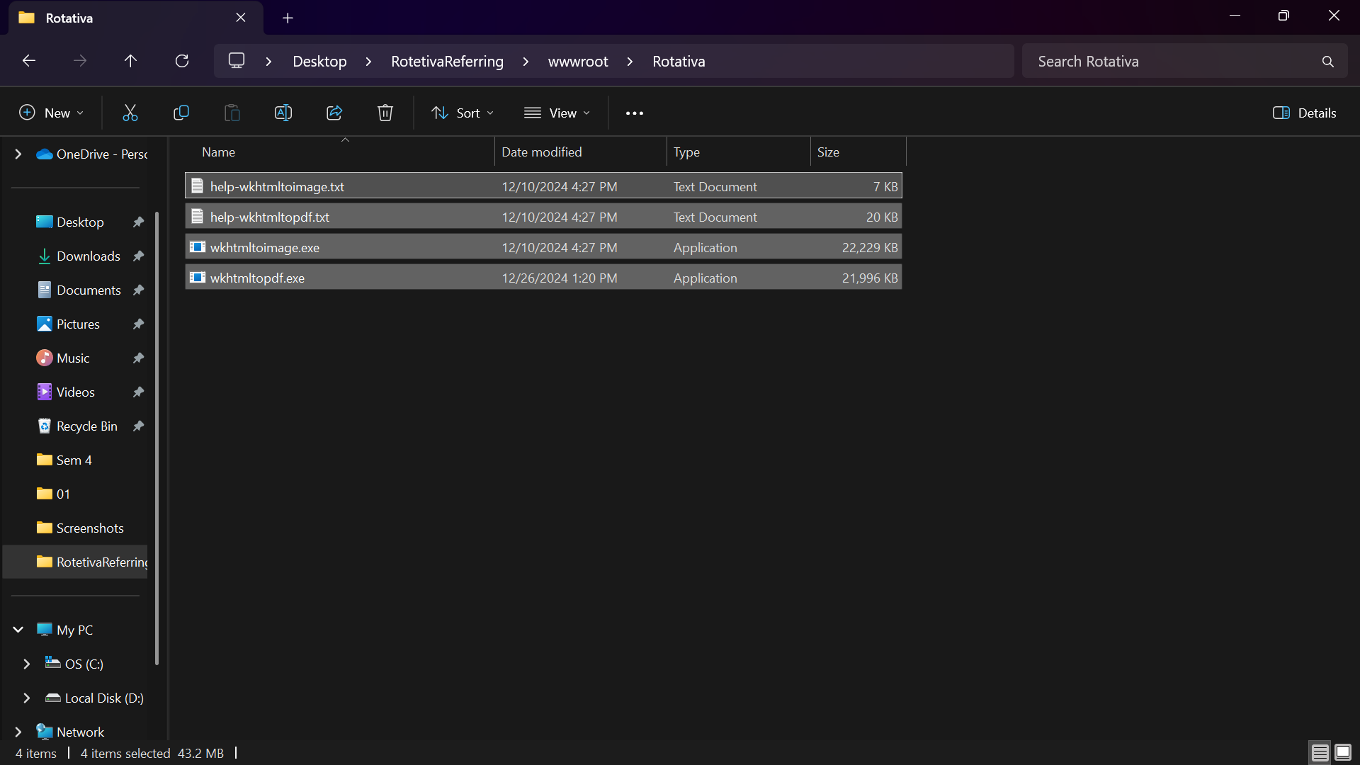

* Now, configure Rotativa in your Program.cs as shown in the image below.

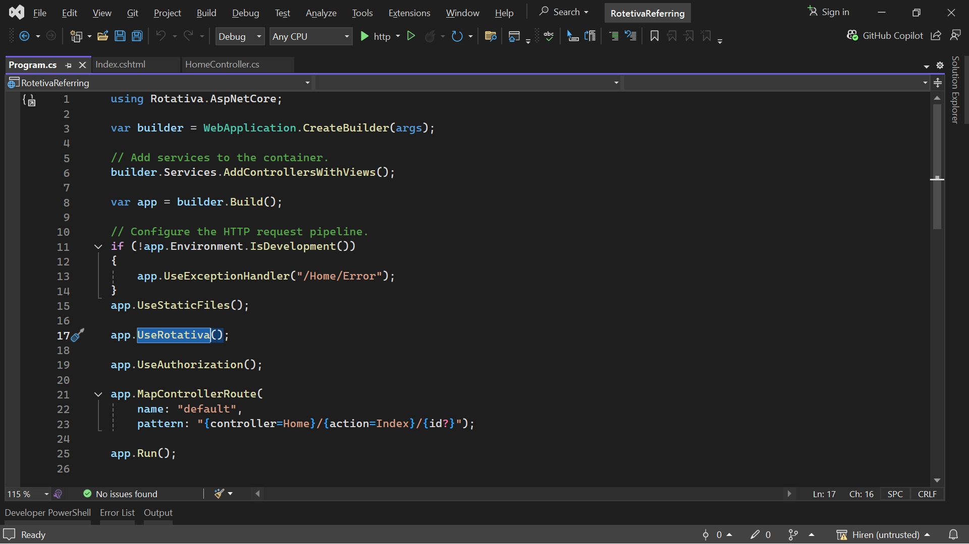

* Create a Controller to Generate PDF

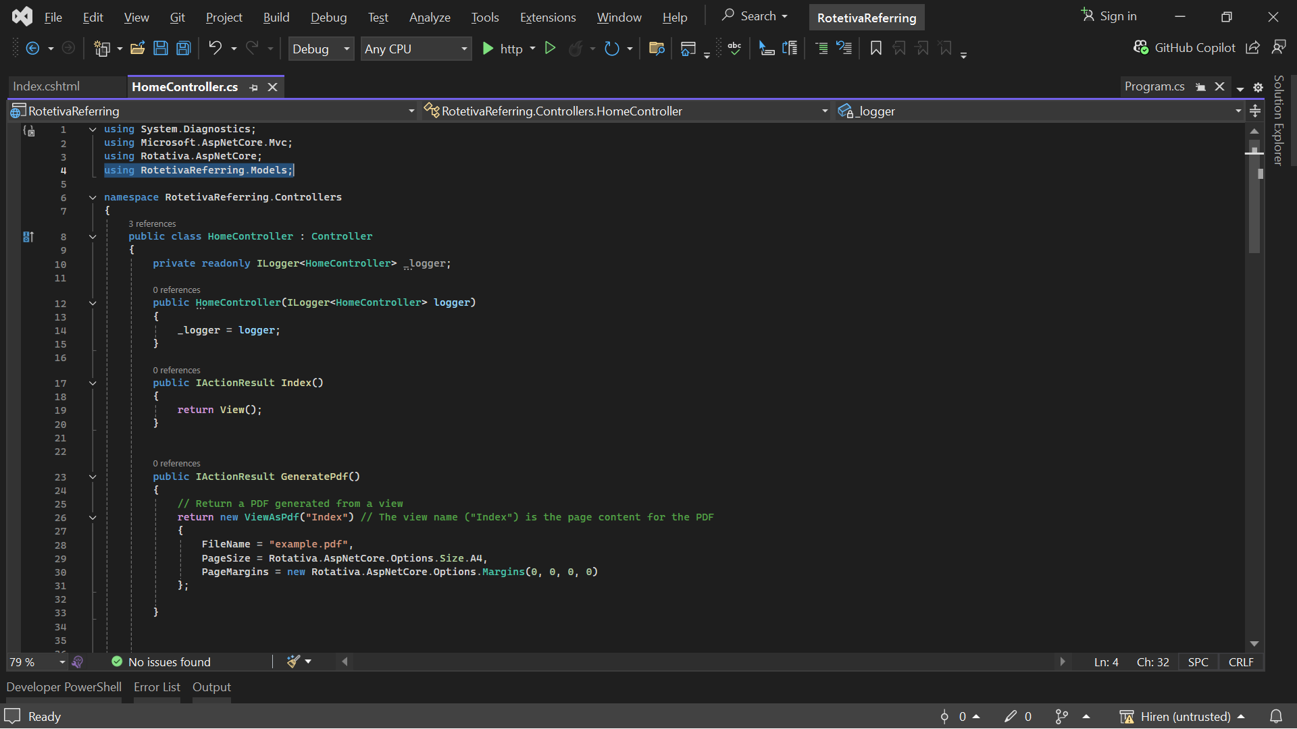

* Create a View to Render HTML Content

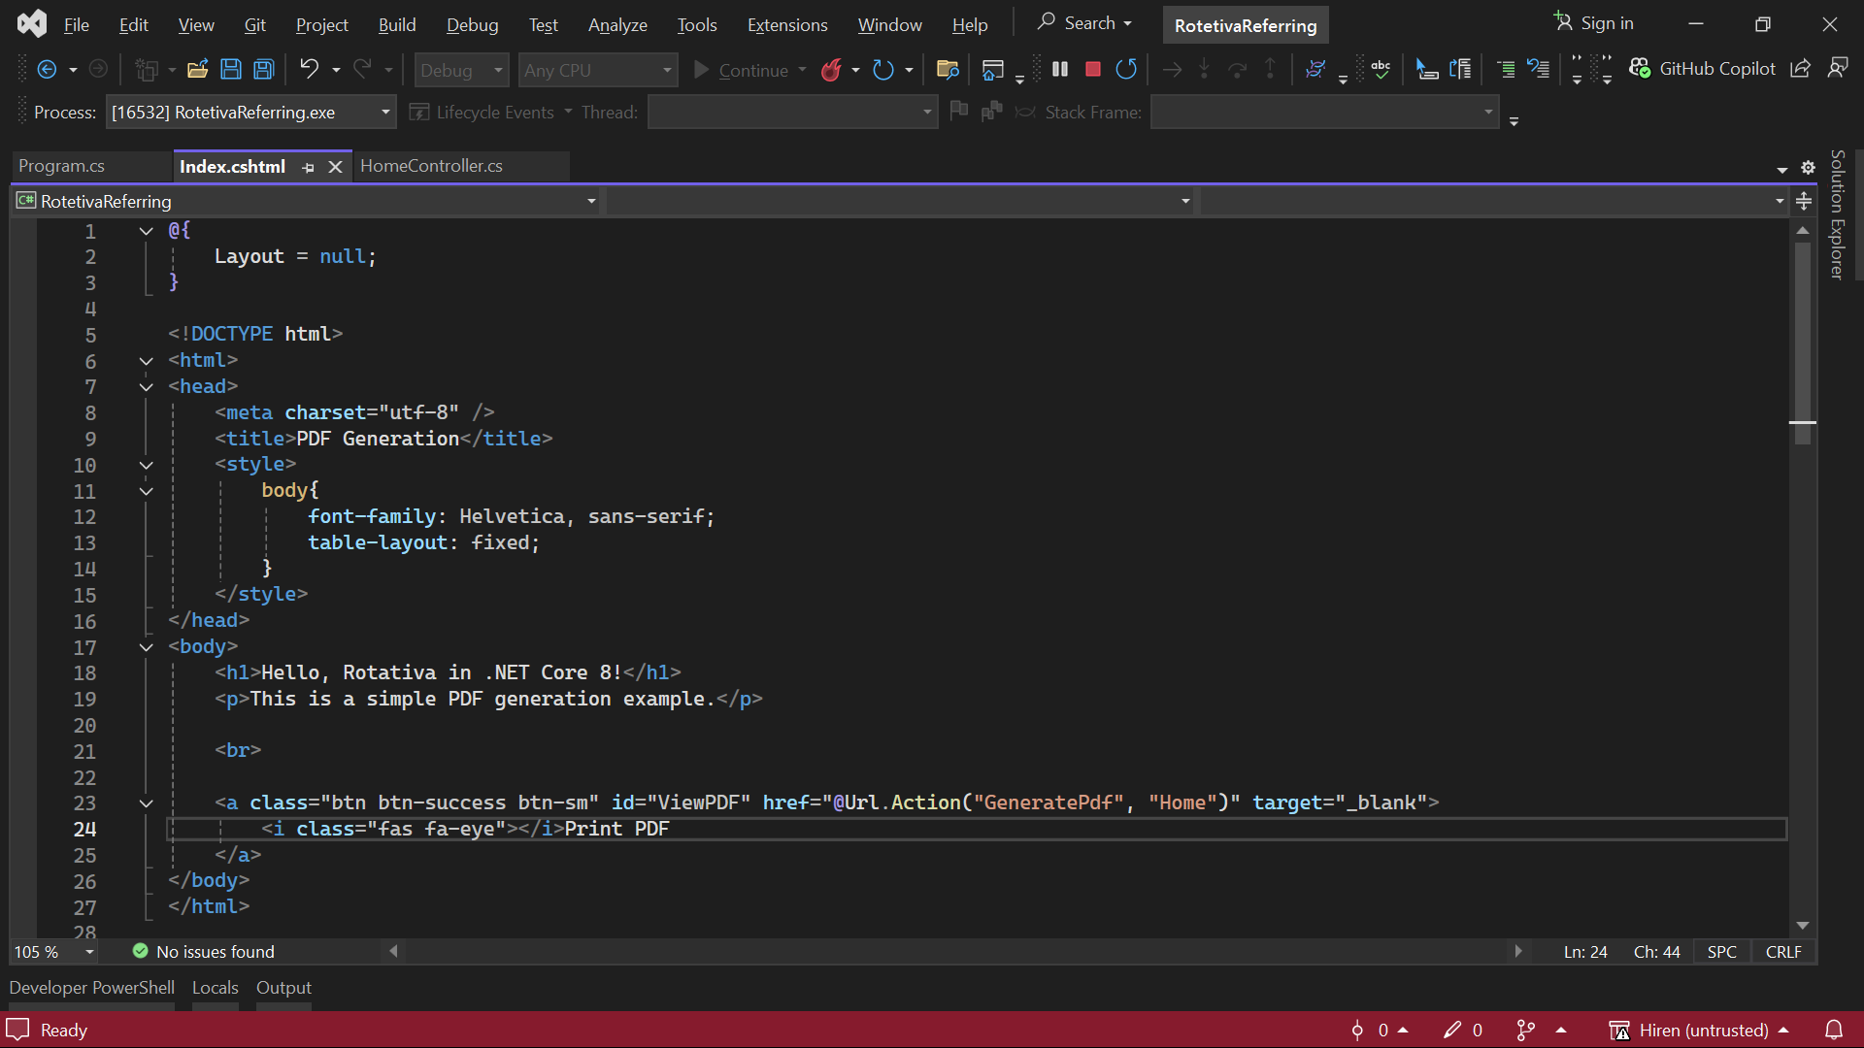

* When you run the project, you will see the results.

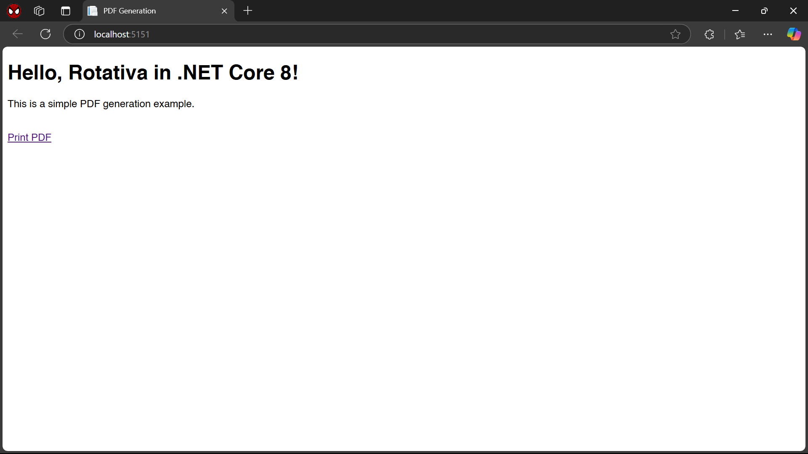

* After downloading the PDF, you will see the result.

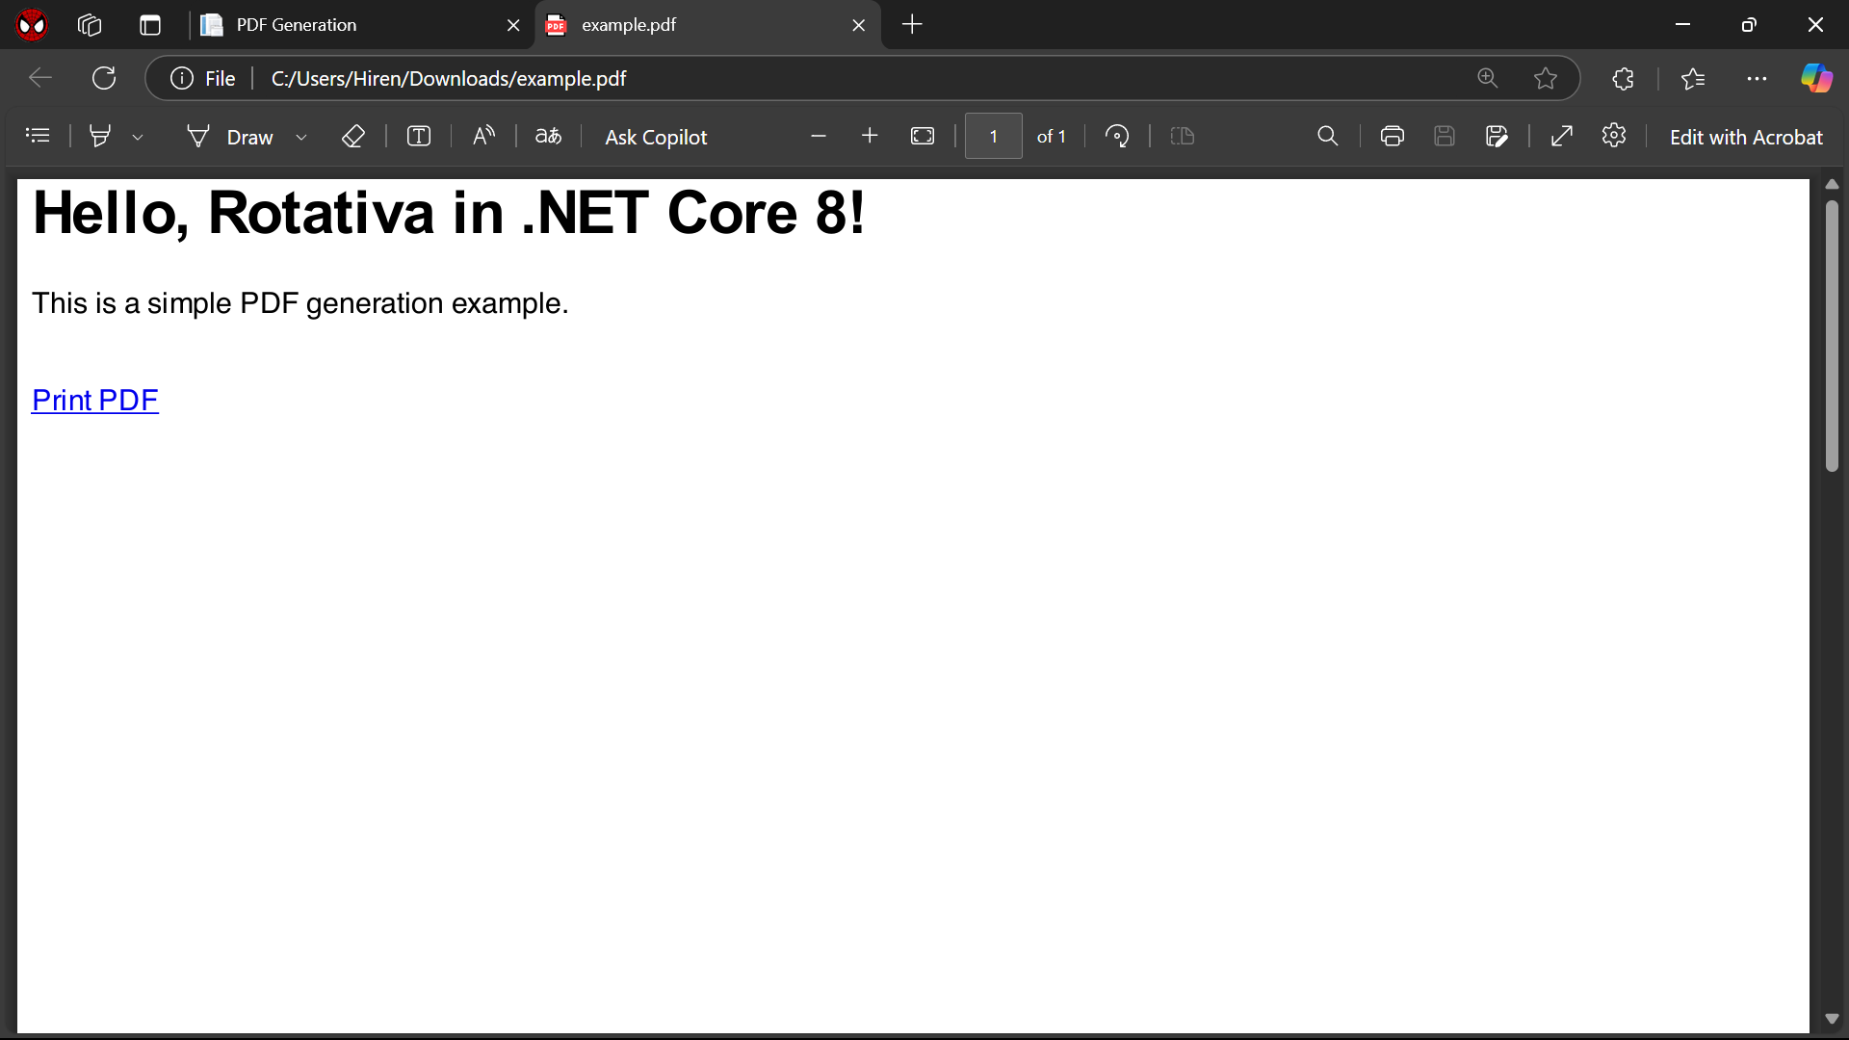

Now, let's try to generate a PDF for dynamic data.

I have covered the following points:

1. **Dynamic Data**
2. **Header and Footer Repetition**
3. **Page Numbers on Every Page**

* Create a ViewModel for that, as shown in the image below.

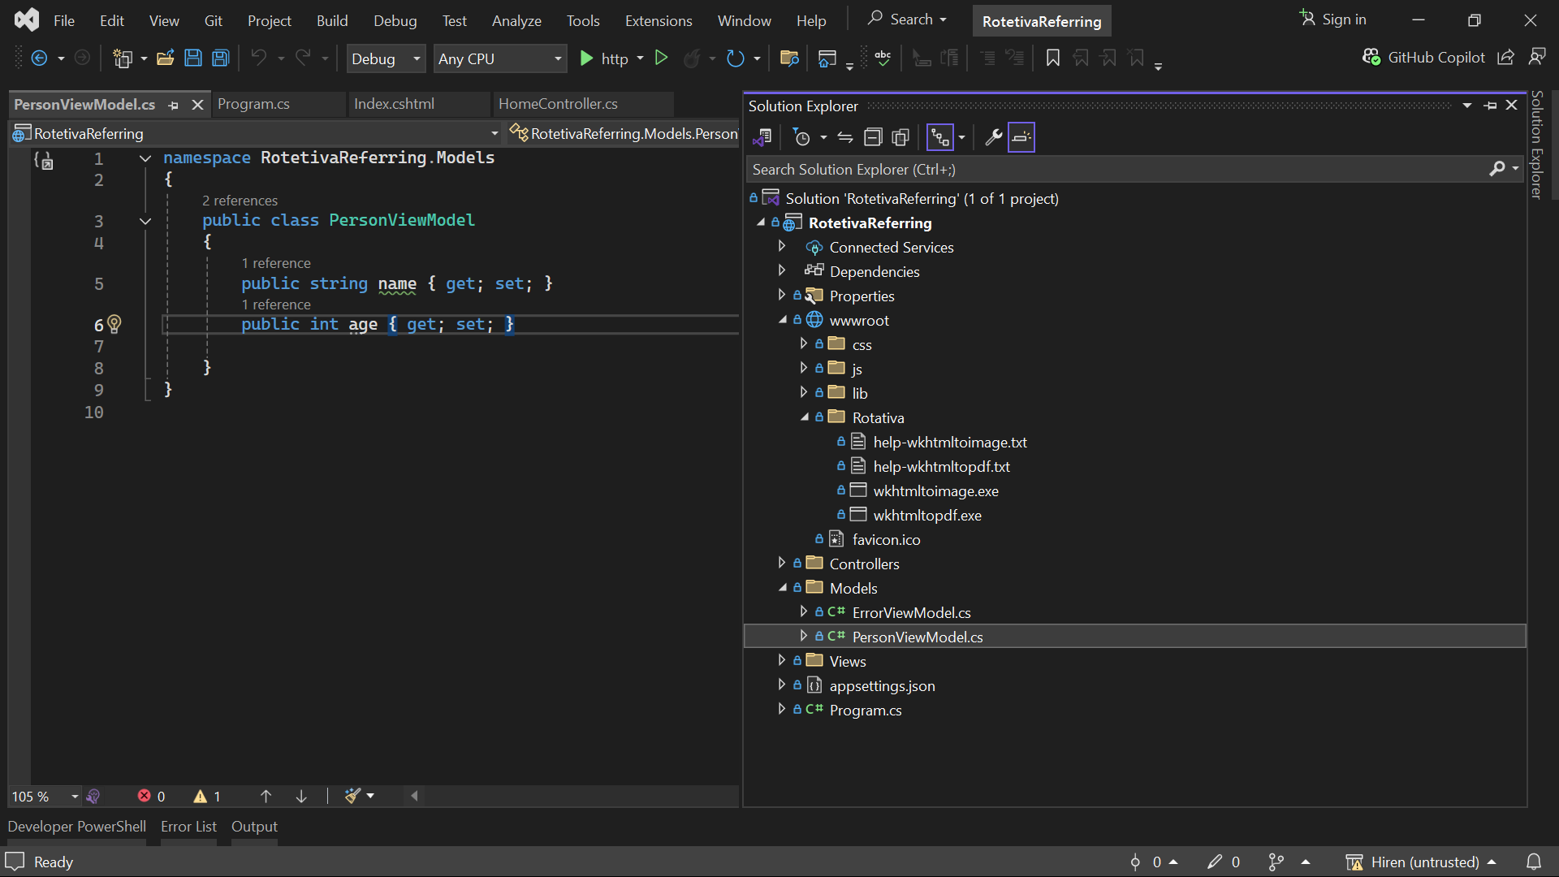

* Now, make changes in the controller code as follows.

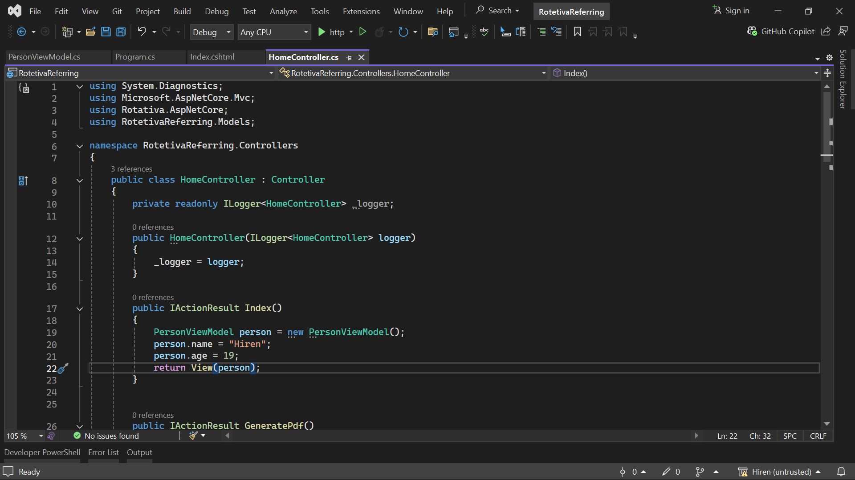

* Now, access that model in your view as follows.

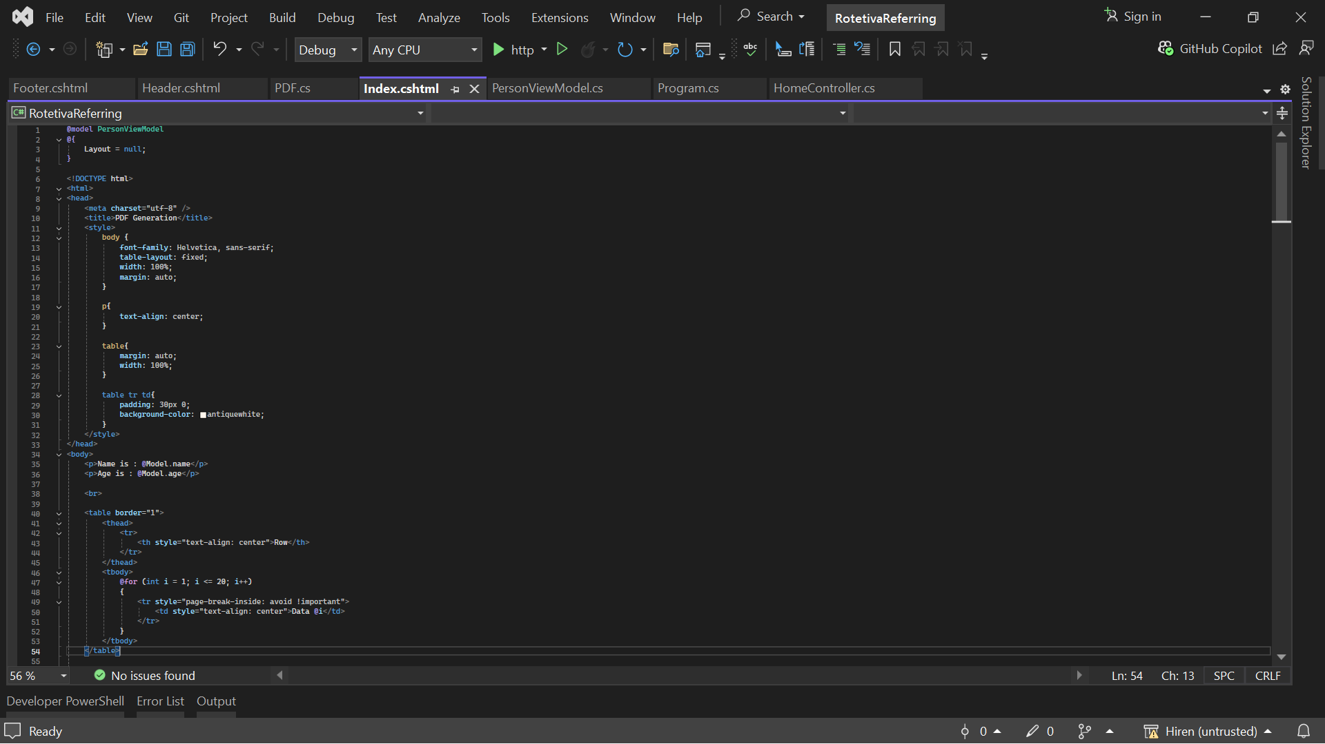

* Now, let's start working on the Header and Footer sections.
* Create a new controller, for example, named 'PDF'. Inside this controller, define two action methods as shown in the image below.

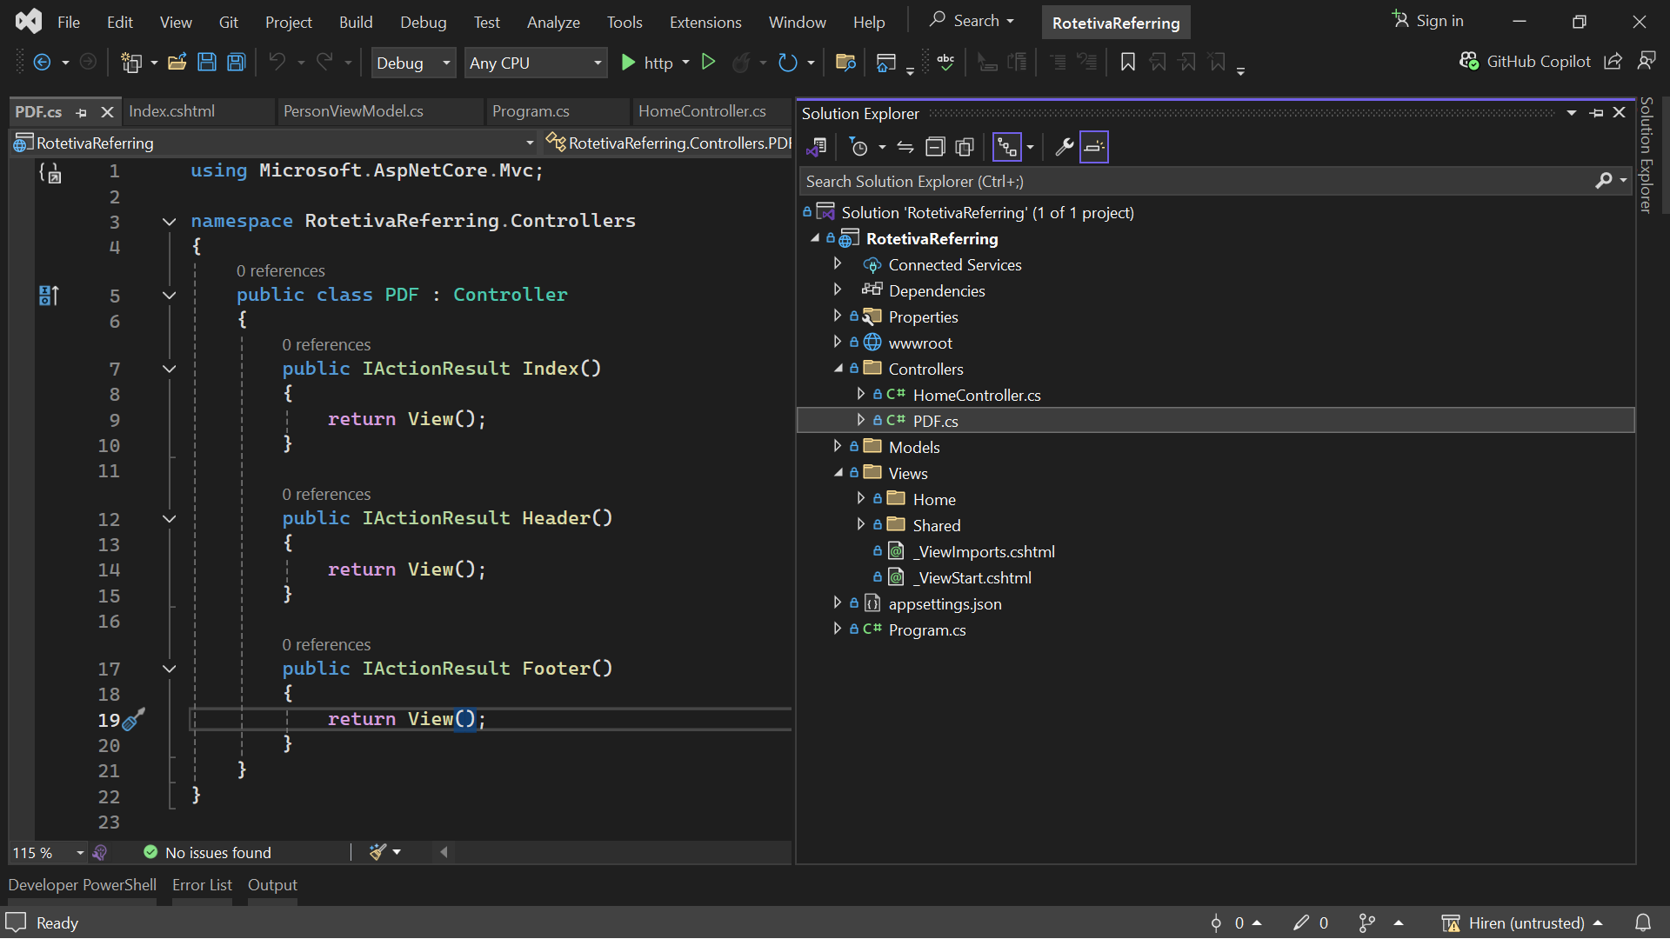

* Now, let's create the view for those action methods.
* This is for the Header view.

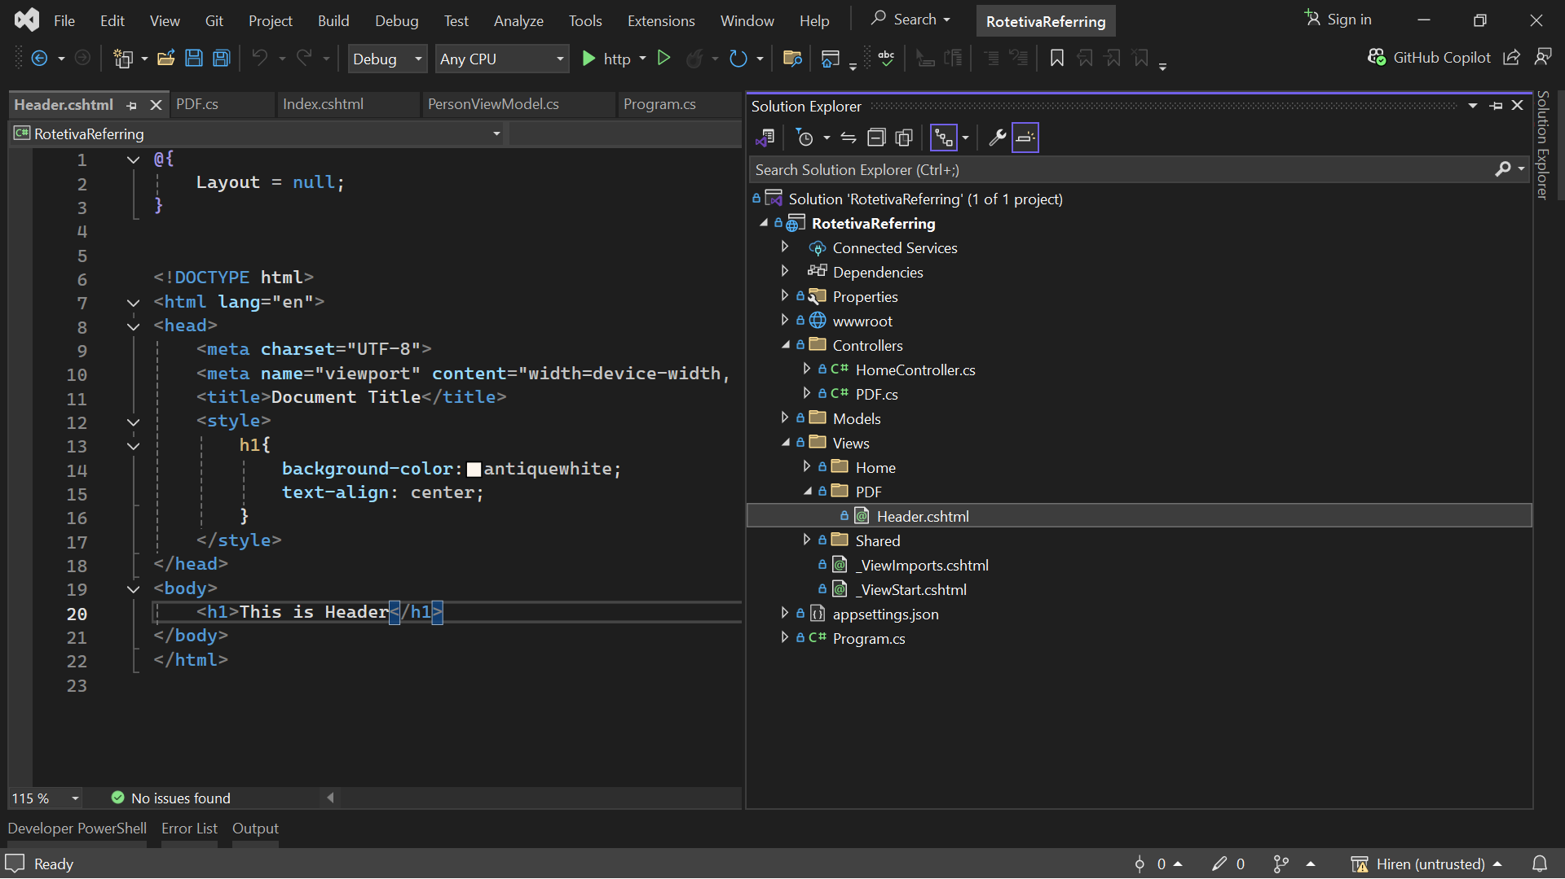

* This is for the Footer view with dynamic page numbers.
* First, apply this script in the Footer view.

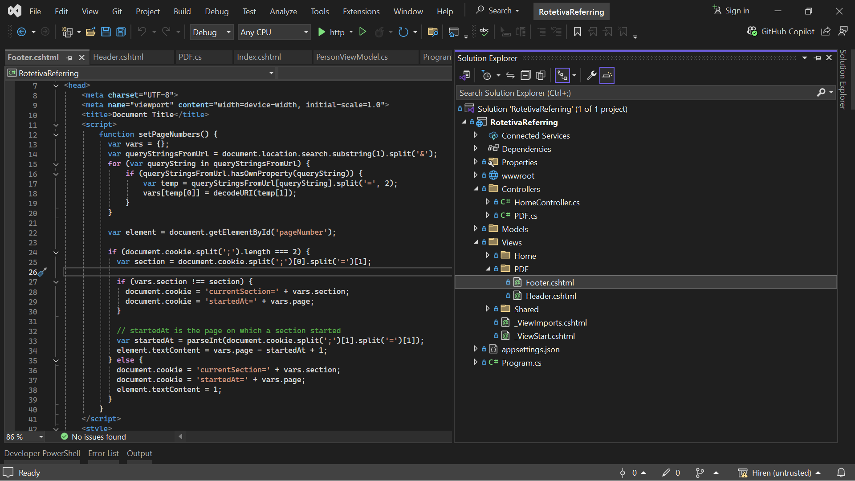

* Below is the view of the footer with page numbers.
* **Don't forget to call the setPageNumbers() function on body load.**

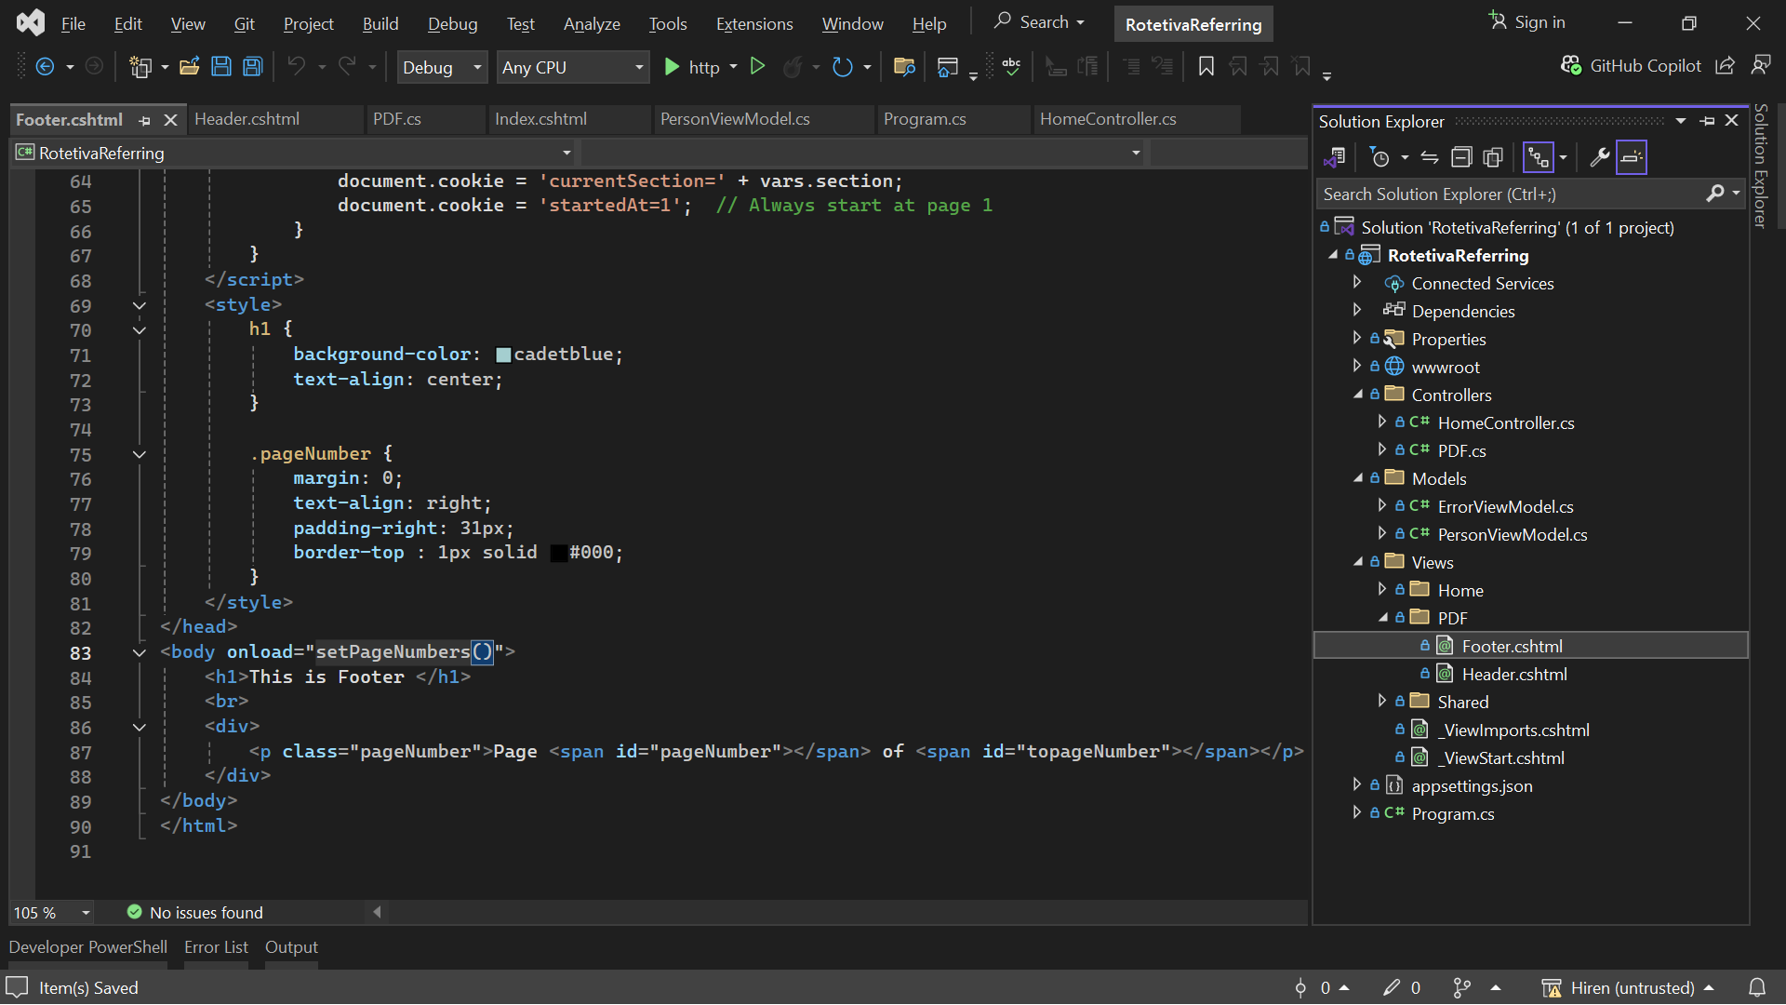

* Now, we need to integrate the header and footer with the main view for downloading the PDF.
* Go to the main controller and make the changes as shown in the image below.

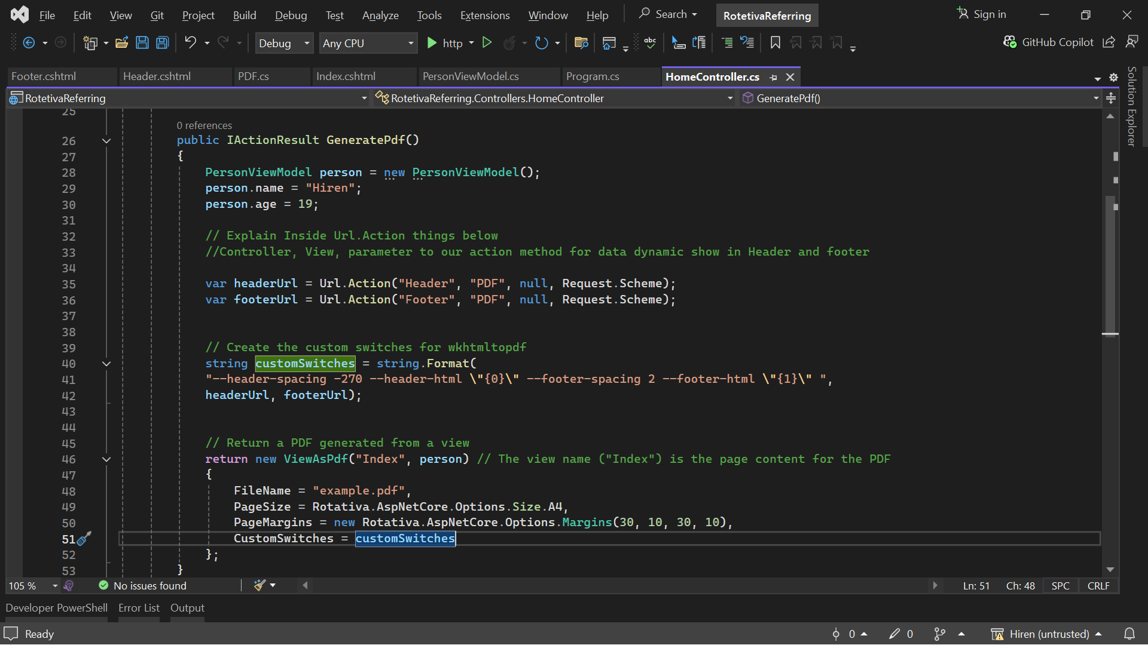

* As a result, you should see the output as shown in the images below.

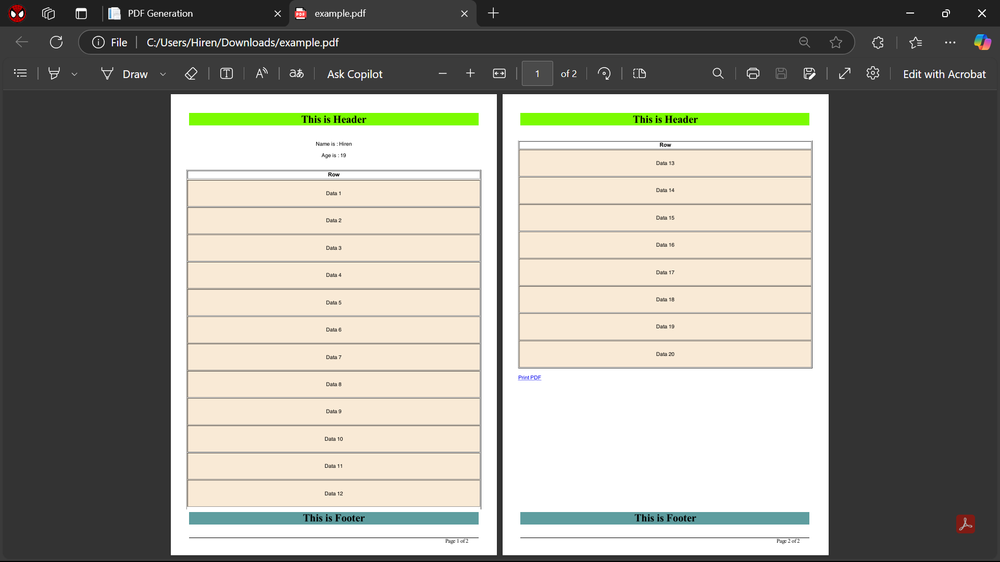  
  
THANK YOU 😊

If you have any questions, feel free to message me on LinkedIn: [Hiren Patel](https://www.linkedin.com/in/hiren-patel-524809282/).