MODULE -1

Q.1 Write a simple "Hello World" program in two different programming languages of your choice. Compare the structure and syntax?

Ans. In Java :

public class learn {

public static void main(String[] args) {

System.out.println("Hello World!");

}

In C:

#include<stdio.h>

void main(){

printf("Hello world);

}

Q2. Research and create a diagram of how data is transmitted from a client to a server over the internet?

Ans.

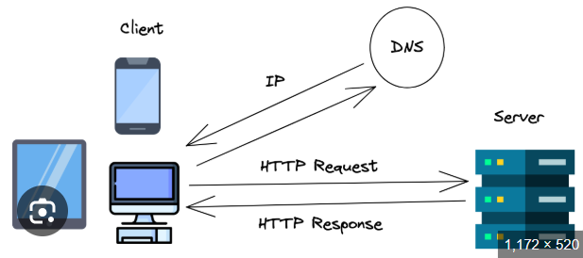

Q.3 Design a simple HTTP client-server communication in any language?

Ans. 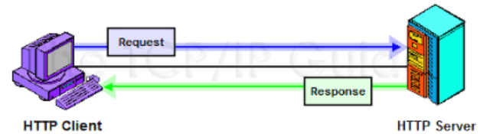

Q.4 Research different types of internet connections (e.g., broadband, fiber, satellite) and list their pros and cons?

Ans.

| **Type** | **Pros** | **Cons** |
| --- | --- | --- |
| **DSL** | Cheap, uses phone line, widely available | Slower, speed drops with distance |
| **Cable** | Fast, good for streaming & gaming | Shared bandwidth, upload slower |
| **Fiber** | Very high speed, low latency, future-proof | Limited availability, costly install |
| **Wireless** | Easy setup, works in rural areas | Weather/signal issues, less stable |
| **Satellite** | Works anywhere, good for remote areas | Expensive, high latency, weather issues |
| **Mobile (4G/5G)** | Portable, fast (esp. 5G), easy setup | Data caps, speed depends on coverage |

Q.5 Simulate HTTP and FTP requests using command line tools (e.g., curl).

Ans.

HTTP:-

1. GET Request:-

curl <http://example.com>

FTP:-

1. List Files on FTP Server

curl ftp://ftp.example.com/

Q.6 Identify and explain three common application security vulnerabilities. Suggest possible solutions

Ans.

**3 Common Application Security Vulnerabilities**

1. **SQL Injection (SQLi)**
   * **Issue:** Malicious SQL in input → database hacked.
   * **Fix:** Use prepared statements, sanitize input.
2. **Cross-Site Scripting (XSS)**
   * **Issue:** Malicious script runs in user’s browser.
   * **Fix:** Escape/validate input, use CSP.
3. **Cross-Site Request Forgery (CSRF)**
   * **Issue:** User tricked into unwanted actions (like money transfer).
   * **Fix:** Use CSRF tokens, SameSite cookies.

Q.7 Identify and classify 5 applications you use daily as either system software or application software?

Ans.

### ****Five applications I use daily and their classification****

1. **Microsoft Word** → Application Software (used for creating and editing documents).
2. **Google Chrome** → Application Software (used for browsing the internet).
3. **WhatsApp (Desktop/Web)** → Application Software (used for communication and messaging).
4. **Windows Operating System** → System Software (manages computer hardware and provides a platform for applications).
5. **Audio Driver** → System Software (enables communication between the operating system and sound hardware).

Q.8 Design a basic three-tier software architecture diagram for a web application?

Ans.

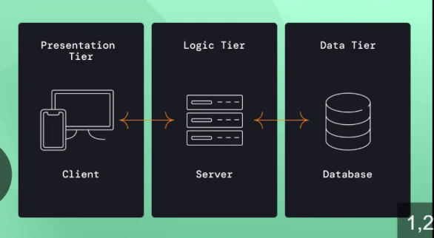

Q.9 Create a case study on the functionality of the presentation, business logic, and data access layers of a given software system?

Ans.

# ****Case Study: Online Food Ordering System****

### ****1. Presentation Layer (UI)****

* User interface (web/app).
* Shows menus, takes input (login, orders, payment).
* Tech: HTML, CSS, JS, React.

### ****2. Business Logic Layer****

* Handles rules & processing.
* Validates login, calculates bills, manages orders.
* Tech: Java, Node.js, Python, .NET.

### ****3. Data Access Layer****

* Stores and retrieves data.
* Keeps user info, restaurant menu, orders, payments.
* Tech: MySQL, MongoDB, PostgreSQL.

**Workflow:** User orders → Business Layer checks & processes → Database stores order.

**Conclusion:** 3-tier = **UI + Logic + Data** → organized, secure, scalable.

Q.10 Explore different types of software environments (development, testing, production). Set up a basic environment in a virtual machine?

Ans.

Q.11 Write and upload your first source code file to Github?

Ans. There are screenshot that I made 2 word of practical and theory I write a code in this two word file:-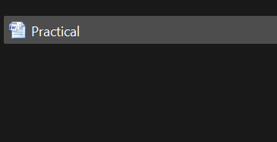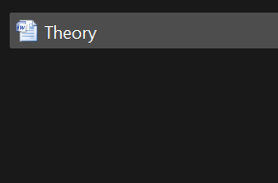

Uploads:-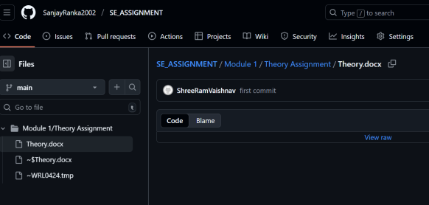

Q.12 Create a Github repository and document how to commit and push code changes?

Ans.Git repo that I have made already:- in this repo it have a one folder that is module and I have write a code in this two word and after write a code intilize git by git bash and add origin after git add command use ,git commit command use and push in origin.

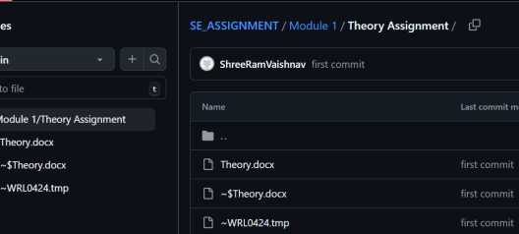

Q.14 Create a student account on Github and collaborate on a small project with a classmate?

Ans.

Q.15 Create a list of software you use regularly and classify them into the following categories: system, application, and utility software?

Ans.

1. **Microsoft Word** → Application Software (used for creating and editing documents).
2. **Google Chrome** → Application Software (used for browsing the internet).
3. **WhatsApp (Desktop/Web)** → Application Software (used for communication and messaging).
4. **Windows Operating System** → System Software (manages computer hardware and provides a platform for applications).
5. **Audio Driver** → System Software (enables communication between the operating system and sound hardware).

Q.16 Follow a GIT tutorial to practice cloning, branching, and merging repositories?

Ans.

Clone a Repository:-

Ex- git clone <https://github.com/octocat/Hello-World.git>.

Create a New Branch:-

Ex- git checkout -b my-feature.

Merge Branches

Ex- git merge my-feature

Q.17 Write a report on the various types of application software and how they improve productivity?

Ans.

Q.18 Create a flowchart representing the Software Development Life Cycle (SDLC).

Ans.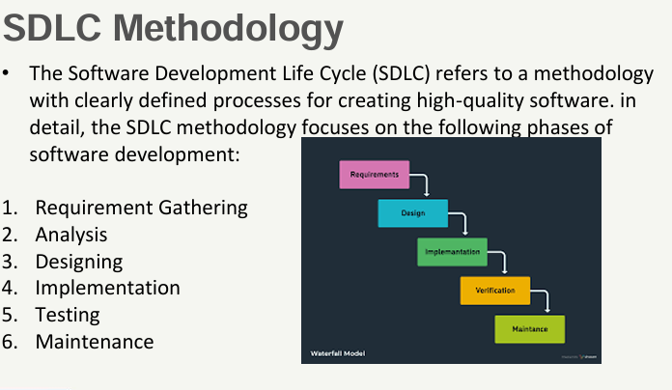

Q.19 Write a requirement specification for a simple library management system?

Ans.

# Requirement Specification – Library Management System

### ****1. Introduction****

The system manages books, users, and borrowing/returning activities in a library.

### ****2. Functional Requirements****

* **User Management:**
  + Add/update/delete members.
  + Manage login (admin, librarian, member).
* **Book Management:**
  + Add/update/delete books.
  + Search books by title, author, subject.
* **Transaction Management:**
  + Issue and return books.
  + Track due dates and fines.
  + Maintain borrowing history.

### ****3. Non-Functional Requirements****

* **Usability:** Easy-to-use interface.
* **Security:** Only authorized users can manage books/transactions.
* **Performance:** Quick search and fast transactions.
* **Scalability:** Should support more users/books in the future.

Q.20 Perform a functional analysis for an online shopping system?

Ans.

# Functional Analysis – Online Shopping System

### ****Main Functions****

1. **User Management**
   * User registration, login, profile update.
2. **Product Management**
   * Browse/search products.
   * View product details (price, description, reviews).
3. **Shopping Cart**
   * Add/remove/update items.
   * View total cost.
4. **Order Management**
   * Place orders.
   * Track order status (pending, shipped, delivered).
5. **Payment Management**
   * Secure payment (cards, UPI, wallets).
   * Generate receipts.
6. **Admin Functions**
   * Manage products, categories, stock.
   * View sales reports.

Q.21 Design a basic system architecture for a food delivery app?

Ans.

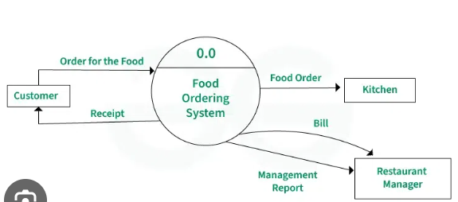

Q.22 Develop test cases for a simple calculator program?

Ans. Test Cases:-

* First We take two or more inputs and one operator this operator perform operation.
* Second We Put some conditions of like sum ,sub ,mul and div that put inputs in it.
* After switch case perform and we got some output that we call.

Q.23 Document a real-world case where a software application required critical maintenance?

Ans.

Q.24 Create a DFD for a hospital management system?

Ans.

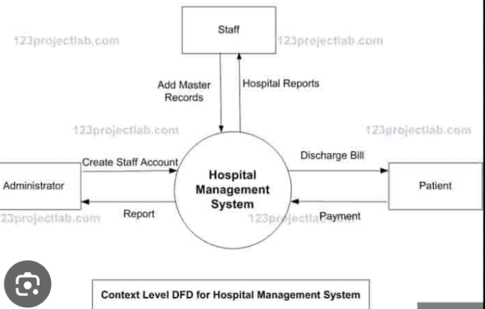

Q.25 Build a simple desktop calculator application using a GUI library?

Ans.

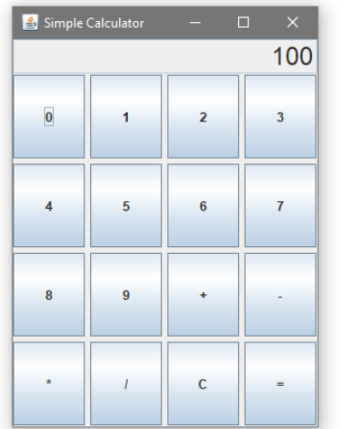

Q.26 Draw a flowchart representing the logic of a basic online registration system?

Ans.



