Natural Language Search

With the increasing amount of information available on the Internet one of the most challenging tasks is to provide search interfaces that are easy to use without having to learn a specific syntax. The development and availability of efficient and appropriate search functions are still a challenge in the field of database and information systems. Consider, for example, the context of tourism information systems where intuitive search functionality plays a crucial role for economic success. Querying an information system in natural language is especially appealing in the tourism domain because users usually have very different backgrounds regarding their computer literacy. Hardly any computer scientist or technically interested person has problems understanding the Boolean logic underlying conventional web search engines. Unfortunately, a growing majority of people using search engines has.
Hence, we have developed a query interface exploiting the intuitiveness of natural language. The system allows to transform open text to flight search query such as “cheap fares to spain from london on 2nd April”. The open text parser engine will convert this as a Oneway query to Madrid from London on 2015/04/02 for 1ADT.

Features of OpenText Search.
1) Single Text box Search.
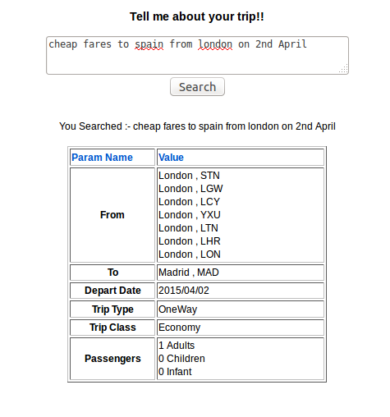

The Engine has only one text box to enter various inputs. Traditional search widgets has minimum 7 input box. The engine provides huge simplicity in this area and lets user give choice to ask query in their own way.

2) Automatic nearest airport selection
If user ignores to provide his starting point. The system will try to find out nearest commercial airports from his current location. There are 9000+ airports or air field world wide but only 3900+ airports has scheduled passenger flights. The engine ensures that when it auto select airport it takes care while selecting airport. The system never selects airport which doesn't operate passenger flights. In the given screen-shot, the query has start point missing, It has correctly selected nearest airport which is Ahmedabad.
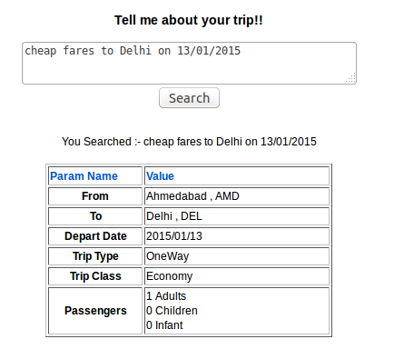

3) Speed
The System parser is really very fast It takes around 150 ms to process inputs and convert that into HTML or JSON output. The system use various technology like Cache , BerkleyDB and Persistence to enhance performance.

4) Pluggable
The system is designed to sit outside the main system and function independently. The system takes search text as a inputs and provide parsed query in JSON format. The specific JSON query than can be feed into main system to search flights.

5) Spelling correction
The system looks for spelling correction. The City names are not normally part of dictionary so they never comes under the spelling correction. We have enhanced spelling correction to City names as well. This gives us benefit against any possible typo in city name which is were likely to happen. In below given search Mumae has wrong spelling but that is corrected by the parser.

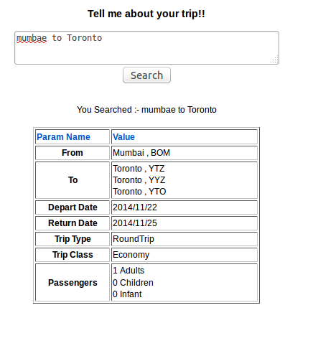

6) Enhanceable
We have tried to cover very wide range of possibilities while designing and developing this service. The system can add possible enhancements by adding support for it.

Several Samples that are easily parsed by the system and converted into Air Search query.

1) goa to bangalore in december

2) i'd like to visit Scranton, PA in June for three days

3) looking for a weekend in florida in summer

4) Cheap Rome fares

5) i would like to spend two weeks in miami this winter

6) want to take two week holiday in pattaya this winter

7) Tuna fishing off Jamaica in July

8) tickets to jamaica for party of six

9) I want to visit New York in the third week of July

10) flights vancouver tokyo sept 1 to 14

11) what are the fares for greece in summer

12) one way ticket to moscow july 7

13) Visit Mumbai in January 2014

14) spring break miami trip for two

15) Looking for flights to Frankfurt in summer

16) ny - las vegas next weekend

17) looking for one way ticket to london

18) can i get the cheapest fares for los angeles starting sept 9 and returning sept 18

19) family trip to San Diego zoo next month

20) Ahmadabad to Australia for 10 to 15 days

21) cheap flights toronto london july 18 to aug 3

22) what does it cost for rome to barcelona

23) Want best rates to Montreal in the fall

24) yow yhz september return

25) Want cheap fares to Las Vegas in February

26) a week in jamaica in august

27) mnp to nyc feb 18 - 21

28) Best fares to Lisbon and Algarve for June

29) good fares to spain from londom in 2nd half April

30) toronto to sydney at christmas for two weeks

31) Flights to California in June second week

32) what are the rates for travel to italy in the summer

33) best price new york to prague july 18 to 30

34) best prices for week holiday to ny spring break

35) refundable fare vancouver london april 1 to 10

36) Ahmadabad to Melbourne next Thursday for 4 days

37) Family trip to Los Angeles and Disneyland in August

38) i want to go to athens from madrid april 18

39) Antigua for two weeks in November

40) I want to visit new york for a weekend in winter

41) three day visit lancaster pa march weekend of 15th

42) Ahmadabad to Singapore next Tuesday

43) mumbai two weeks jan 18 to feb 2

44) three day visit lancaster pa march weekend of 15th

45) two tickets vancouver to madrid september 15 returning the 30th

46) lowest fares edmonton to paris around summer

47) i am looking for inexpensive flights from toronto to ny

48) three day visit lancaster pa weekend of march 15th

49) I want a cheap Halifax fare middle of July

50) I want to take the kids skiing to Quebec City in January

