**CCNA ASSIGNMENT**

**Module – 1**

1. Explain what is the OSI reference model?

* OSI stands for Open System Interconnection is a reference model that describes how information from a software application in one computer moves through a physical medium to the software application in another computer.
* OSI consists of seven layers, and each layer performs a particular network function.
* OSI model was developed by the International Organization for Standardization (ISO) in 1984, and it is now considered as an architectural model for the inter-computer communications.
* OSI model divides the whole task into seven smaller and manageable tasks. Each layer is assigned a particular task.
* Each layer is self-contained, so that task assigned to each layer can be performed independently.

1. What is a Network?

A network is a collection of computers, servers, mainframes, network devices, peripherals, or other devices connected to allow data sharing. An example of a network is the Internet, which connects millions of people all over the world. To the right is an example image of a home network with multiple computers and other network devices all connected.

1. What are Routers?

Routers are networking devices operating at layer 3 or a network layer of the OSI model. They are responsible for receiving, analysing, and forwarding data packets among the connected computer networks. When a data packet arrives, the router inspects the destination address, consults its routing tables to decide the optimal route and then transfers the packet along this route.

1. Explain Encapsulation.

In computer networking, encapsulation is a method of designing modular communication protocols in which logically separate functions in the network are abstracted from their underlying structures by inclusion or information hiding within higher-level objects.

1. What is Peer-to-Peer Communication?

A peer to peer network is a simple network of computers. Here each computer acts as a node for file sharing within the formed network. Here each node acts as a server and thus there is no central server to the network. This allows the sharing of a huge amount of data. The tasks are equally divided amongst the nodes. Each node connected in the network shares an equal workload. For the network to stop working, all the nodes need to individually stop working. This is because each node works independently.

1. What is TCP and UDP?

|  |  |  |
| --- | --- | --- |
| **Feature** | **TCP** | **UDP** |
| **Connection status** | Requires an established connection to transmit data (connection should be closed once transmission is complete) | Connectionless protocol with no requirements for opening, maintaining, or terminating a connection |
| **Data sequencing** | Able to sequence | Unable to sequence |
| **Guaranteed delivery** | Can guarantee delivery of data to the destination router | Cannot guarantee delivery of data to the destination |
| **Retransmission of data** | Retransmission of lost packets is possible | No retransmission of lost packets |
| **Error checking** | Extensive error checking and acknowledgment of data | Basic error checking mechanism using checksums |
| **Method of transfer** | Data is read as a byte stream; messages are transmitted to segment boundaries | UDP packets with defined boundaries; sent individually and checked for integrity on arrival |
| **Speed** | Slower than UDP | Faster than TCP |
| **Broadcasting** | Does not support Broadcasting | Does support Broadcasting |
| **Optimal use** | Used by HTTPS, HTTP, SMTP, POP, FTP, etc | Video conferencing, streaming, DNS, VoIP, etc |

1. What is Internetwork Operating System software?

Cisco IOS (Internetwork Operating System) is a proprietary operating system that runs on Cisco Systems routers and switches. The core function of Cisco IOS is to enable data communications between network nodes.

1. Explain LAN and draw any example.

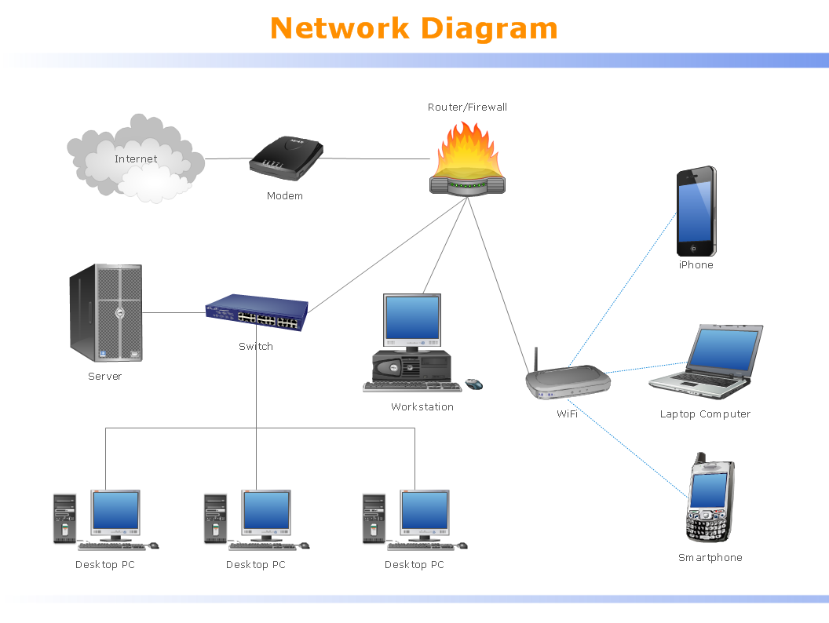

A local area network (LAN) is a devices network that connect with each other in the scope of a home, school, laboratory, or office. Usually, a LAN comprise computers and peripheral devices linked to a local domain server. All network appliances can use a shared printers or disk storage. A local area network serve for many hundreds of users. Typically, LAN includes many wires and cables that demand a previously designed network diagram. They are used by IT professionals to visually document the LANs physical structure and arrangement.

1. Explain Network Device - Router Switch and Hub.

* Hub - A Hub is just a connector and connects the wires coming form different sides. There is no signal processing or regeneration. It is an electronic device that operates on only physical layers of the OSI model.
* Switch - Switch is a point to point communication device. It operators at the data link layer of OSI model. It uses switching table to find out the correct destination.
* Router - Routers are the multiport devices and more sophisticated as compared to repeaters and bridges. It contains a routing table that enables it to make decision about the route i.e. to determine which of several possible paths between the source and destination is the best for a particular transmission.

1. Describe Router and switch connection in LAN.

Router and Switch are both network connecting devices. Router works at network layer and is responsible to find the shortest path for a packet whereas Switch connects various devices in a network. Router connects devices across multiple networks.

1. Types of Cable - explain types of Ethernets and speed.

Coaxial Cables: A coaxial cable is used to carry high-frequency electrical signals with low losses. It uses 10Base2 and 10Base5 Ethernet variants. It has a copper conductor in the middle that is surrounded by a dielectric insulator usually made of PVC or Teflon. The dielectric insulator is surrounded by a braided conducting metallic shield which reduces EMI (Electromagnetic Interference) of the metal and outside interference; and finally, the metallic shield is covered by a plastic covering called a sheath usually made of PVC or some other fire-resistant plastic material. Its maximum transmission speed is 10 Mbps. It is usually used in telephone systems, cable TV, etc.

Twisted Pair Cable: Twisted pair is a copper wire cable in which two insulated copper wires are twisted around each other to reduce interference or crosstalk. It uses 10BASE-T, 100BASE-T, and some other newer Ethernet variants. It uses RJ-45 connectors.

Fiber Optic Cable: Fiber optic cables use optical fibers which are made of glass cores surrounded by several layers of cladding material usually made of PVC or Teflon, it transmits data in the form of light signals due to which there are no interference issues in fiber optics. Fiber optics can transmit signals over a very long distance as compared to twisted pairs or coaxial cables. It uses 10BaseF, 100BaseFX, 100BaseBX, 100BaseSX, 1000BaseFx, 1000BaseSX, and 1000BaseBx Ethernet variants. Hence, it is capable of carrying information at a great speed.

1. Explain TCP/IP -List of Protocol and port Number.

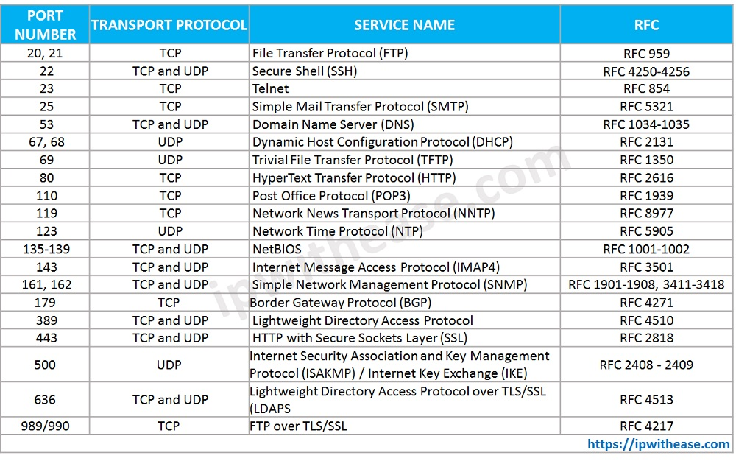

1. Explain Node (backbone) and Physical layer.

A backbone or core network is a part of a computer network which interconnects networks, providing a path for the exchange of information between different LANs or subnetworks.A backbone can tie together diverse networks in the same building, in different buildings in a campus environment, or over wide areas. Normally, the backbone's capacity is greater than the networks connected to it.

A large corporation that has many locations may have a backbone network that ties all of the locations together, for example, if a server cluster needs to be accessed by different departments of a company that are located at different geographical locations. The pieces of the network connections (for example: Ethernet, wireless) that bring these departments together is often mentioned as network backbone. Network congestion is often taken into consideration while designing backbones