IT7742 Assignment 1 – Technical Report
Bank4U – Digital Banking Prototype (Sprint 1)
Student ID: 20231990 | Student Name: Keyur

1. UML Class Diagram
The Bank4U domain model is shown below with the abstract classes Person and Account, the relationship between Customer and StaffCustomer and the three subclasses of Account accompanied by their
overridden methods.
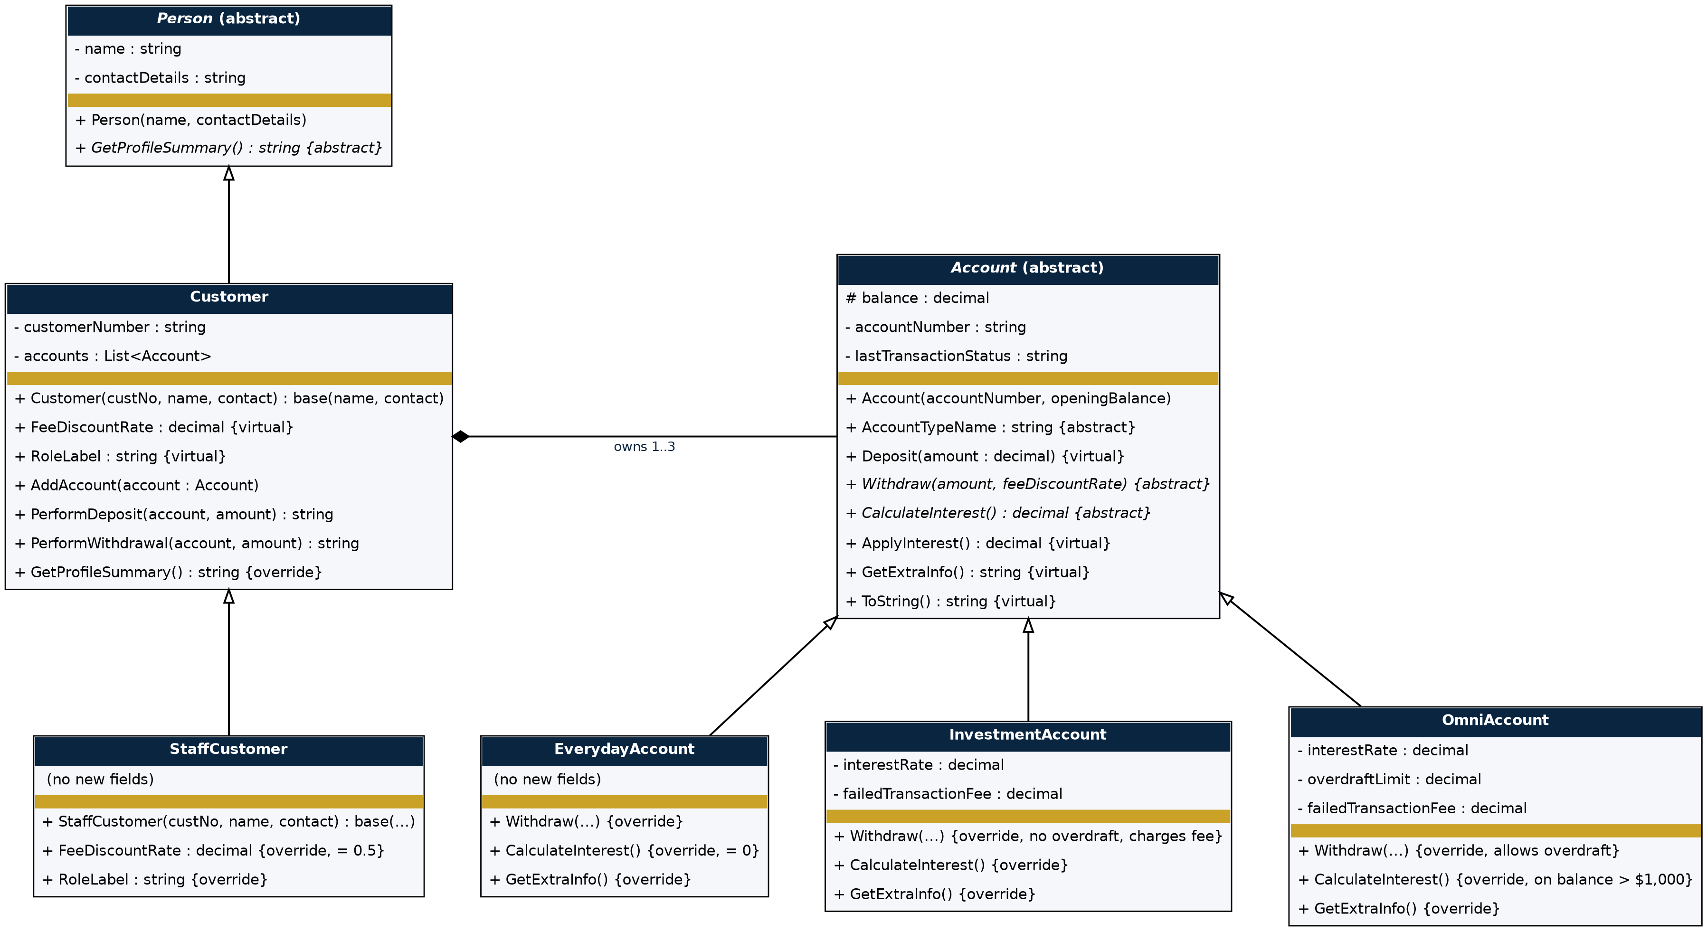

2. User Flow Diagram
This flow diagram traces the user journey from launching Bank4U, selecting a customer and then choosing one of the accounts and then making a deposit, withdrawal or calculating the interest.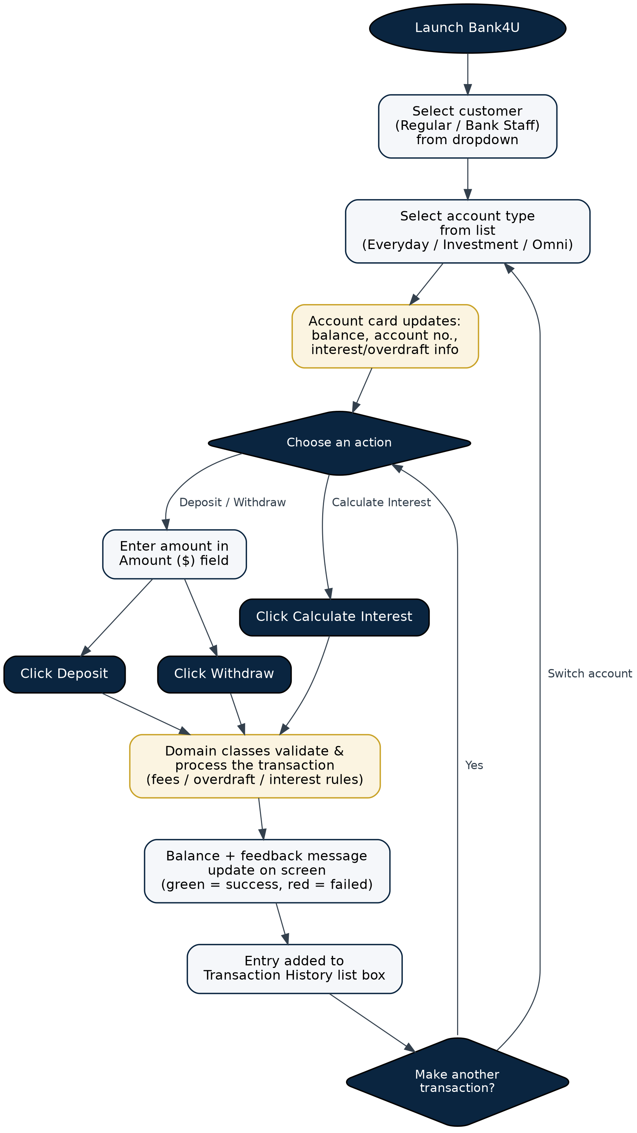

3. Technical Justification

Shared behaviour between related types of objects are expressed in the abstract classes Person and Account, which are separated from each other, allowing each of the subtypes to still specialise as needed. Person stores a name and contact information and announces an abstract GetProfileSummary() method, as a plain Person object is never used by itself, but Customer and StaffCustomer objects must be printed with their profile information. The same goes for Account: Balance, AccountNumber and LastTransactionStatus are common to all accounts, but Withdraw() and CalculateInterest() are abstract as the overdraft, fee and interest rules differ immensely between EverydayAccount, InvestmentAccount and OmniAccount.

The forms code was purposefully written in polymorphism, and not checked using if or switch statements. StaffCustomer overrides FeeDiscountRate method and returns 0.5 rather than the default value of 1.0, so the same PerformWithdrawal() method in Customer uses the correctly discounted amount for any customer; it never checks whether the customer is staff or not. The same idea is applied to GetExtraInfo(), which each Account subclass overrides to provide its own interest, overdraft, fee information; the only difference is that GetExtraInfo() returns a string (and MainForm.cs prints it).

A Customer has multiple accounts, using a List<Account> (Demo data provides one Everyday, one Investment and one Omni account per Customer). There were three reasons for using a list rather than three separate fields: One, a customer might have only one account; Two, the rest of the code (populating the account list box, entering the selected account) doesn't need to be aware of and care about how many accounts there are; Three, the number of accounts a customer holds can change.
4. Business Logic Assumptions

Accounts for everyday use do not pay interest and don't allow overdrafts or fees for transactions.

Interest is paid at a fixed rate per investment account and a fixed charge only if a withdrawal is rejected because of a lack of funds.

Omni accounts can overdraw up to a certain amount with a fixed amount per overdraw account and pay interest on any amount above $1,000.

All staff customers are entitled to 50% discount on ALL transactions where a fee would normally apply.

All balances, interest rates and fees listed in the demo data are illustrative and for testing purposes only, and not indicative of actual bank rates.

5. GitHub Repository
The entire project source code is maintained in version control, on GitHub. The repository is private and the lecturer is a collaborator to allow the view of the commit history and code.
https://github.com/keyur232/20231990-bank4u-sprint1

