**Acknowledgement**

I would like to express special gratitude towards Prof. Jaydeep Rathod, who gave us this opportunity to present this wonderful project on **Bhramani Electricals Lamps & Lights,** sir also helped us in completing our project. Secondly during our information gatherings we came to knew about so many new things which helped us to think out of the box.

**Index**

* Introduction of Project
* Project Profile
  + Disadvantages of Existing System
  + Need /Advantages of the New System
  + Objective of the System
  + Tools and Technology
* Entities of System
* Data Flow Diagram
* Entity Relationship Diagram
* Data Dictionary
* Bibliography

**Introduction of Project**

* Bhramani Electricals Lights & Lamps is an online shopping website about Lamp and Light.
* Latest lights features or smart lights, decorative lights, garden lights, indoor and outdoor lights, LED lights etc. are available on our website.

|  |  |
| --- | --- |
| **Project Profile** | |
| Project Title : | Bhramani Electricals Lamps & Lights |
| Objective : | For buying Lamps & Lights through e-commerce website |
| Type : | Website |
| Duration : | 6 Months |

**Disadvantages of Existing System**

* Shop is not available 24 / 7.
* Customer has to visit shop physically.
* Many a times stock in not sufficient in shop for the customer to get the clear picture of the products.

**Advantages of the New System**

* Shop is available 24 / 7 so that customers can shopping anytime, anywhere, anyway.
* Different Collection of items are available so that customers has transparency and acceptability for easy selection of product and view more products.

**Objective of the System**

* Admin can manage whole website.

Like, Manage category

Manage sub - category

Manage products

* User can select and purchase product.
* User can also add their selected product into wish-list.
* User can give feedback and read another feedback.
* Admin read feedback and report it.
* Visitors view product, view feedback, search product.

|  |  |
| --- | --- |
| **Tools and Technology** | |
| Operating System : | Window 11 |
| Front – Ended : | HTML, CSS (106.0.5249.119) |
| Back – Ended : | PHP (version 7.0), MySQL (version 8.0) |
| Other tools : | MS Office |
| Server : | Visual Studio Code (version 1.72.0) |

**Entities of System**

* ADMIN
* CUSTOMER
* VISITOR

ADMIN

* login
* forgot / reset password
* manage users
* manage category
* manage subcategory
* manage product
* manage order
* manage feedback
* report
* logout

CUSTOMER

* registration
* login
* forgot / reset password
* view category
* view subcategory
* view product
* place order
* manage wish-list
* give / view feedback
* logout

VISITOR

* view category
* view subcategory
* view product
* view feedback

**Data Flow Diagram**

* Context level Diagram
* 1st Level DFD – ADMIN
* 1st Level DFD – CUSTOMER
* 1st Level DFD – VISITOR
* 2nd Level DFD for ADMIN
  + login process
  + category process
  + sub-category process
  + product process
* 2nd Level DFD for CUSTOMER
  + login process
  + order process

Context level Diagram for

Bhramani Electricals Lamps & Lights

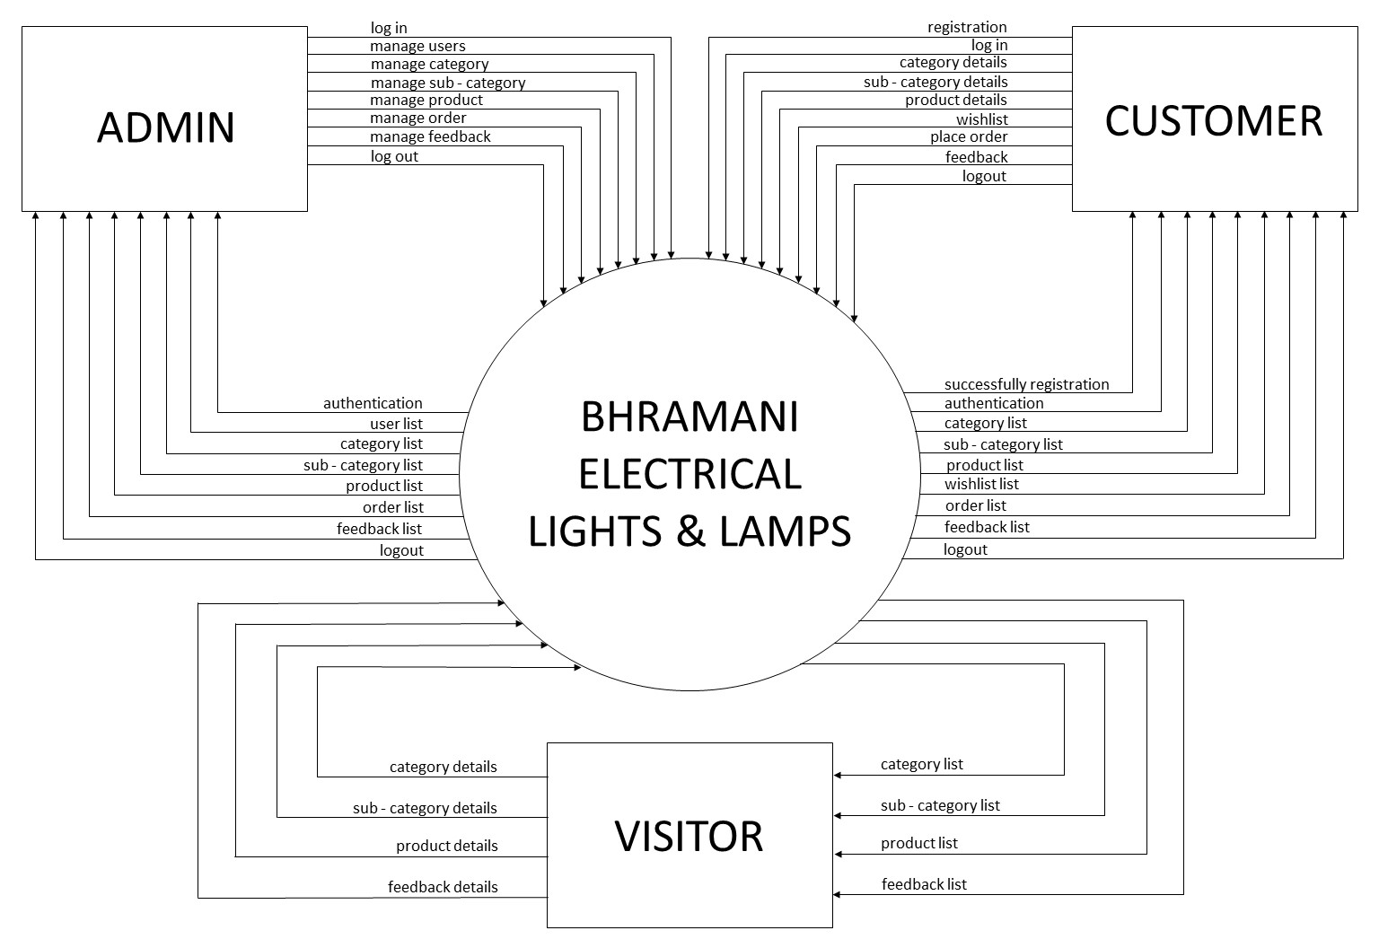

1st Level Data Flow Diagram

ADMIN

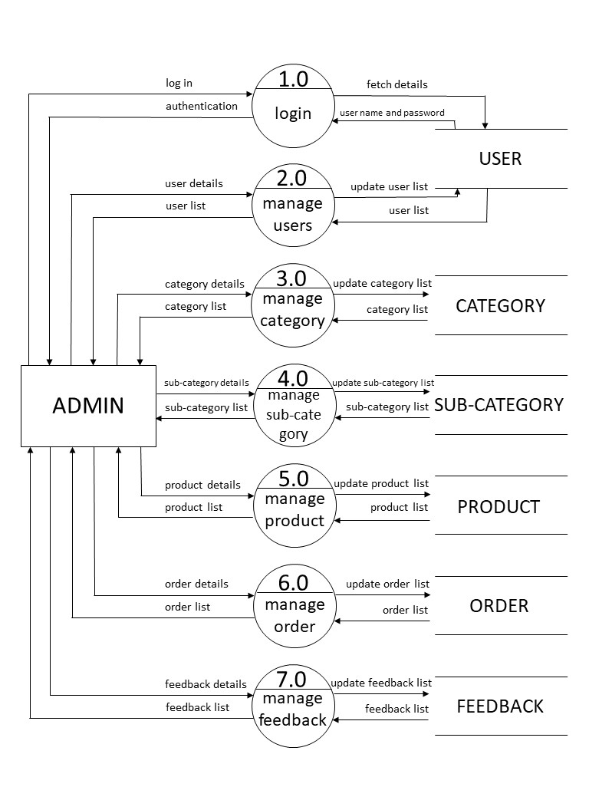

1st Level Data Flow Diagram

CUSTOMER

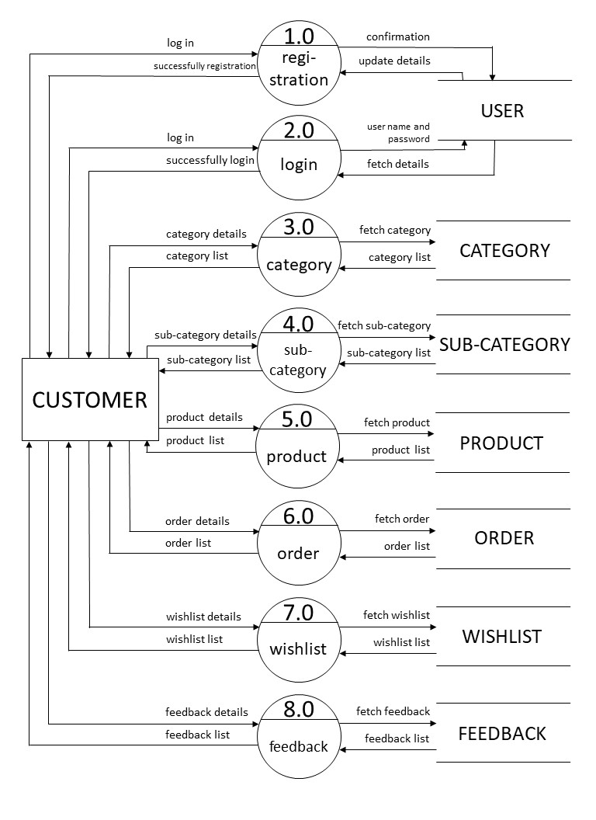

1st Level Data Flow Diagram

VISITOR

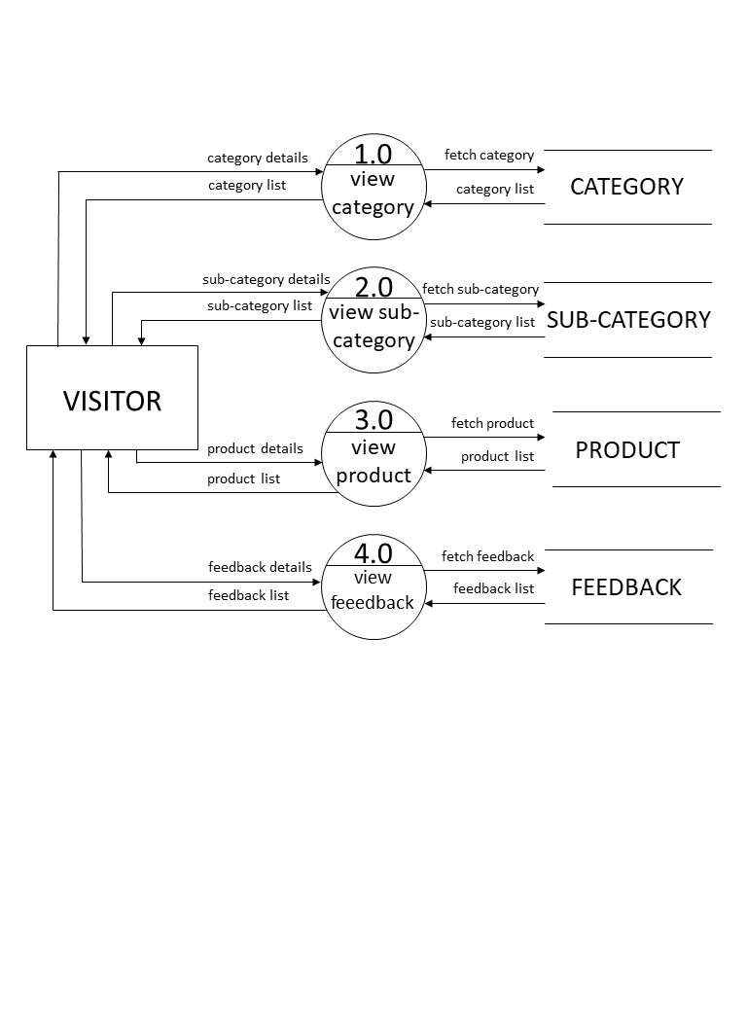

2nd Level Data Flow Diagram

login process for ADMIN

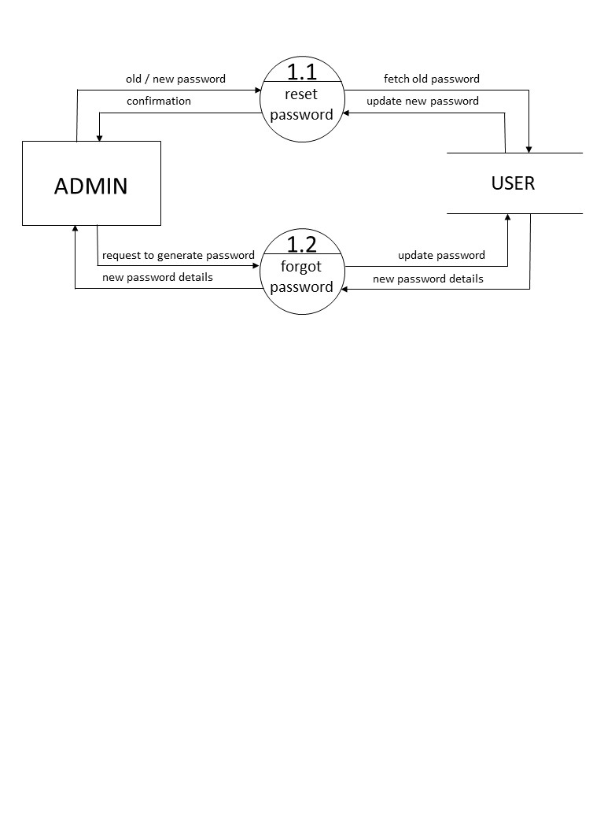

2nd Level Data Flow Diagram

category process for ADMIN

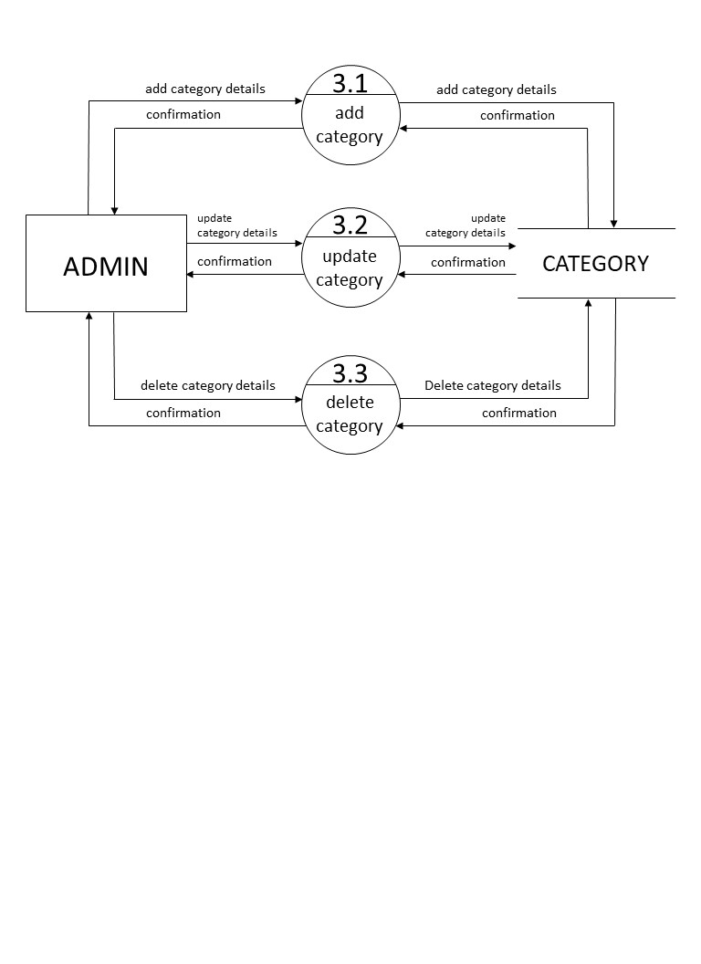

2nd Level Data Flow Diagram

subcategory process for ADMIN

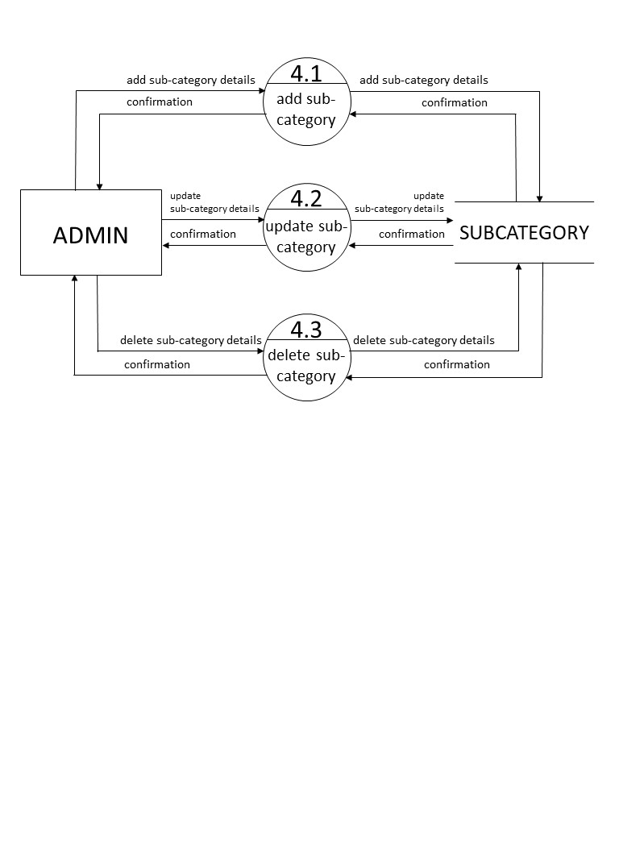

2nd Level Data Flow Diagram

product process for ADMIN

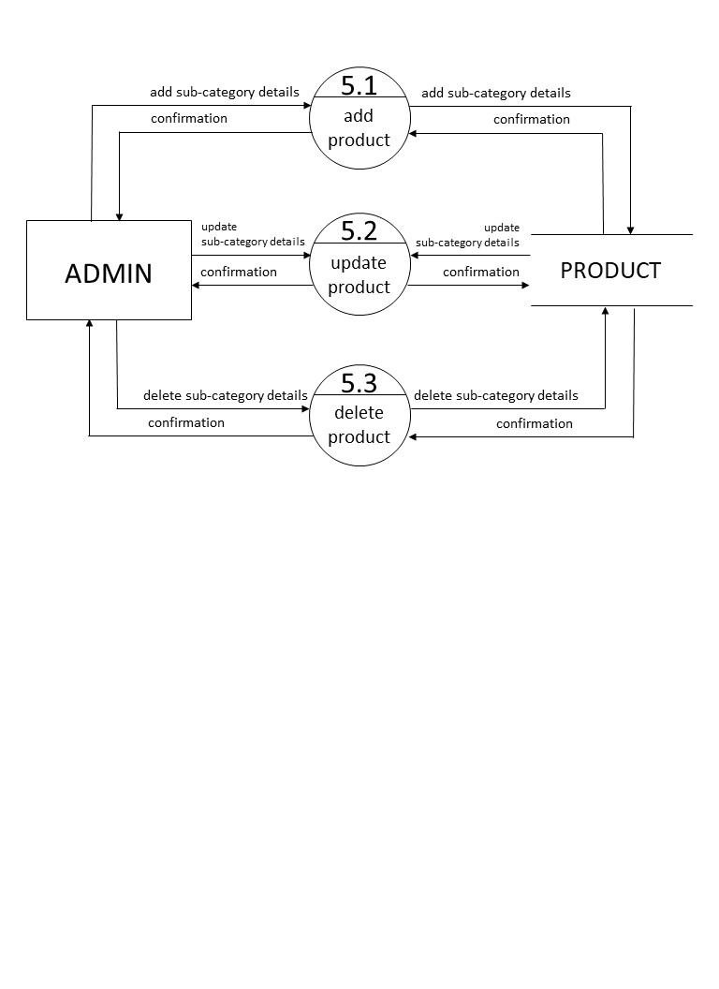

2nd Level Data Flow Diagram

login process for CUSTOMER

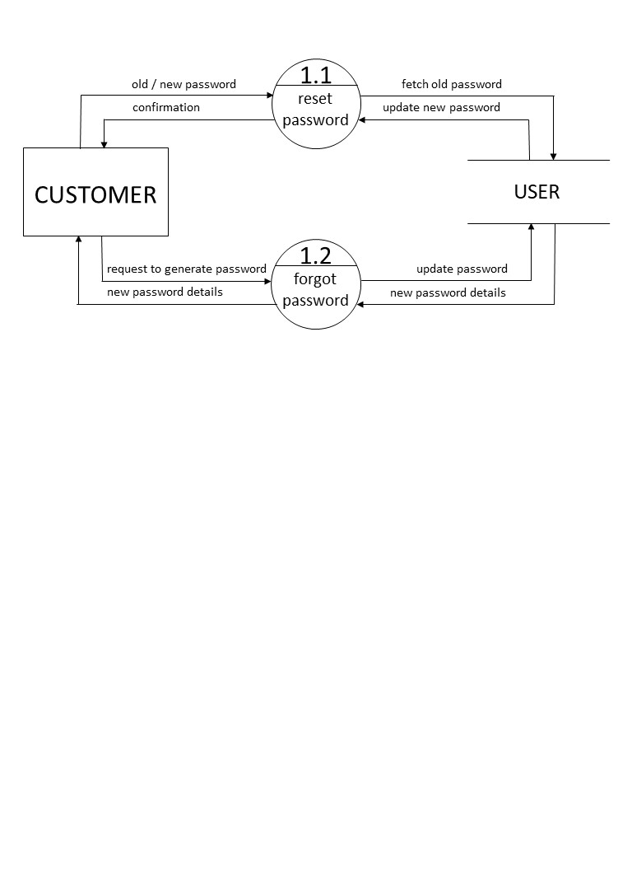

2nd Level Data Flow Diagram

order process for CUSTOMER

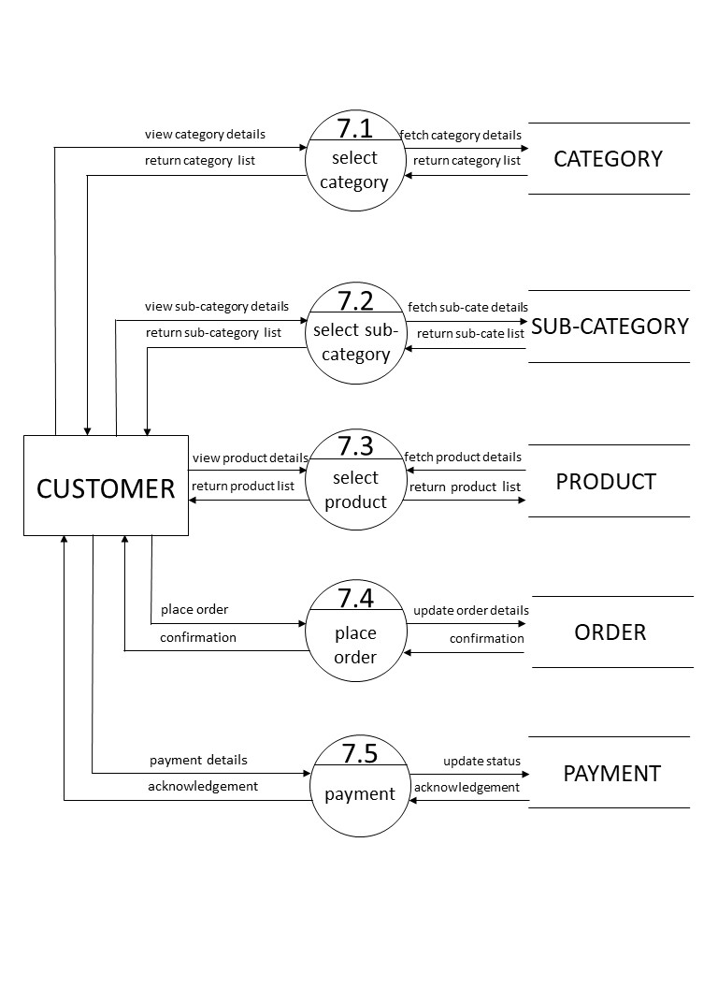

**ERD**

**Entity Relationship Diagram**

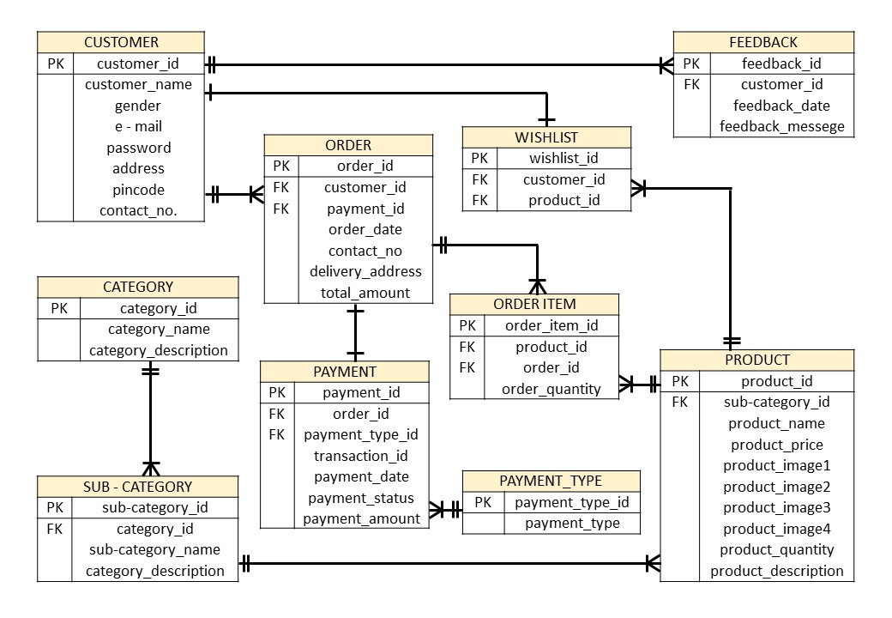

**Data Dictionary**

**contains following tables**

* Customer
* Category
* Sub – category
* Product
* Wishlist
* Order
* Order item
* Payment type
* Payment
* Feedback

Customer table :-

* Primary Key : customer_id

This table store the information regarding the customers.

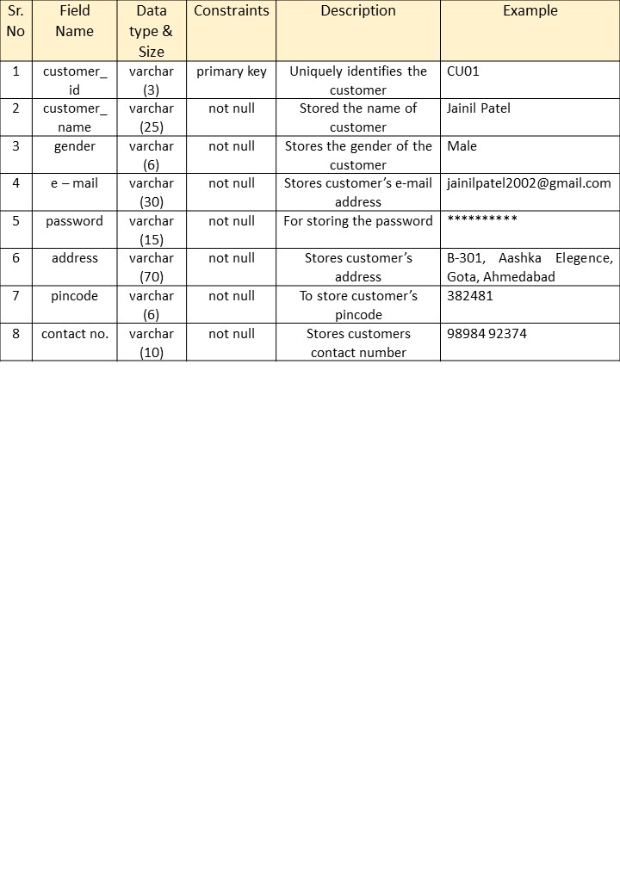

Category table :-

* Primary Key : category_id

This table is used to the information about category.

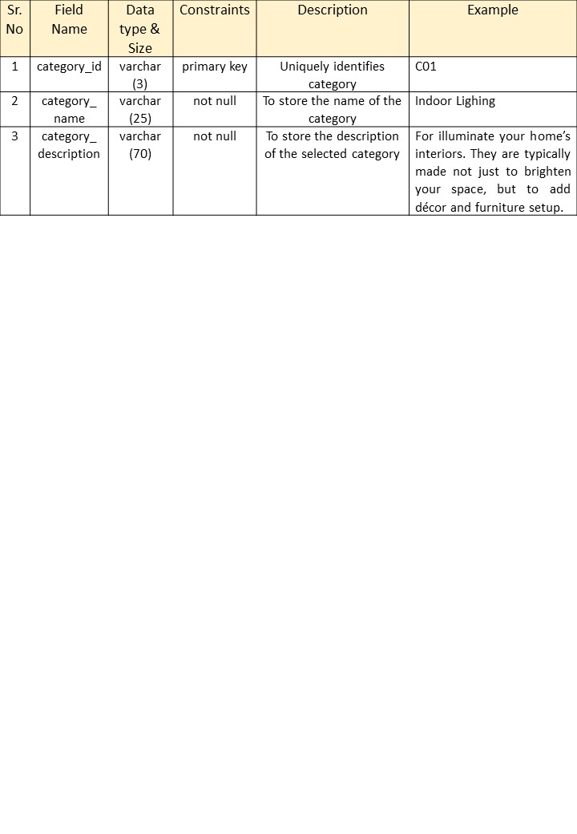

Sub - category table :-

* Primary Key : sub-category_id
* Foreign Key : category_id

This table is used to store the sub-category details of the selected category.

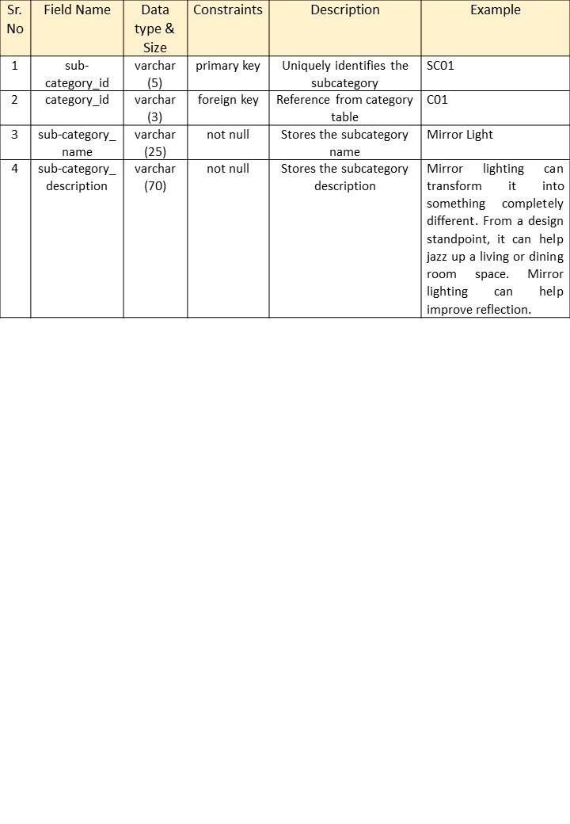

Product table :-

* Primary Key : product_id
* Foreign Key : sub-category_id

This table is used to store information about the product.

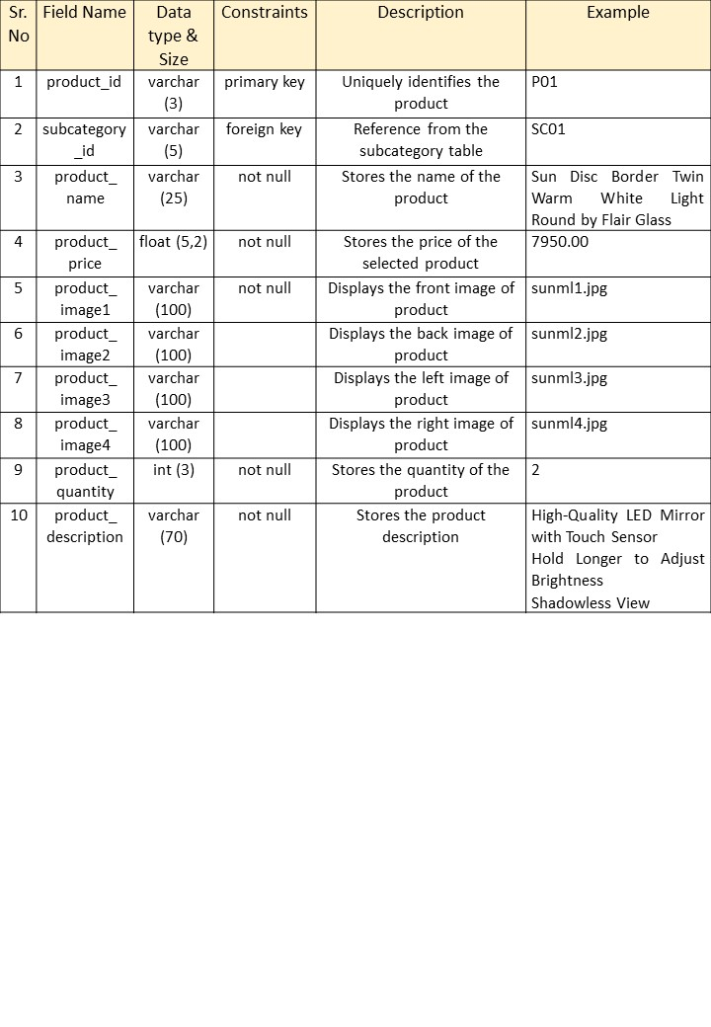

Wishlist table :-

* Primary Key : wishlist_id
* Foreign Key1 : customer_id
* Foreign Key2 : product_id

This table stores the description of product you stored in wishlist.

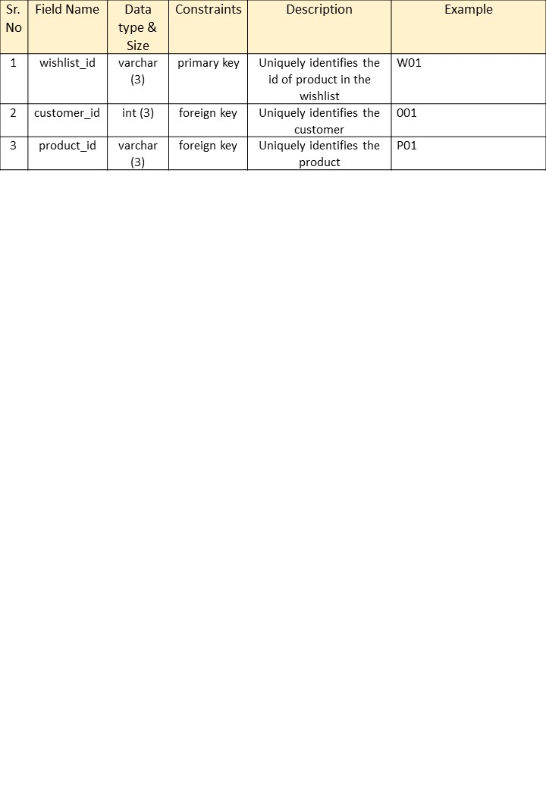

Order table :-

* Primary Key : order_id
* Foreign Key1 : customer_id
* Foreign Key2 : payment_id

This table shows the details of the product which customer orders.

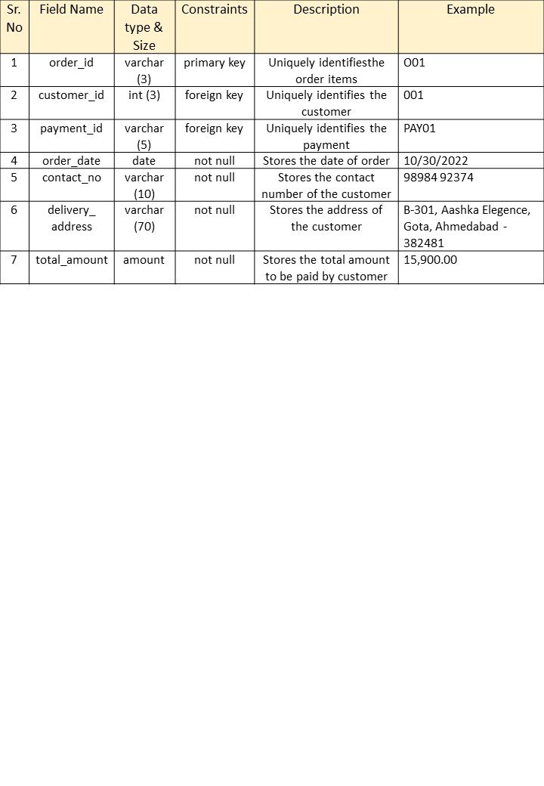

Order item table :-

* Primary Key : order_item_id
* Foreign Key1 : product_id
* Foreign Key2 : order_id

This table shows the items which are ordered by customers.

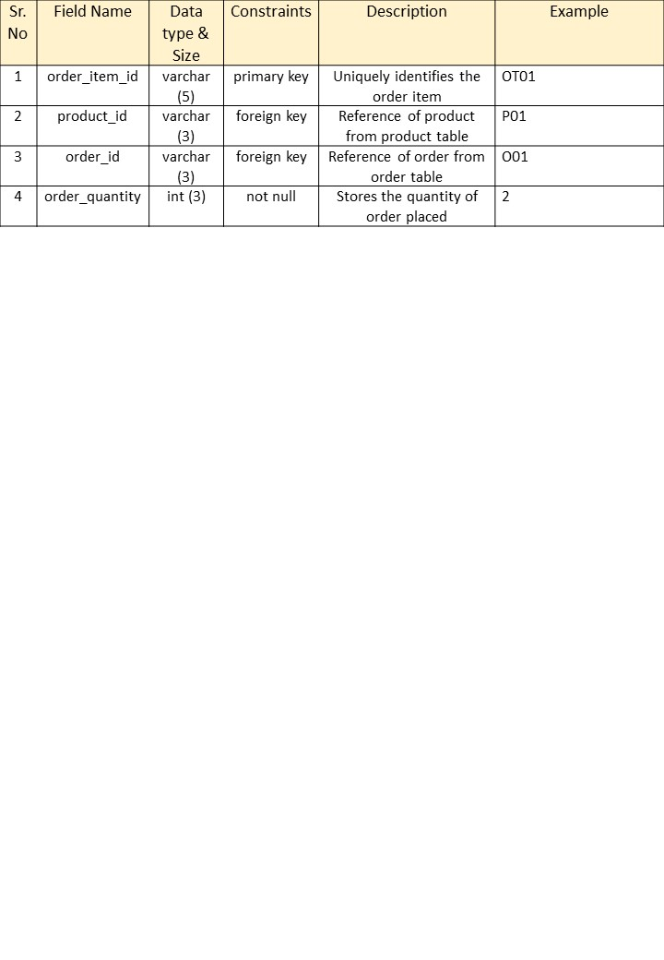

Payment type table :-

* Primary Key : payment_type_id

This table shows the mode of payment choose by customer.

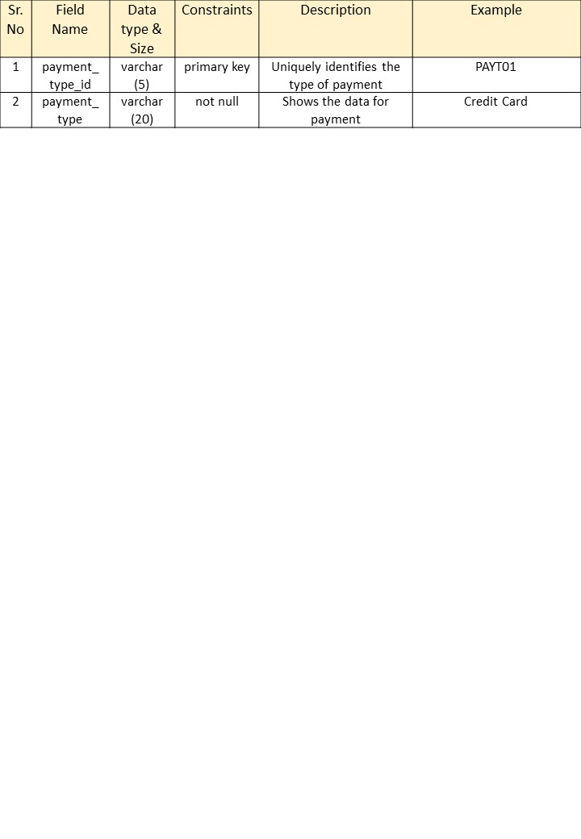

Payment table :-

* Primary Key : payment_id
* Foreign Key1 : order_id
* Foreign Key2 : payment_type_id

This table shows the details for payment done by customer.

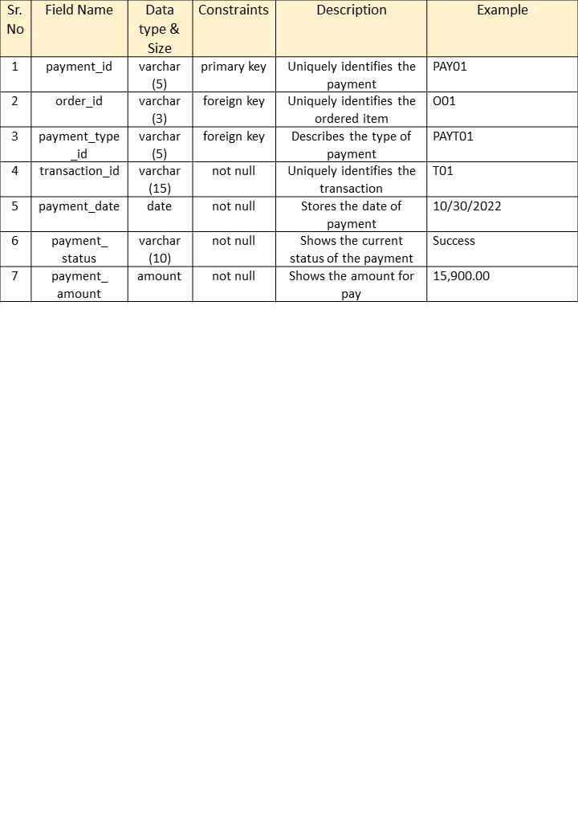

Feedback table :-

* Primary Key : feedback_id
* Foreign Key : customer_id

This table stores the feedback given by customer.

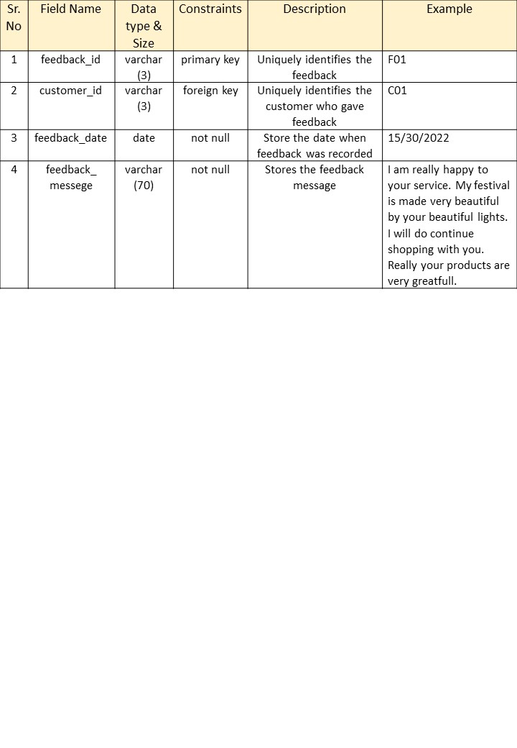

**Bibliography**

* Book :
  + Developing Web Application in PHP and AJAX (Author – B M Harwani)
  + Object Oriented Analysis and Design (Author – Arpita Gopal & Netra Patil)
* Online Reference :
  + [www.w3schools.com](http://www.w3schools.com)
  + [www.javatpoint.com](http://www.javatpoint.com)
  + [www.tutorialspoint.com](http://www.tutorialspoint.com)
  + [www.learn-php.org](http://www.learn-php.org)