ME 7120: Project 3

Application of Newark Beta Methods

To a 2D frame problem

ME-7120 Finite Element Method Applications

Due: December 9, 2016

Team Members:

Jay Vora

Sagar Sangle

Mayank Patel

Guided by

Dr. Joseph Slater

**Table of contents:**

1. **Nomenclature**
2. **Project Introduction**
3. **Problem Description**
4. **Methodology**
5. **Newmark beta methods**
6. **Method’s comparison**
7. **Conclusion**

# Nomenclature

E = Modulus of elasticity

G = Modulus of rigidity

υ = Poisson’s ratio

A = Area

ρ = Material Density

I = Moment of inertia

Ψ = Eigen Vectors

ωi = Natural frequency

# Project Introduction

This project allowed us to learn about the Newmark beta method of integration for achieving dynamic response of the frame structure problem elaborated below. We proceeded with the Beam2 example from WFEM and modified it for our problem structure. Five Newmark beta methods were applied to same structural problem and were compared to understand how future displacement, velocities and acceleration varies with respect to time step. Also compared and saw how those methods perform with damping and without damping.

1. **Problem Description**

An L shape frame structure is shown below is constrained at node 1 in X and Y directions. Also node 51 is constrained in Y direction. The properties that are taken in consideration are given below.

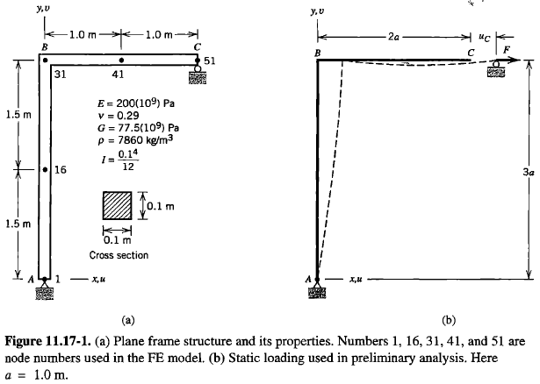 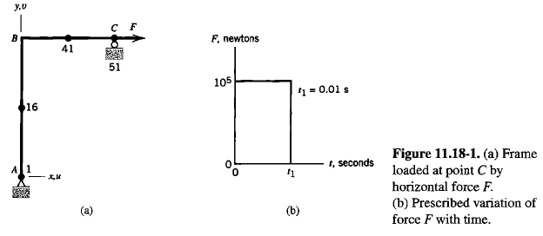

Figure 1 FEA Frame structure Figure 2 Loading & Boundary Conditions

The properties taken into consideration are from this example itself which are as follows

E = 200(109) Pa;  
G = 77.5(109) Pa;  
υ = 0.29  
A = 0.1\*0.1m2  
ρ = 7860 kg/m3  
I = 0.14/12 m4

1. **Methodology**

Using our beam code from WFEM we modified it for our frame structure problem and from there to obtain our stiffness and mass matrices. Further we reduced K and M matrices which was 306 X 306 before was reduced to 150X150 by applying boundary conditions. The frame deformation after applying the force of 100000N for 0.01 seconds looks like this.

E:\Project_3\Main structure Displacement figure\Main Structure.emf

Figure 3 Main frame deformation

Thereafter we found out the damping matrix C from the following equation.

*ΨT \* C \* Ψ = 2 \* ξ \* ωi;*

From this equation we get the damping matrix C which is a diagonal matrix. After calculating C

1. **Newmark beta methods**

The Newmark beta methods have following details which are applied to the main code to check the variation in displacement velocity and acceleration.

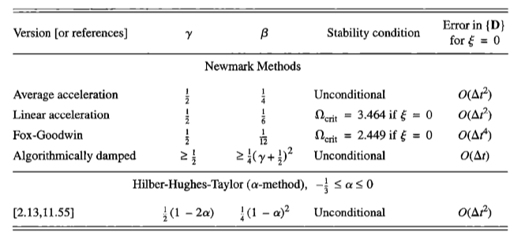

Table 1 Newmark beta method details

Here we are going to compare 5 different Newmark beta methods such as linear acceleration method, average acceleration method, algorithmically damped method, Hilber-Huges-Taylor method and Fox Goodwin method. All the 5 simulations are done without damping and with damping to understand the vibrational behavior.

The plots for the future displacement are as follows. The rest of the plots are in the appendix folder added in the project3.

**Linear Acceleration Method**

**E:\Project_3\without Damping\Linear Acceleration Method\Fig-1.emf**

Figure 4 without damping

**E:\Project_3\with Damping\Linear Acceleration Method\Fig-1.emf**

Figure 5 with damping

**Average Acceleration Method**

**E:\Project_3\without Damping\Average Acceleration Method\Fig-1.emf**

Figure 6 without damping

**E:\Project_3\with Damping\Average Acceleration Method\Fig-1.emf**

Figure 7 without damping

**Algorithmically Damped Method**

**E:\Project_3\without Damping\Algorithmically damped Method\Fig-1.emf**

Figure 8 without damping

**E:\Project_3\with Damping\Algorithmically damped Method\Fig-1.emf**

Figure 9 with damping

**Hilber-Huges-Taylor Method**

**E:\Project_3\without Damping\Hilber-Hughes-Taylor Method\Fig-1.emf**

Figure 10 without damping

**E:\Project_3\with Damping\Hilber-Hughes-Taylor Method\Fig-1.emf**

Figure 11 with damping

**Fox Goodwin Method**

**E:\Project_3\without Damping\Fox-Godwin Method\Fig-1.emf**

Figure 12 without damping

**E:\Project_3\with Damping\Fox-Godwin Method\Fig-1.emf**

Figure 13 without damping

The comparison charts of the methods can be shown as follows.

**Comparison of methods without damping (zeta = 0)**

|  |  |  |  |  |  |  |
| --- | --- | --- | --- | --- | --- | --- |
| ***Method Name*** | ***Gamma*** | ***Beta*** | ***Maximum Displacement*** | ***Maximum Velocity*** | ***Maximum Acceleration*** | ***Time Step*** |
| ***Linear Acceleration Method*** | 1 / 2 | 1 / 6 | 0.004 | 2.4634 | 1.13e+05 | 0.000001 |
| ***Average Acceleration Method*** | 1 / 2 | 1 / 4 | 0.0042 | 1.8774 | 7.5619e+04 | 0.0001 |
| ***Algorithmically Damped Method*** | 0.55 | 0.2756 | 0.0040 | 0.7171 | 2.8389e+03 | 0.0001 |
| ***Hilber-Hughes-Taylor Method***  ***(α = - 0.25)*** | 0.75 | 0.3906 | 0.0039 | 0.5090 | 1.4206e+03 | 0.0001 |
| ***Fox-Godwin Method*** | 1 / 2 | 1 / 2 | 0.0040 | 2.4388 | 1.2949e+05 | 0.000001 |

**Comparison of methods with damping ( zeta = 0.02)**

|  |  |  |  |  |  |  |
| --- | --- | --- | --- | --- | --- | --- |
| ***Method Name*** | ***Gamma*** | ***Beta*** | ***Maximum Displacement*** | ***Maximum Velocity*** | ***Maximum Acceleration*** | ***Time Step*** |
| ***Linear Acceleration Method*** | 1 / 2 | 1 / 6 | 0.0035 | 0.8468 | 28534 | 0.000001 |
| ***Average Acceleration Method*** | 1 / 2 | 1 / 4 | 0.0036 | 0.6924 | 19317 | 0.0001 |
| ***Algorithmically Damped Method*** | 0.55 | 0.2756 | 0.0035 | 0.4995 | 2815.3 | 0.0001 |
| ***Hilber-Hughes-Taylor Method***  ***(α = - 0.25)*** | 0.75 | 0.3906 | 0.0035 | 0.4215 | 918.6227 | 0.0001 |
| ***Fox-Godwin Method*** | 1 / 2 | 1 / 2 | 0.0035 | 0.8453 | 28648 | 0.000001 |