# Code Unnati Innovation Marathon

A

Report on

**“FitMate: AI-Powered Fitness Form Detection ”**

**Team ID:10574**

**Team Leader:Patel Nishil Vijaybhai**

**TABLE OF CONTENTS**

|  |  |
| --- | --- |
| ABSTRACT | 1 |
| 1. Background | 2 |
| 1. Problem Statement | 3 |
| III. Methodology | 4 |
| IV. Implementation | 6 |
| V. Results and Outcomes | 9 |
| CONCLUSION | 10 |
| REFERENCES | 11 |

**ABSTRACT**

Maintaining the correct form during exercise is essential to maximize **training efficiency** and prevent **injuries**. However, many individuals, especially those working out at home, often perform exercises incorrectly due to the **lack of real-time guidance**. Traditional fitness applications rely on **pre-recorded workout videos** or **wearable tracking devices**, which fail to provide **dynamic posture correction** and **real-time feedback**. Personal trainers can help improve form, but they are not always **accessible or affordable** for everyone. This creates the need for an **AI-powered solution** that dynamically **analyzes movement**, provides **instant feedback**, and ensures the **proper execution of exercises**.

FitMate is a **web-based AI fitness assistant** that uses **computer vision** to **monitor and modify** user movements in real time. The system leverages **MediaPipe and OpenCV** to track **body landmarks**, analyze **joint angles**, and detect **incorrect postures** during exercises such as **push-ups, squats, shoulder presses, and planks**. Unlike traditional fitness tracking methods that rely on **wearables and deep learning models**, FitMate utilizes **angle-based calculations**, making it **faster, more efficient, and widely accessible**. By computing the **angles between key joints** such as **shoulders, elbows, knees, and hips**, the system can accurately determine whether a movement is performed correctly.

FitMate provides **immediate corrections** when users make mistakes, such as **incorrect knee alignment in squats, improper elbow angles in push-ups, or sagging hips in planks**. Additionally, the system features an **automated rep counting mechanism**, ensuring that only **properly executed repetitions** are counted. This allows users to **track their workout progress accurately**, eliminating **incorrect reps and reinforcing proper movement patterns**. As a result, users develop better habits, improve training performance, and **reduce the risk of injuries**.

Unlike other fitness solutions that require **complex deep learning models or expensive sensors**, FitMate operates **entirely through a webcam-based interface**, making it accessible to anyone with a **computer and an internet connection**. The system's ability to **analyze and validate movement in real time** enables users to **train independently** without needing a personal trainer. This project aims to **bridge the gap between technology and fitness** by providing an **affordable and AI-powered training solution** that ensures **proper exercise execution** without requiring additional hardware or subscriptions.

By integrating **real-time movement validation**, FitMate offers an **interactive fitness coaching experience** that enhances training efficiency, reduces injury risk, and **boosts user confidence** during workouts. This **innovative system** empowers individuals to **improve their posture and accuracy** conveniently from their **home, gym, or any training environment**. With its **scalability and modularity**, FitMate has the potential to **support a broader range of exercises, integrate personalized coaching, and revolutionize the way fitness tracking is conducted in the future**.

1. **BACKGROUND**

Movement and physical fitness play an important role in overall health and well-being. Maintaining a **proper training form** is essential to ensure **muscle activation, joint safety, and workout efficiency**. However, many individuals, especially those who train at home, lack **real-time guidance and feedback** on their posture. This often leads to **poor movement execution**, increasing the risk of **injuries, reduced effectiveness, and long-term health complications**.

Video tutorials and fitness tracking applications provide guidance, but they have significant limitations when it comes to **real-time posture correction and form verification**. Below are some of the most common challenges faced by fitness enthusiasts:

1. **Lack of Real-Time Feedback**  
   Most fitness applications provide **static instructional content**, such as **pre-recorded videos and text-based guidelines**, that do not adapt to a user's **actual movements**. These methods fail to detect **improper posture, incorrect joint angles, or dangerous movements**, making it difficult for users to **self-correct their form** during workouts.
2. **High Risk of Injury Due to Incorrect Form**  
   Without proper posture, individuals often perform exercises incorrectly, leading to potential injuries. Some of the most common mistakes include:

* **Push-ups** – Incorrect elbow positioning, lack of core engagement, or incomplete reps.
* **Squats** – Poor knee alignment, excessive forward-leaning, or improper depth.
* **Planks** – Sagging hips, raised glutes, or shoulder misalignment.
* **Shoulder Press** – Incomplete arm extension or lack of proper posture support.

Repeating incorrect movements over time can **strain muscles, ligaments, and joints**, increasing the risk of **long-term physical injuries**.

1. **Limited Access to Personal Trainers**  
   Hiring a **professional trainer** is one of the best ways to ensure **proper form and injury prevention**. However, **high costs and accessibility issues** make personal coaching unattainable for many people. Home workout users, in particular, often lack **expert guidance**, making it difficult to determine whether they are **performing exercises correctly**.

These challenges highlight the need for a **real-time, AI-powered fitness solution** that can provide **accurate posture correction, feedback, and exercise validation**, ensuring that users **train safely and effectively**.

1. **PROBLEM STATEMENT**

Maintaining the **correct posture and form** during exercise is essential for ensuring **efficient muscle engagement, injury prevention, and optimal fitness results**. However, many individuals, especially those who train at home, **lack access to real-time feedback and expert supervision**, often leading to improper execution of exercises. Incorrect form can result in **muscle strain, joint stress, long-term injuries, and reduced workout effectiveness**. While some users turn to **fitness apps and pre-recorded workout tutorials**, these methods fail to provide **live posture corrections**, ultimately reinforcing poor exercise habits.

To address these challenges, there is a need for a **real-time AI-powered fitness tracking system** that can **dynamically analyze posture using computer vision, detect incorrect movements, and provide immediate feedback to prevent injuries**. Additionally, it should ensure that **repetitions are counted accurately**, eliminating inconsistencies in workout tracking.

**FitMate bridges this gap** by utilizing **computer vision-based pose estimation and joint angle analysis** to provide users with **instant feedback** on their **movement form, posture, and accuracy**. The system leverages **MediaPipe and OpenCV** to detect **improper movement patterns**, validate **correct repetitions**, and guide users toward **proper exercise execution**. Unlike traditional fitness tracking methods that rely on **wearables or deep learning models**, FitMate is a **cost-effective, user-friendly, and highly accessible solution** that works entirely through a **web-based interface**, requiring only a standard webcam.

By integrating **real-time form validation and automated rep counting**, FitMate empowers users to **train more effectively, minimize the risk of injuries, and enhance overall fitness performance**—all without the need for **wearable sensors, additional hardware, or complex AI models**.

1. **METHODOLOGY**

FitMate is designed as a **real-time AI-powered fitness tracking system** that utilizes **computer vision-based pose estimation** to provide **instant feedback on exercise form**. By leveraging **MediaPipe and OpenCV**, the system accurately detects **key body landmarks**, calculates **joint angles**, and analyzes **movement accuracy**. Unlike traditional **deep learning models**, which rely on **large datasets and complex neural networks**, FitMate employs a **lightweight and efficient approach** using **geometric angle-based analysis** to evaluate posture and exercise execution.

The methodology of this project can be divided into several key steps:

****1. Technologies Used****

FitMate integrates various advanced technologies to ensure **precise and efficient** movement tracking:

* **📌 MediaPipe Pose Estimation** – Detects and tracks **body landmarks in real time**, identifying key joints for accurate movement assessment.
* **📌 OpenCV** – Processes the **live video feed** from the webcam and extracts **frame-by-frame body position data**.
* **📌 Python (NumPy, Math Libraries)** – Performs **angle calculations** between joints to determine **postural correctness**.
* **📌 Web-Based Interface** – Allows users to **access the system directly through a browser**, eliminating the need for additional hardware or software installations.

### ****2. How It Works: Step-by-Step Process****

**1. User Selects an Exercise**

* The user visits the **FitMate web interface** and selects one of the available exercises: **Push-ups, Squats, Planks, or Shoulder Press**.

1. **Live Video Capture & Pose Detection**

* The **webcam captures the user’s real-time movements**.
* **MediaPipe detects key body landmarks**, including **shoulders, elbows, wrists, hips, knees, and ankles**.

1. **Joint Angle Calculation & Posture Analysis**

* The system **calculates the angles** between key joints to determine **proper movement execution**.
* For example:
  + In **push-ups**, the system calculates **elbow angles** to ensure the user **lowers their body correctly**.
  + In **squats**, it ensures that the **knees bend to an appropriate depth** while maintaining **an upright posture**.

4. **Real-Time Form Validation & Feedback**

* The system **compares the calculated angles** with **predefined thresholds** for correct form.
* If an exercise is **performed incorrectly**, the system **displays real-time feedback on the screen** (e.g., “Keep your back straight!” or “Lower your hips!”).

**5. Automated Rep Counting**

* The system **only counts valid repetitions**, ensuring that users perform exercises **correctly** before advancing in their workout.
* If the movement **does not meet the required form criteria**, the rep **is not counted**, helping users maintain **proper technique**.

### ****3. Exercise-Specific Movement Analysis & Posture Validation****

Each exercise requires **customized posture validation logic** to ensure accurate tracking and form correction:

#### **1. Push-Up Detection**

* **Key Landmarks Used:** Shoulders, elbows, wrists, hips.
* **Angle Calculation:** The **elbow angle** must drop **below a certain threshold** to count as a proper **push-down phase**.
* **Validation Criteria:**  
  ✅ The body must remain **aligned from head to heels** throughout the movement.  
  ✅ The **chest must lower close to the ground** for a valid rep.

#### **2. Squat Detection**

* **Key Landmarks Used:** Hips, knees, ankles, shoulders.
* **Angle Calculation:** The system **tracks knee and hip angles** to ensure **proper squat depth**.
* **Validation Criteria:**  
   **Knees should not extend past the toes** to maintain joint safety.  
   The user must squat **below a defined hip angle threshold** (e.g., **90°** for a proper squat).

And other exercises can be incorporated

1. **IMPLEMENTATION**

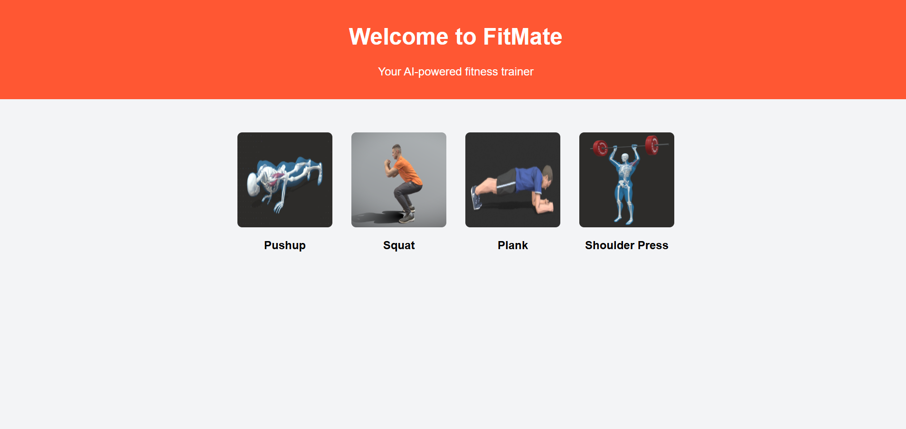

Figure 1(a) User Interface



Figure 1(b) Running Phase

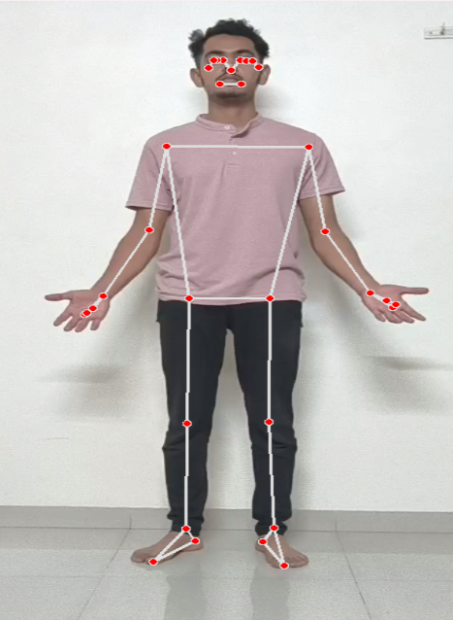

Figure 2 Landmark Mapping and Angle Calculation

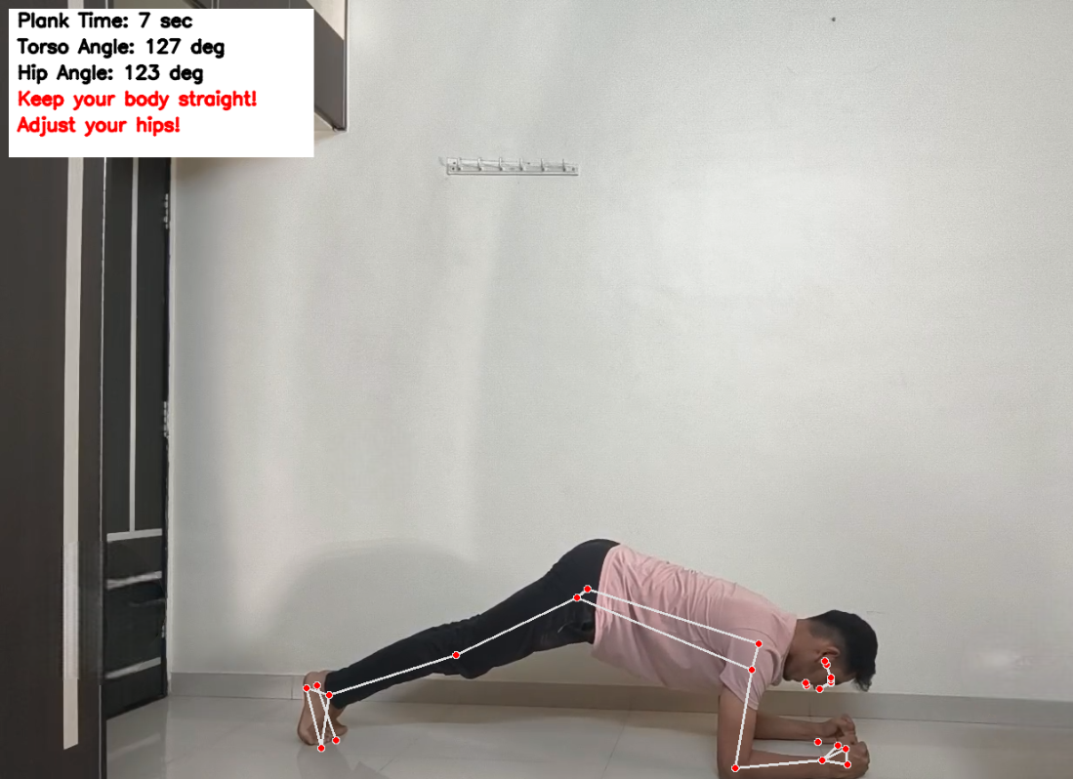

Figure 2(a) Form Feedback(Incorrect Form)

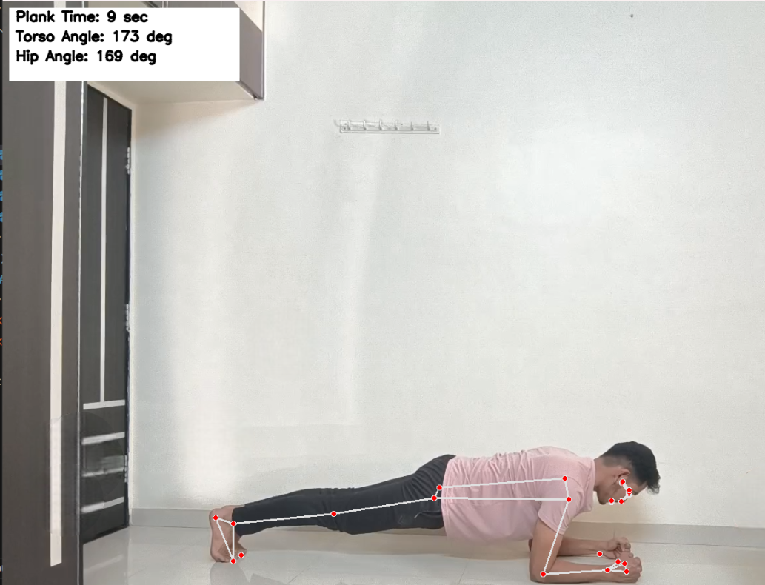

Figure2(b) Proper Form after Feedback

Other Exercise Examples:

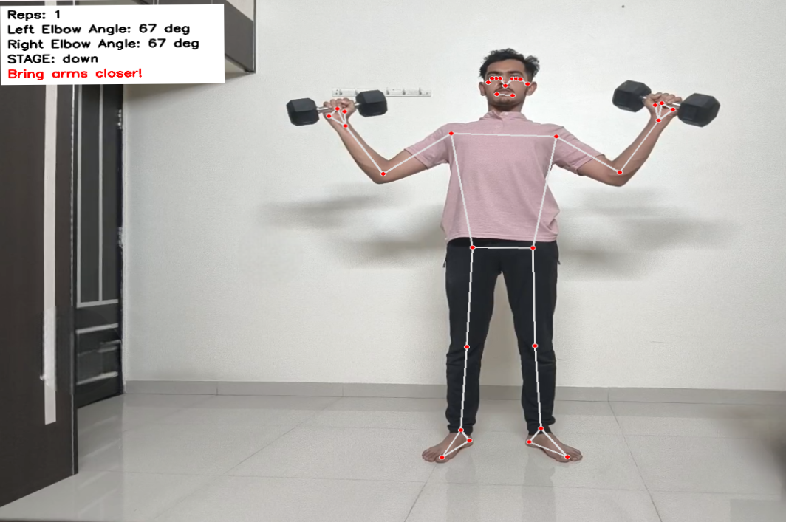

Figure 3(a) Shoulder Press improper elbow angle

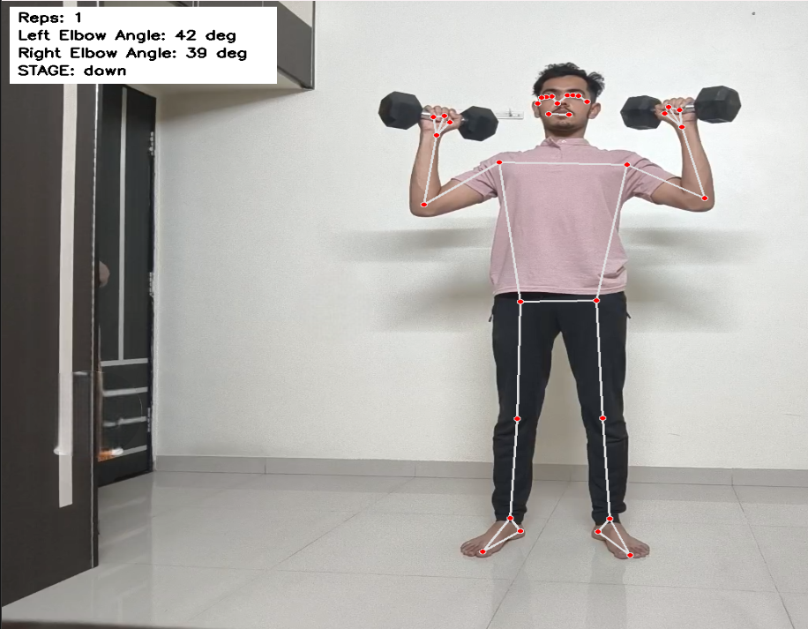

Figure 3(b)Arms Closer Elbows Tucked

### ****Results & Outcomes****

The **implementation of FitMate** has successfully demonstrated acceptably **decent accuracy in real-time form tracking, posture validation, and automated rep counting**. By leveraging **computer vision based pose estimation**, FitMate ensures that users **perform exercises in the correct posture** , reducing injury risks while also improving workout efficiency. Below are the key results and outcomes observed

### ****1. Performance Metrics****

* **Pose Estimation Accuracy:**
* The system detects key body landmarks with an accuracy of **±5° in calculation of angles**, ensuring **stable tracking of movement**.
* Works efficiently at **25-30 FPS**, providing **real-time feedback with minimal lag**.
* **Real-Time Form Correction:**
* Provides **instant alerts** for incorrect posture, helping users **improve exercise execution while also performing it.**
* Detects **hip and torso misalignment, incorrect knee positioning, bad elbow angles, and back posture problems**.
* **Automated Rep Counting:**
* Ensures that **only correctly executed repetitions** are counted.
* Prevents false rep counting due to **incomplete or incorrect movements**.

### ****2. Key Achievements****

* **Real-Time Posture Analysis & Correction:**
* Accurately tracks body posture and provides **immediate on-screen feedback** if incorrect movement is detected.
* Unlike **traditional fitness tracking apps**, FitMate actively monitors **exercise form** instead of just tracking movement.
* **Versatile Multi-Exercise Support:**
* FitMate effectively detects and tracks movements for:  
  ✔ **Push-ups** – Ensures full elbow extension and correct body alignment.  
  ✔ **Squats** – Detects knee bending angle and upright posture maintenance.  
  ✔ **Planks** – Validates hip alignment and core engagement.  
  ✔ **Shoulder Press** – Recognizes full arm extension above the head.
* **User Accessibility & Convenience:**
  + The **web-based system** eliminates the need for **installing additional resources**.
  + Works on any **computer with a webcam**, making it **cost-effective and widely accessible**.

**CONCLUSION**

FitMate seamlessly integrates **computer vision-based pose estimation** with **real-time exercise tracking** to help users maintain **proper workout form, prevent injuries, and maximize training efficiency**. By utilizing **MediaPipe and OpenCV**, the system accurately detects **body landmarks, analyzes joint angles, and provides instant feedback** to correct improper posture. Unlike traditional fitness apps that rely on **pre-recorded workout tutorials or wearable sensors**, FitMate continuously **monitors movement in real-time**, ensuring that **only correctly executed repetitions are counted**. This dynamic approach allows users to **develop better exercise habits, enhance movement accuracy, and eliminate common workout mistakes**, ultimately leading to safer and more effective training sessions.

With its **web-based accessibility**, FitMate removes the need for **expensive fitness devices or complex AI-driven models**, making **real-time posture correction available to a wider audience**. As the system evolves, **future enhancements** such as **AI-powered coaching, mobile compatibility, and support for additional exercises** will further enhance its capabilities. By bridging the gap between **technology and fitness**, FitMate empowers users to **train safely, improve their form, enhance workout efficiency, and achieve their fitness goals with confidence**.

**REFERENCES**

1. **[Squat University](https://squatuniversity.com/2016/04/20/the-real-science-of-the-squat/),**The Real Science of the Squat.
2. **[Mediapipe](https://ai.google.dev/edge/mediapipe/solutions/vision/pose_landmarker/python)**,Pose landmark Detection guide
3. **[Nicholas Renotte](https://github.com/nicknochnack/MediaPipePoseEstimation),** Media Pipe Pose Estimation