| **SET-JU-Logo (2).png**  **A**  **Report**  **on**  **“Tire Pressure And Temperature Monitoring System”**  **- Fundamentals of Innovation and Venture Development in Entrepreneurship**  **BACHELOR OF TECHNOLOGY**  **IN**  **COMPUTER SCIENCE AND SYSTEMS ENGINEERING**  **(INTERNET OF THINGS)**  **Submitted by**  **Name:- Anish Giri**  **USN:-20btrco019**  **Name:- Nitish Patel**  **USN:-20btrco038**  **Name:- Hasibullah Habibi**  **USN:-20btrco051**  **Name:- Sudhakar Kumar Sah**  **USN:-20btrcs174**  **…**  **Under the guidance of**  **Ashish Kumar Singh**  **Assistant Professor**  **Faculty of Engineering & Technology**  **Jain (Deemed-To-Be University)**  **Department of Computer Science & Engineering**  Jain Global Campus, KanakapuraTaluk - 562112  Ramanagara District, Karnataka, India  2022-2023 |
| --- |



Faculty of Engineering and Technology

Computer Science and Engineering

Jain Global Campus, Kanakapura Taluk - 562112  
Ramanagara District, Karnataka, India

**2022-2023**

CERTIFICATE

This is to certify that the work on “**Tire Pressure And Temperature Monitoring System”** as part of **Research and Entrepreneurship Project (21PC3ED58)** is carried out by **Anish Giri(20btrco019), Nitish Patel(20btrco038), Hasibullah Habibi(20btrco051),Sudhakar Kumar Sah(20btrcs174)** bonafide students of **Bachelor of Technology in Computer Science and Engineering-IOT** at the **Faculty of Engineering & Technology, Jain University, Bangalore**, during the year **2022-2023**.

|  |  |  |
| --- | --- | --- |
| Basavaraju D R  Assistant Professor  Computer Science and Engineering, Faculty of Engineering & Technology, Jain University, Bangalore | Dr. Devraj Verma C  Professor and Head  Computer Science and Engineering, Faculty of Engineering & Technology, Jain University, Bangalore | Dr. Hariprasad S A  Director  Faculty of Engineering & Technology, Jain University, Bangalore |

**(Fill this according to your document content)**

**Table of contents**

|  |  |  |
| --- | --- | --- |
| **S.No** | **Content** | **Page No.** |
| **1.** | **Introduction** | **3** |
| **2** | **Literature Survey** | **3-4** |
| **3** | **Hardware Description** | **4-5** |
| **4** | **Software Description** | **5-6** |
| **5** | **Experimental Results** | **6** |
| **6** | **Conclusion** | **7** |
| **7** | **References** | **8** |



**Abstract:**

The Tire Pressure Monitoring system is presented to monitor changes in tyre pressure and temperature. The Arduino Uno Board is connected with MXP4115A Pressure Sensor, and LM35 Temperature Sensor to create the suggested system.The system detects high and low tyre pressures, as well as tyre temperature, and presents the data on the display. Splunk Enterprise indexes the log from the Tire Pressure Monitoring system. Splunk Enterprise is a search, analytics, and visualisation platform for machine-generated data from apps, sensors, and devices. It interacts with various log file and stores file data in the form of events in local indexes. Dashboards and Reports can be built with Splunk Enterprise Pivots.

1. **INTRODUCTION**

Tire pressure is meant to monitor the air pressure inside the pneumatic tyres on cars and plays a vital part in vehicle safety and fuel consumption considerations. Vehicles that travel with low or high tyre pressure use more gasoline. If air leakage from the tyre is not discovered, it might cause major problems while the car is running. As a result, real-time tyre pressure monitoring in automobiles is a significant aspect. The indirect approach and the direct method are the two types of TPMS monitoring schemes available. The indirect technique, such as TPMS with the Circumference method and TPMS with the Frequency method, is based on the wheel speed signal. The Direct approach relies on a pressure sensor, such as a TPMS pressure sensor. The downside of the indirect approach is that the data is not exact, there is a high rate of failure, and it is difficult to maintain, whereas the direct method is highly accurate and quick to discover. As a result, the Direct approach is used in the suggested system.

The driver receives real-time tyre pressure information via the gauge, pictogram display, and warning or indicator light. To show tyre pressure and, the suggested system employs gauges and indicator lights. Because a tire's safety parameters are intimately tied to its pressure, TPMS systems have the capability of measuring tyre pressure. Almost all TPMS systems use electronic devices in small modules installed adjacent to the valve and on the outer section of the rim, in other words, inside the tyre, to measure the physical values pressure with particular sensors.

The suggested project is built on an embedded system that uses a Arduino Uno as a low-cost microcontroller computer. The Arduino uno board is 8 bit embedded platform enables floating point calculations, which improves the system's real-time speed.

1. **LITERATURE SURVEY**
2. A contemporary car contains numerous sensors that are dispersed throughout the vehicle. These sensors communicate with the car's electronic control units (ECUs) and deliver messages that the vehicle either acts on or displays to the driver. The temperature of the car's key components, as well as the climate control for the vehicle cabin, is monitored by sensors. Other sensors help with steering, acceleration, and braking, all of which are important for the vehicle's driver-assisted functioning. As vehicles become more autonomous and closer to achieving Level 5 self-driving capabilities, the overall number of sensors used in vehicles grows year after year.[1]
3. With the use of a wireless network and wireless charging/remote charging, a system is devised to monitor tyre pressure of any type of car. The pressure sensor detects low or excessive pressure within the tyre and alerts the kit, which subsequently generates a sound alarm. The signal is transmitted by wireless communication, which can be Bluetooth or Wi-Fi, and wireless charging is utilised to charge the tyre pressure kit battery.[2]
4. uses unique integration techniques to provide a TPMS solution that delivers real-time tyre pressure monitoring in both stationary and moving conditions, as well as alerting the driver to underinflated tyres. A pressure sensor, microprocessor, RF transmitter, and long-life battery are all included in the unit. The TPMS unit uses an on-board RF receiver to communicate and displays real-time tyre pressure for all four tyres.[3]
5. The use of wireless communication to monitor tyre pressure was proposed. An electronic unit is directly screwed onto the tyre stem in the proposed TPMS. A pressure sensor and switch, a signal conditioning unit, a microcontroller, an RF transmitter, and a battery are all included in the unit. The TPMS device connects with an OnboardRF receiver, which displays real-time tyre pressure for all tyres. To prevent erroneous data receiving from neighbouring vehicles, the system and each TPMS device have a unique ID code. When tyre pressure reaches the maximum or lowest safe pressure levels, or when it varies abruptly, the alert is triggered. The user interface allows them to modify the lower and higher limits of tyre pressure or the safe range of rapid changes.[4]
6. **Hardware Description**

The suggested Embedded system uses a Arduino Uno board to monitor tyre pressure in real time with Splunk Enterprise. Tire pressure and temperature are monitored with, MPX4115A pressure sensor, and LM35 temperature sensor.

The following figure depicts the block diagram of the proposed system for real-time tyre pressure monitoring. The data are displayed on a terminal and shows the various pressures and temperatures of the tyre.

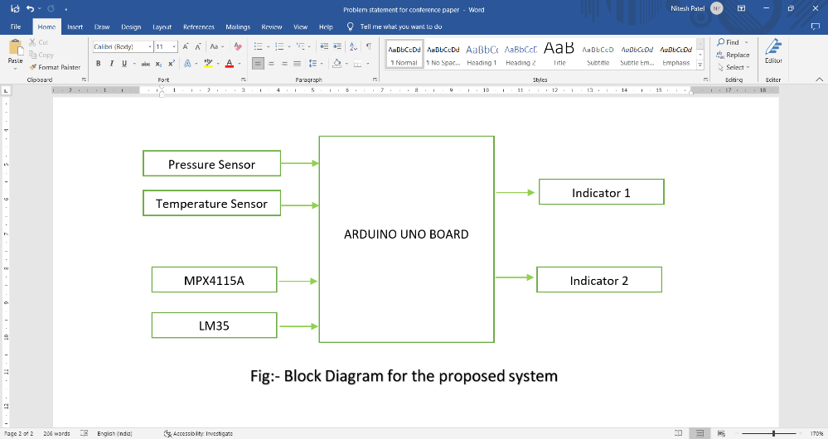

MPX4115A Pressure sensor

The MPX4115A is an absolute, altimeter/barometer pressure sensor in 6 pin SIP package. This device is designed to sense absolute air pressure in an altimeter or barometer (BAP) applications. NXP BAP sensor integrates on-chip bipolar op amp circuitry and thin film resistor networks to provide high level analogue output signal and temperature compensation. The small form factor and high reliability of on-chip integration makes NXP BAP sensor logical and economical choice for application designers.

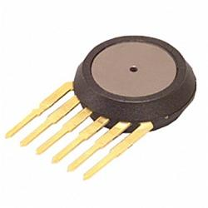

Fig:- MPX411A pressure sensor

LM35 Temperature sensor

The LM35 is one kind of commonly used temperature sensor that can be used to measure temperature with an electrical o/p comparative to the temperature (in °C). It can measure temperature more correctly compare with a thermistor. This sensor generates a high output voltage than thermocouples and may not need that the output voltage is amplified. The LM35 has an output voltage that is proportional to the Celsius temperature. The scale factor is .01V/°C.

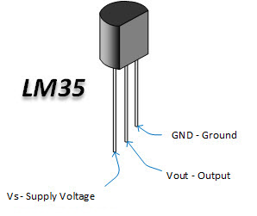

Fig:- LM35 Temperature Sensor

1. **Software Description**

The suggested system makes use of Splunk Enterprise, which employs machine learning methods such as regression and classification to collect, deploy, evaluate, transform, and visualise tyre pressure monitoring system data logs.

Splunk Enterprise 7.2.0

Splunk Enterprise is a data collection, management, and analysis tool. Sensors, devices, and operational technology can provide real-time information. The key features include the ability to search for and examine a certain result, create dashboards to visualise and analyse data logs, and save data for later use. The advantages include real-time processing, the ability to enter data in any format, including CSV (Comma Separated Values), JSON (Javascript Object Notation), and others, and the ability to precisely forecast the resources required for scaling up the infrastructure.

Splunk Components

The components of the Splunk Enterprise are shown in Figure 1.

Splunk Forwarder, Splunk Indexer, and Search Head are the three essential components. The forwarder is used to forward data, whereas the indexer is used to parse and index the data. Searching, analysing, and reporting are all done with the search head.

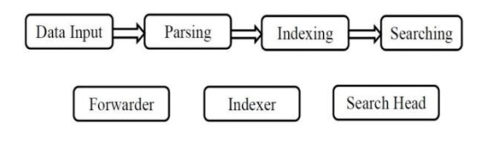

Fig.1: Splunk Components

Visualization

The visualisation aids in the clear and precise communication of complicated ideas and data patterns. Splunk offers a variety of ways to create reports and dashboards that illustrate the search results generated by the data it has indexed. The ability to retrieve large amounts of data is one of the most essential advantages of visualisation. Splunk offers a variety of chart formats to help you visualise your data.

Dashboards

Dashboards are a collection of searches, visualisations, and input elements that capture and present information.Dashboards are a common way to measure and track performance, and they're also a good way to keep track of specific data. Splunk offers a number of options for producing useful dashboards based on searches and visual visualisations. Using Splunk for monitoring frequently results in a dashboard with many visualisations. The report panels on a dashboard can be a chart, gauge, table, or a list of search results.

Machine Learning Algorithm

Splunk Enterprise uses the DecisionTree algorithm, a machine learning technique, to search and predict indexed data. It's a method for predicting outcomes using predictor variables. Both classification and regression trees use decision trees. To fit a model to predict the value of a categorical variable, a decision tree estimator is used.

1. **Experimental Results**

In the proposed effort, around 10log datasets of tyre pressure monitoring pressure were processed. Splunk Enterprise is used to process the TPMT logs and provide visualisations such as pivots, dashboards, and reports.

Following figure depicts the tyre pressure monitoring system's experimental setup. Arduino Uno Board, Mpx4115A pressure sensor and LM35 temperature sensor make up the test setup.

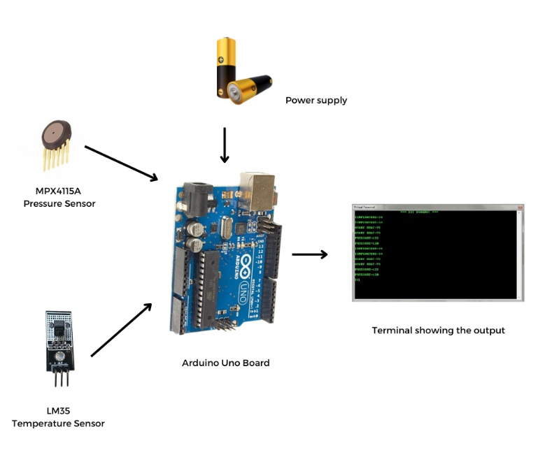

Fig. Experimental Setup

**Hardware Results**

The tyre pressure information displayed in gauge is shown in Figure below Kilopascal is the unit of measurement for pressure and degree celcius which is the unit of temperature.

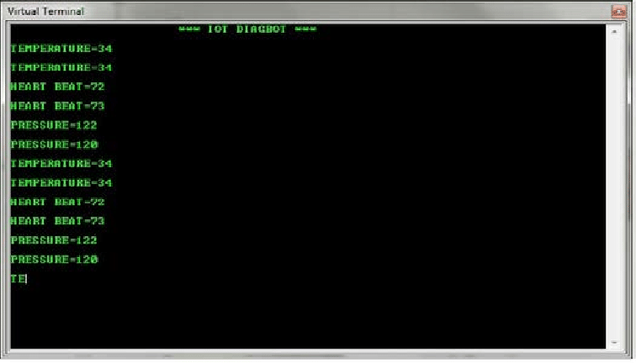

1. **Conclusion**

The  pressure of car tyres are monitored in this study utilising a real-time tyre pressure monitoring system based on Splunk Enterprise. The TPMS logs are indexed and monitored in real time using the Splunk Enterprise tool with the machine learning toolkit, which includes visualisation pivots, dashboards, and reports. As a result, it can be used to assess system performance, troubleshoot any failures, and track business data.

1. **REFERENCES**

[1]S. Abdelhamid, H. S. Hassanein, and G. Takahara, “Vehicle as a Mobile Sensor,” Procedia Computer Science, vol. 34, pp. 286–295, Jan. 2014. [Online]. Available: http://www.sciencedirect.com/science/ article/pii/S1877050914008801

[2] Snehal R.Javheri, Biplap Kumar and Bej Raj Singh Patel, “Wireless Tire Pressure Monitoring System for Motor Vehicles”, International Conference on Ubiquitous and Future Networks (ICUFN), pp. 744-748, June 2017

[3] Sharmila and Vibin Mammen Vinod, “Design of a Real-Time Tire Pressure Monitoring System for LMV’s”, International Conference on Green Engineering and Technologies (IC- GET), pp. 103-106, 2016

[4 ]Nouman Naim Hasan, Adeel Arif, Muhammad Hassam, Syed Shabeeh and Usman Pervez, “Implementation of Tire Pressure Monitoring system with Wireless Communication”, International Conference on Communication Computing and Control Applications, 2011.