**Intermediate SQL Query**

* --Inner Join On Both Table

SELECT *

FROM EmployeeDemographics

Inner Join EmployeeSalary

On EmployeeDemographics.EmployeeID = EmployeeSalary.EmployeeID

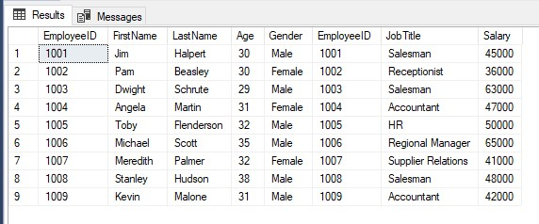

* --Full Outer Join

SELECT *

From EmployeeDemographics

FUll Outer Join EmployeeSalary

On EmployeeDemographics.EmployeeID = EmployeeSalary.EmployeeID

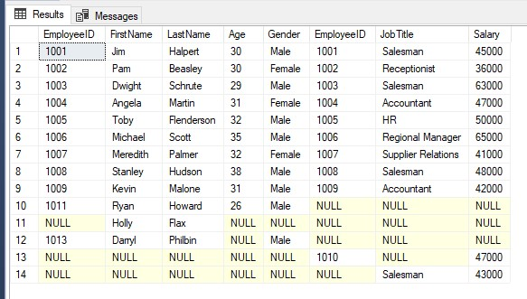

* --left outer join

SELECT *

From EmployeeDemographics

Left Outer Join EmployeeSalary

On EmployeeDemographics.EmployeeID = EmployeeSalary.EmployeeID

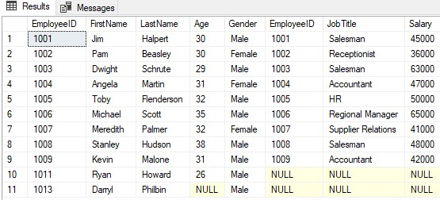

* --Right Outer Join

SELECT *

From EmployeeDemographics

Right Outer Join EmployeeSalary

On EmployeeDemographics.EmployeeID = EmployeeSalary.EmployeeID

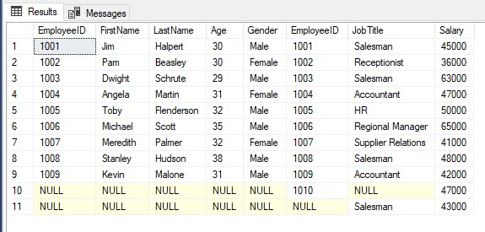

* --left outer join with specific columns

SELECT EmployeeSalary.EmployeeID, FirstName, LastName,Salary

From EmployeeDemographics

Left Outer Join EmployeeSalary

On EmployeeDemographics.EmployeeID = EmployeeSalary.EmployeeID

* /*Use case-1 Company is pressuring Michael to meet his quarterly Quota and michael is almost there and he needs like a thousand more dollars

and he comes up with the genius idea to deduct pay for the highest pay employee at his branch besides himself so how does he go about doing this

identifying the person that makes the most money*/

SELECT EmployeeDemographics.EmployeeID, FirstName, LastName, Salary

From EmployeeDemographics

Inner Join EmployeeSalary

On EmployeeDemographics.EmployeeID = EmployeeSalary.EmployeeID

Where FirstName <> 'Michael'

Order by Salary Desc

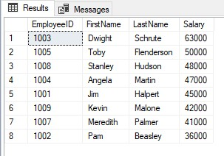

* **SO Michael Pay A thousand dollar from Dwight Salary**
* Use case-2 accountant makes mistake to calculate Average salary of Salesman Find Avg salary of saleman

Select JobTitle , Avg(Salary) As 'Average salary'

From EmployeeDemographics

Inner Join EmployeeSalary

On EmployeeDemographics.EmployeeID = EmployeeSalary.EmployeeID

Where JobTitle = 'Salesman'

Group by JobTitle

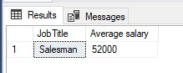

--Union

Create Table WareHouseEmployeeDemographics

(EmployeeID int,

FirstName varchar(50),

LastName varchar(50),

Age int,

Gender varchar(50))

Insert into WareHouseEmployeeDemographics Values

(1013,'Darryl','Philbin',Null,'Male'),

(1050,'Roy','Anderson',31,'Male'),

(1051,'Hidetoshi','Hasagawa',40,'Male'),

(1052,'Val','Johnson',31,'Female')

Select *

From EmployeeDemographics

Union

Select *

From WareHouseEmployeeDemographics

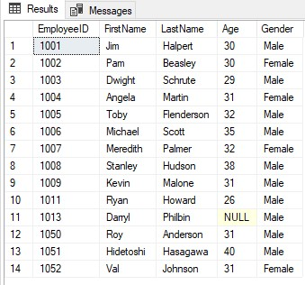

Select *

From EmployeeDemographics

Union All

Select *

From WareHouseEmployeeDemographics

* --CASE

SELECT FirstName, LastName ,Age,

CASE

When Age = 38 Then 'Stanley'

When Age > 30 Then 'Old'

Else 'Baby'

End As 'Age group'

From EmployeeDemographics

Where Age is Not Null

Order by Age

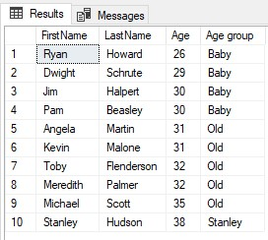

* SalaryRise based on their JobTitle

Select Firstname, Lastname, JobTitle, Salary,

CASE

When JobTitle = 'Salesman' Then Salary + (Salary * 0.10)

When JObTitle = 'Accountant' Then Salary + (Salary * 0.5)

When JobTitle = 'HR' Then Salary + (Salary * 0.2)

Else Salary + (Salary * 0.01)

End As 'SalaryAfterRise'

From EmployeeDemographics

Inner Join EmployeeSalary

On EmployeeDemographics.EmployeeID = EmployeeSalary.EmployeeID

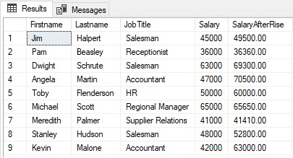

--Having Clause

Select JobTitle, Count(JobTitle)

From EmployeeDemographics

Inner Join EmployeeSalary

On EmployeeDemographics.EmployeeID = EmployeeSalary.EmployeeID

Group By JobTitle

--If We want to add condition on group by function then we Must use Having Clause instead of Where

Select JobTitle, Count(JobTitle)

From EmployeeDemographics

Inner Join EmployeeSalary

On EmployeeDemographics.EmployeeID = EmployeeSalary.EmployeeID

Group By JobTitle

Having Count(JobTitle)>1

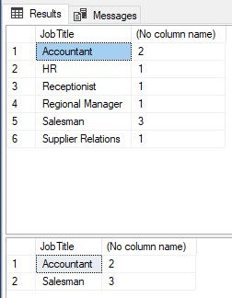

* --Update and Delete Query

Select * From EmployeeDemographics

Update EmployeeDemographics

Set EmployeeID = 1012

Where FirstName = 'Holly' And LastName = 'Flax'

Update EmployeeDemographics

Set Age = 35, Gender= 'Female'

Where EmployeeID = 1012

Delete From EmployeeDemographics

Where EmployeeID = 1012

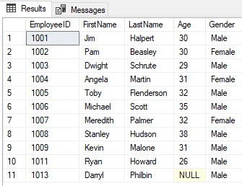

* --Aliasing

Select FirstName + ' ' + Lastname As 'Full Name'

From EmployeeDemographics

Select Demo.EmployeeID, Demo.FirstName, Demo.LastName, salary.Salary,warehouse.Age

From EmployeeDemographics as Demo

Left Outer Join EmployeeSalary salary

On Demo.EmployeeID = salary.EmployeeID

Left Outer Join WareHouseEmployeeDemographics warehouse

on Demo.EmployeeID = warehouse.EmployeeID

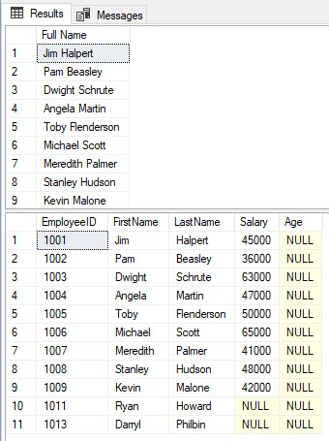

* --Partition By

Select EmployeeDemographics.EmployeeID,FirstName,LastName, Age,Gender,

Count(Gender) Over (Partition By Gender) As TotalGender

From EmployeeDemographics

Inner Join EmployeeSalary

On EmployeeDemographics.EmployeeID = EmployeeSalary.EmployeeID

