**ADVANCE SQL QUERY**

**/\***

**CTE**

**\*/**

WITH CTE_Employee as

(SELECT FirstName, LastName, Gender, Salary,

Count(Gender) Over (partition by Gender) As TotalGender,

AVG(Salary) Over (Partition by Gender) As AvgGenderSalary

From EmployeeDemographics

Inner Join EmployeeSalary

On EmployeeDemographics.EmployeeID = EmployeeSalary.EmployeeID

Where EmployeeSalary.Salary > '45000'

)

--Select * From CTE_Employee

Select FirstName, TotalGender, AvgGenderSalary From CTE_Employee

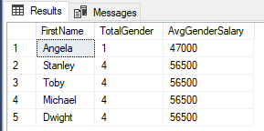

**/\***

**Temp_Table**

**\*/**

CREATE TABLE #Temp_Employee

(EmployeeID int,

JobTitle varchar(50),

Salary int

)

INSERT INTO #Temp_Employee VALUES

(10010,'HR',45000)

INSERT INTO #Temp_Employee

SELECT *

FROM EmployeeSalary

Select * From #Temp_Employee

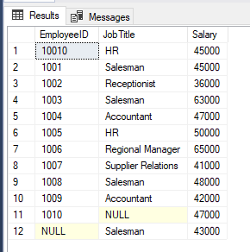

Drop Table IF Exists #Temp_Employee2

CREATE TABLE #Temp_Employee2(

JobTitle varchar(50),

EmployeePerJob int,

AvgAge int,

AvgSalary int)

INSERT INTO #Temp_Employee2

SELECT JobTitle, Count(JobTitle),Avg(Age),Avg(Salary)

From EmployeeDemographics

Inner Join EmployeeSalary

On EmployeeDemographics.EmployeeID = EmployeeSalary.EmployeeID

Group By JobTitle

Select * From #Temp_Employee2

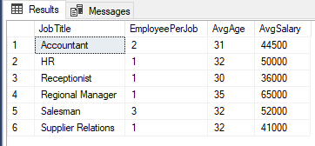

**/\***

**String Functions TRIM, LTRIM, RTRIM, REPLACE, UPPER, LOWER, SubString**

**\*/**

CREATE TABLE EmployeeErrors

(EmployeeID varchar(50),

FirstName varchar(50),

LastName varchar(50))

Insert Into EmployeeErrors Values

('1001 ','Jimbo','Halbert'),

(' 1002','Pamela', 'Beasely'),

('1005','TOby', 'Flenderson - Fires')

SELECT *

From EmployeeErrors

--Using TRIM, LTRIM, RTRIM

Select EmployeeID , TRIM(EmployeeID) AS TRIMID

From EmployeeErrors

Select EmployeeID , LTRIM(EmployeeID) AS TRIMID

From EmployeeErrors

Select EmployeeID , RTRIM(EmployeeID) AS TRIMID

From EmployeeErrors

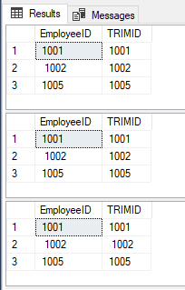

**--Using Replace**

Select LastName , REPLACE(LastName, '- Fires','') as LastNameFixed

From EmployeeErrors

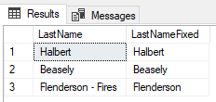

**--Using SubString**

Select FirstName, SUBSTRING(FirstName,2,3)

From EmployeeDemographics

Select demo.FirstName,SUBSTRING(demo.FirstName,1,3) , er.FirstName, SUBSTRING(er.FirstName,1,3)

From EmployeeDemographics as demo

Inner Join EmployeeErrors as er

On SUBSTRING(demo.FirstName,1,3) = SUBSTRING(er.FirstName,1,3)

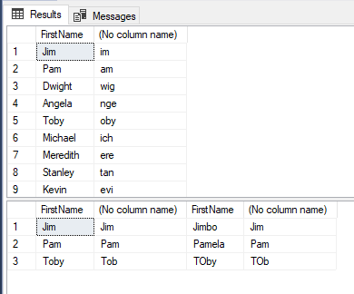

**--Using UPPER And Lower**

Select FirstName,UPPER(FirstName) as UPPER_FirstName, LOWER(FirstName) as LOWER_FirstName

From EmployeeDemographics

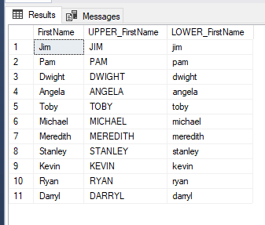

**/\***

**PROCEDURE**

**\*/**

Create Procedure Test

AS

Select *

From EmployeeDemographics

EXEC Test

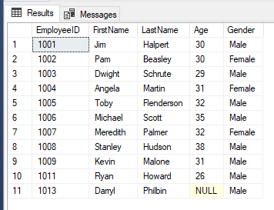

Create Procedure Temp_Employee

@JobTitle nvarchar(100)

As

CREATE TABLE #Temp_Employee3(

JobTitle varchar(50),

EmployeePerJob int,

AvgAge int,

AvgSalary int)

INSERT INTO #Temp_Employee3

SELECT JobTitle, Count(JobTitle),Avg(Age),Avg(Salary)

From EmployeeDemographics

Inner Join EmployeeSalary

On EmployeeDemographics.EmployeeID = EmployeeSalary.EmployeeID

Where JobTitle = @JobTitle

Group By JobTitle

Select * From #Temp_Employee3

EXEC Temp_Employee @JobTitle = 'Salesman'

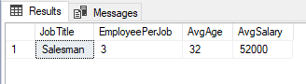

**/\***

**SubQueries (in the select, From, Where Statement)**

**\*/**

--SubQuery in Select

Select EmployeeID, Salary, (Select Avg(Salary) From EmployeeSalary) As AvgSalary

From EmployeeSalary

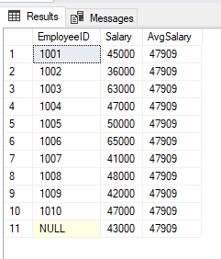

**--DO with Partition By**

Select EmployeeID, Salary, Avg(Salary) Over() As AvgSalary

From EmployeeSalary

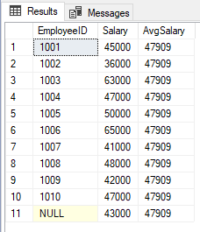

**--SubQuery in From**

Select a.EmployeeID, a.AvgSalary

From(Select EmployeeID, Salary, Avg(Salary) Over() As AvgSalary

From EmployeeSalary) a

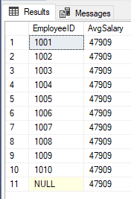

**--SunQuery in Where**

Select EmployeeID, Salary, JobTitle

From EmployeeSalary

Where EmployeeID In (

Select EmployeeID

From EmployeeDemographics)

