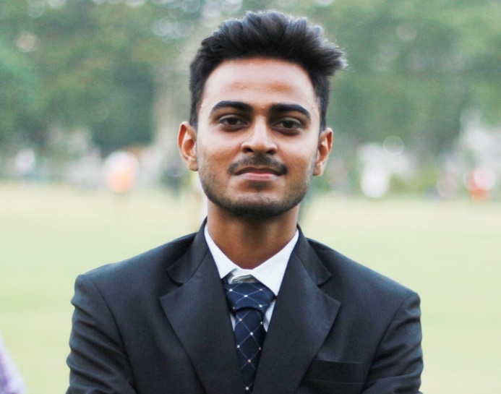

EDUCATION

–

Bachelors of Engineering (Information Technology)

2015-2019

Birla Vishvakarma Mahavidyalaya 7.89 CPI

Higher Secondary (G.S.H.S.E.B.)

2013-2015

Vivekanand Vidyalaya 86.33%

Secondary School (G.S.E.B.)

2012-2013

Hiraba Vidhyalaya 85.16%

INTERNSHIP

Personal Info

**C-DAC (Ahmedabad)**

* I have completed 6 week internship in C-DAC and learnt basic Java programming language with database and UI designing with XML and completed assignment based on Java.

PROJECTS

F-303, Raghvendra Avenue, Mahadevnagar, Vastral, Ahmedabad-382 418.





+91 7069948442



Patelsanket864@gmail.com

**Web Project:** It’s an E-Commerce website for online selling books of computer engineering from well-known authors.

**Android Project:** It’s a “Smart College Application” based on android that provides document sharing facility and live chat with faculty.

**Computer Graphics Project:** It’s a game like Hangman which is developed in C++ language.

C:\Users\dell\Desktop\Calendar-512.png

25-03-1998



Github.com/patelsanket864

Google.com/patelsanket864

**Programming Language:** C, C++, JAVA

**Scripting Language:** Python, PHP

**Web Technologies:** HTML, CSS, JavaScript

**Operating System:** Microsoft Windows, Ubuntu, Linux

**Programming Environment:** GNU/GCC, Sublime, Notepad++, Android Studio

* Participated in TCS Codevita
* Volunteer at Bachhpan NGO
* Instructor at Invincible NGO
* Event Manager in Maphorlfe (Udaan 2018)

Technical SkillsSkills

EXTRA CURRICULAR ACTIVITIES

[linkedin.com/in/sanket-patel-65a113153](https://www.linkedin.com/in/sanket-patel-65a113153)

* Playing Cricket
* Trekking
* Doing Exercise
* Watching Series

HOBBIES

**Declaration:** I, Sanket Patel, hereby declare that the information above is correct up to my knowledge and I take responsibility for the above mentioned particulars.

J//M