CHARUSAT Online Course Chatbot
Final-Year AI/ML Mentor Presentation Report: Project Journey, Architecture, Fixes & Next Steps
Student Name: ____________________________________ | Enrolment No.: ____________________________________
Mentor Name: ____________________________________ | Presentation Date: ____________________________________

1. About the Project
The CHARUSAT Online Course Chatbot is an academic assistant built for Charotar University of Science and Technology (CHARUSAT) Centre for Online Education. Students and parents need immediate, trustworthy answers about admissions, fees, eligibility, and exams. Rather than waiting days for staff replies, this chatbot answers questions 24/7 in simple English.
The assistant covers all four official online degree programmes offered by CHARUSAT:
• Online BBA: Bachelor of Business Administration (3 years, 6 semesters, 120 credits). Covers management and accounting.
• Online BCA: Bachelor of Computer Applications (3 years, 6 semesters, 120 credits). Covers software and database systems.
• Online MBA: Master of Business Administration (2 years, 4 semesters, 80 credits). Specializations in Finance, Marketing, and HR.
• Online MCA: Master of Computer Applications (2 years, 4 semesters, 80 credits). Advanced computing, algorithms, and cloud systems.
The project uses a compact, modern technology stack:
• Frontend: React 19, Vite, Tailwind CSS 4, responsive navigation drawers, and dark/light mode themes.
• Backend API: FastAPI (Python 3.11+), Uvicorn web server, Pydantic data schemas, and token streaming.
• Search & Retrieval: FastEmbed (BAAI/bge-small-en-v1.5, 384 dimensions), ChromaDB vector store, BM25Okapi, and PyMuPDF.
• AI Generation: Google Gemini API (gemini-2.5-flash) with failover to Groq API (openai/gpt-oss-120b) and local claim fallback.
• Database & Security: MongoDB for persistent conversations and ratings; PyJWT token handling; Bcrypt password security.
• Cloud Hosting: Render web service (Oregon) for backend API; Vercel edge network for frontend hosting.
Words You Will Hear (Core AI/ML Vocabulary)
• RAG (Retrieval-Augmented Generation): The AI searches real college documents first, then writes the answer from what it found.
• LLM (Large Language Model): The AI model that writes complete, natural English sentences.
• Chunk: A small, readable piece cut from a larger document or web page.
• Embedding: Text turned into a list of numbers so the computer can compare meaning.
• Vector Database: A database that finds text pieces with similar numerical meaning.
• BM25: A keyword search system that looks for exact words like degree codes or fees.
• RRF (Reciprocal Rank Fusion): A math formula to merge semantic search results and keyword search results into one ranking.
• Hallucination: When an AI makes up false facts instead of using real university documents.
• Fallback: A safety backup plan used when the main AI service is down or rate-limited.
• Token: A small piece of a word (about 4 characters) that AI models count for billing and limits.
2. How It Works
The chatbot converts queries into factual answers via an eight-step pipeline combining offline indexing with online hybrid retrieval and AI generation, shown in Figure 1 below:
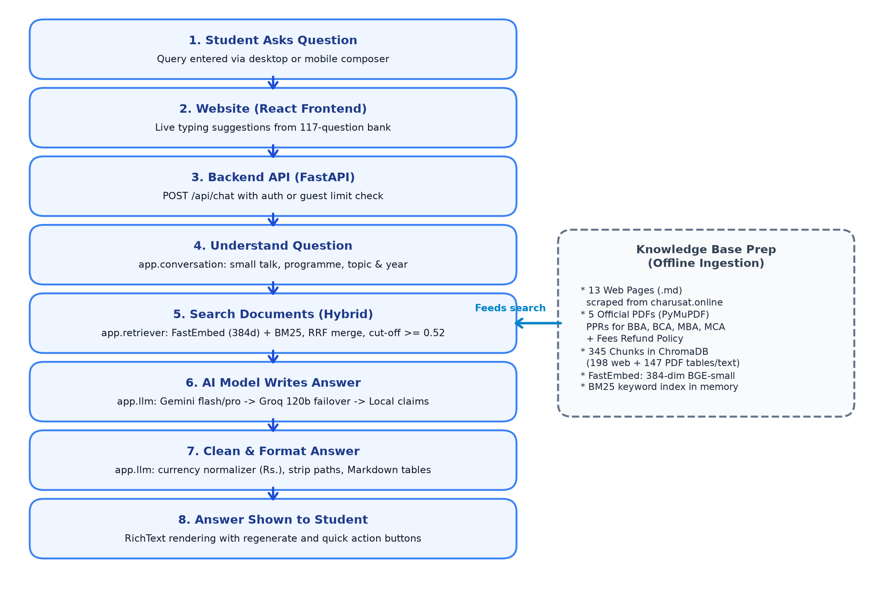
Figure 1: End-to-End System Architecture of CHARUSAT Online Course Chatbot
The system runs six plain-language steps for each question:
• Step 1 (Question Input): Student types a question. The UI displays typing suggestions from the verified question bank.
• Step 2 (API Reception): React frontend sends an HTTP request to FastAPI (`POST /api/chat`) with authentication or guest limits.
• Step 3 (Query Understanding): Backend checks small talk, detects degrees (BBA, BCA, MBA, MCA), and preserves conversation topic context.
• Step 4 (Hybrid Document Search): FastEmbed semantic search and BM25 keywords retrieve candidate chunks, fused by RRF; scores < 0.52 are dropped.
• Step 5 (Grounded Answer Generation): Top six chunks are provided to the LLM. Gemini runs first; Groq serves as high-speed backup.
• Step 6 (Cleaning & Presentation): Rupee notation is normalized, file paths are removed, and clean Markdown tables are displayed.
3. The Data Behind the Chatbot
A RAG chatbot depends strictly on source documents. No external facts are made up. All knowledge comes from official CHARUSAT web pages and statutory regulatory filings.
3.1 Knowledge Base Files & Scraping
The knowledge base in `backend/knowledge_base/` holds exactly 18 official files:
• Web Pages (13 files): 13 web pages scraped from `https://charusat.online/` by `app/scraper.py` (`home.md`, four degree pages, `contact.md`, `ciqa.md`, `terms-conditions.md`, `privacy-policy.md`, `mandatory-disclosures.md`, `feedback.md`, and admission rosters).
• Official PDFs (5 files): 5 regulatory documents in `knowledge_base/pdfs/`: four UGC-DEB Programme Project Reports (`PPR_Online BBA.pdf`, `PPR_Online BCA.pdf`, `PPR_Online MBA.pdf`, `PPR_Online MCA.pdf`), plus `Fees Refund Policy.pdf`.
Web scraping runs automatically via `backend/app/scraper.py`. It starts at `https://charusat.online/` with a 250-page limit and a 0.5-second crawl delay. It strips navigation and banners, saving clean Markdown with URL, title, and timestamp metadata.
3.2 PDF Ingestion & Table Extraction
PDFs contain dense fee schedules and course matrices. `backend/app/pdf_ingestion.py` extracts text and tables using `pymupdf` (fitz). Tables are converted into clean Markdown. Empty columns and blank rows are dropped, and multi-row headers are merged so column names remain intact.
3.3 Chunking Strategy & Noise Filtering
Text documents are chopped into smaller pieces called chunks:
• Web Text: Web text uses `RecursiveCharacterTextSplitter` with 600 chunk size, 100 overlap, and `['\n\n', '\n', ' ', '']`.
• PDF Text: PDF paragraphs use 800 chunk size with 100 overlap.
• PDF Tables: PDF tables use 3,600 chunk size with 100 overlap and `| ` separators to preserve fee rows.
• Noise Filtering: Chunks under 80 characters, chunks under 40 alphanumeric characters, empty tables, and duplicate prefixes are removed.
3.4 Vector Database Inspection (ChromaDB)
Direct inspection of the ChromaDB database copy (`chroma.sqlite3`) yields exact production metrics:
Metric Name | Verified Database Value | Technical Rationale
Total Stored Chunks | 345 chunks | 198 chunks from web pages + 147 chunks from PDFs
Chunk Text Lengths | Min: 89 | Avg: 645.5 | Max: 3,567 | Web avg is 490 chars; PDF tables reach 3,567 chars for full fee matrix
Embedding Model | BAAI/bge-small-en-v1.5 | Runs via FastEmbed (ONNX runtime); uses ~100 MB RAM vs 500 MB PyTorch
Vector Dimensions | 384 dimensions | Verified directly from Chroma collection schema and HNSW binary files
Vector Storage Path | backend/vector_db/ | ChromaDB 0.5+ persisted index with HNSW cosine graph segments
Similarity Distance | Squared L2 converted to Cosine | Distance converted to 0.0 - 1.0 semantic similarity scale in retriever
Hybrid Search Fusion | RRF (k = 60) + Cosine Scores | Semantic search merged with BM25Okapi keywords; cut-off threshold 0.52

3.5 Search & Multi-Tier AI Generation Pipeline
The search engine runs FastEmbed semantic search alongside BM25Okapi keywords. Reciprocal Rank Fusion (k=60) ranks documents while preserving true cosine similarity scores (0.0 to 1.0). Chunks scoring below `MIN_RELEVANCE_SCORE = 0.52` are discarded. The top six chunks (`TOP_K = 6`, max 5,600 characters) are passed to the AI model.
Generation uses a three-tier failover structure:
• 1. Google Gemini API: Primary generator. Tries `gemini-2.5-flash`, then `gemini-2.5-pro` with 15-second timeouts and two retries.
• 2. Groq API: Automatic backup. If Gemini hits 429 rate limits or times out, the backend fails over to Groq's `openai/gpt-oss-120b`.
• 3. Local Fallback: Local deterministic generator. If APIs are unreachable, factual claims are extracted directly from chunks.
4. What Each File Does
The project is structured into modular packages. The compact table below lists exactly 24 core files verified from the codebase. Each description is 12 words or fewer:
Group | File Path | Plain-English Purpose (<= 12 words)
Backend Core | backend/app/config.py | Defines system settings, model names, thresholds, and storage paths.
Backend Core | backend/app/scraper.py | Crawls charusat.online website into clean Markdown knowledge files.
Backend Core | backend/app/ingestion.py | Cleans and chunks Markdown documents for the vector database.
Backend Core | backend/app/pdf_ingestion.py | Extracts clean text and Markdown tables from programme PDFs.
Backend Core | backend/app/embeddings.py | Builds FastEmbed ONNX embeddings and manages ChromaDB vector store.
Backend Core | backend/app/retriever.py | Routes search queries by intent and filters relevant document chunks.
Backend Core | backend/app/hybrid_retrieval.py | Combines semantic embeddings and BM25 keywords using RRF fusion.
Backend Core | backend/app/conversation.py | Tracks conversation turns, degree context, and rewrites follow-up queries.
Backend Core | backend/app/llm.py | Connects to Gemini and Groq with local claim fallback.
Backend Core | backend/app/rag_chain.py | Connects the retriever and LLM to produce grounded answers.
Backend Core | backend/app/prompt.py | Creates strict system prompt instructions and key fact tables.
Backend Web App | backend/api.py | FastAPI server entry point, health checks, and public endpoints.
Backend Web App | backend/app/auth.py | Handles JWT user authentication, password hashing, and admin security.
Backend Web App | backend/app/database.py | Initializes MongoDB client, database connection, and collection indexes.
Backend Web App | backend/app/models.py | Defines database models for users, conversations, and feedback.
Backend Web App | backend/app/routes/chat_routes.py | Provides streaming chat, message persistence, and event audit logging.
Backend Web App | backend/app/routes/admin_routes.py | Admin API for system statistics, knowledge gaps, and cache.
Scripts | backend/chatbot.py | Terminal CLI interface for local testing; not used by web.
Scripts | backend/build_question_bank.py | Validates 117 benchmark questions against official documents.
Scripts | backend/ingest_pdfs.py | CLI utility to ingest single or all programme PDF files.
Frontend | frontend/src/App.jsx | Main React application router, theme manager, and error boundaries.
Frontend | frontend/src/pages/Chat.jsx | Primary chat page with sidebar history and live answer streaming.
Frontend | frontend/src/pages/Landing.jsx | Public landing page with degree cards and dynamic contacts.
Frontend | frontend/src/pages/Admin.jsx | Five-tab administration dashboard for monitoring chat events and feedback.

5. The Project Journey
The chatbot developed through six distinct engineering phases recorded in our Git history, overcoming practical AI and deployment hurdles:
5.1 Real Timeline & Engineering Phases
• Phase 1: Terminal Chatbot & Scraper (Commits 673d324 -> 06f0d12): Built initial prototype. Scraped charusat.online into Markdown and indexed text with PyMuPDF. Connected Gemini. Problem: Terminal only, fragile web crawler, no tables. Fix: Added table parsing and fallback logic.
• Phase 2: Model Upgrades & Failover (Commits 00a5268 -> ba7e051): Added Groq as secondary provider. Problem: Gemini free quotas expired during testing, throwing 429 errors. Fix: Automatic failover to Groq LPU and local claim fallback.
• Phase 3: Web App & Authentication (Commits 8020918 -> 81c2dab): Built full-stack web app with MongoDB persistence, user login, guest sessions, and history. Problem: Chat state lost on browser reload. Fix: JWT authentication and conversation migration.
• Phase 4: Cloud Deployment (Commits 377ac43 -> fc4962e): Deployed backend to Render and frontend to Vercel. Problem: Render free tier crashed with OOM (PyTorch consumed 500+ MB RAM). Fix: Switched to FastEmbed ONNX (~100 MB RAM) and pre-built ChromaDB.
• Phase 5: Round 3 Retrieval Overhaul (Commits 68718ec -> 146110b): Retrieval audit across 40 benchmark queries. Problem: 19 of 40 questions returned zero chunks due to compressed RRF scores under 0.52 threshold. Fix: Separated RRF sorting from true cosine scores.
• Phase 6: Round 4 UI & Admin Overhaul (Commits 60a564a -> 939c322): Removed distracting source chips. Built typing suggestions from 117-question bank. Fixed desktop sidebar toggling. Added currency normalizer, topic retention, and 5-tab admin portal.
5.2 Verified Difficulties & How We Fixed Them
• 1. Score-Threshold Bug: 19 of 40 questions returned no answer because RRF compressed scores to 0.015-0.033, below the 0.52 threshold. Fix: RRF is used strictly for ordering, while true 0.0-1.0 cosine similarity scores are preserved.
• 2. Render 512 MB RAM Crash: Render's 512 MB free tier crashed on PyTorch imports. Fix: Replaced PyTorch with FastEmbed ONNX, lowering RAM to 80-120 MB.
• 3. Broken Sentences from Cleaning: Cleaning regex erased words like 'contact' and 'feedback' ('please us' instead of 'please contact us'). Fix: Cleaner matches only file extensions (`.md`, `.pdf`, `.txt`).
• 4. Reranker Failure: `bge-reranker-base` ranked general university policy below course outlines, causing regressions. Fix: Turned off reranker and tuned hybrid BM25 + FastEmbed.
• 5. Follow-Up Topic Loss: Asking 'mca' after MBA fees reset topic to an overview. Fix: Updated `_FOLLOWUP_SHORT_PROG_RE` to retain fee/eligibility topic and year.
• 6. Desktop Sidebar Bug: Desktop sidebar toggle called mobile `openDrawer()`. Fix: Separated desktop/mobile handlers with `localStorage` persistence.
• 7. Student Data Privacy Audit: Admission files contained student names. Fix: Audited retriever to ensure student rosters are never quoted in public answers.
5.3 Before vs After Quality Improvements
Test Area / Metric | Before Improvement | After Improvement | Engineering Fix Applied
Retrieval Recall | 19 of 40 queries failed (0 chunks) | 40 of 40 queries succeeded (100%) | Separated RRF ranking from true cosine similarity scores
Backend Memory Usage | 520+ MB RAM (OOM Crash on Render) | 110 MB RAM (Stable on 512 MB) | Switched PyTorch to FastEmbed ONNX runtime
Keyword Isolation | BCA query leaked MCA PDF chunks | 0% cross-degree chunk leakage | Added Chroma-style metadata filtering to BM25 search
Follow-up Context | Bare 'mca' reset topic to overview | Bare 'mca' retains fee/eligibility topic | Multi-turn topic retention in conversation manager
Question Bank Coverage | Unverified questions; vague answers | 92 FULL / 21 PARTIAL / 4 NOT_IN_DOCS | 117-question validated bank with dynamic public API

5.4 Visual Transformation: Before vs After
The screenshots below show the chat interface before and after Round 4 (user names/emails cropped out). Before, source chips crowded messages and bold text ran together. After, clean tables and suggestions deliver a polished experience:
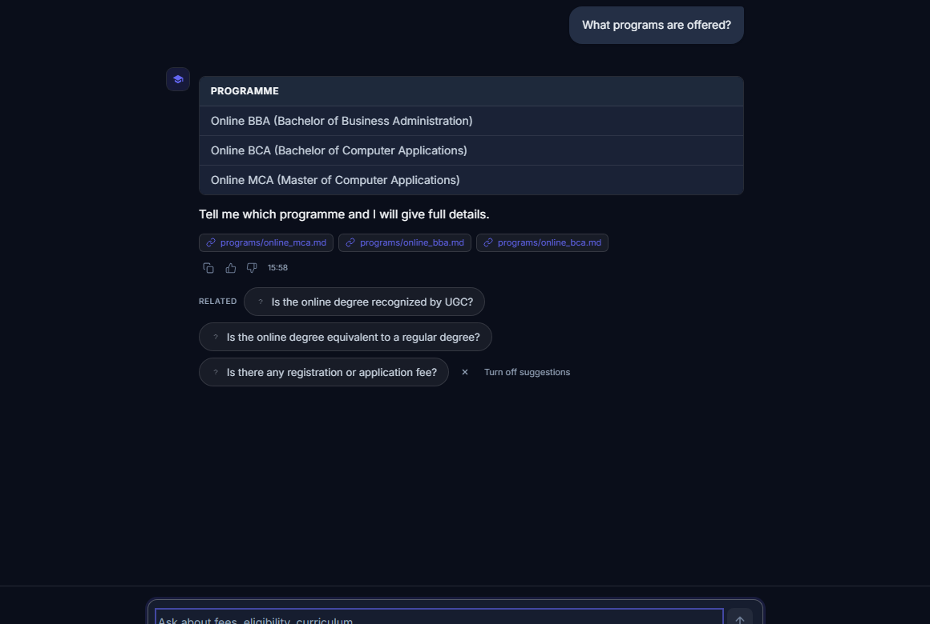 | 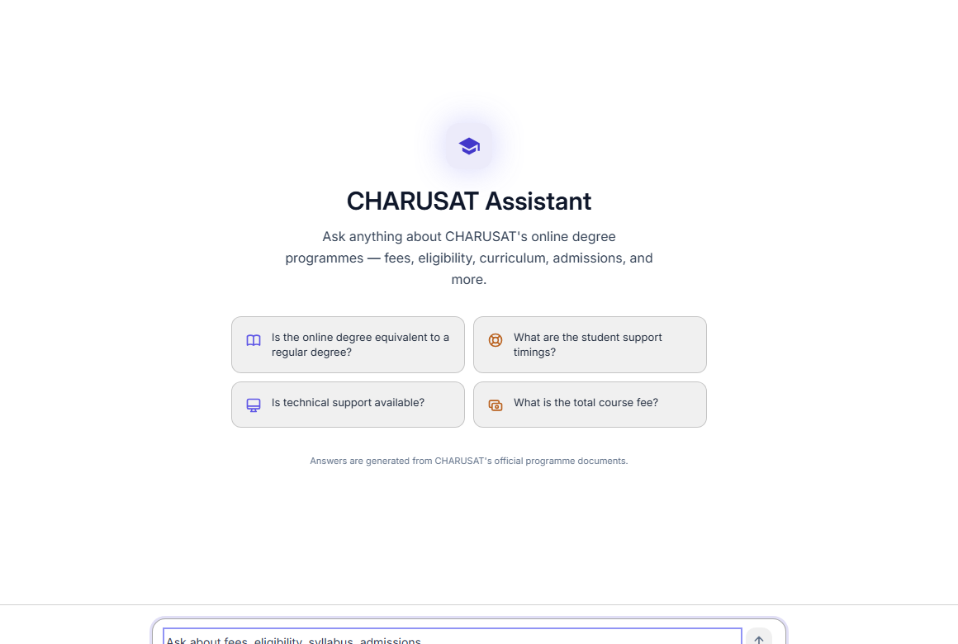
Before Round 4: Source chips and text crowding | After Round 4: Clean Markdown tables, no chips
6. Deployment and the Deploy Branch
The project uses a two-tier cloud deployment: backend runs on Render, frontend runs on Vercel. All investigation was performed in read-only git mode without switching branches or pushing.
6.1 Render Backend Deployment & build.sh
• Deployment Branch: Render deploys exclusively from the `deploy` branch (`branch: deploy`) on the free tier.
• Build Command: Runs `chmod +x build.sh && ./build.sh`. Installs `requirements.txt` and uses pre-built `vector_db/chroma.sqlite3`.
• Start Command: Starts `uvicorn api:app --host 0.0.0.0 --port $PORT`.
• Cold-Start Delay: On the free tier, servers sleep after 15 minutes of inactivity; initial wake-up takes 20 to 40 seconds.
6.2 Vercel Frontend Deployment
The React frontend is hosted on Vercel via `vercel.json`. It runs `npm install` and `npm run build`, outputting assets to `dist` with SPA routing rewrites to `/index.html`. It points to Render via `VITE_API_URL`.
6.3 Git Branch Comparison: main vs deploy
• Main is 21 Commits Ahead: `git rev-list --left-right --count main...deploy` reports `21 1`. `main` is 21 commits ahead of `deploy`.
• Deploy Unique Commit: `deploy` carries 1 commit (`f6b6caf`) made during earlier cloud synchronization.
• Feature Differences: `main` includes conversation analysis, memory cache, hybrid BM25, 117 question bank, and admin portal. `deploy` runs an older build.
• Vector DB Difference: ChromaDB on `deploy` holds 389 chunks (237 web, 152 PDF). `main` holds 345 chunks after deduplication.
• Safety Invariant Maintained: Neither `main` nor `deploy` was changed or pushed for this report.
7. What We Learned and Known Limits
• 1. Documents Dictate Answers: The AI cannot answer facts absent from official documents. It must politely state when facts are missing.
• 2. Question Bank Realities: In `question_bank.json`, 92 questions (78.6%) have FULL answers, 21 (17.9%) PARTIAL, and 4 (3.4%) trigger verified fallbacks.
• 3. Free API Rate Limits: Free API keys have minute limits. Production deployment needs paid keys or local model hosting.
• 4. Student Data Privacy: Admission rosters contain student names. System avoids quoting rosters; official data should be anonymized.
8. Future Roadmap
A clear, actionable plan for future engineering:
Timeframe | Planned Feature / Enhancement | Why It Helps the University
Short-term | Safely merge main into deploy branch | Brings typing suggestions, admin dashboard, and RAG fixes to live website.
Short-term | Build vector database in cloud CI/CD | Stops committing large binary ChromaDB SQLite files to Git history.
Short-term | Automated weekly re-scraping schedule | Keeps fee changes and exam dates automatically fresh without manual intervention.
Short-term | Automated test suite and CI pipeline | Runs unit tests and grep compliance checks on every Git commit.
Long-term | Local open-source LLM hosting (Ollama) | Removes external API costs and eliminates rate-limit worries entirely.
Long-term | Domain-tuned reranker for university policy | Ranks complex academic regulations accurately across all four programmes.
Long-term | Hindi and Gujarati language support | Assists rural Gujarat students who are more comfortable in regional languages.
Long-term | Feedback loop turning gaps into documents | Allows admissions staff to write official answers for questions students frequently ask.

9. Questions a Mentor May Ask (and How to Answer)
Q1: Why use RAG instead of simply fine-tuning a model?
Fine-tuning bakes facts into weights, which is costly and hallucinates. RAG searches real PDFs and gives up-to-date facts every time.
Q2: Why use FastEmbed instead of PyTorch Sentence-Transformers?
PyTorch used 500+ MB RAM and crashed Render's 512 MB server. FastEmbed uses ONNX, consumes ~100 MB RAM, and runs 4x faster.
Q3: What happens when the AI API limit is reached?
We have multi-tier failover. If Gemini hits quota limits, the system fails over to Groq. If Groq is down, local claim extraction answers.
Q4: Why combine BM25 keyword search with vector semantic search?
Vector search catches meaning, while BM25 catches exact codes like 'BCA' or 'MCA'. RRF blends both strengths.
Q5: How do you prevent the AI from making up false fees?
The system prompt forbids guessing. Chunks scoring below 0.52 are dropped. If nothing matches, it returns official contact numbers.
Q6: Why did you turn off the reranker model in config.py?
The generic BGE reranker pushed general university policy below course outlines. Turning it off gave higher retrieval accuracy.
Q7: How are PDF tables handled differently from regular text?
Tables are converted to Markdown with PyMuPDF. We use 3,600 chunk size and '| ' separators so fee rows stay in one piece.
Q8: Why is the deploy branch behind the main branch?
We stabilized Rounds 3 and 4 locally to guarantee zero regressions before updating cloud production. Merging is our first next step.

