**Lab 09**

**Name : Shani Patel**

**Seneca ID :152243192**

**Submission data : 06/08/2021**

Open your Windows command prompt and go the following directory where MongoDB is installed:

* cd C:\Program Files\MongoDB\Server\4.2\**bin**

To run MongoDB, execute ***mongod***

* mongod

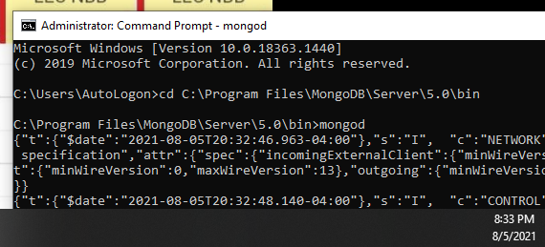

When MongoDB starts successfully, open another Windows command prompt and go the same *bin* directory:

* cd C:\Program Files\MongoDB\Server\4.2\**bin**

and execute ***mongo***

* mongo

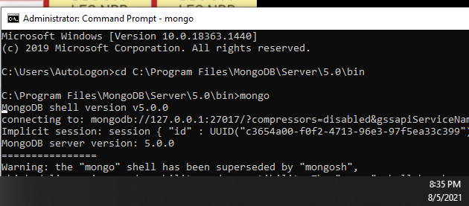

* show dbs

You should see the database *college* added to the list of your databases. To see the documents inside the database:

* use college
* db.students.find().forEach(printjson)

or

* db.students.find().pretty()

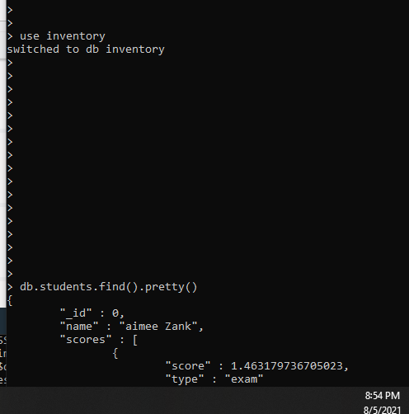

1. Write an update statement to add new fields *program* and *term* to all documents in the *students* collection and set them to values “*CPA*” and *1*.

|  |
| --- |
| db.students.updateMany({}, {"$set" : {"program" : "CPA", "term" : 1}}) |

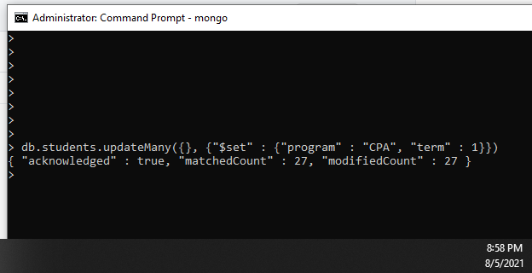

1. Write an update statement to modify the value of the *program* field to “*BTM”* for all documents in the *students* collection.

|  |
| --- |
| db.students.updateMany({}, {"$set" : {"program" : "BTM"}}) |

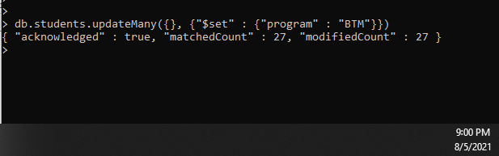

1. Write an update statement to modify the value of the program field to “*CPA”* for the student named *Jonie Raby*.

Before executing an update statement or a delete statement, you can use the *find()* method with the update or delete criteria, to see how many documents will be affected.

Write the update statement in the box below.

|  |
| --- |
| db.students.updateMany({"name" : "Jonie Raby"}, {"$set" : {"program" : "CPA"}} |

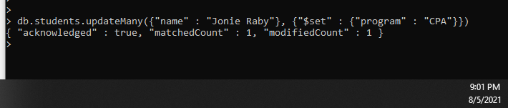

How many documents are there with the value *Jonie Raby* for the *name* field? __1_____

How many documents were updated? ___1_____

1. Write a query to show only the *program* field for the document that the value of the filed *name* is *Jonie Raby*.

|  |
| --- |
| db.students.find({"name" : "Jonie Raby"}, {"program" : 1, "_id" : 0}) |

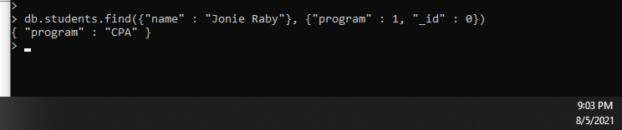

1. Write an update statement to increase the value of the *term* field by 2 for documents with *_id* 20, 22, and 24.

|  |
| --- |
| db.students.updateMany({"_id" : {"$in" : [20,22,24]}}, {"$inc" : {"term" : 2}}) |

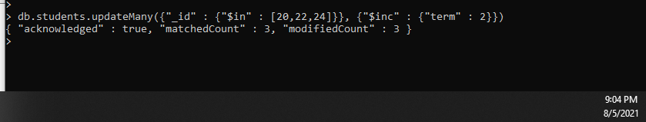

1. Write an update statement to remove the *term* field from documents that the value of the *term* filed is 3.

|  |
| --- |
| db.students.updateMany({"term" : 3}, {"$unset" : {"term" : 1}}) |

