Name: Shani Patel
Subject code: NBB
Submission date: 18/06/2021

- Display last name and job title for all employees who perform the same job as Davies. Exclude Davies from this query.

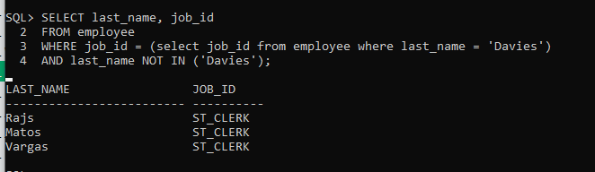

- Display last name, job title and hire date for all employees hired after Grant.
Sort the output by the most recent hire date.

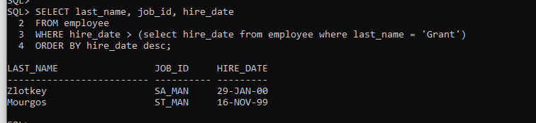

- Display city, province name, postal code and country code for all cities located in countries with NAMES (not Country Codes) starting on letter I (meaning Italy, Israel and India).
If the province is blank, show message Unknown.
Heading sample should be like:
City, Province, PCode, CC
Sort the output by city ascending. Do NOT use Join method.
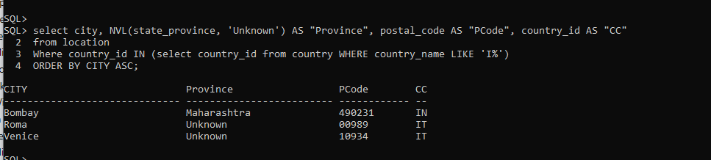

- Display last name, job title and salary for all employees who earn less than the Average salary in the Sales department. Do NOT use Join method.
Sort the output by top salaries first and then by job_title.

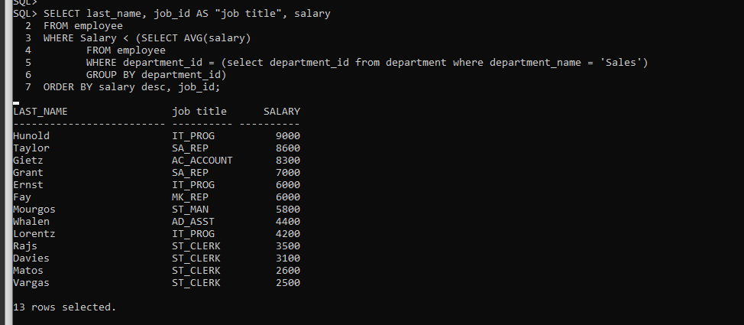

- Display last name, job title and salary for all employees whose salary matches any of
the salaries from the IT Department. Do NOT use Join method.
Sort the output by salary ascending first and then by last_name.

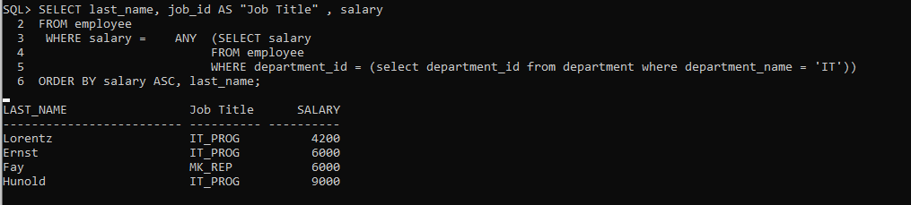

- Display last name and salary for all employees who earn less than the Lowest salary in ANY department.
Sort the output by top salaries first and then by last name.
