**LAB 01**

**Name:** Shani Patel

**Subject code:** NBB

**Submission date:** 03/06/2021

1. Write a query to display the After-tomorrow’s date in the following format:

*September 28th of year 2016*

Your result will depend on the day when you create this query.

Label the column *After Tomorrow.*

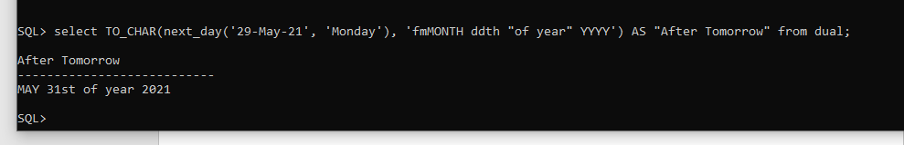

2. For each employee in departments 50 and 60 display last name, first name, salary, and salary increased by 7% and expressed as a whole number.

Label the column *Good Salary*.

Also add a column that subtracts the old salary from the new salary and multiplies by 12. Label the column Annual Pay Increase.

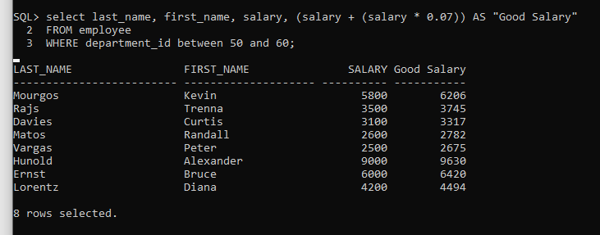

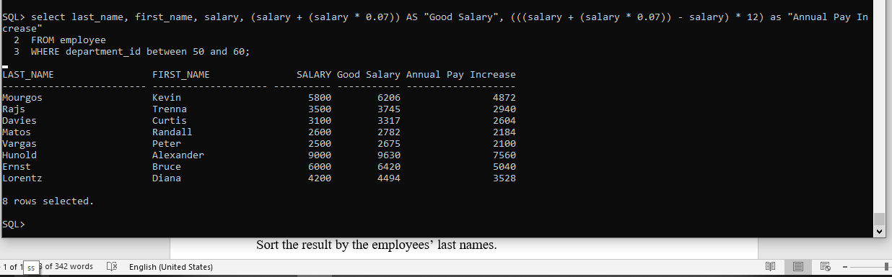

3. Write a query that displays the employee’s Full Name and Job Title in the following format:

*DAVIES, CURTIES is Store Clerk*

for all employees whose last name ends with *S* and first name starts with *C* or *K*.

Give this column an appropriate label like *Person and Job*

Sort the result by the employees’ last names.



4. For each employee hired before 1992 who is earning more than $10000, display the employee’s last name, salary, hire date and calculate the number of YEARS between TODAY and the date the employee was hired. Round the number of years up to the closest whole number. Label the column Years Worked.

Order your results by the highest paid people first and then by number of years employed. 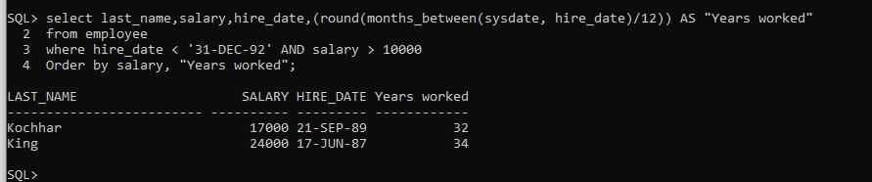

5. Create a query that displays the city names, country codes and state province names, but only for those cities that start on *S* and have at least 8 characters in their name. If city does not have province name assigned, then put *Unknown Province.*

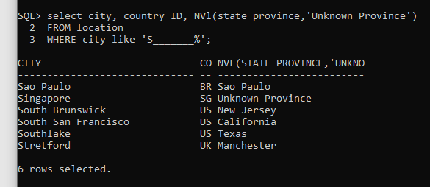

6. Display each employee’s last name, hire date, and salary review date, which is the first Tuesday after a year of service, but only for those hired after 1997.

Label the column REVIEW DAY.

Format the dates to appear in the format similar to

*TUESDAY, August the Thirty-First of year1998*

