**LAB 02**

**Name:** Shani Patel

**Seneca ID:** 152243192

**Seneca email:** [sgpatel22@myseneca.ca](mailto:sgpatel22@myseneca.ca)

**Subject code:** NBB

**Submission date:** 10/06/2021

1. Display the department number and Highest, Lowest and Average pay per each department. Name these results *High, Low and Avg.*

Sort the output so that department with highest average salary are shown first.

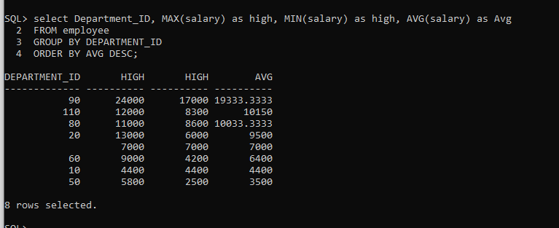

1. Display how many people work the same job in the same department. Name these results *Dept#, Job and HowMany.* Include only jobs that involve more than one person.

Sort the output so that jobs with the most people involved are shown first.

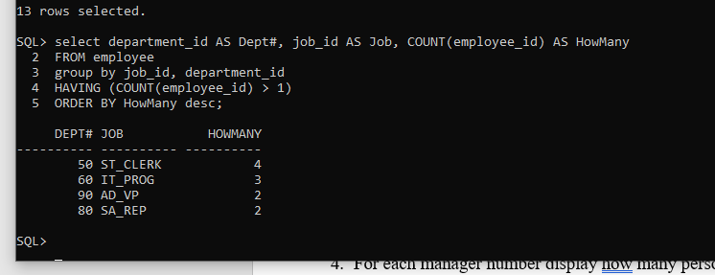

1. For each job title display the job title and total amount paid each month for this type of the job. Exclude titles *AD_PRES* and *AD_VP* and also include only jobs that require more than $15,000.

Sort the output so that top paid jobs are shown first.

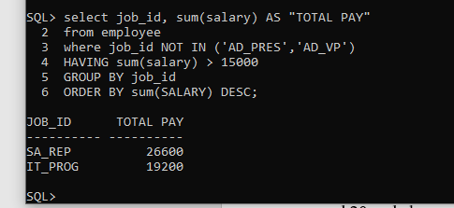

1. For each manager number display how many persons he / she supervises. Exclude managers with numbers 100, 101 and 102 and also include only those managers that supervise more than 2 persons.

Sort the output so that manager numbers with the most supervised persons are shown first.

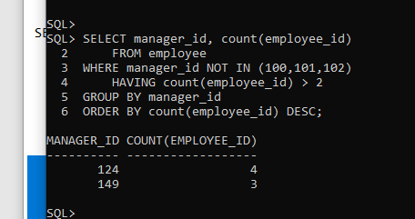

1. For each department show the latest and earliest hire date, but exclude departments 10

and 20 and also exclude those departments where the last person was hired in this century (Century started on Jan 01st 2000). Sort the output so that most recent latest hire dates are shown first.

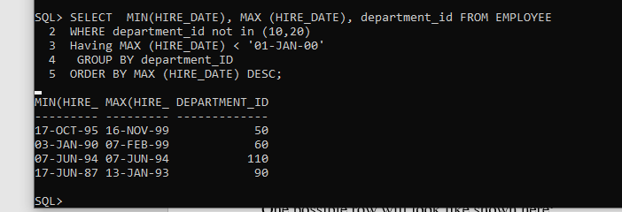

1. For each department show its name, city and how many people work there, excluding departments which name starts on S (do not use LIKE here) and showing only those ones that employ at least 3 persons. Sort the output by department name ascending.

One possible row will look like shown here:

**Executive Seattle 3**

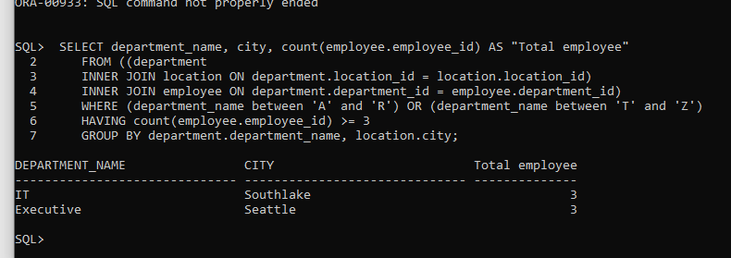

1. BONUS *Variation of Q6, Sounds like Assign1 question*, where you will show only departments that do not begin on A and with less than 3 employees, including also Empty departments. One possible row will look like shown here:

**Contracting Seattle 0**

