**LAB 04**

**Name:** Shani Patel

**Seneca ID:** 152243192

**Seneca email:** [sgpatel22@myseneca.ca](mailto:sgpatel22@myseneca.ca)

**Subject code:** NBB

**Submission date:** 23/06/2021

1. The HR department needs a list of Department IDs for departments that do not contain the job ID of ST_CLERK. Exclude NULL departments from your result. Use a set operator to create this list.

SELECT department_id "Department IDs" from department

MINUS

SELECT department_id from employee WHERE employee.job_id = 'ST_CLERK';

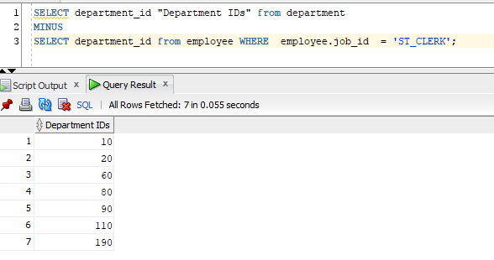

1. Display list with employee’s Id, Job Id and Salary that will include the current job and salary and all previous Jobs , if they have them (here you will display salary of -1). Use a set operator for this report.

SELECT employee_id, job_id, salary

FROM employee

UNION ALL

SELECT employee_id, job_id, -1

FROM job_history

ORDER BY employee_id;

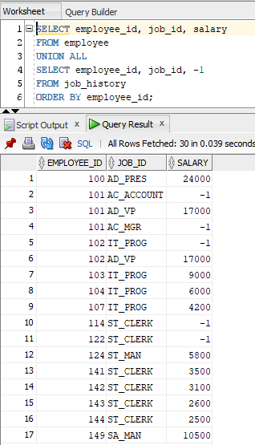

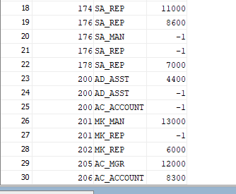

1. Display cities that no warehouse is located in them. Use set operator to answer this question.

By using set operator

SELECT city

FROM locations

WHERE location_id IN (SELECT location_id FROM locations

MINUS

SELECT location_id FROM warehouses)

ORDER BY city;

OR (NOT IN)

SELECT city

FROM locations

WHERE location_id NOT IN (SELECT location_id FROM warehouses)

ORDER BY city;

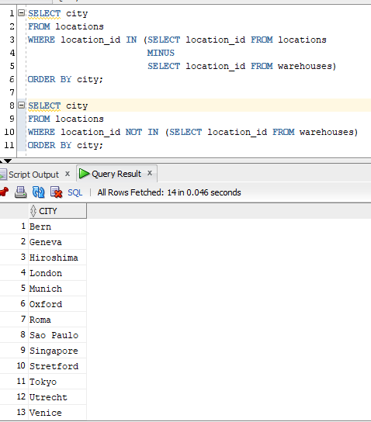

1. Display the category ID, category name, and the number of products in category 1, 2, and 5. In your result, display first the number of products in category 5, then category 1 and then 2.

Use ANY method to solve this problem.

SELECT category_id, category_name, count(*) TotalProducts

FROM product_categories JOIN products USING(category_id)

WHERE category_id = ANY (SELECT category_id FROM products WHERE category_id IN (1,2,5))

GROUP BY category_id, category_name

ORDER BY TotalProducts desc;

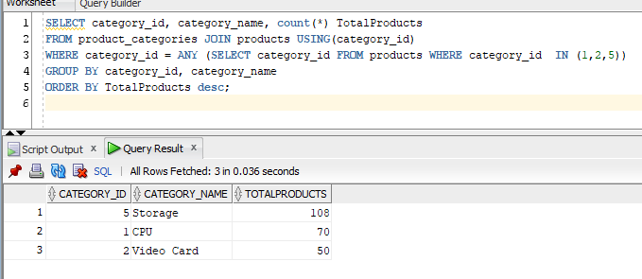

1. Display product ID for ordered products whose quantity in the inventory is greater than 250. (You are not allowed to use JOIN for this question.)

select product_id from products

INTERSECT

select product_id from inventories WHERE inventories.quantity > 250;

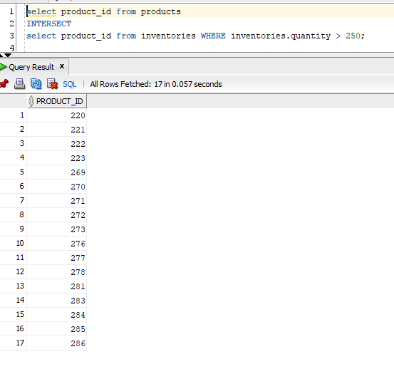

1. We need a single report to display all warehouses and the city and state that they are located in, also all states regardless of whether they have warehouses in them or not.

If state value is blank, display **No State**.

Here is a partial output:

**Loc# City State Warehouse**

**------- -------------------- ----------------- -----------------**

1 Roma No State

2 Venice No State

3 Tokyo Tokyo Prefecture

4 Hiroshima No State

5 Southlake Texas

5 Southlake, Texas

6 South San Francisco California

6 San Francisco

SELECT location_id "Loc#", city AS "City", NVL(state, 'NO State') AS "State", TO_CHAR(' ') "Warehouse"

FROM locations

UNION

SELECT location_id , TO_CHAR(' '), TO_CHAR(' '), warehouse_name

FROM warehouses;

