**Title of work:** Inventory test

**Name:** Shani Patel

**Student number :**152243192

**Section Code:** NEE

**Date submitted:** 09/07/2021

**Professor's name:** Tevin Apenteng

**Question 1 Class Diagram**

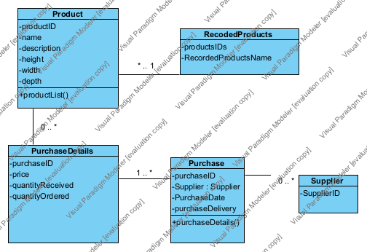

Question 2: An Object Level Sequence Diagrams

**2A. Create Product**

|  |  |  |  |
| --- | --- | --- | --- |
| Use Case Name | Create Product Information | | |
| Triggering Event | A new product of interest to the business | | |
| Brief Description | Allows the Owner to record a new product. | | |
| Actors | Owner | | |
| Related Use Cases |  | | |
| Preconditions | Owner has opened the Main Menu. | | |
| Post Conditions | Product is saved to the database and now can be purchased or used in a service. | | |
| Flow of activities | Actor | | System |
|  |  | Requests to add a new product | Displays a list of products currently recorded in the system and prompts to add a new product. |
|  |  | Enters the product name, description, height, width, and depth of the new product. | Verifies that all of the data is entered. Displays the newly created product and requests to save. |
|  |  | Request to save | Saves the product and returns to the main menu |
| Exception Conditions | * Owner chooses to cancel adding the product | | |

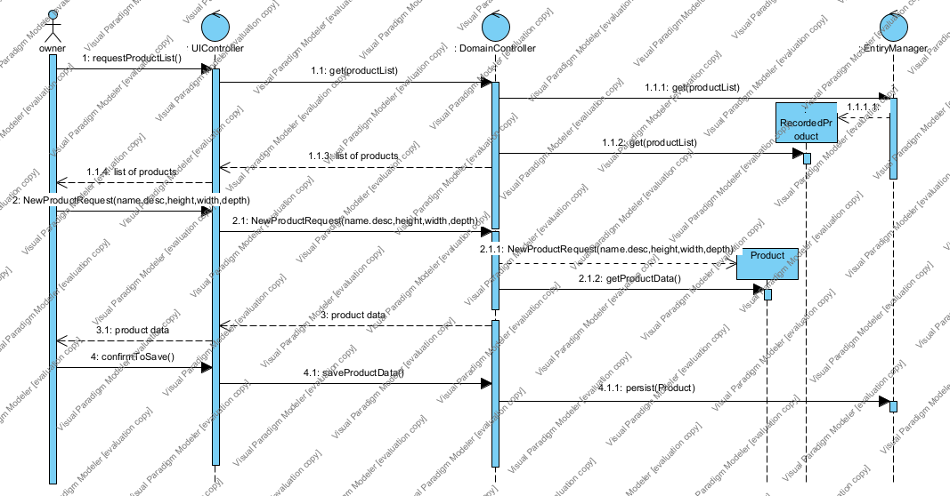

**2B. Create Purchase**

|  |  |  |  |
| --- | --- | --- | --- |
| Use Case Name | Create Purchase | | |
| Triggering Event | Purchase of a product. | | |
| Brief Description | Allows the Owner to record a new purchase. | | |
| Actors | Owner | | |
| Related Use Cases |  | | |
| Preconditions | Owner has opened the Main Menu. | | |
| Post Conditions | Purchase is saved to the database and now can be queried. | | |
| Flow of activities | Actor | | System |
|  | 1. | Requests to add a new purchase | Displays a list of suppliers and prompts for selection. |
|  | 2. | Selects a supplier. | Verifies that a supplier was selected. Displays a calendar and prompts for purchase date and expected delivery date. |
|  | 3. | Selects purchase date and expected delivery date | Verifies that purchase date and delivery date were selected.  Creates a unique identifier for the purchase. Prompts to enter product details. |
|  | loop | Chooses new detail | Displays a list of products and prompts for selection. Prompts for price, quantity ordered, and quantity received |
|  | 4. | Selects a product and enters price and quantity. | Product must be selected.  Price and quantity must be entered  Data is valid  Dollar value of the detail is calculated and added to the total dollar value of the purchase  Dollar value of purchase and purchase detail are displayed  Prompts to add another product |
|  | End | When all products selected | Displays purchase including totals, date and list of products.  Verifies that at least one product has been selected.  Prompts to save purchase |
|  | 5. | Chooses to save | Saves the purchase and returns to the main menu |
| Exception Conditions | * Owner chooses to cancel adding the purchase | | |

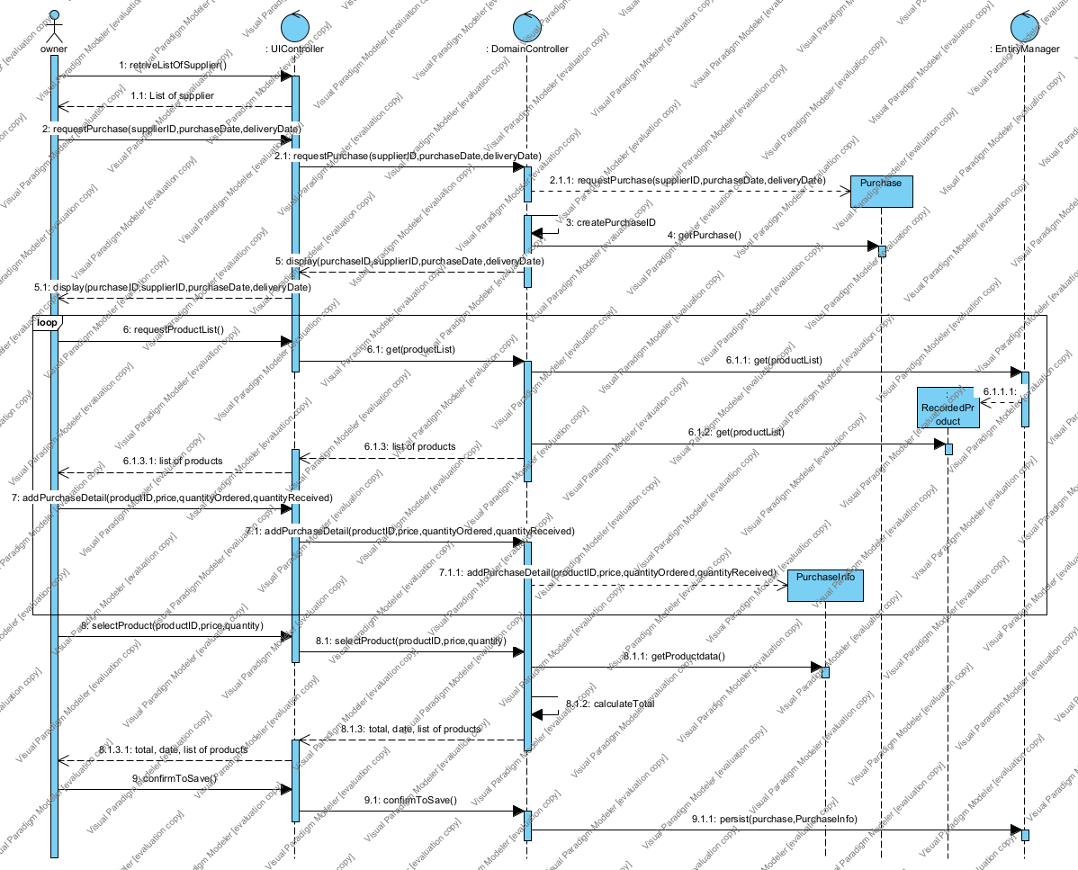

**(Supplier)**

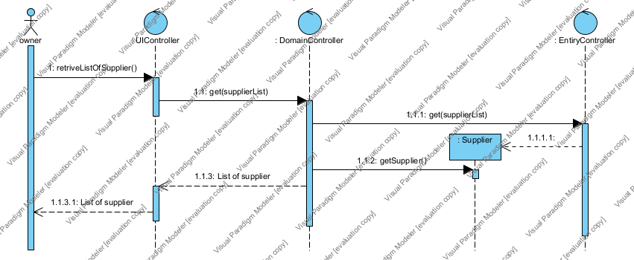

In the create purchase I create the one part of the sequence diagram(supplier) in new sequence diagram because if I create supplier diagram into create Purchase diagram than diagram looks massy.

**Question 3**

Wayne would like the system to suggest how much he should expect delivery to cost. To do that, he needs to know how much the purchase will weigh. How would you change your model to support this request?

Well, there is the simple way to calculate the weight of the purchases is that whenever Wayne purchase the new product from the buyers she calculates the weight of that purchase and added to the total weight just as we did to calculate the total dollars of the products. So, by this way she calculates the total weight of the products which helps her to calculate the expected delivery cost.

**Question 4**

**What is WHMIS? Is this important to Wayne?**

The Full form of the WHIMS is “Workplace Hazardous Materials Information System” and its main purpose is that employers receive safety and health information about the hazardous products. I can say that WHIMS is important for Wayne because Wayne’s company also offering moving services to the commercial departments. So many commercial companies have hazardous products like flammable gases, flammable liquid, flammable solid and many more. So, it is an important for the employers of the Wayne’s company to know about the WHIMS for their safety and health.

**Question 5 (worth 2 marks)**

Wayne finds a sale on packing tape and would like to buy six months’ worth of product. How would he use your model to figure out how many to buy?

Well, in this model it not mentioned about the locations so which shows that how many products can be stored so this model cannot directly guide that how many packing tape product that Wayne's buy but yes if I include in this model about the locations and the space about the locations so definitely Wayne's can get ideas about that numbers of packing tape.